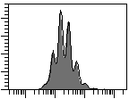
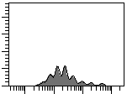
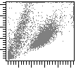
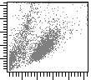
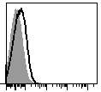
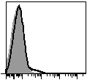
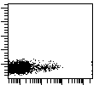
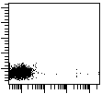
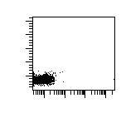
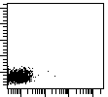
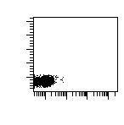
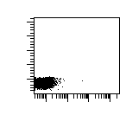
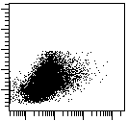
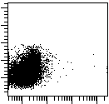
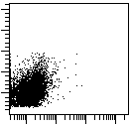
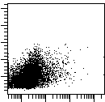
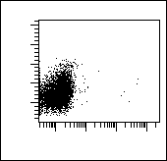
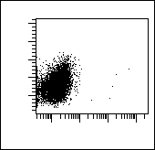
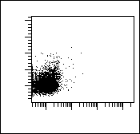
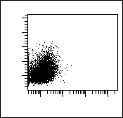
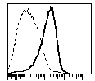
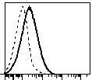
Supp. Fig. 1
A
FSC
Non-Tr
CFSE
0.8%
B
CD25
CD40L
MFI
D
Naive
3.6%
0.2%
0.1%
0.1%
0.3%
0.5%
0.1%
0.1%
Isotype control
21%
0.8 %
Non-Tr
0.8 %
6.1 %
MSC-A
0.5 %
1.8 %
1.2 %
0.5 %
Isotype Control
Naive
Non-Tr
CD25
CD40L
Counts
C
E
IFNγ
IL-2
MSC-A
- - - -
Non-Stimulated
Stimulated
Non-Stimulated
Stimulated
SSC
SSC
IFNγ
IL-2
Non-Stimulated
Stimulated
Non-Stimulated
Stimulated
MFI
SSC
SSC
4.7 %
SSC
MSC-A
Supplemental figure 1. Allogeneic bone marrow derived MSCs suppress HNT CD4⁺ T cell responses. A. CFSE-labeled naïve purified HNT CD4⁺ T cells were activated with anti-CD3 and anti-CD28 mAbs and cultured in the presence of C57Bl/6 bone marrow derived TNFα and IFNγ treated MSCs (MSC-A) or left untreated without MSCs (Non-Tr). After 4 days, CD4⁺ T cells were harvested and size and CFSE fluorescence analyzed by FACS. Values represent percentage of undivided cells. B. Expression of CD25 and CD40L in purified naïve HNT CD4⁺ T cells was analyzed by FACS. Data from one representative experiment out of two is presented. C. Day 4 activated HNT CD4⁺ T cells cultured in the presence or absence of MSC-A were harvested and expression of CD25 and CD40L was assessed by FACS. Data from one representative experiment out of 4, described in Fig. 1, is presented. D. Naïve HNT CD4⁺ T cells were stimulated with PMA and ionomycin in the presence of brefeldin A and production of intracellular IFNγ and IL-2 was assessed by FACS. E. Day 4 activated HNT CD4⁺ T cells were restimulated with PMA and ionomycin in the presence of brefeldin A and production of intracellular IFNγ and IL-2 was assessed by FACS. Percentage of cytokine producing T cells is indicated. Data from 4 independent experiments is presented. Values are represented as mean ± SEM.

Supp. Fig. 2
A
Blood Glucose (mg/dl)
Days post transfer
B
CD4
CD4/MSC
CD4
CD4 + MSC In Vivo
CD4/MSC + MSC in Vivo
Supplemental figure 2. Allogeneic bone marrow derived MSCs delay the onset of T cell mediated autoimmune diabetes. A. Sublethaly irradiated InsHA mice were adoptively transferred with 3x10⁶ naïve Clone 4 CD8⁺ T cells along with 3x10⁶ day 3 activated HNT CD4⁺ T (CD4) or 3x10⁶ day 3 activated HNT CD4⁺ T cells co-cultured with TNFα and IFNγ treated MSCs (CD4/MSC). Some CD4/MSC injected mice addtionally received 10⁶ MSCs on days 0 and 5 after transfer (CD4/MSC + MSC in vivo). Mice were monitored for the onset of autoimmune diabetes by measuring blood glucose levels. A bar is situated at the level of 300 mg/dl, concentration at which mice are considered diabetic. Data from two independent experiments is shown (n=6 mice per group). B. 3x10⁶ day 3 activated HNT CD4⁺ T cells and 3x10⁶ naïve Clone 4 CD8+ T cells were co-injected into sublethaly irradiated InsHA mice (CD4). Some mice additionally received 10⁶ MSC on days 0 and 5 after transfer (CD4 + MSC in vivo). Mice were monitored for the onset of autoimmune diabetes by measuring blood glucose levels. A bar is situated at the level of 300 mg/dl, concentration at which mice are considered diabetic. Data from two independent experiments is shown (n=4 mice per group).

C
ns
INDO
MSC-A
-
-
-
% of IFNγ+ Cells
+
+
+
-
ns

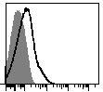
Supp. Fig. 3
Tbet
Activated
Non-Tr
Activated
MSC-A
A
Tbet
Tbet
B
C
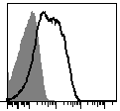
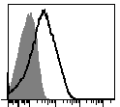
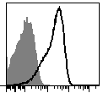
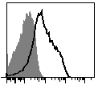
Naive
Activated
Mito
Activated
Mock
Supplemental figure 4. MSCs and MSC mitochondria prevent upregulation of T-bet in activated HNT CD4⁺ T cells. A. Expression of intracellular T-bet was analyzed in naïve purified HNT CD4⁺ T cells by FACS. B. Purified HNT CD4⁺ T cells were activated with anti-CD3 and anti-CD28 mAbs and cultured in the presence of TNFα and IFNγ treated MSCs (MSC-A) or left untreated without MSCs (Non-Tr). After 24h, CD4⁺ T cells were harvested and the expression of intracellular T-bet was analyzed by FACS. C. Naïve HNT CD4⁺ T cells were mitocepted with isolated mitochondria from TNFα and IFNγ treated MSCs or mock mitocepted without mitochondria. 12h later CD4⁺ T cells were activated with anti-CD3 and anti-CD28 mAbs and cultured during 24 h. Expression of intracellular T-bet was analyzed by FACS. Shaded histograms are Isotype-matched controls. Data from one out of 3-4 independent experiments is presented.

