SUPPLEMENTAL MATERIAL

Supplementary Table 1. The information of antibodies which were used in IHC and FCM.

Antibody/Labelling Kit | Conjugate | Isotype Control | Host | Clone | Manufacturer | Catalog #
Anti-mouse PLZF | PE | PE-Mouse IgG1, κ | Rat | Monoclonal | BD | 564850
Anti-mouse c-Kit | APC | APC-Rat IgG2b, κ | Rat | Monoclonal | BD | 553356
Anti-mouse DDX4-MVH/VASA | Unconjugated | FITC- Rat IgG2b | Rabbit | Monoclonal | Invitrogen | MA5-15565
Anti-mouse CD44 | PE | PE- Rat IgG2b | Rat | Monoclonal | BD | 561860
Anti-mouse CD140a | APC | APC-Rat IgG2a | Rat | Monoclonal | BD | 562777
Anti-mouse Sca-1 | PE | PE-Rat IgG2a | Rat | Monoclonal | BD | 560654
Anti-mouse CD34 | PE | PE-Rat IgG2a | Rat | Monoclonal | BD | 551387
Anti-mouse CD45 | FITC | FITC- Rat IgG2b | Rat | Monoclonal | BD | 561088
Anti-mouse SALL4 | Unconjugated | - | Rabbit | Monoclonal | Abcam | ab29112
Rabbit HRP/DAB IHC Detection Kit | - | - | Goat | Monoclonal | Abcam | ab236466

Supplementary Information 1.

Time-dependent flow rate (Q) with respect to the height of culture medium were analytically calculated based on Hagen–Poiseuille equation (1) for the given dimensions of resistive channel region using MATLAB. Here, hydraulic resistances (R_{h}) of the tissue chamber, medium perfusion compartments, and medium flow channel are ignored because their resistances are significantly lower respective to that of the resistive microchannel region. Equations 1 and 2 are obtained as follows where μ and ρ are the dynamic viscosity (Pa⸱s) and density (kg/m³) of cell culture medium; h₀ is the initial hydraulic-head length (m) at the medium reservoir tank; w, h and L are the width (m), height (m) and length (m) of the resistive microchannel; A and g are the area of the tube cross-section (m²) and the acceleration of gravity (m/s²), respectively.

[1]

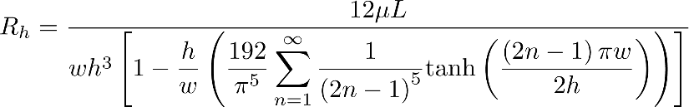

[2]

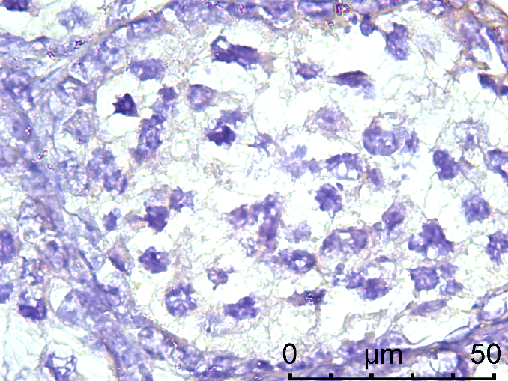

Supplementary Figure 1. Negative control micrograph presenting non-immunolabelling for the SALL4 SSPC marker (1000x).

