Supplementary data file for:

Report of a phase 1 clinical trial for safety assessment of human placental mesenchymal stem cells therapy in patients with Critical limb ischemia (CLI)
Zeinab Shirbaghaee¹, Saeed Heidari Keshel¹, Mehdi Rasouli¹, Majid Valizadeh², Seyed Saeed Hashemi Nazari³, Mohammad Hassani⁴*, and Masoud Soleimani^{1,5} *

¹Department of Tissue Engineering and Applied Cell Sciences, School of Advanced Technologies in Medicine, Shahid Beheshti University of Medical Sciences, Tehran, Iran.
²Obesity Research Center, Research Institute for Endocrine Sciences, Shahid Beheshti University of Medical Sciences
³Prevention of Cardiovascular Disease Research Center, Department of Epidemiology, School of Public Health and Safety, Shahid Beheshti University of Medical Sciences, Tehran, Iran.
⁴Department of Vascular and Endovascular Surgery, Ayatollah Taleghani Hospital Research Development committee, Shahid Beheshti University of Medical Sciences, Tehran, Iran.
⁵Applied Cell Sciences and Hematology Department, Faculty of Medical Sciences, Tarbiat Modares University, Tehran, Iran.
Corresponding authors
Dr. Masoud Soleimani.
E-mail: Soleim_m@modares.ac.ir
Dr. Mohammad Hassani
E-mail: drmhasani57@sbmu.ac.ir

Supplementary data file include Fig S1 to S2 and Table S1 to S3

Figure S1. Flow cytometric characterization of PM-MSCs. The cells were negative for CD45, CD34 (hematopoietic stem cell markers). They displayed positive expression for MSCs markers; CD105, CD90 and CD29.
Figure S1. a. Placenta 1 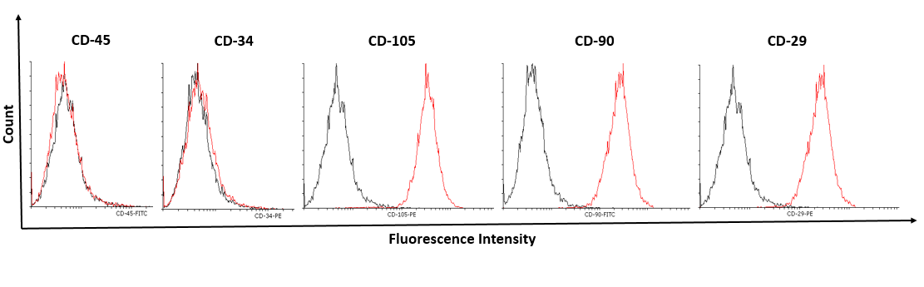

Figure S1. b. Placenta 2 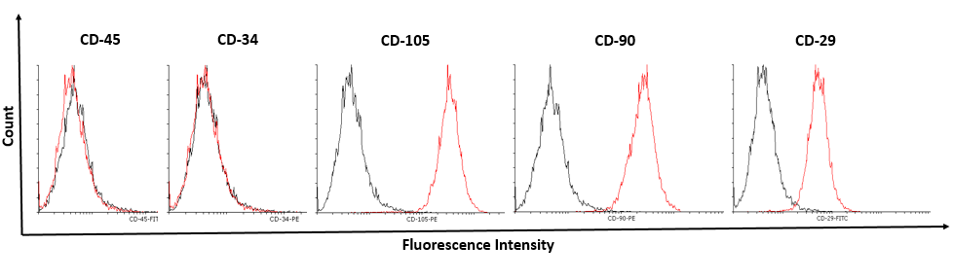

Figure S2. Flow cytometry of CD4 and CD8 and CD25 on patients with CLI.

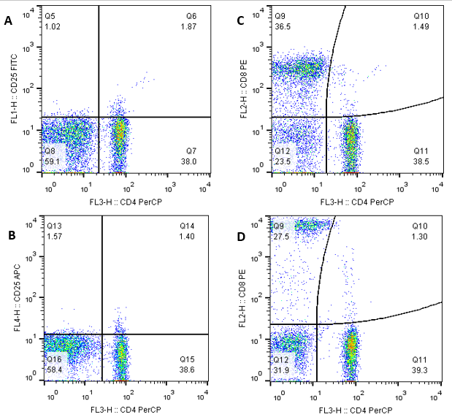
Figure S2. a. Patient 2, A. CD4/CD25 before P-MSC injection, B. CD4/CD25 after P-MSC injection, C. CD4/CD8 before P-MSC injection, D. CD4/CD8 after P-MSC injection.

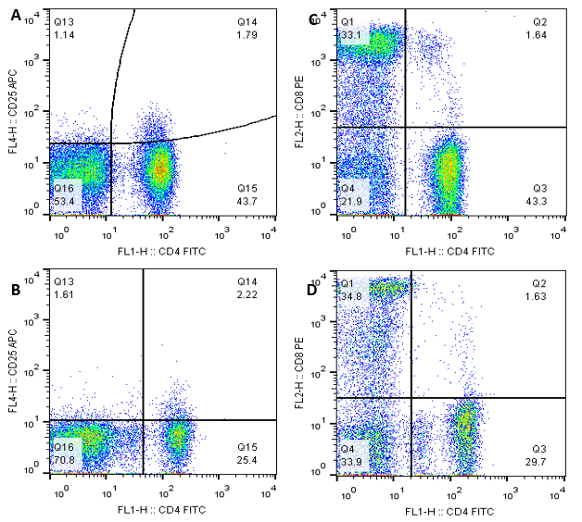
Figure S2. b. Patient 4, A. CD4/CD25 before P-MSC injection, B. CD4/CD25 after P-MSC injection, C. CD4/CD8 before P-MSC injection, D. CD4/CD8 after P-MSC injection.

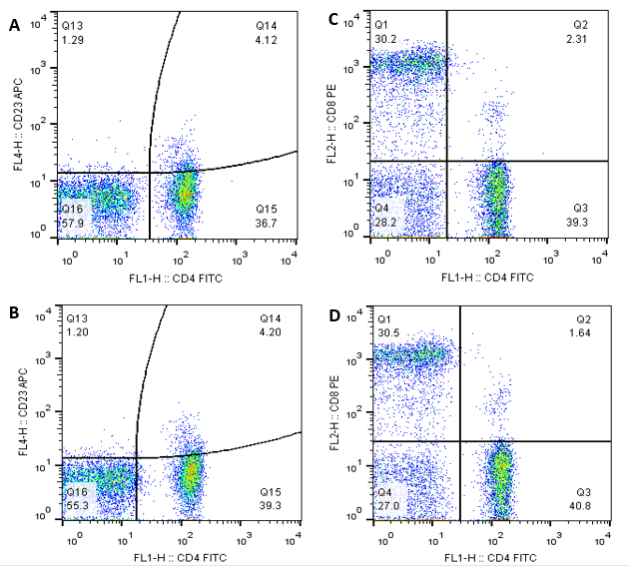
Figure S2. c. Patient 9, A. CD4/CD25 before P-MSC injection, B. CD4/CD25 after P-MSC injection, C. CD4/CD8 before P-MSC injection, D. CD4/CD8 after P-MSC injection.

Table S1. Comparison of CD4, CD8, and CD25 markers results on baseline and 6 Months after implantation of P-MSCs
Case number | CD4% |  | CD8% |  | CD25% |  | CD4/CD25% |  | CD4/CD8%
Case number | Before | After | Before | After | Before | After | Before | After | Before | After
1 | 46.1 | 50.8 | 21.1 | 22.9 | 1.3 | 1.46 | 4.98 | 2.7 | 0.43 | 9.03
2 | 38.5 | 39.3 | 36.5 | 27.5 | 1.02 | 1.57 | 1.87 | 1.4 | 1.49 | 1.3
3 | 43.1 | 45.5 | 22.9 | 22 | 1.61 | 0.54 | 3.75 | 1.86 | 7.53 | 4.76
4 | 43.3 | 29.7 | 33.1 | 34.8 | 1.14 | 1.61 | 1.79 | 2.22 | 1.64 | 1.63
6 | 44.1 | 20.2 | 31.7 | 18 | 3.17 | 1 | 8.61 | 2.77 | 2.99 | 1.09
7 | 42.2 | 44.8 | 40.9 | 39.3 | 0.77 | 0.74 | 3.32 | 4.18 | 3.13 | 2.96
8 | 45.1 | 45.6 | 31.4 | 20.5 | 1.09 | 1.64 | 3.84 | 5.31 | 1.83 | 0.32
9 | 39.3 | 40.8 | 30.2 | 30.5 | 1.29 | 1.21 | 4.12 | 4.2 | 2.31 | 1.64
mean(SD) | 40.8 | 33.23 | 28.33 | 24.07 | 1.26 | 1.03 | 3.41 | 2.74 | 2.61 | 1.71

Table S2. Laboratory findings before the first and after the last cell infusions.
Variables | Patient 1  Base line, 6month | Patient 2  Base line, 6month | Patient 3  Base line, 6month Base line, , 6 month | Patient 4  Base line, 6month | Patient 5 | Patient 6  Base line, 6month | Patient 7  Base line, 6month | Patient 8  Base line, 6month | Patient 9  Base line, 6month | Normal Range | Mean (SD)  Base line, 6month | Significantly different (P ˂ 0.05)?
WBC count (× 10⁹/L) | 7800 6500 | 9300 13000 | 11800 13200 | 15300 14600 | 27700 25000 | 10500 11000 | 11700 11500 | 11200 12200 | 10500  11000 | 3400-12500 | 12.87  13.11 | No
Fbs(mg/dl) | 90 86 | 200 180 | 70 75 | 205 131 | 200 190 | 84 80 | 114 96 | 86 76 | 97 95 | 70-115 | 127.33  112.11 | Yes
Hb A1C (%) | 5.1 5.2 | 7 6.5 | 5.7 5.3 | 7 6.5 | 7 7 | 5.1 5.2 | 6.5 6 | 5.1 5.1 | 5 4.9 | 3-6 | 5.94  5.74 | No
BUN (mg/dl) | 16 20 | 11 8 | 11 8 | 11 10 | 15 13 | 10 11 | 14 12 | 13 12 | 11 9 | 8-21 | 12.44  11.44 | No
Cr (mg/dl) | 0.8 1.3 | 1.1 0.8 | 1.2 0.8 | 1 0.9 | 0.8 1 | 1 0.9 | 1 0.9 | 1.1 1 | 0.8 0.8 | 0.7-1.4 | 0.98  0.93 | No

Table S3. Characteristics of placenta donors
Donor No | age | birth history | Medical status | COVID-19 vaccine | Hepatitis B Vaccine | Tetanus Vaccines
1 | 26 | Yes/ 1 | healthy | BBIBP-CorV( Sinopharm)/ 3 dose | Recombivax HB/ 3 dose | Tdap
2 | 24 | No | healthy | BBIBP-CorV( Sinopharm)/ 3 dose | Recombivax HB/ 3 dose | Tdap

