Additional file 3: Figure S2.
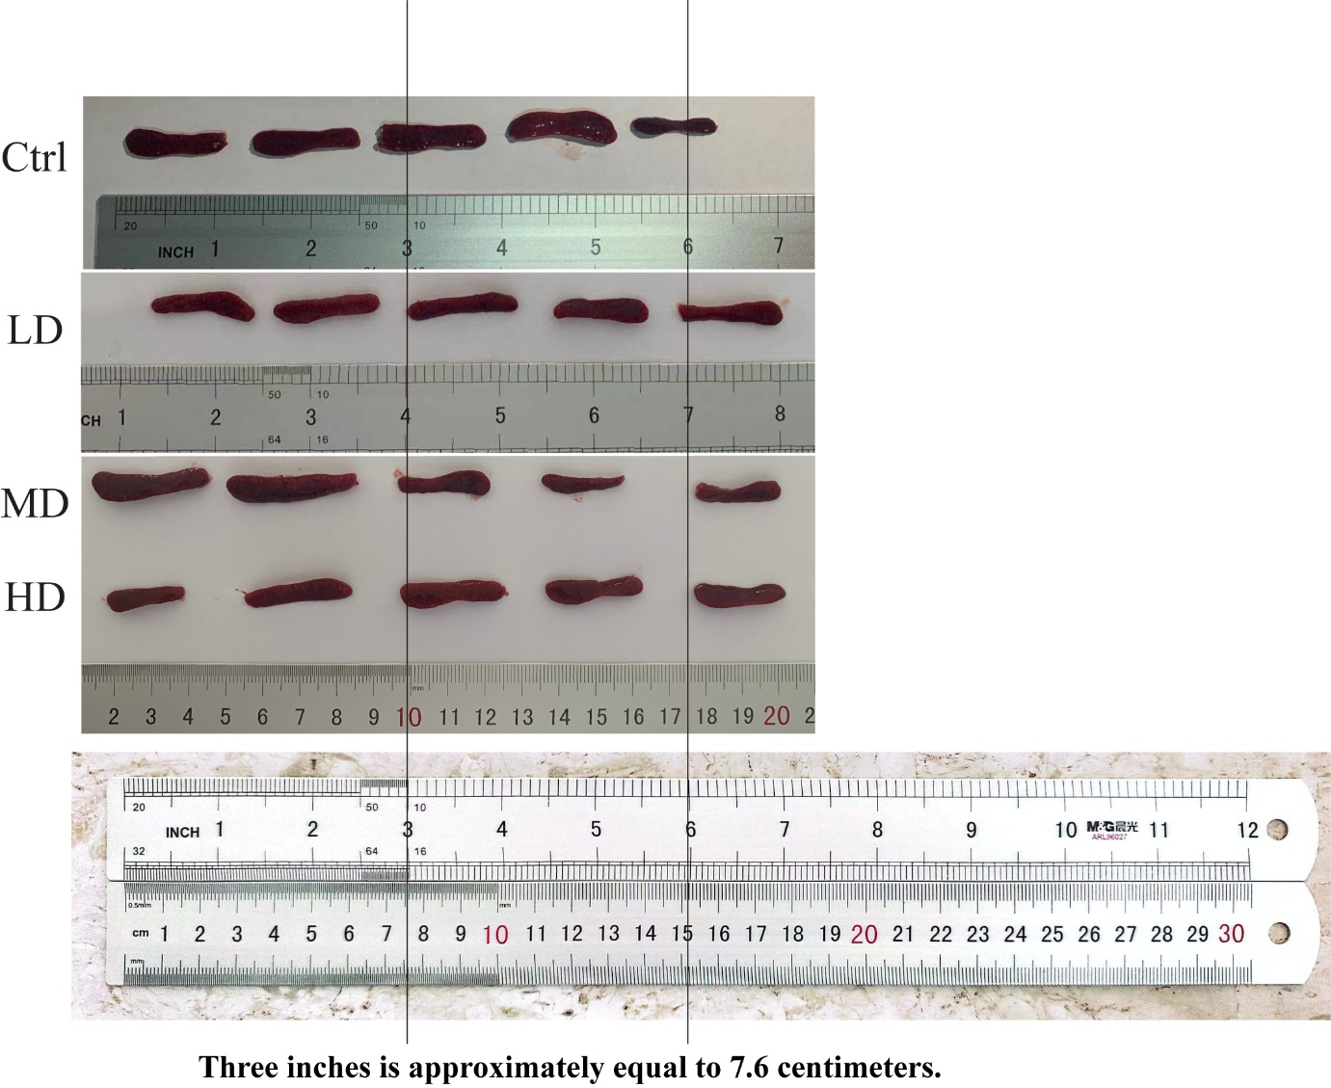

Additional file 3: Figure S2. hUC-MSC transplantation effects on spleen weight of 14-week-old MRL/lpr mice. Spleen weight ratio of mice in the MSC transplantation groups (MD and HD groups) showed a decrease compared with the Ctrl. (Ctrl: control, LD: low dose, MD: middle dose, HD: high dose). Compare the distance measured by two rulers of different units. The result indicated that the distance measurement was the same. The number of mice is n = 5.

