Supplementary Table 1. Product ID of Antibodies

Immunofluorescence staining antibody | Product ID
KRT15/ CK15 | Abcam, ab80522
KRT19/ CK19 | Abcam, ab76539
CD31 | Abcam, ab76533
VIM | Abcam, ab92547
KRT 14 | Abcam, ab51054
CXCR4 | Abcam, ab124824
AQP5 | Affinity Biosciences, AF5169
LAM | Abcam, ab11575
hTERT | Abcam, ab111584
Flow Cytometry Antibody | Product ID
CD29 | Biolegend, 303015
CD49f | Biolegend, 313607
CK-kit | BD, 550953
HLA-ABC | Biolegend, 311403
HLA-DR | Biolegend, 307605
CD117 | Biolegend, 313213
SSEA-1 | Biolegend, 125609
CD90 | Biolegend, 328115

Supplementary Table 2. Primer sequences used in this study.
Gene | Primer sequences (5’-3’)
LGR5 | F:CATCGCAGCAGTGAACAT
LGR5 | R:GCCAGAGTAAGCAGGAAA
SOX2 | F:CCATGCAGGTTGACACCGTTG
SOX2 | R:TCGGCAGACTGATTCAAATAATACAG
KRT5 | F:GAGGAATGCAGACTCAGTGGA
KRT5 | R:CACTGCTACCTCCGGCAAG
KRT7 | F:ATCGACAAGGTGCGGTTTCT
KRT7 | R:TCAAAGATGTCTGGGAGGCG
KRT14 | F:GCAGCAGAACCAGGAGTACAA
KRT14 | R:AGGAGGTCACATCTCTGGATGAC
KRT19 | F:TGAGGAGGAAATCAGTACGCT
KRT19 | R:CGACCTCCCGGTTCAATTCT
MUC5B | F:TCAAGTCCGCATCAACACGA
MUC5B | R:CTGAGTACTTGGACGCTCCG
AMY1B | F:GAGGGGTTCAGGTCTCTCCA
AMY1B | R:TGTTCCTGCACTCACAGCAT
AQP5 | F:CCGCTCACTGGGTTTTCTGG
AQP5 | R:TTTGATGATGGCCACACGCT
GAPDH | F:GCACCGTCAAGGCTGAGAAC
GAPDH | R:TGGTGAAGACGCCAGTGGA
KRT15 | F: CCAGTCCGTGCCTTAGAG
KRT15 | R: AGGAACAGCCGCCATACA
Ki67 | F:ACGCCTGGTTACTATCAAAAGG
Ki67 | R:CAGACCCATTTACTTGTGTTGGA

Supplementary figure 1.

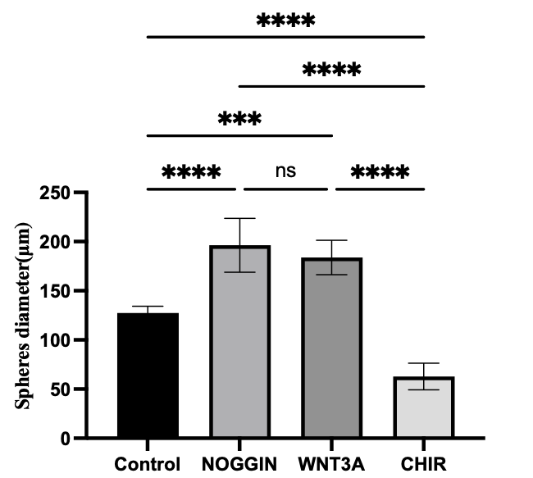
Supplementary Figure 1. Measurement of the diameter of hMSGSCs spheres upon supplementation with different signal pathway factors (day 10) (*P < 0.05, ****P < 0.0001, ns=non-significant)

