Supplementary Materials
Vocal fold restoration after scarring: Biocompatibility and efficacy of an MSC-based bioequivalent (Svistushkin et al.)
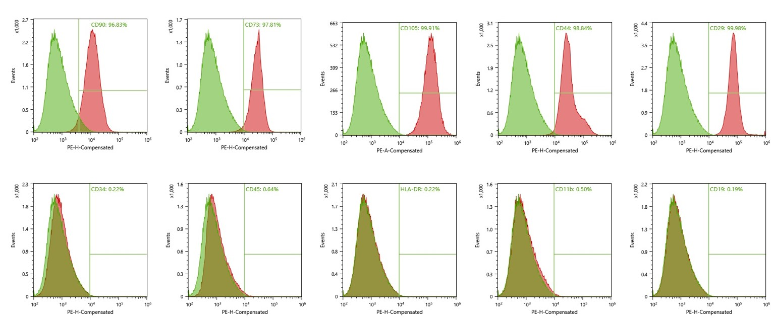
Figure S1. Immunophenotyping the MSC culture (representative graphs achieved using flow cytometry).

