ADDITIONAL FILE 1
Titel
Bone marrow from periacetabular osteotomies as a novel source for human mesenchymal stromal cells

Authors
Maximilian Handke, Anastasia Rakow, Debora Singer, Lea Miebach, Frank Schulze, Sander Bekeschus, Janosch Schoon, Georgi I. Wassilew

__________________________________________________________________________

Table S1 Patient and sample data
donor# | age | sex | surgical treatment | BM weight [g] | BM-MNC isolation | number of BM-MNCs isolated [x 10⁶] | BM-MNC-FACS | H&E  histology | CFU | MSC-FACS | post-thaw viability | viability | cell number | β-gal | Alizarin Red | ALP activity | P1NP assay | NileRed/ DAPI | total protein | proteo-glycan | spheroid histology
1 | 18 | f | PAO | 1.41 | x | 32.8 |  |  |  | x |  | x | x |  |  | x | x | x | x | x | x
2 | 29 | m | PAO | 1.11 | x | 20.3 |  |  |  | x |  | x | x |  | x | x | x | x | x | x | x
3 | 31 | f | PAO | 0.57 | x | 21.2 |  |  |  | x | x | x | x | x | x | x | x | x | x | x | x
4 | 36 | f | PAO | 0.45 | x | 11.8 |  |  |  | x |  | x | x |  | x | x | x | x | x | x | x
5 | 25 | m | PAO | 0.68 | x | 28.3 |  |  |  | x | x | x | x | x | x | x | x | x | x | x | x
6 | 23 | f | PAO | 0.78 | x | 40.5 |  |  |  | x | x | x | x | x | x | x | x | x | x | x | x
7 | 34 | f | PAO | n.d. |  | n.d. |  | x
8 | 29 | f | PAO | n.d. |  | n.d. |  | x
9 | 27 | m | PAO | n.d. |  | n.d. |  | x
10 | 25 | f | PAO | n.d. |  | n.d. |  | x
11 | 33 | f | PAO | n.d. |  | n.d. |  | x
12 | 40 | f | PAO | 0.51 | x | 38.5 | x
13 | 32 | m | PAO | 0.72 | x | 12.9 | x | x
14 | 27 | m | PAO | 0.23 | x | 21.8 | x
15 | 39 | m | PAO | 0.71 | x | 20.6 | x
16 | 33 | f | PAO | 0.29 | x | 9.3 | x
17 | 38 | f | PAO | 0.58 | x | 59.2 | x
18 | 36 | f | PAO | 0.36 | x | 4.8
19 | 39 | m | PAO | 0.56 | x | 21.8
20 | 29 | m | PAO | 0.24 | x | 4.7 |  |  |  |  | x |  |  | x
21 | 30 | m | PAO | 0.60 | x | 8.2
22 | 35 | m | PAO | 0.44 | x | 7.9 |  |  |  |  | x |  |  | x
23 | 44 | f | PAO | 0.49 | x | 10.0
24 | 42 | f | PAO | 0.25 | x | 2.1
25 | 31 | f | PAO | 0.35 | x | 6.8
26 | 36 | f | PAO | 0.27 | x | 3.0
27 | 30 | f | PAO | 0.47 | x | 20.3 |  |  |  |  | x |  |  | x
28 | 43 | m | PAO | n.d. | x | 23.1 |  |  | x
29 | 40 | f | PAO | n.d. | x | 23.4 |  |  | x
30 | 37 | m | PAO | n.d. | x | 29.7 |  |  | x
31 | 41 | m | PAO | n.d. | x | 32.8 |  |  | x
32 | 74 | f | THA | 4.44 | x | 505.0 | x |  |  | x | x | x | x | x |  | x | x | x | x | x | x
33 | 81 | f | THA | 2.57 | x | 180.5 | x |  |  | x | x | x | x | x | x | x | x | x
34 | 58 | m | THA | 4.53 | x | 235.5 | x |  |  | x | x | x | x | x | x | x | x | x | x | x | x
35 | 86 | f | THA | 4.41 | x | 247.5 | x |  |  | x |  | x | x |  | x | x | x | x | x | x | x
36 | 62 | m | THA | 3.89 | x | 236.5 | x |  |  | x | x | x | x | x | x | x | x | x | x | x | x
37 | 59 | m | THA | 3.14 | x | 403.0 | x |  |  | x | x | x | x | x | x | x | x | x | x | x | x
38 | 83 | f | THA | n.d. |  | n.d. |  | x
39 | 63 | m | THA | n.d. | x | 54.5 |  |  | x
40 | 41 | f | THA | n.d. | x | 118.2 |  |  | x
41 | 65 | f | THA | n.d. | x | 94.8 |  |  | x
42 | 61 | f | THA | n.d. | x | 40.2 |  |  | x
Abbreviations: ALP, alkaline phosphatase; β-gal, β-galactosidase staining; BM, bone marrow; BM-MNCs, bone marrow mononuclear cells; CFU, colony forming unit assay; FACS, fluorescence activated cell sorting; H&E, haematoxylin & eosin; MSC, mesenchymal stem/stromal cell; n.d., not determined; P1NP, human procollagen type I N-terminal propeptide; PAO, periacetabular osteotomy; THA, total hip arthroplasty

Table S2 Preoperative medication and concomitant diseases of patients whose bone marrow was used for BM-MSC isolation and subsequent BM-MSC characterization.
donor# | age | sex | surgical treatment | preoperative concomitant medication | comorbidities
1 | 18 | f | PAO | none | irritable bowel syndrome, migraine, atopic dermatitis, allergic rhinitis, eating disorder, depressive disorder
2 | 29 | m | PAO | none | history of multiple fractures and surgeries of the right-sided lower leg, spinal disc herniation L4/5
3 | 31 | f | PAO | none | none
4 | 36 | f | PAO | none | history of right-sided humerus fracture, history of appendectomy
5 | 25 | m | PAO | none | history of appendectomy
6 | 23 | f | PAO | L-thyroxine, venlafaxine | hypothyroidism, depressive disorder, nephrolithiasis, history of surgical treatment of spinal disc herniation L4/5
32 | 74 | f | THA | candesartan, lercanidipine, allopurinol | arterial hypertension, hyperuricemia, history of lumbar spinal disc herniation, history of SARS-CoV2-infection
33 | 81 | f | THA | ASA, atorvastatin, lisinopril, metoprolol, lercanidipine, indapamide, metformin, insulin glulisine, insulin glargine | arterial hypertension, hyperlipoproteinemia, peripheral arterial disease, IDDM, diabetic polyneuropathy, obesity
34 | 58 | m | THA | none | none
35 | 86 | f | THA | ASA, candesartan, amlodipine, atorvastatin, vitamin B12, macrogol | arterial hypertension. coronary artery disease, hyperuricemia, varicosis, unilateral carotid artery stenosis, history of right-sided total knee arthroplasty, left-sided total hip arthroplasty, cholecystectomy and hysterectomy
36 | 62 | m | THA | spironolactone, simvastastin, bisoprolol | arterial hypertension, proteinuria, primary hyperaldosteronism / Conn's syndrome, history of surgery for pectus excavatum
37 | 59 | m | THA | hydrochlorothiazide, spironolactone, ramipril / amlodipine, carvedilol, metformin, sitagliptin | arterial hypertension, NIDDM, COPD, obesity
Abbreviations: ASA, acetylsalicylic acid; COPD, chronic obstructive pulmonary disease; IDDM, insulin dependent diabetes mellitus; NIDDM, non-insulin-dependent diabetes mellitus; PAO, periacetabular osteotomy; THA, total hip arthroplasty

Figure S1
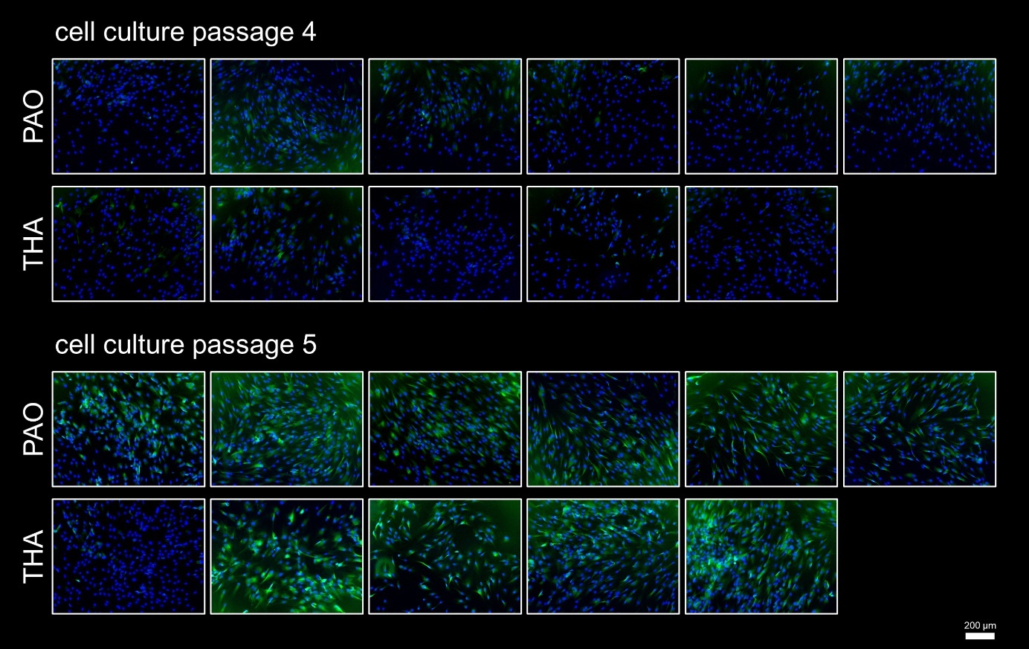
Fig. S1 Fluorescence images of BM-MSCs from cell culture passage four and five isolated from six PAO samples and five THA samples stained for senescence-associated beta galactosidase. Green, beta galactosidase; blue, nuclei.

Table S3 Median values of multiplexed cell signaling molecules and p-values of the according group comparisons.
analyte | PAO - EM  median [pg/ml] | THA - EM  median [pg/ml] | p-value | PAO - OM  median [pg/ml] | PAO - OM  median [pg/ml] | p-value
HGF | 339 | 589 | 0.276 | 22.3 | 118 | 0.096
IL-1RA | 469 | 443 | 0.747 | 137 | 213 | 0.310
IL-6 | 2,182 | 1,350 | 0.214 | 407 | 146 | 0.175
IL-8 | 328 | 186 | 0.306 | 861 | 400 | 0.055
SCF | 8.88 | 9.65 | 0.937 | 16.0 | 7.50 | 0.066
MCP-1 | 2,642 | 1,584 | 0.751 | 175 | 330 | 0.240
M-CSF | 1.39 | 0.71 | 0.455 | 3.02 | 1.43 | 0.116
OPG | 31,374 | 21,609 | 0.134 | 25,060 | 17,696 | 0.485
TGF-ß1 | 6.61 | 14.3 | 0.113 | 8.94 | 6.61 | 0.015
SDF | 4,084 | 3,811 | 0.310 | 562 | 642 | 0.542
TIMP2 | 13,811 | 9,046 | 0.065 | 15,070 | 9,492 | 0.039
VEGF | 448 | 418 | 0.818 | 189 | 125 | 0.048
Abbreviations: EM, expansion medium, OM, osteogenic medium

