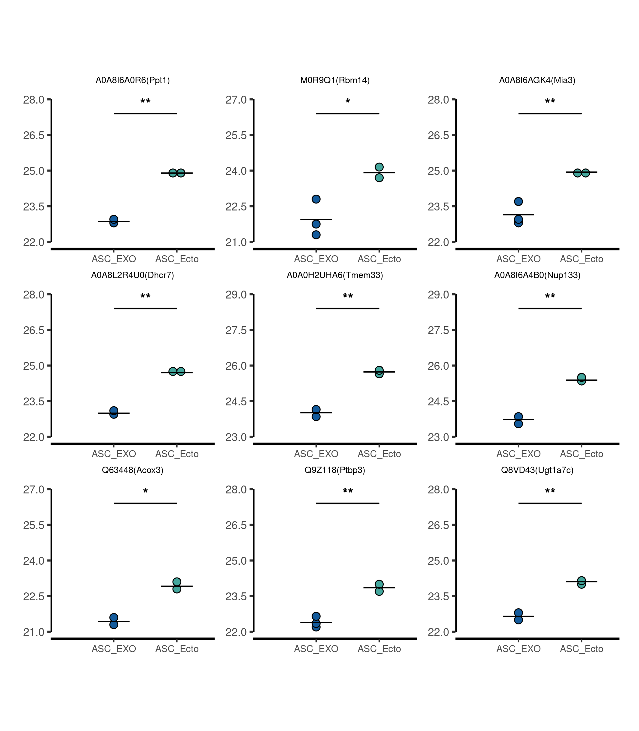
Supplementary Fig. 3. Top 9 most down-regulated proteins.

