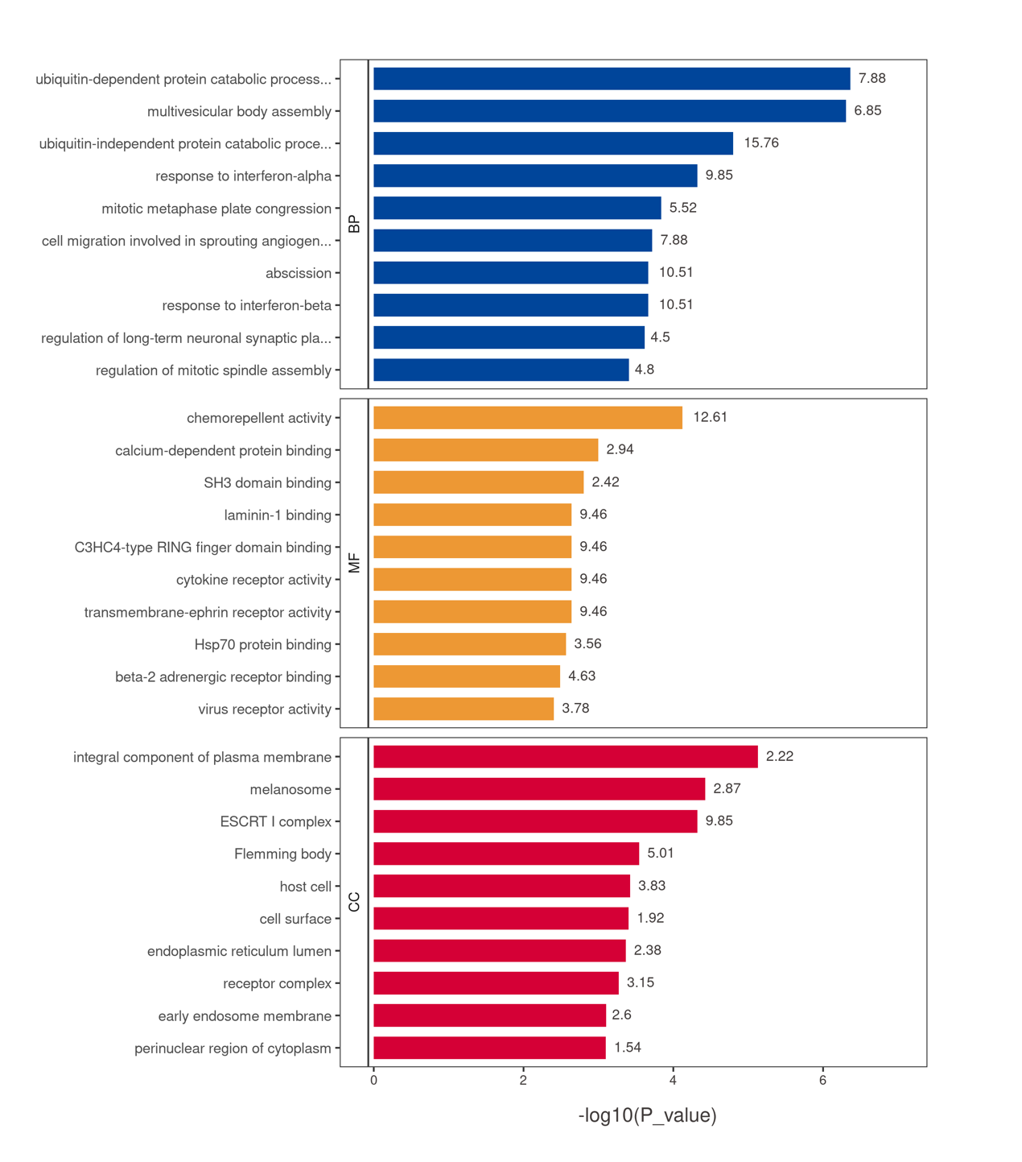
Supplementary Fig. 4. GO analysis. BP, biological processes; CC, cellular components; MF, molecular functions.

