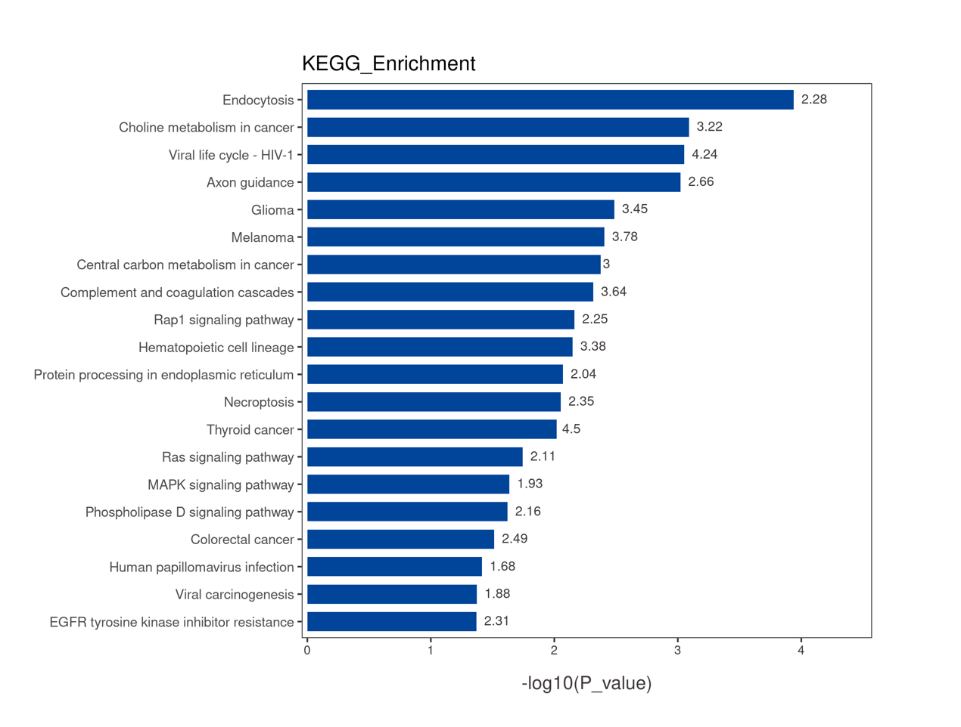
Supplementary Fig. 5. KEGG pathways enrichment analysis.

