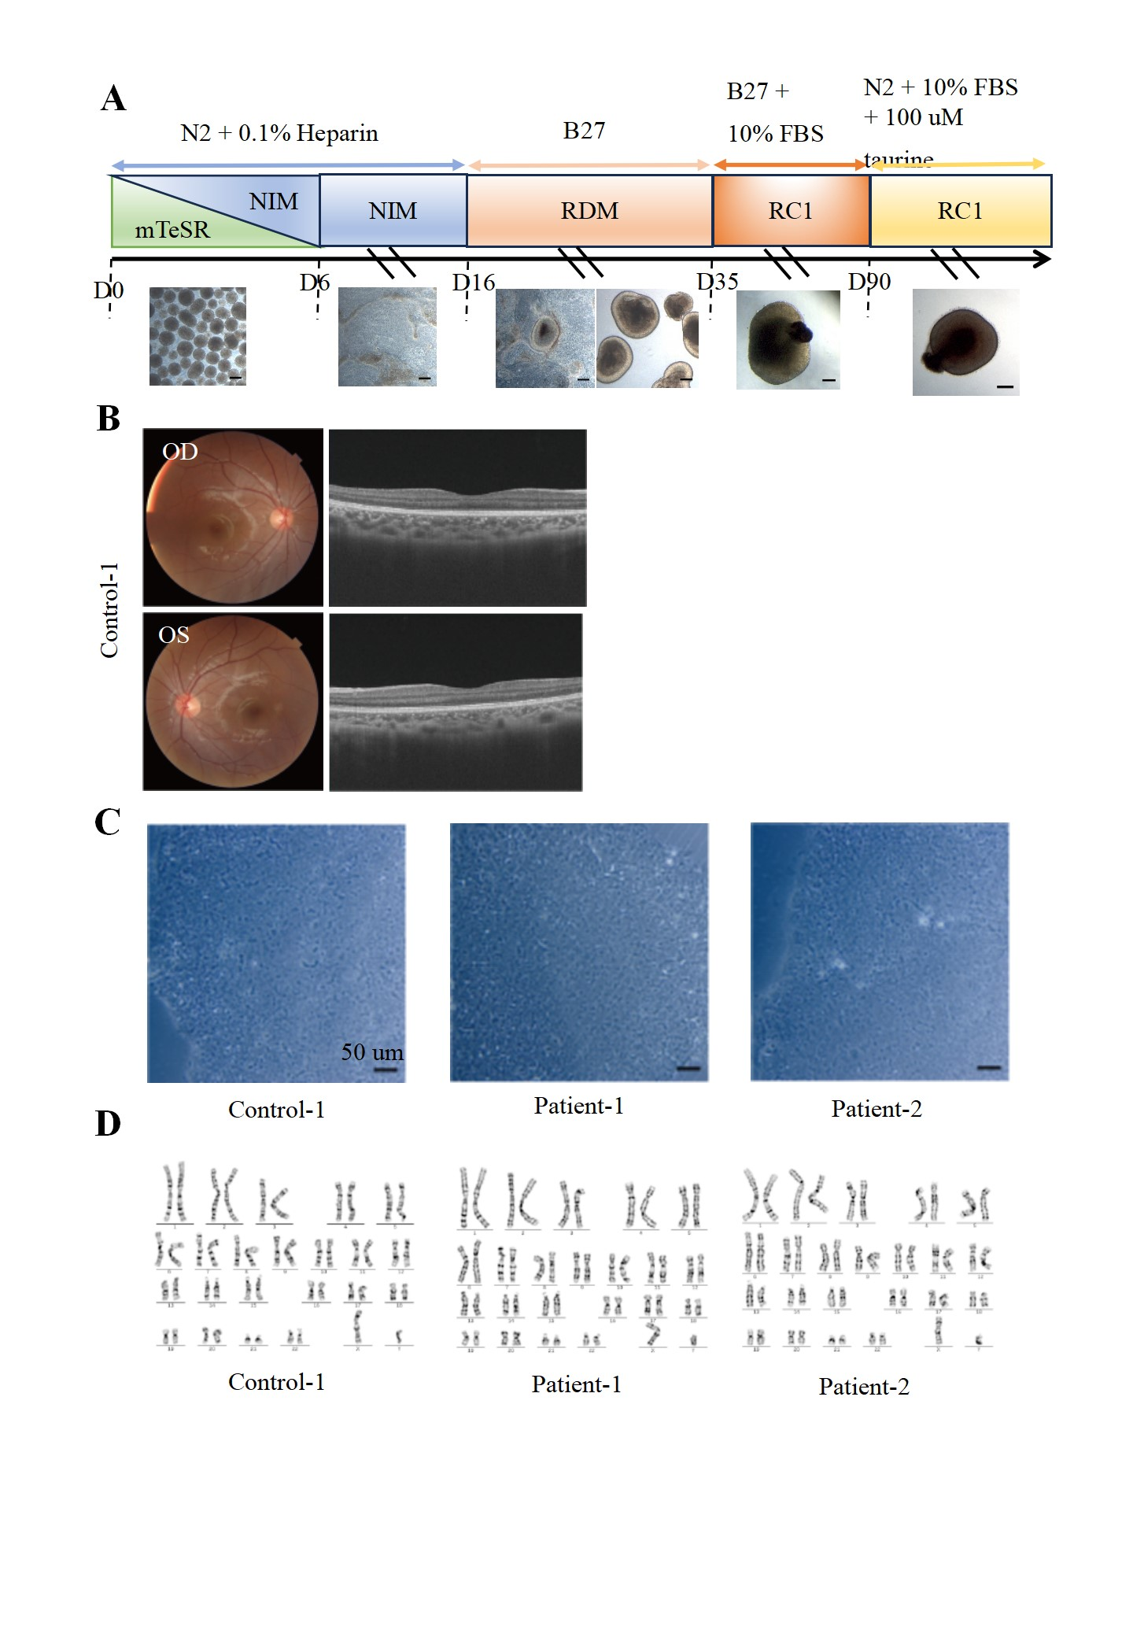
Figure S1. The workflow of ROs differentiation and characterization of hiPSC lines. (A). The workflow of ROs differentiation. Scale bar. 200 µm. (B). Fundus photograph and OCT of control-1. (C). Morphology of hiPSCs in control-1, patient-1, and patient-2. Scale bar, 50 µm. (D). Karyotypes of hiPSC lines in control-1, patient-1, and patient-2.

