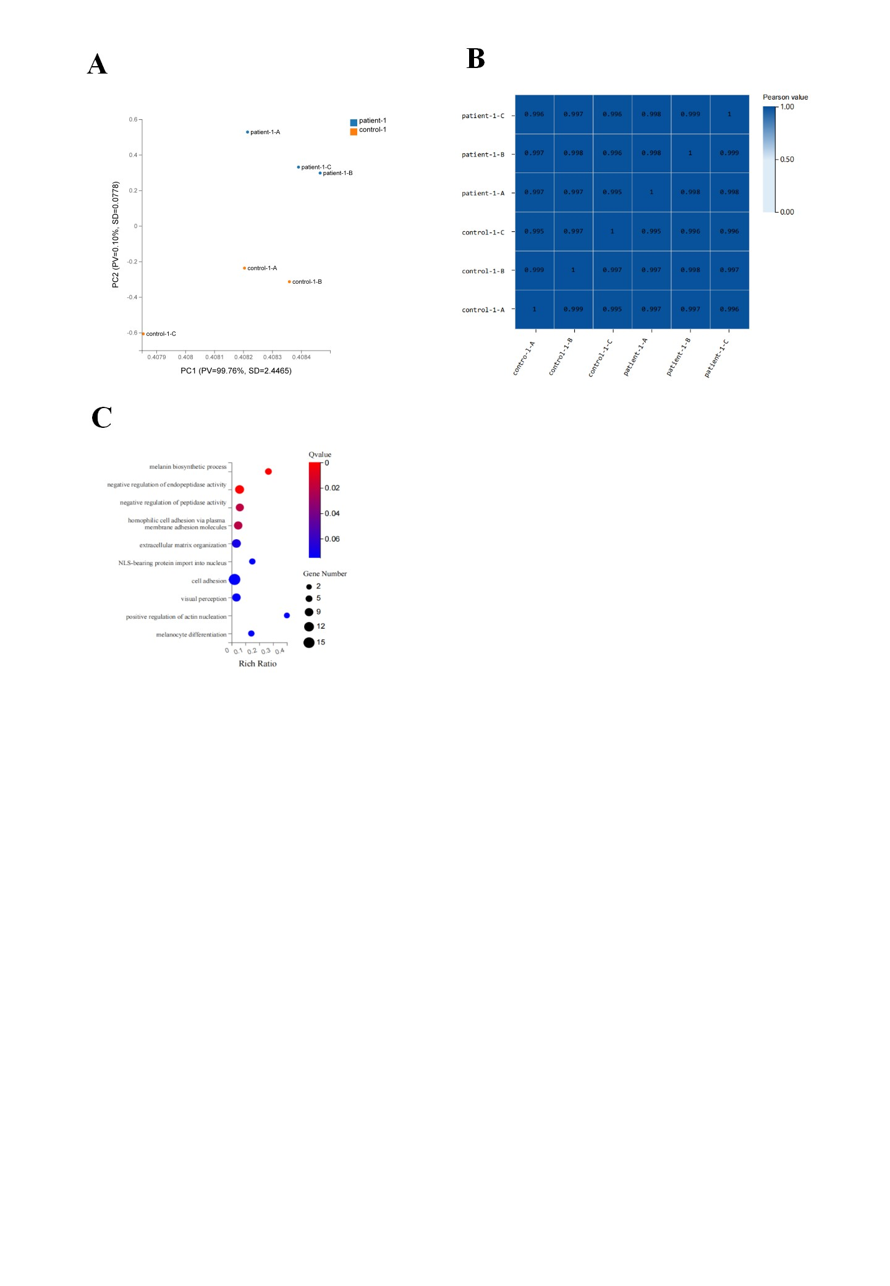
Figure S2. Characterization of the ROs in the early stage. (A). Immunofluorescence staining of eye filed transcription factors PAX6, retinal progenitor cells marker CHX10 and OTX2 in ROs at week 6. Scale bar, 20 µm. (B). Full-scale image of ROs with OTX2 staining at week 6. Scale bar, 100 µm. (A, B). The cell nuclei were stained with DAPI (blue).

