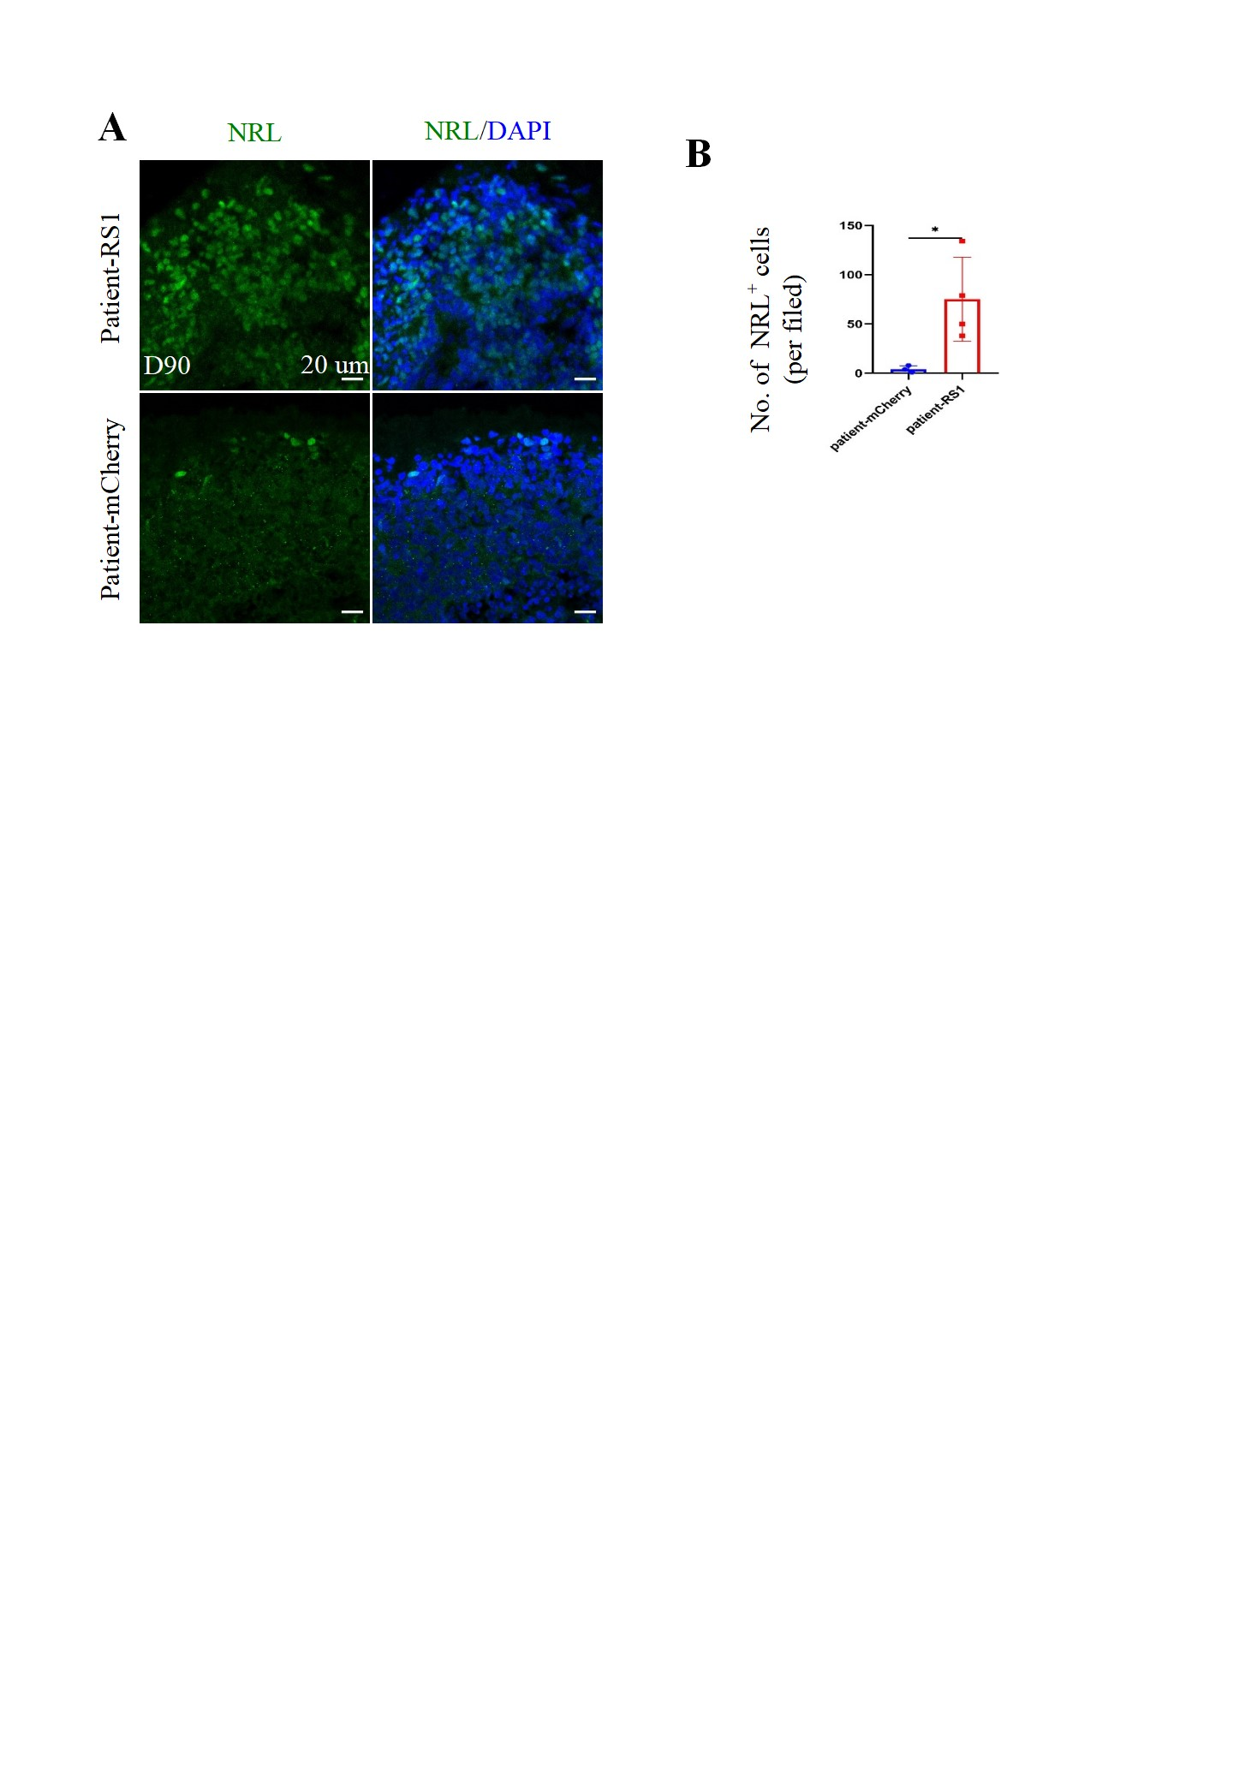
Figure S3. Identification of the RS1 secretory pathway. (A). The full-legend blots of RS1 in cells under reducing conditions. (B). The full-legend blots of RS1 in cell culture medium under reducing conditions. (C). The full-legend blots of RS1 in cells under non-reducing conditions. (D). Representative of immunofluorescence staining images of RS1 with ER (GRP94) and Golgi (Golgi97) in HEK293T overexpression cells. The cell nuclei were stained with DAPI (blue). Scale bar, 10 µm.

