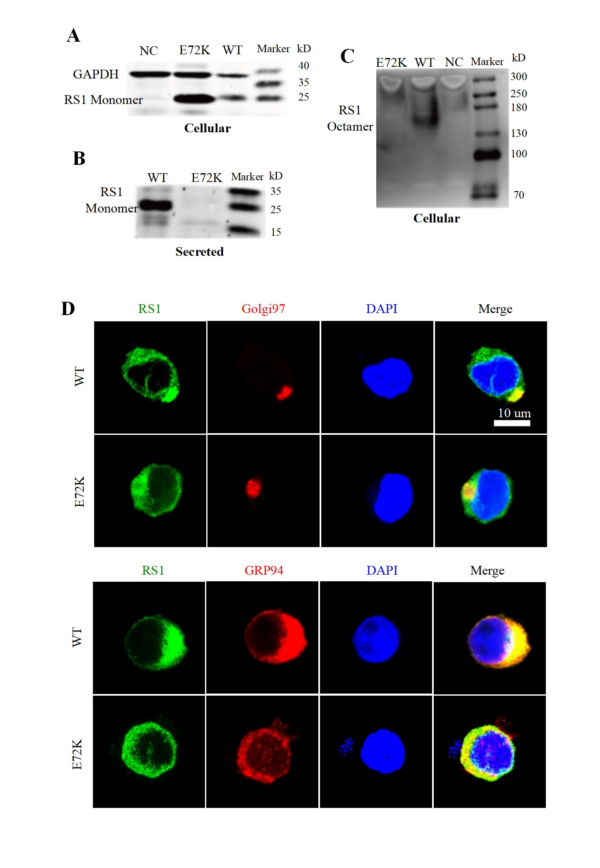
Figure S5. RNA-seq results. (A). PCA plot of RNA-seq. (B). Pearson correlation coefficient heatmap of RNA-seq results. (C) The bubble plot of the top 10 GO BPs of upregulated genes.

