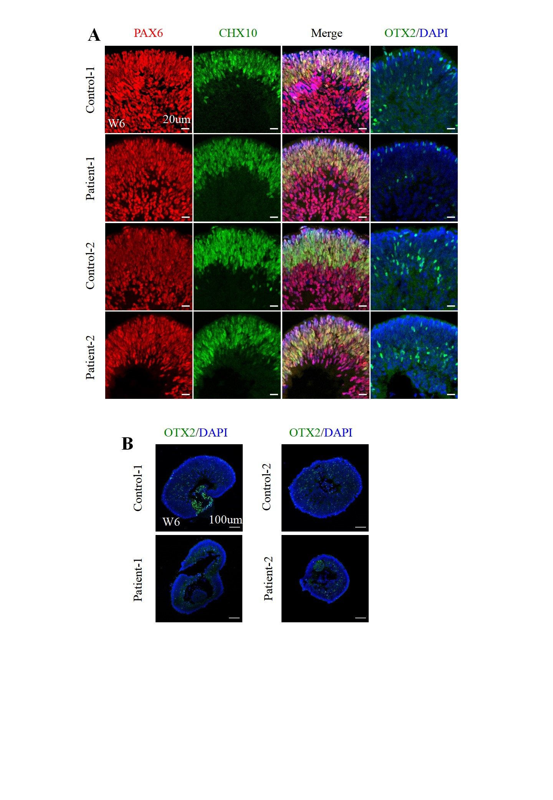
Figure S6. The expression level of NRL in AAV2.7m8 treated ROs. (A). Representative immunofluorescence staining images of NRL in patient-RS1 and patient-mCherry ROs at day 90. The cell nuclei were stained with DAPI (blue). Scale bar, 20 µm. (B). The NRL-positive cells were quantified in patient-RS1 and patient-mCheery ROs at day 90.

