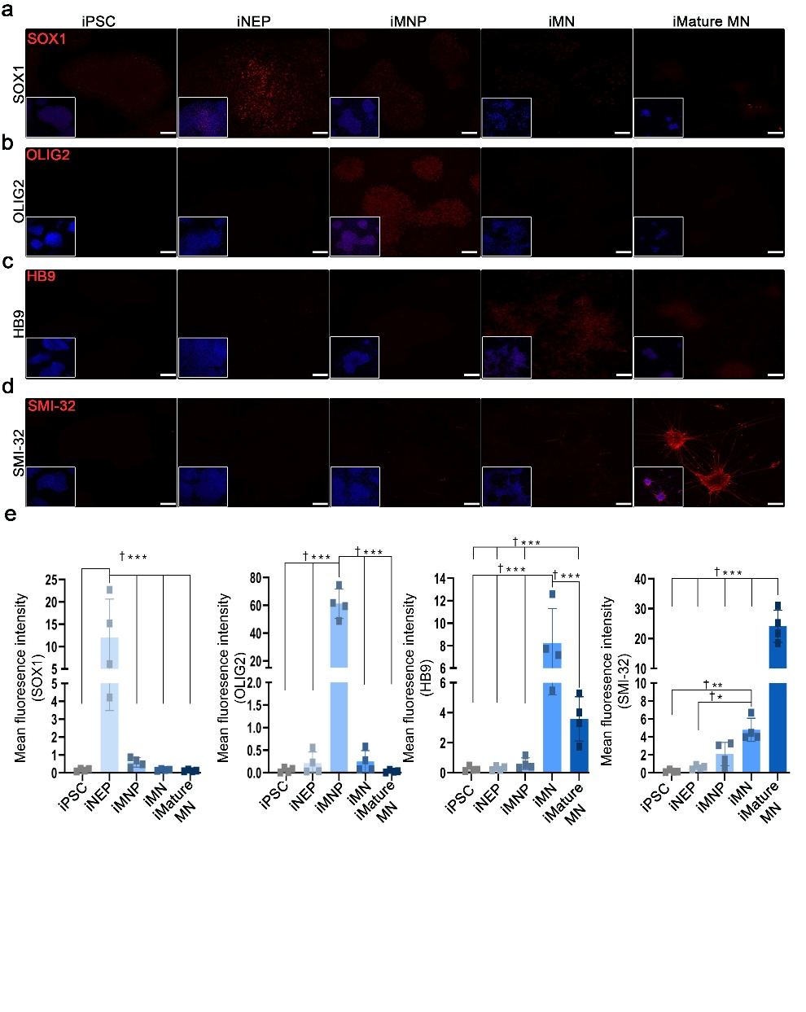

Additional file 1: Figure S1. Generation of induced pluripotent stem cell (iPSC)-derived motor neurons.
a Representative fluorescence time course images of iPSC, iNEP, iMNP, iMN, and iMature MN using SOX1 markers in the course of time. b Representative fluorescence images of iPSC, iNEP, iMNP, iMN, and iMature MN using OLIG2 markers in the course of time. c Representative fluorescence images of iPSC, iNEP, iMNP, iMN, and iMature MN using HB9 markers in the course of time. d Representative fluorescence images of iPSC, iNEP, iMNP, iMN, and iMature MN using SMI-32 markers in the course of time. e Quantification of the fluorescence intensity of markers at each stage (iNEP: n=4, iMNP; n=4, iMN: n=4, and iMature MN: n=4). Data are presented as mean ± SEM. Statistical significance was estimated using the Kruskal–Wallis test with post hoc analysis and the Mann–Whitney (†) test with the least significant difference post hoc analysis (*); *, † P < 0.05, **†† p < 0.01. Scale bars = 50 μm. iPSCs, induced pluripotent stem cell; iNEPs, induced pluripotent stem cell-derived neuron epithelial progenitor cells; iMNPs, induced pluripotent stem cell-derived motor neuron progenitor cells; iMNs, induced pluripotent stem cell-derived motor neuron cells; iMature MNs, induced pluripotent stem cell-derived mature motor neuron cells; IF, Immunofluorescence staining; SOX1 = iNEP, OLIG2 = iMNP, HB9 = iMN, SMI-32= iMature MN.
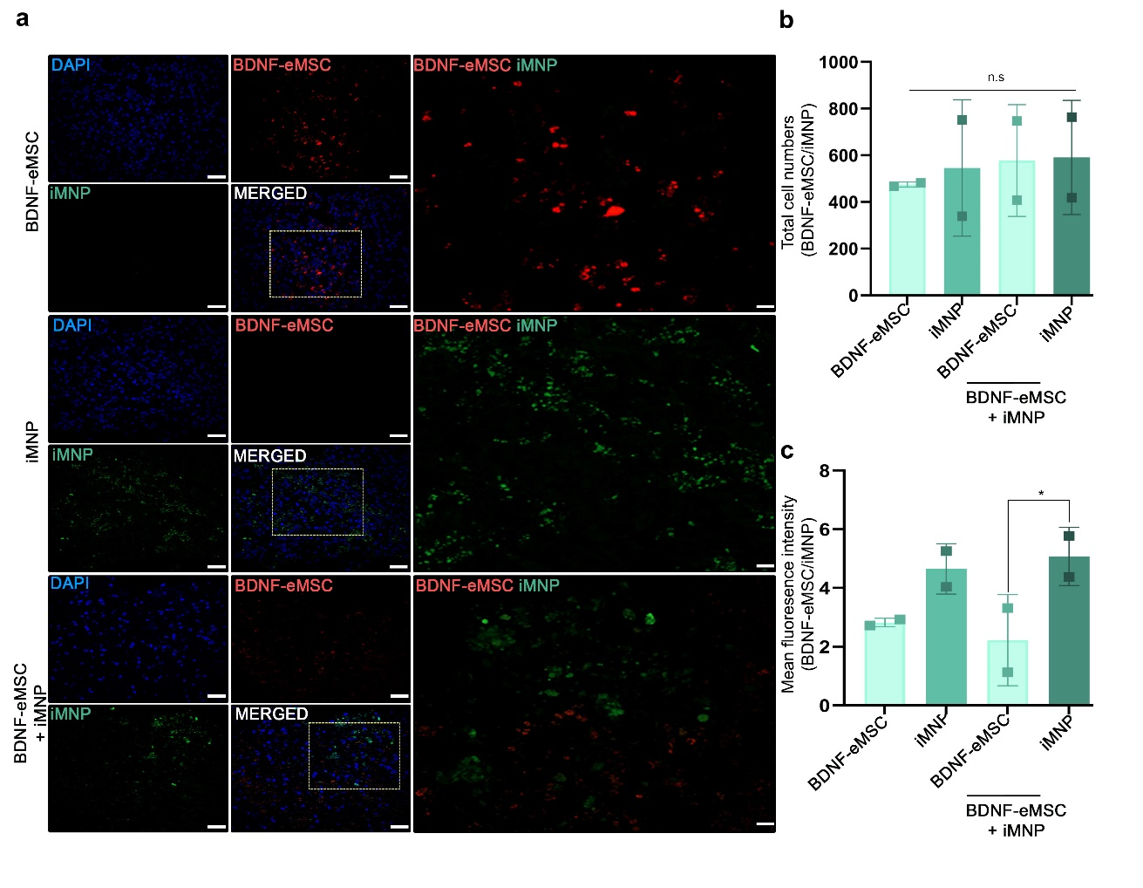

Additional file 2: Figure S2. Transplanted cells at the lesion site one week after cell transplantation.
a Representative fluorescence images of PKH26 (BDNF-eMSC) and PKH 67 (iMNP) at the lesion site one week post-cell transplantation. b Numbers of engrafted cells at the lesion site (BDNF-eMSC: n=2, iMNP; n=2, BDNF-eMSC+iMNP n=2). c Quantification of fluorescence intensity of engrafted cells at the lesion site (BDNF-eMSC: n=2, iMNP; n=2, BDNF-eMSC+iMNP n=2). Data are presented as mean ± SEM. Statistical significance was estimated using the Kruskal–Wallis test with post hoc analysis and the Mann–Whitney (†) test with the least significant difference post hoc analysis (*); *, † P < 0.05, **†† p < 0.01. Scale bars = 50 μm. BDNF-eMSC, Brain-derived neurotrophic factor over-expressing engineered mesenchymal stem cells; iMNPs, induced pluripotent stem cell-derived motor neuron progenitor cells; IF, Immunofluorescence staining.

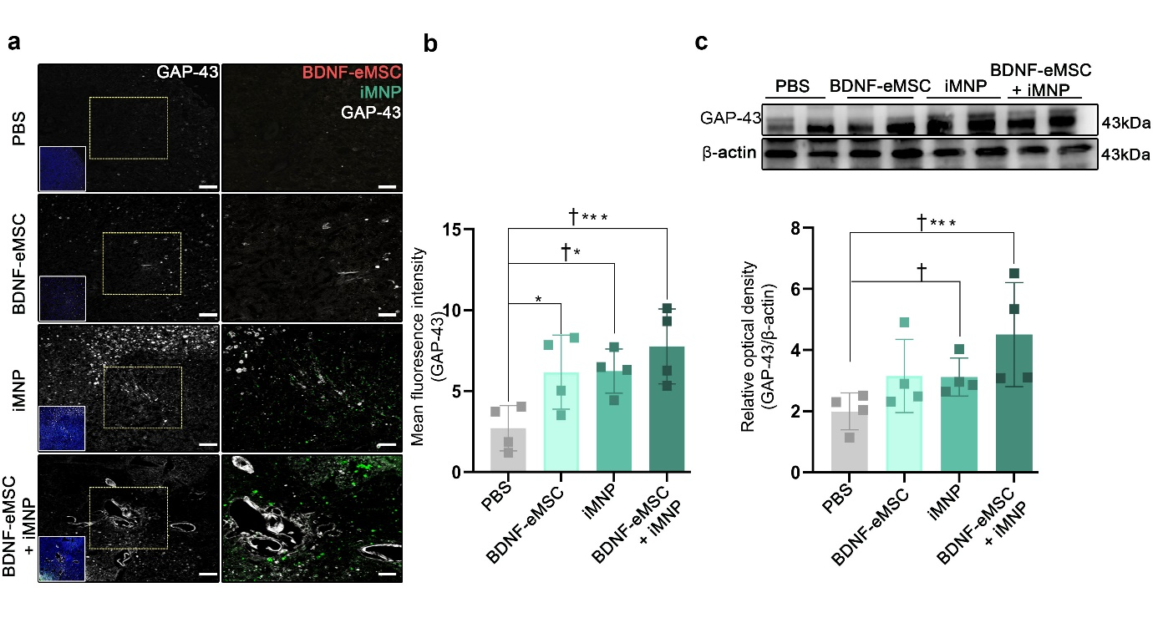

Additional file 3: Figure S3. Enhancements of growth density of neuronal process by BDNF-eMSC and iMNP at the lesion site.
a Representative fluorescence image of GAP-43 at the lesion site 12 weeks post-injury. b Quantification of fluorescence intensity of GAP-43 at the lesion site (PBS: n=4, BDNF-eMSC: n=4, iMNP: n=4, BDNF-eMSC+iMNP n=4). c WB results of GAP-43 expression at the lesion site segment (approximately 1 cm) (PBS: n=4, BDNF-eMSC: n=4, iMNP: n=4, BDNF-eMSC+iMNP n=4). Full-length WB images are presented in Additional file 4: Fig.4. Data are presented as mean ± SEM. Statistical significance was estimated using the Kruskal–Wallis test with post hoc analysis and the Mann–Whitney (†) test with the least significant difference post hoc analysis (*); *, † P < 0.05. Scale bars = 50 μm. BDNF-eMSC, Brain-derived neurotrophic factor over-expressing engineered mesenchymal stem cells; iMNP, induced pluripotent stem cell-derived motor neuron progenitor cells; IF, Immunofluorescence staining; WB, Western blot.

