Supplementary data

Supplementary Table 1: Primer sequences

Target | Orientation | Sequence (5'-3') | primer length | used for detection of | Reference
OCT4 | Forward | GGGGGTTCTATTTGGGAAGGTA | 22bp | pluripotency marker | [66]
OCT4 | Reverse | ACCCACTTCTGCAGCAAGGG | 20bp | pluripotency marker | [66]
PAX6 | Forward | TCGAAGGGCCAAATGGAGAAGAGAAG | 26bp | Ectoderm differentiation | [67]
PAX6 | Reverse | GGTGGGTTGTGGAATTGGTTGGTAGA | 26bp | Ectoderm differentiation | [67]
NESTIN | Forward | CCTCAAGATGTCCCTCAGCC | 20bp | Ectoderm differentiation | [68]
NESTIN | Reverse | CCAGCTTGGGGTCCTGAAAG | 20bp | Ectoderm differentiation | [68]
FOXA2 | Forward | GCATTCCCAATCTTGACACGGTGA | 24bp | Endoderm differentiation | [67]
FOXA2 | Reverse | GCCCTTGCAGGCAGAATACACATT | 24bp | Endoderm differentiation | [67]
SOX17 | Forward | AGGAAATCCTCAGACTCCTGGGTT | 24bp | Endoderm differentiation | [67]
SOX17 | Reverse | CCCAAACTGTTCAAGTGGCAGACA | 24bp | Endoderm differentiation | [67]
T | Forward | CAGTGGCAGTCTCAGGTTAAGAAGGA | 26bp | Mesoderm differentiation | [67]
T | Reverse | CGCTACTGCAGGTGTGAGCAA | 21bp | Mesoderm differentiation | [67]
EOMES | Forward | ATCATTACGAAACAGGGCAGGC | 22bp | Mesoderm differentiation | [69]
EOMES | Reverse | CGGGGTTGGTATTTGTGTAAGG | 22bp | Mesoderm differentiation | [69]
GAPDH | Forward | GAAGGTGAAGGTCGGAGTC | 19bp | housekeeping gene | [67]
GAPDH | Reverse | GAAGATGGTGATGGGATTTC | 20bp | housekeeping gene | [67]
P53 | Forward | AAACTACCAACCCACCGACC |  | qPCR Lung organoid treatment with EV and cisplatin | [70]
P53 | Reverse | TCTGGCCTTGAAACCACCTT |  | qPCR Lung organoid treatment with EV and cisplatin | [70]
CASPASRE7 | Forward | CCGAGTGCCCACTTATCTGT |  | qPCR Lung organoid treatment with EV and cisplatin | [33]
CASPASRE7 | Reverse | ACCTGTCGCTTTGTCGAAGT |  | qPCR Lung organoid treatment with EV and cisplatin | [33]
FASL | Forward | GCAGCCCTTCAATTACCCAT |  | qPCR Lung organoid treatment with EV and cisplatin | [71]
FASL | Reverse | CAGAGGTTGGACAGGGAAGAA |  | qPCR Lung organoid treatment with EV and cisplatin | [71]
Transgene | orientation | Sequence (5'-3') | product length | used for | Reference
SeV | Forward | GGATCACTAGGTGATATCGAGC | 181 | Detection of Sendai Virus genome and transgenes | Cytotune Sendai Virus 2.0 kit by Thermo Fisher
SeV | Reverse | ACCAGACAAGAGTTTAAGAGATATGTATC | 181 | Detection of Sendai Virus genome and transgenes | Cytotune Sendai Virus 2.0 kit by Thermo Fisher
KOS | Forward | ATGCACCGCTACGACGTGAGCGC | 528 | Detection of Sendai Virus genome and transgenes | Cytotune Sendai Virus 2.0 kit by Thermo Fisher
KOS | Reverse | ACCTTGACAATCCTGATGTGG | 528 | Detection of Sendai Virus genome and transgenes | Cytotune Sendai Virus 2.0 kit by Thermo Fisher
KLF4 | Forward | TTCCTGCATGCCAGAGGAGCCC | 410 | Detection of Sendai Virus genome and transgenes | Cytotune Sendai Virus 2.0 kit by Thermo Fisher
KLF4 | Reverse | AATGTATCGAAGGTGCTCAA | 410 | Detection of Sendai Virus genome and transgenes | Cytotune Sendai Virus 2.0 kit by Thermo Fisher
C-MYC | Forward | TAACTGACTAGCAGGCTTGTCG | 532 | Detection of Sendai Virus genome and transgenes | Cytotune Sendai Virus 2.0 kit by Thermo Fisher
C-MYC | Reverse | TCCACATACAGTCCTGGATGATGATG | 532 | Detection of Sendai Virus genome and transgenes | Cytotune Sendai Virus 2.0 kit by Thermo Fisher

Supplementary Table 2: Antibodies used in this study
marker; clone | Cat.no, company | Lot number | Dilution
goat anti-rabbit AlexaFluor488 | Ab150077, Abcam | GR3375958-1 | 1:1000
goat anti-mouse AlexaFluor647 | A11004, ThermoFisher | 2198584 | 1:1000
Mouse anti-rabbit IgG-HRP | sc-2357, SantaCruz | K0221 | 1:1000
m-IgGκ BP-HRP | sc-516102, SantaCruz | 3118 | 1:1000
ACE-2 | ab272500, Abcam | GR3416296-3 | 1:50
EpCAM | sc-25308, SantaCruz | B0822 | 1:50
TMPRSS2 | ab92323, Abcam | Gr3344246-1 | 1:50
MUC5AC | ab198254, Abcam | GR3321127-6 | 1:25
SOX2 | ab97959, Abcam | GR342127-1 | 1:500
Acetylated alpha tubulin | sc-23950, SantaCruz | B0822 | 1:50
CALNEXIN | ab22595, Abcam | 1013331-2 | 1:500
CD63 | sc-5275, SantaCruz | L0221 | 1:100

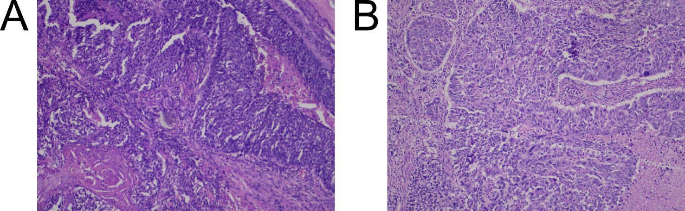
Supplemental Figure 1. H&E stains of patient tumors
Biopsies of NSCLC tumor tissue were obtained from patients, fixed in 10% formalin and embedded in paraffin blocks. Blocks were cut into 5 µm slices and mounted onto glass slides for staining. Shown are H&E stainings of solid, non-keratinizing NSCLC tissue from (A) LC0001 and (B) LC0008.

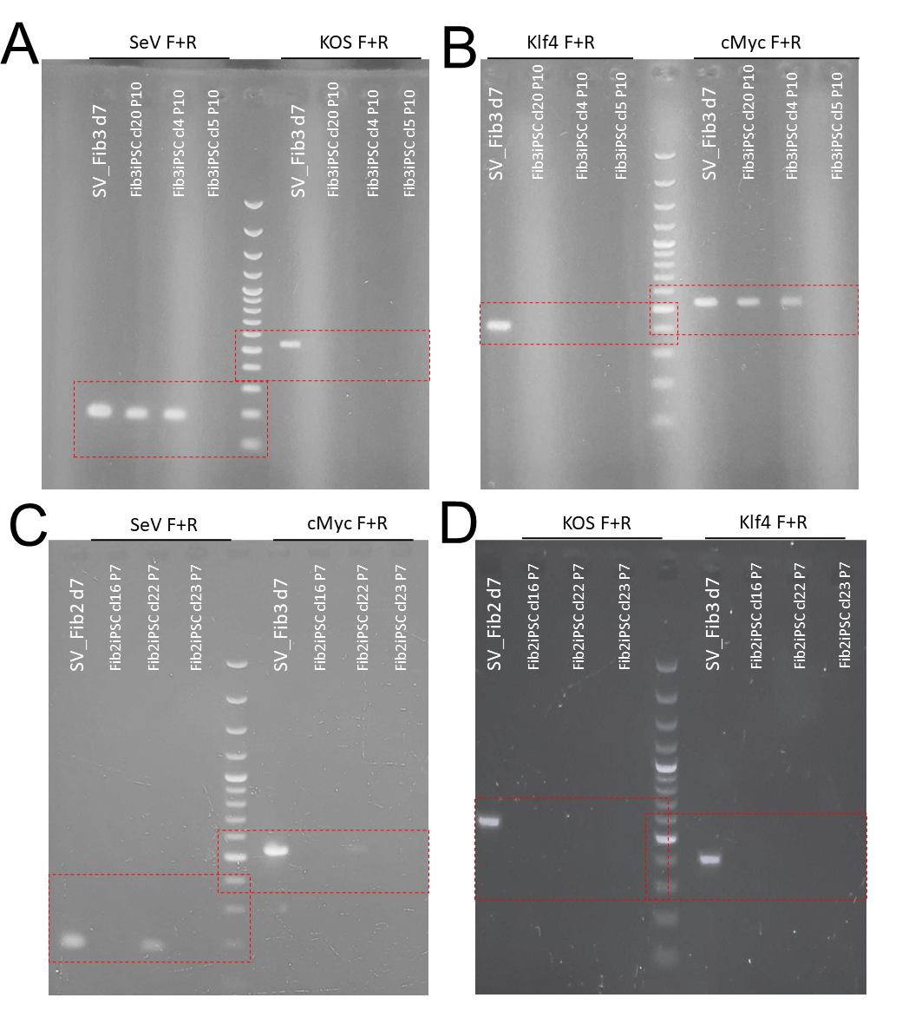
Supplemental Figure 2. Full electrophoresis blots for the detection of Sendai virus genome
Established iPSC clones of LC008 (A-B) and LC0001 (C-D) were analyzed for the presence of Sendai virus genome and the transgenes. Images of full-length electrophoresis gels for each PCR are shown. Cropping of images was done along the red dashed lines. Cropped images are shown in Figure 1.

Supplementary methods

Section 1 Generation and characterization of iPSC
- Generation of iPSC from normal lung fibroblasts
To generate patient-derived induced pluripotent stem cells (iPSCs), normal lung fibroblasts were isolated from patients with NCSCL. The lung fibroblasts were cultured for 1-3 passages. Before reprogramming, cells were stained for CD90 and analyzed using flow cytometry. CD90⁺ cells were selected for reprogramming using the Cytotune 2.0 kit (A16517, Thermo Scientific), following manufacturer’s protocol. In brief, fibroblasts were counted using a hemocytometer and 1x10⁵ cells were seeded in a well of a 6-well plate in fibroblast medium. Between 24h to 48h after seeding, the medium was replaced, and 35 µl of Sendai virions were added to the cells. The mixture was gently mixed and then incubated at 37°C for 24h. The medium was changed every 2nd day until day 7 post infection. On day 7 post infection, cells were detached using trypsin, counted and seeded in MEF medium on a monolayer of irradiated CD1 MEFs at two different cell concentrations. The following day, the medium was exchanged for iPSC medium. The cells were cultured for 2-3 weeks with daily medium changes. After 2-3 weeks, a 24-well plate was coated with geltrex, and individual iPSC colonies were selected and expanded. These iPSC colonies were subsequently cultured under feeder-free conditions.
- Karyotyping
iPSC were incubated with 10µl of KaryoMAX Colcemid Solution in PBS (Gibco, Life Technologies) 2h at 37°C for arresting the cells in metaphase. Subsequently, the cells were detached using 0,25% Trypsine (Gibco, Life Technologies) solution in Versene (EDTA) 0,02% solution (Lonza) Then the cells were treated with hypotonic 1% sodium citrate (Merck) solution for 30 min. at 37°C and fixed with ice-cold methanol and glacial acetic acid (3:1) solution. The fixed cells were dropped onto wet cold slides. The prepared chromosome slides were stained by Giemsa using trypsin (GTG-banding) method. At least 20 metaphases with a resolution of 400 - 500 bands per haploid chromosome set were analyzed by light microscopy and semi-automated karyotyping systems Lucia Karyo (Czech Republic) or Ikaros (Germany). The karyotype results were displayed against ISCN 2020 [72].
- RT-PCR for the detection of Sendai virus genome and transgenes
RNA from iPSC clones was isolated using Direct-zol™ RNA Miniprep Kit (Zymo Research). Additionally, RNA from transduced fibroblasts, obtained 7 days post infection, was isolated and employed as a positive control. A quantity of 1µg of RNA from each condition was utilized for cDNA synthesis, which was performed using the High Capacity cDNA Reverse Transcription Kit (Applied Biosystems). Subsequently, PCR was performed with AmpliTaq Gold, using 20 ng of cDNA per reaction. PCR conditions were as follows: 95°C for 5 min, 35 cycles of 95°C for 30 sec, 53°C-60°C for 30 sec, 72°C for 30 sec followed by 72°C for 7 min and kept at 4°C until gel electrophoresis. Primers were employed in accordance with the manufacturer’s protocol. For gel electrophoresis, samples were mixed with a loading dye. Samples were loaded onto a 1.5% agarose gel mixed with Ethidium Bromide. A 100bp plus DNA (SM0321, ThermoFisher) ladder was loaded alongside the samples. Gel electrophoresis was performed at 120V for 90 min. Afterwards, bands were visualized using a UV lamp.
- Trilineage Differentiation and RT-qPCR
Trilineage Differentiation was performed using the StemDiff Trilineage Differentiation Kit (Stemcell Technologies) according to manufacturer's guidelines. Afterwards, cells were detached and processed for RT-qPCR. RNA was isolated using Direct-zol™ RNA Miniprep Kit (Zymo Research) and RNA concentration was determined using Nanodrop 2000 (ThermoFisher). According to the manufacturer's instructions, cDNA synthesis was performed employing the High Capacity cDNA Reverse Transcription Kit (Applied Biosystems). 5 ng of cDNA served as template for quantitative PCR (qPCR). Forward and reverse primer stocks were diluted in a 1:100 ratio with RNAse free water. Each qPCR reaction consisted of 5µl of SYBR Green (Fast SYBR Green Master Mix, Applied Biosystems), 0.5µl of the primer pair, and 5ng cDNA. qPCR was performed using a ViiA 7™ instrument (Life Technologies). Glyceraldehyde 3-phosphate dehydrogenase (GAPDH) was employed as a reference gene for normalization. The relative expression of each gene was calculated using the 2^{-ΔΔCT} method. For Trilineage differentiation of iPSC, the expression of OCT4, PAX6, NESIN, FOXA2, SOX17, Brachyury (T) and EOMES was analyzed. In the case of cisplatin and EV treatment of lung organoids, expression of P53, FASL and CASPASE7 was analyzed. Primer sequences are listed in Supplementary Table 1.
- Immunofluorescence of iPSC and iPSC derived lung organoids
Detection of pluripotency markers in iPSC was achieved by immunofluorescence as described previously [73]. Cells were stained for OCT-4, NANOG, TRA1-60 and SSEA4 using the Embryonic Stem Cell Marker Panel (ab109884, Abcam) and incubated overnight at 4°C. Subsequently, cells were stained with secondary antibodies (Supplementary Table 2) for 1h at RT.
Lung organoids derived from iPSCs were subjected to immunofluorescence staining, following the protocol established for epithelial organoids outlined on the the Stemcell Technologies website, with specific optimization tailored for lung organoids. Briefly, organoids were harvested from Matrigel dome, rinsed in ice cold PBS for 10-20 min, allowed to settle by gravity, and then minced into fragments ranging in size from 50 to 500µm using a sharp scalpel. Fragments were fixed, permeabilized, and blocked for 24h at RT. Primary antibodies (Supplementary Table 2) were applied to the fragments and incubated for 72h at 4°C. Afterwards, incubation with secondary antibodies was performed for 24h at 4°C, followed by Hoechst staining for 20 min. Fragments were cleared and mounted in ProLong Gold mounting solution. Imaging was performed using a confocal microscope 24h after mounting.
- Branching lung differentiation
Lung differentiation was performed using the StemDiff Branching Lung Organoid Kit (#100-0195, Stemcell Technologies) according to the manufacturer's instructions. Organoids from day 50 of differentiation were employed for both immunofluorescence staining and EV treatment.
- Differentiation of iPSC into MSC and iPSC-MSC trilineage differentiation
MSC differentiation was performed according to the protocol outlined by [29]. Briefly, iPSC colonies were seeded on plates coated with geltrex.. When cells reached a confluency of 70-80%, medium was changed to Mesencult medium (#05439, Stemcell Technologies), supplemented with 10% hPL and 1% L-Glu. On the 7th day of differentiation, the cells were passaged onto gelatin-coated plates at a density of 5000 cells/cm². Subsequent medium changes were performed every 2-3 days and cell passaging was conducted at 7-day intervals. The differentiation process continued until day 35. Afterwards, iPSC-MSC were expanded in preparation for flow cytometry, EV isolation and further MSC differentiation. The differentiation of iPSC-MSCs into adipogenic, chondrogenic, and osteogenic lineages, was performed according to the method published by [74].
- Flow cytometry
To assess the purity of isolated primary lung fibroblasts and examine the surface marker expression of iPSC-derived MSC, flow cytometry was employed. Cells were collected using Trypsin, centrifuged for 4 min at 300xg and washed once with PBS. Cells were stained with the following antibodies: CD90-APC (ab13350, Abcam), CD34-PE (12-0349-42, ThermoFisher), CD45-PECy7 (560675, BD Bioscience), CD14-APC (325607, Biolegend) and CD105-PE (560839, BD Bioscience). Antibodies were diluted 1:100 in 100 µl FACS staining buffer (PBS, 2% FCS, 2mM EDTA). Next, cells were stained for 30 min at 4°C followed by a series of washing steps with FACS staining buffer. Finally, cells were resuspended in a 500 µl FACS staining buffer and analyzed using FACS Aria (BD Biosciences). The acquired data were analyzed with FlowJo software (Tree Star, Inc.).
Section 2 EV isolation and characterization
- iPSC-derived MSC culturing
iPSC-derived iMSC cells were maintained in low-glucose DMEM (11880028, Gibco), supplemented with 2% iFBS, 2.4 mM Glutamax (A12860-01, Gibco), 10 ng/ml fibroblast growth factor (PHG0367, Gibco), and 5 ng/ml epidermal growth factor (E9644-.2MG, Sigma-Aldrich). Cell culturing was performed using Cell+ culture flasks (83.3912.302, Sarstedt), and subculturing was carried out using 0.25% Trypsin-EDTA solution (sc-391060, SantaCruz) once cells had reached 80% confluence. Cell media for iPSC-MSC derived EV (without cisplatin) isolation was collected throughout cell culturing, when confluence was above 60%.
- EV isolation
EV were isolated from LC0008 patient iPSC-MSC using 35 nm qEV iZON-SEC columns (SP7, IZON Science LTD). Columns were initially equilibrated in room temperature (RT) and rinsed with DEPC-PBS (0.2 µm filtered) following manufacturer’s instructions. Subsequently, 5 mL of the sample was introduced into the column, and elution was performed with DEPC-PBS. The eluate was collected in 15 fractions of 5 mL. The EV-containing fractions were determined by Zetasizer Nano Zs (Malvern Instruments Ltd., UK). Fractions displaying attenuator measurements below 11 and containing at least 70% particles the size of which exceeds 40 nm were chosen and concentrated to 300 µl using 3 kDa Amicon spin filters (Merck Millipore, USA). Concentrated samples were then aliquoted and stored at -80 °C until further use.
- Nanoparticle Tracking Analysis
Total particle amount and size was assessed using (Nanosight NS500, Malvern) with NanoSight NTA Software v3.0 and the following settings: camera level 13, and detection threshold 7 and 25 °C.
- Transmission electron microscopy (TEM)
3 μl of EV suspension was placed on a carbon film-coated copper TEM grid. Next, samples were negatively stained with 1% uranyl formate for 1 to 3 minutes in the dark, air-dried and examined using JEM-1230 (JEOL, Japan) TEM.
- ELISA
A double sandwich enzyme-linked immunosorbent assay (dsELISA) for detecting CD63 and calnexin (Supplementary Table2) was used to identify EVs derived from mesenchymal cells. Calnexin, an endoplasmic reticulum protein, was used to confirm the purity of our sample. dsELISA was performed as previously described elsewhere [75]. Briefly, the dsELISA plate was coated with 100 ul of 1 ug/mL TIM4-Fc protein (AG-40B-0180B-C010, Adipogen LifeSciences, San Diego, CA, USA,) at +4 °C overnight in a shaker. The plates were blocked for an hour the following day and rinsed with a washing buffer prior to incubation of previously diluted 1:20 EV samples. Then, samples were incubated with the respective primary antibodies - CD63 (sc-5275, SantaCruz) and calnexin (AB22595, Abcam) for 2 hours on a shaker, washed four times and incubated with mouse immunoglobulin kappa binding protein conjugated to horseradish peroxidase (m-IgGκ BP-HRP) (sc-516102, SantaCruz) and mouse anti-rabbit IgG-HRP (sc-2357, SantaCruz) respectively, for 1 hour at RT. The reaction was started with addition of 3,3′,5,5′-tetramethylbenzidine (TMB) (T8665-100ML, Sigma-Aldrich) after four separate washes of the plate. 1M H2SO4 was used to stop the reaction. Absorbance was measured at 450 nm using a spectrophotometer (μQant, BioTek), and data was analyzed using Gen5 2.0 software (BioTek, Agilent). For every sample, a non antibody containing control was made to check for nonspecific reaction. A positive control of iMSC cells was made to validate the experimental process and a non-primary antibody control was made to assess secondary antibody nonspecific binding. For each sample and control, duplicates were created.
Section 3 Cisplatin cytotoxicity
- CCK8 assay
iPSC-MSC viability was measured using a Cell Counting Kit-8 (CCK8; 96992, Sigma Aldrich). Firstly, 1 × 10⁴ cells were seeded in a 96-well plate in triplicate and incubated for 24 h. Then, cells were treated with 10 µL cisplatin at different concentrations (10, 20, 50 and 100 µg/mL) at 37 °C in a humidified atmosphere containing 5% CO₂ for 24 and 48h. Next, a 10 uL CCK-8 solution was added to cells, followed by incubation for 2 h at 37 °C in a humidified atmosphere containing 5% CO₂. The absorbance was detected at 450 nm by a microplate reader (BioTek Cytation 5, Agilent). Each experiment had 3 technical and biological replicates. The results were analyzed using GraphPad Prism 8 (GraphPad Software Inc., USA). The organoids in matrigel (approximate cell number for BLO was 2 x 10⁴ and 1.1 x 10⁴ LCO) were seeded on a 24-well plate. BLO were cultured for 2 consecutive days and LCO for 7 days for organoid formation. The EVs, EV-cispt and cisplatin at doses 0.07 µg/ml and 20 µg/ml were diluted in organoid culture medium and incubated for 48h. Cell viability was assayed using a CCK8 kit according to manufacturer’ s protocol. For BLO 2 and LCO 3 replicates were used.
- LDH assay
LDH test (CyQUANT, C20300, ThermoFisher) was used to test iPSC-MSC acute toxicity to cisplatin exposure (24 and 48h) as well as BLO and LCO acute toxicity to cisplatin, EV-cispt and MSC-EV exposure (24 and 48h). Two sets of replicates for each condition were used: one high control and one for the actual assay. Replicates of 100 µl of media without cells were used to serve as the blank for that condition. After 24 hours in culture the cells and blanks were treated with 100 µl of their respective drug solutions at predetermined concentrations in serum free media. Triton X-100 was used as a positive control. On the day of the assay the cytotoxicity reagents were prepared according to the manufacturer's protocol. Absorbance was measured at 490 nm and 680 nm using a microplate reader (BioTek Cytation 5, Agilent).

Supplementary References

67 Yang L, Soonpaa MH, Adler ED, et al. Human cardiovascular progenitor cells develop from a KDR+ embryonic-stem-cell-derived population. Nature 2008;453:524–528.
68 Qin J, Sontag S, Lin Q, et al. Cell Fusion Enhances Mesendodermal Differentiation of Human Induced Pluripotent Stem Cells. Stem Cells Dev 2014;23:2875–2882.
69 Teo AKK, Arnold SJ, Trotter MWB, et al. Pluripotency factors regulate definitive endoderm specification through eomesodermin. Genes Dev 2011;25:238–250.
70 Gurer DC, Erdogan İ, Ahmadov U, et al. Transcriptomics Profiling Identifies Cisplatin-Inducible Death Receptor 5 Antisense Long Non-coding RNA as a Modulator of Proliferation and Metastasis in HeLa Cells. Front Cell Dev Biol 2021;9.
71 Das H, Koizumi T, Sugimoto T, et al. Quantitation of Fas and Fas ligand gene expression in human ovarian, cervical and endometrial carcinomas using real-time quantitative RT-PCR. Br J Cancer 2000;82:1682–1688.
72 Nomenclature ISC on HC, McGowan-Jordan J, Hastings RJ, et al. ISCN 2020: An International System for Human Cytogenomic Nomenclature (2020). Karger, 2020.
73 Baghbaderani BA, Syama A, Sivapatham R, et al. Detailed Characterization of Human Induced Pluripotent Stem Cells Manufactured for Therapeutic Applications. Stem Cell Rev 2016;12:394.
74 Ciuffreda MC, Malpasso G, Musarò P, et al. Protocols for in vitro Differentiation of Human Mesenchymal Stem Cells into Osteogenic, Chondrogenic and Adipogenic Lineages. Methods Mol Biol Clifton NJ 2016;1416:149–158.
75 Yoshida T, Ishidome T, Hanayama R. High Purity Isolation and Sensitive Quantification of Extracellular Vesicles Using Affinity to TIM4. Curr Protoc Cell Biol 2017;77:3.45.1-3.45.18.

