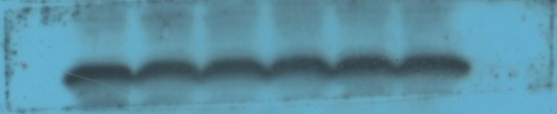
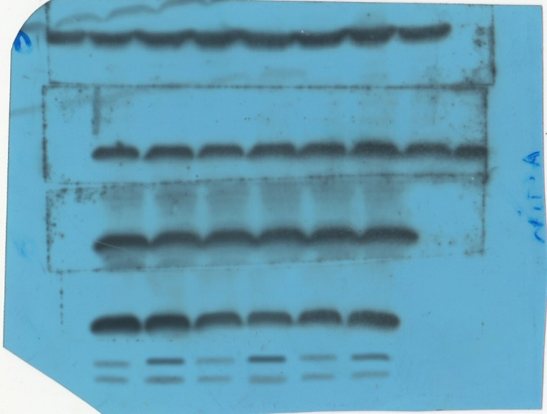
Additional file 1: Uncropped blots of western blot analysis indicated the expression of exosomal surface markers, including CD9 and CD81.
25 KDa
35 KDa
35 KDa
25 KDa
CD81
CD9

