Title page
Titles: Human adipose and synovial-derived MSCs synergistically attenuate osteoarthritis by promoting chondrocyte autophagy through FoxO1 signaling way

Authors: Jianqun Wu^{1,2†} Songqiang Huang^{3†} Yangyi Yu^{1,2} Qiang Lian^{1,2} Yang Liu^{4,5} Wenfeng Dai^{1,2} Qisong Liu^{1,2} Yonghao Pan^{4,5} Gui-ang Liu^{1,2} Kai Li^{4,5} Chao Liu^{4,5}* Guangheng Li^{1,2}*
Affiliations:
¹Division of adult joint reconstruction and sports medicine, Department of Orthopedic Surgery, The First Affiliated Hospital (Shenzhen People's Hospital), School of Medicine, Southern University of Science and Technology, Shenzhen, 518055, China
²Shenzhen Key Laboratory of Musculoskeletal Tissue Reconstruction and Function Restoration, Shenzhen People's Hospital, Guangdong, China
³Department of Pharmacology, School of Medicine, Southern University of Science and Technology, Guangdong, China
⁴Department of Biomedical Engineering, College of Engineering, Southern University of Science and Technology, Shenzhen, Guangdong, China
⁵Guangdong Provincial Key Laboratory of Advanced Biomaterials, Southern University of Science and Technology, Shenzhen Guangdong, China
†Jianqun Wu and Songqiang Huang contributed equally to this work.
*Corresponding author
Guangheng Li, MD, PhD
Address: 1017 Dongmen North Road, Luohu District, Shenzhen, China, 518020
Telephone: +86 13803893279
Email: liguangheng@hotmail.com
Chao Liu, PhD
Address: 1088 Xueyuan Avenue, Nanshan District, Shenzhen, China, 518055
Telephone: +86 18123891753
Email: liuc33@sustech.edu.cn

List of Supplementary Materials
Materials and Methods
Fig S1 to S6 for multiple supplementary figures
Tables S1 to S2 for multiple supplementary tables
Materials and Methods
ADSCs and SDSCs flow-cytometric analysis
For flow cytometric analysis, 1×10⁶ P3 collected and resuspended in 100μl flow cytometric staining buffer within tubes. Subsequently, 5 μl antibody of CD44, CD90, CD29, CD34, CD45 and CD19 were added to the tube and incubated for 30 min at 4℃. One tube without antibodies as a blank control. Finally, these cells were centrifuged at 1500 rpm for 5 min and resuspended with 500 ml PBS for flow cytometric analysis by BD FACSCalibur (BD Biosciences).
Osteogenic, adipogenic, chondrogenic differentiation of SDSCs and ADSCs
Chondrocytes were cultured in 24-well plate at density of 2500 cells/cm² in differentiation medium. The osteogenic differentiation medium containing 0.1 mmol/L dexamethasone, 50 mg/ml ascorbate and 10 mmol/L β-glycerophosphate. Adipogenic differentiation medium containing 1 mmol/L dexamethasone, 1 mmol/L rosiglitazone, 10 mg/ ml insulin and 0.5 mmol/L IBMX; Chondrogenic differentiation medium containing 0.1μM dexamethasone, 100 μg/ml sodium pyruvate, 40 μg/ml L-proline, 50 μg/ml L-ascorbic acid, 50 mg/ml ITS,10 ng/ml TGFβ3¹. Differentiation media were changed 2-3 day and induction until 14 days, cells were stained with oil red O, alcian blu and alizarin red staining, followed by microscopy observation.
Cell immunofluorescence
Briefly, cells in plates were fixed in 4% paraformaldehyde (PFA) for 20min, permeabilized with 0.5% triton for 5 min, and then blocked with 1% BSA containing 0.05% Triton X for 30 min. Cells were incubated with primary antibodies (Ki67, Col2, MMP13, LC3-II) at 4 °C overnight. Subsequently, the cells were washed three times with PBS and incubated with secondary antibodies. All primary and secondary antibodies were listed in extended data table 2. Immunofluorescence visualization was performed using a confocal microscope (Carl Zeiss, Germany). Each experiment was conducted in triplicate, and representative images were displayed.
Enzyme-linked immunosorbent assay
The concentration of IL-1β, IL-10, TNFα in the coculture medium were measured using a human specific enzyme-linked immunosorbent assay (ELISA) kit (R&D Systems, Abcam, R&D Systems) according to the manufacturer’s instructions. Absorbance measurements were taken with a microplate reader at a wavelength of 450 nm, and the results were compared to a standard curve.
MDC staining
After treatments described in the research design, primary chondrocytes were incubated with 0.05 mM MDC for 20 min at 37℃, as reported in a previous study². After washed with PBS for three times, immunofluorescence visualization was performed using confocal microscope and representative images were shown.
Western blotting
Total protein from chondrocytes was extracted using RIPA buffer and 1 mM PMSF. proteins were separated by sodium dodecyl sulfate-polyacrylamide gel electrophoresis (SDS-PAGE) and subsequently transferred by electroblotting to polyvinylidene difluoride (PVDF) membranes. These membranes were blocked with 5% BSA and incubated with primary antibodies (GAPDH, Col2, MMP13, LC3-II, p62, p-FoxO1, t-FoxO1, p-FoxO3, t-FoxO3) at 4℃ overnight. Then membranes were washed with TBST for three times, and incubated in homologous HRP-conjugated secondary antibodies. The intensity of chemiluminescence bands was detected using image analysis software.
Fig S1 to S5 for multiple supplementary figures
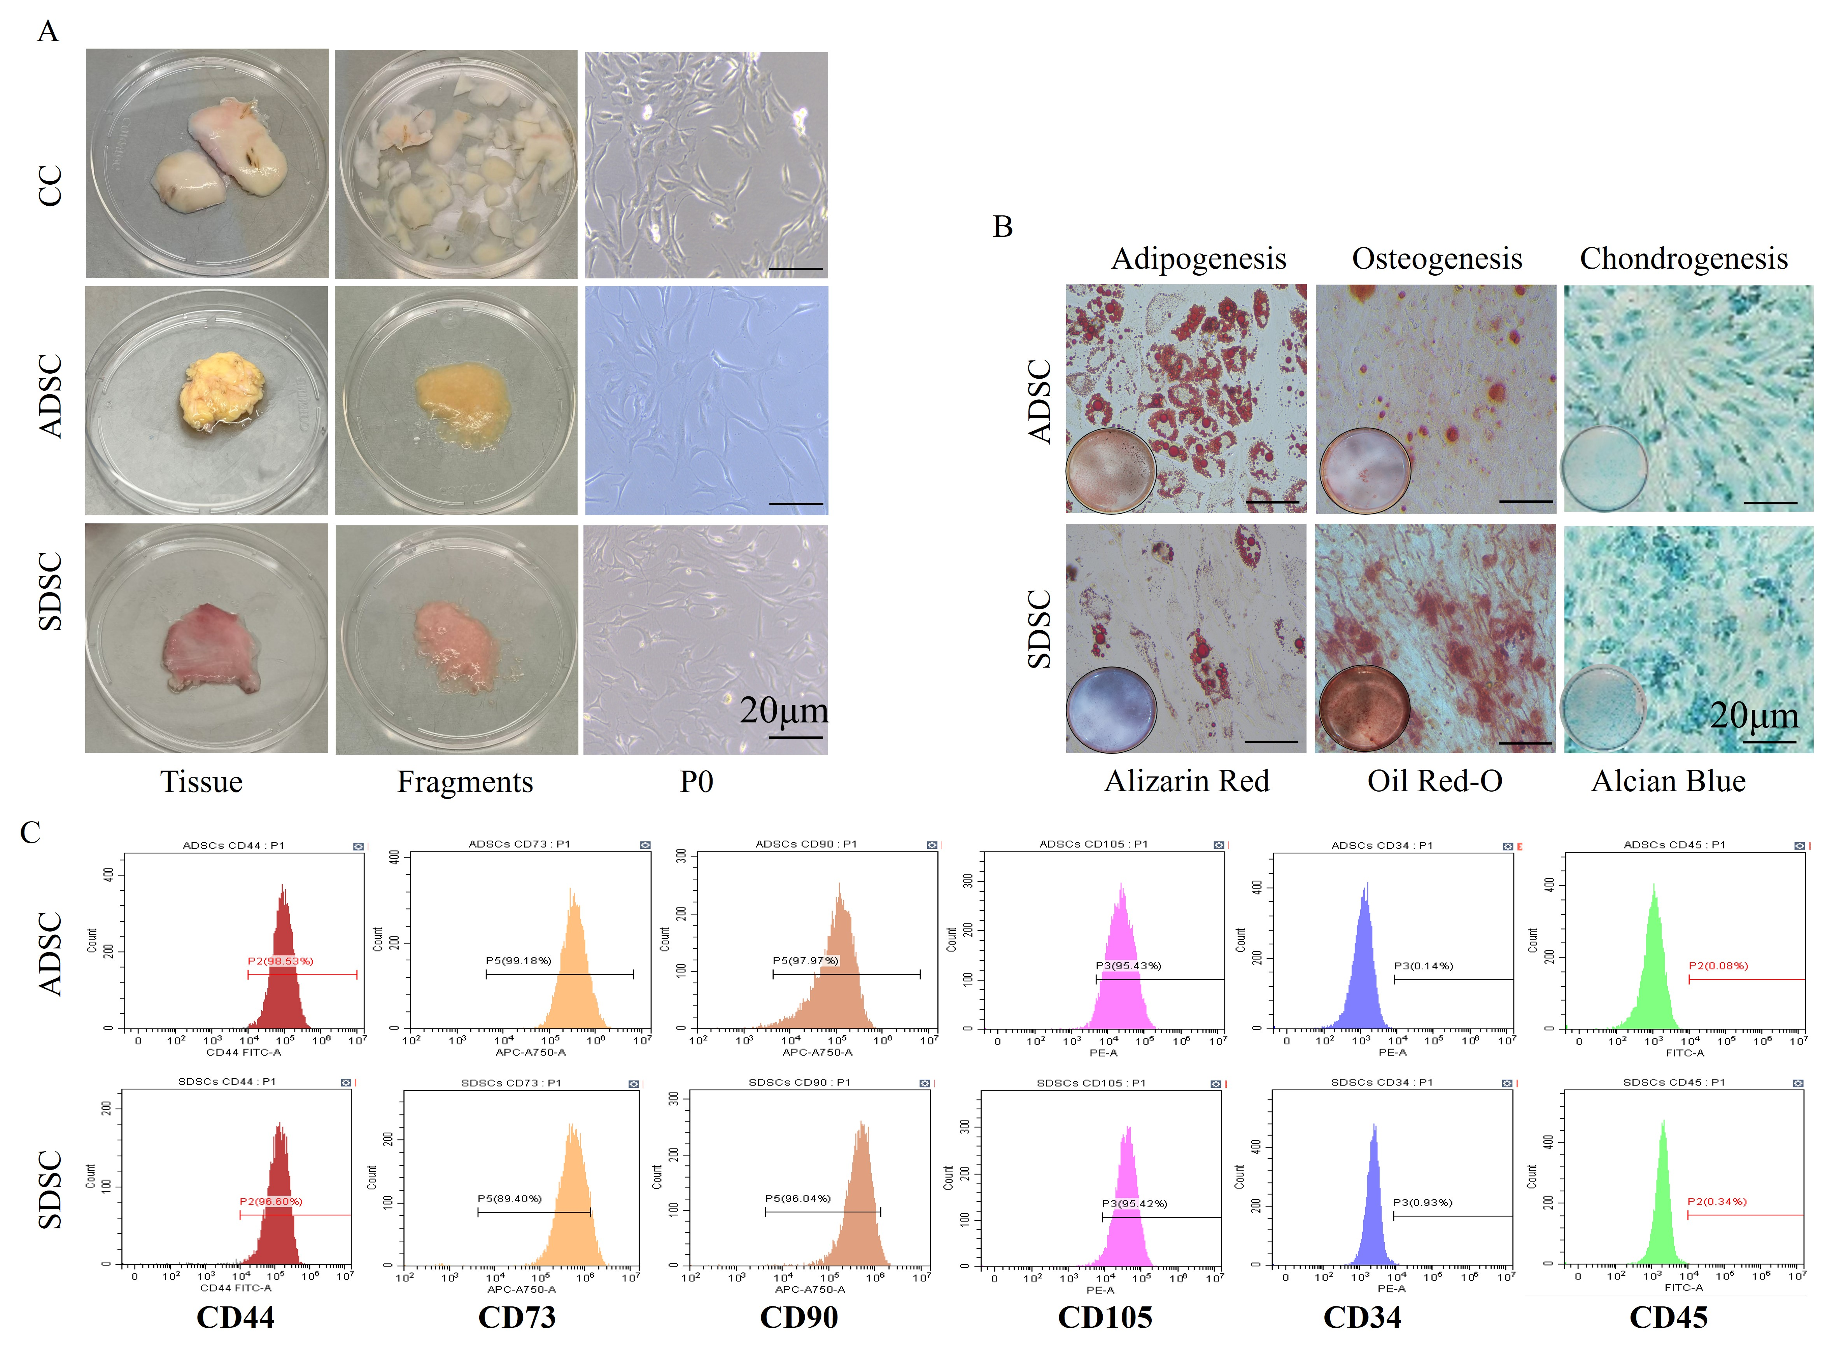
Supplementary Fig.1. Preparation of CC, ADSCs and SDSCs. A, CC, ADSCs, SDSCs exhibited a representative spindle-like morphology (scale bar: 50 μm). B, SDSCs and ADSCs showed multi-potential differentiation capacity for osteogenesis, adipogenesis and chondrogenesis (scale bar: 50 μm). C, Flow cytometric analysis of characteristic cell surface markers of SDSC and ADSCs.
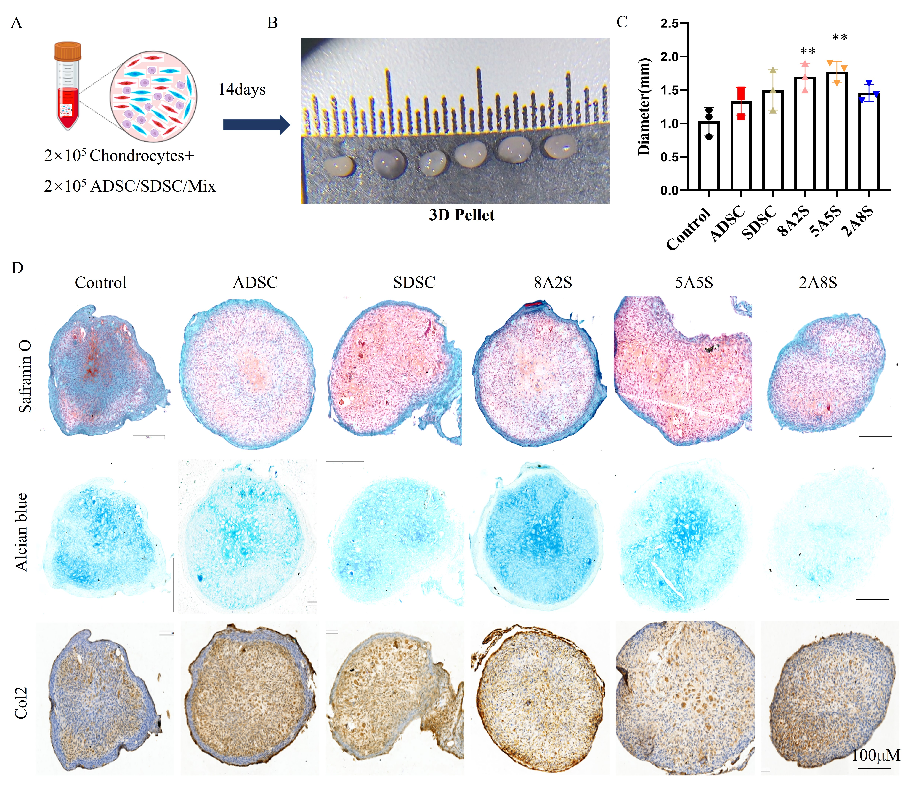
Supplementary Fig.2. Evaluation of cartilage regeneration of the pellet of chondrocytes, ADSCs and SDSCs. A, Schematic illustration of chondrocytes, ADSC and SDSC pellet co-culture. B, the chondrocytes pellet of gross view and quantitative analysis of diameter(C). D, Safranin O, alcian blue and immunohistochemical staining for Col2.
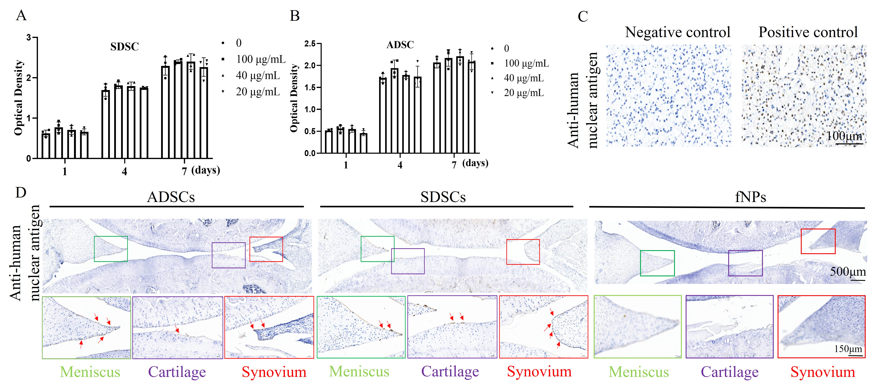
Supplementary Fig.3. A, B, Detection of viability fNP incubation ADSCs and SDSCs by CCK-8 assay. C, Immunohistochemical staining of anti-human nuclear antigen in human skin tissue. D, Immunohistochemical staining of anti-human nuclear antigen in fNP-ADSCs or SDSCs in knee at 12 weeks, the fNPs only in OA knee at 4 weeks after injection.
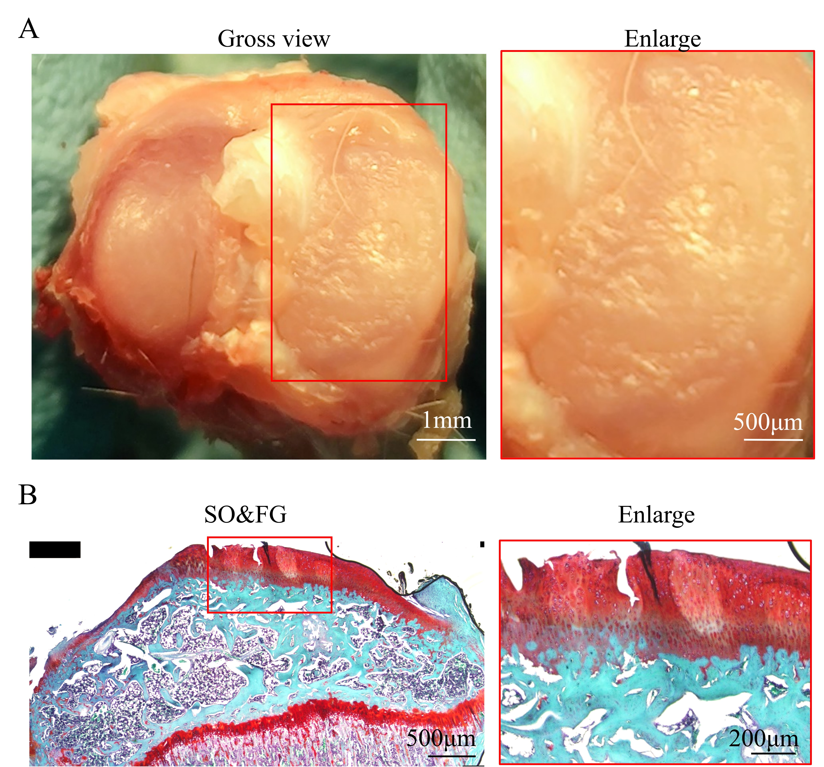
Supplementary Fig.4 The rats developed mild OA at 4 weeks after pMMx. A and B, The gross view and Safranin O/Fast green staining of knee at 4 weeks.
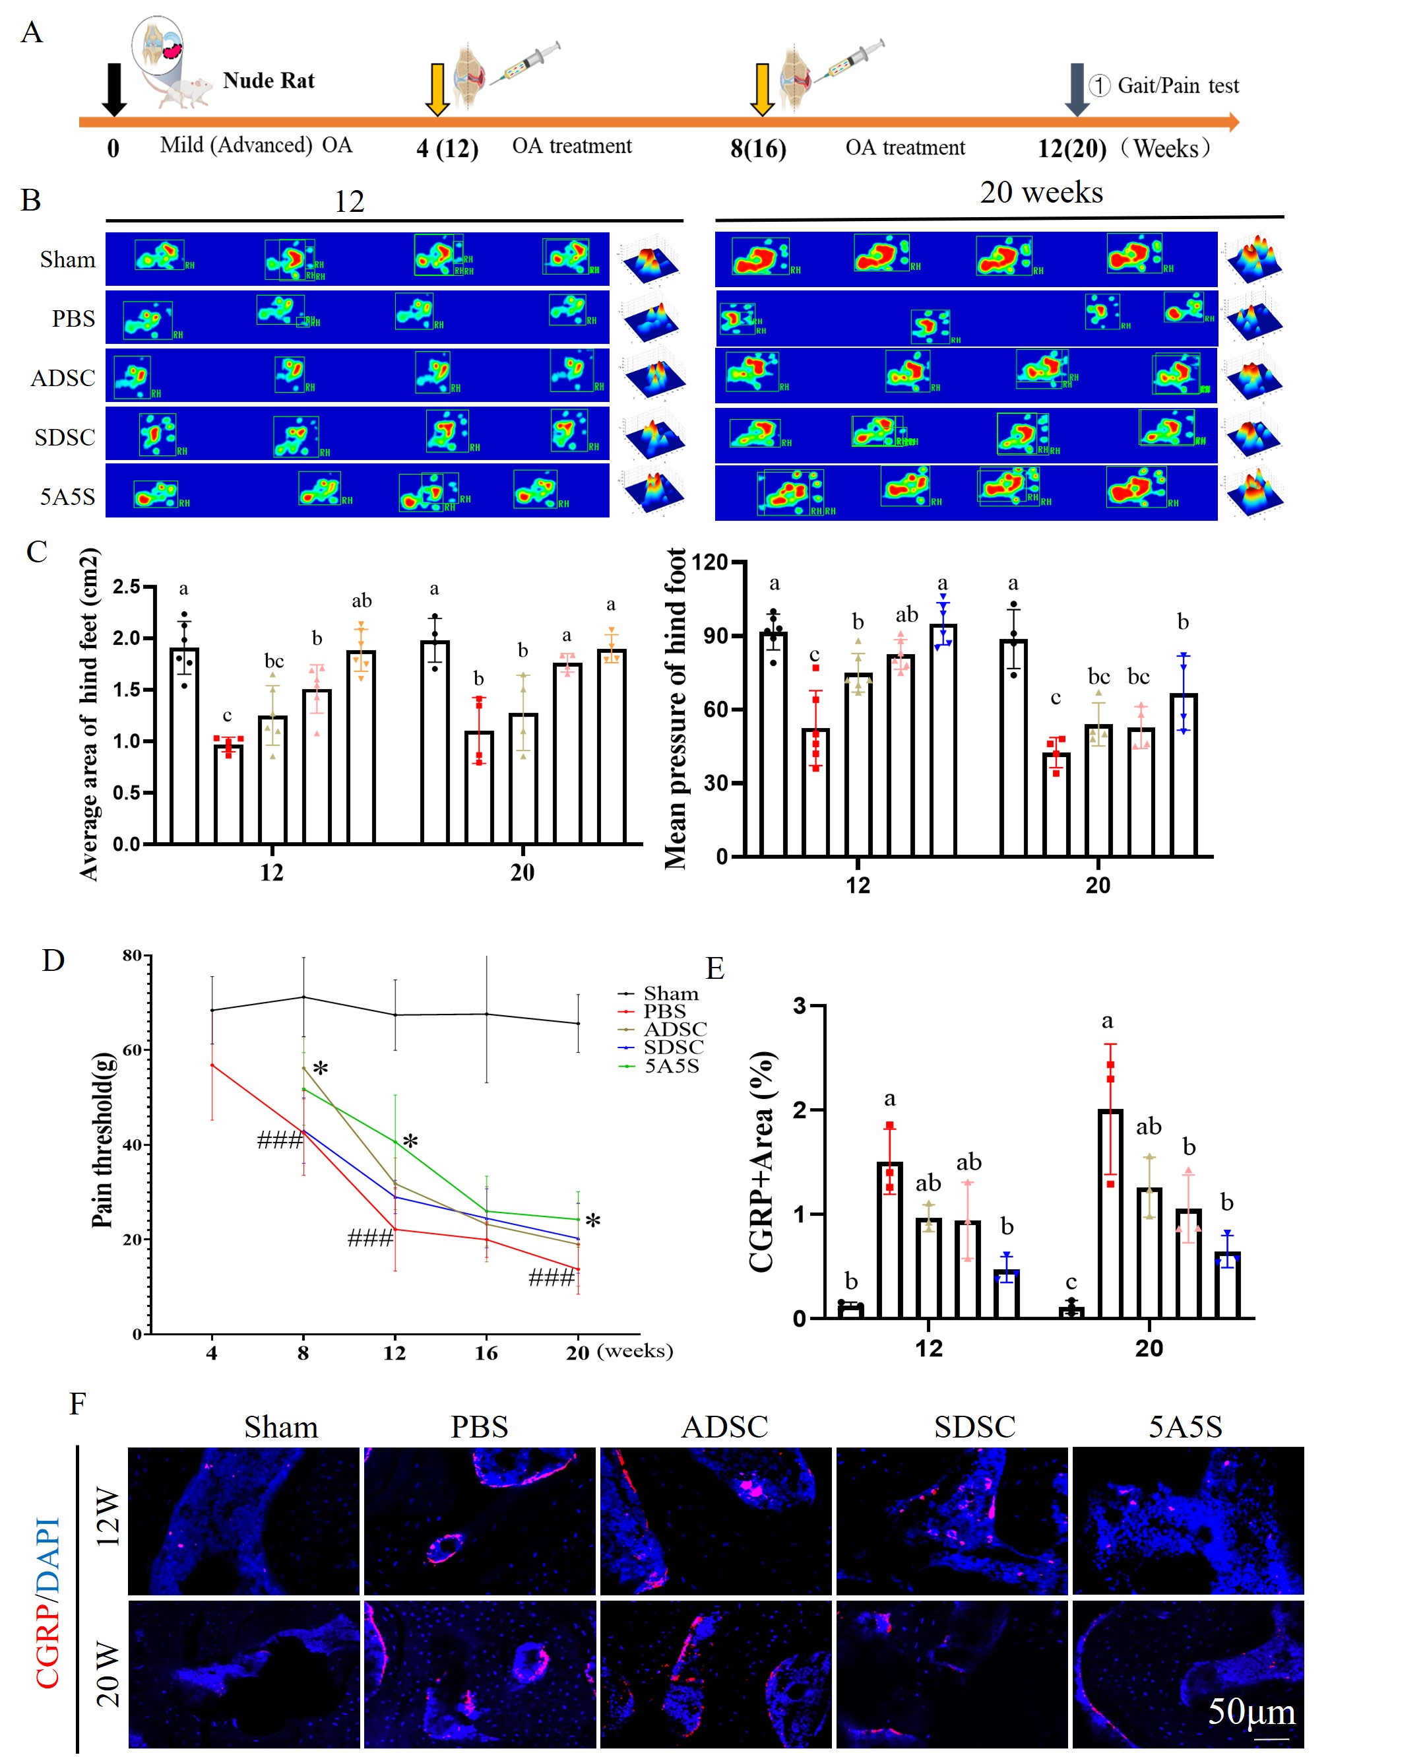
Supplementary Fig.5. A combination of ADSCs and SDSCs in equal amounts improved the gait, pain, and subchondral bone changes in early and advanced OA. A. schematic illustration of intra-injection of ADSCs and SDSCs for OA therapy. B, C, the representative signal images of gait and evaluated mean of print area and pressure intensity. D, mechanical pain thresholds from 4 weeks to 20 weeks by von Frey test. F, CGRP+ nerves in the subchondral bone and the ratio of the area (E). (All data were shown as the mean ± SD. #denotes compared with sham, ###P＜0.001;* denotes compared with PBS, *P＜0.05).
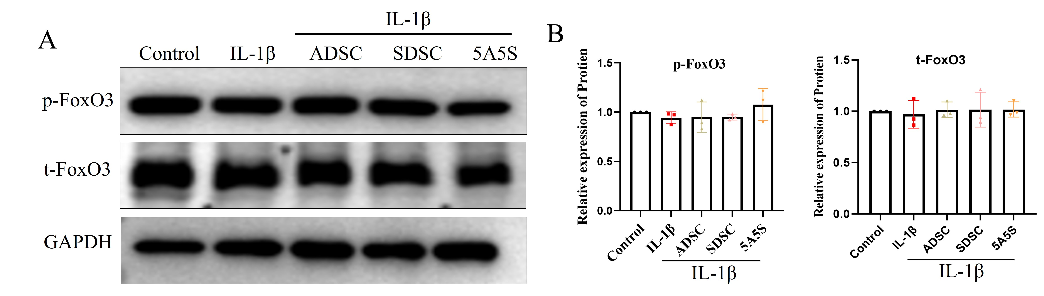
Supplementary Fig.6. FoxO3 signaling pathway not involved in the cartilage regeneration after the treatment of ADSCs and SDSCs conditioned medium. A, p-FoxO3, and t-FoxO3 by Western blot and (B) the quantitative analysis of the bands.
Tables S1 to S2 for multiple supplementary tables
Supplementary table1. ADSCs and SDSCs coculture ratio and cell counts
 | ADSC | SDSC | 8A2S | 5A5S | 2A8S
Ratio  （ADSC:SDSC） | 10：0 | 0：10 | 8：2 | 5：5 | 2：8
Cell count（in vitro）  （ADSC:SDSC） | 2×10⁵ | 2×10⁵ | 1.6×10⁵  0.4×10⁵ | 1×10⁵  1×10⁵ | 0.4×10⁵  1.6×10⁵
Cell count（in vivo）  （ADSC:SDSC） | 1×10⁶ | 1×10⁶ |  | 5×10⁵  5×10⁵
Supplementary table2. Primary and secondary antibodies
Antibodies | Sources | Identifier
Rabbit polyclonal to Ki67 | Abcam | Ab15580
Rabbit polyclonal to CGPR | CellSignaling Technology | 14959S
Rabbit polyclonal to Collagen II | Abcam | Ab34712
Rabbit polyclonal to IL-1β | Servicebio | GB11113-100
Rabbit monoclonal to MMP13 | Abcam | Ab219620
Rabbit polyclonal to LCII | Proteintech | 14600-1-AP
Rabbit polyclonal to P62 | Proteintech | 18420-1-AP
Rabbit polyclonal to p-FoxO1 | Zen-Bioscience | 310198
Rabbit polyclonal to t-FoxO1 | Zen-Bioscience | 340406
Rabbit polyclonal to p-FoxO3 | Zen-Bioscience | 310210
Rabbit polyclonal to t-FoxO3 | Zen-Bioscience | 380728
Rabbit monoclonal to GAPDH | Signalway Antibody | 40493
Anti-rabbit IgG, HRP  -linkedAntibody | CellSignaling Technology | 7074S
References
1. Perrin, S., Julien, A., de Lageneste, O.D., Abou-Khalil, R. & Colnot, C. Mouse Periosteal Cell Culture, in vitro Differentiation, and in vivo Transplantationin Tibial Fractures. Bio Protoc 11, e4107 (2021).
2. Jiang, L.B., et al. Adipose-derived stem cells induce autophagic activation and inhibit catabolic response to pro-inflammatory cytokines in rat chondrocytes. Osteoarthritis Cartilage 24, 1071-1081 (2016).
3. Li, K., et al. Photostable fluorescent organic dots with aggregation-induced emission (AIE dots) for noninvasive long-term cell tracing. Sci Rep 3, 1150 (2013).
4. Yang, C., et al. Single-cell spatiotemporal analysis reveals cell fates and functions of transplanted mesenchymal stromal cells during bone repair. Stem Cell Reports 17, 2318-2333 (2022).
5. Yang, C., et al. Single-cell spatiotemporal analysis reveals cell fates and functions of transplanted mesenchymal stromal cells during bone repair. Stem Cell Reports (2022).

