Additional File 1. Summary of the risk of bias (RoB) in the included studies

The RoB was low overall, as assessed using the Cochran Group's RoB tool for 79 of the finalized randomized controlled trials.
In each assessment domain, the RoB regarding random sequence generation was evaluated as low in 73.1% of the studies, and that for allocation concealment was evaluated as low in 73.1% of the studies. The RoB for the blinding of research participants and investigators was rated as high in 62.5% of studies due to ethical concerns, as many studies did not blind the control group to bone marrow harvest or placebo infusion.
Regarding MACE occurrence, the RoB was low because the endpoint was an objective measurement. Measuring cardiac indicators such as LVEF, LVEDV, LVESV, and infarct size with echocardiograms, MRI, and SPECT, some studies were not clear about the blinding of the assessors, with the RoB evaluated as high or unclear 6.3% and 28.8% of studies, respectively.
The RoB in the outcomes and optional reporting areas was rated as low for 91.3% and 98.8% of the articles, respectively. Graphs summarizing the evaluations by article are presented in Supplementary Figures 1 and 2.
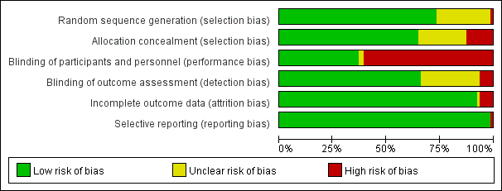
Supplementary Figure 1. Risk of bias graph
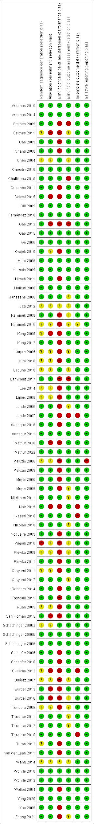
Supplementary Figure 2. Risk of bias summary

