Additional information
Improvement of androgenic alopecia by extracellular vesicles secreted from hyaluronic acid-stimulated induced mesenchymal stem cells
Hyun Geun Oh¹, Minyoung Jung¹, Seon-Yeong Jeong¹, Jimin Kim¹, Sang‑Deok Han¹, Hongduk Kim², Seulki Lee¹, Yejin Lee¹, Haedeun You¹, Somi Park¹, Eun A Kim¹, Tae Min Kim^{2,3}*, Soo Kim¹*

¹R&D Center, Brexogen Inc., Songpa-gu, Seoul 05855, Republic of Korea
²Institutes of Green Bio Science & Technology, Seoul National University, Pyeongchang, Gangwon-do 25354, Republic of Korea
³Graduate School of International Agricultural Technology, Seoul National University, Pyeongchang, Gangwon-do 25354, Republic of Korea

*Correspondence to:
Tae Min Kim, D.V.M., Ph.D.
1447 Pyeongchang Daero, Gangwon-do 25254, Republic of Korea
Tel) +82-33-339-5896, Fax) +82-33-339-5689
E-mail: taemin21@snu.ac.kr

Soo Kim Ph.D.
3F, 9, Beobwon-ro 8-gil, Songpa-gu, Seoul, 05855, Republic of Korea
Tel) +82-2-430-0401, Fax) +82-2-430-0402
E-mail: sue.kim@brexogen.com

Supplemental Methods and Methods
Cell viability assay
Cell Counting Kit-8 (Enzo) was used for the cell viability assay. To measure HFDPC viability against testosterone, 1.5 × 10³ HFDPCs were seeded into a 96-well plate and cultured in complete medium. After a 24 h incubation, the medium was removed from each well. Cells were washed twice in DPBS and treat with 50 μM testosterone in a serum-free DMEM. The cells were then added with HA-iMSC-EVs or iMSC-EVs (10, 25, and 50 μg/mL). After 48 h, the CCK-8 solution was added, and the optical density was measured at 450 nm.

Supplementary Tables
Table S1. List of antibodies used for western blotting.
Antigen | Host | Type | Dilution | Supplier  (Catalog no.)
CD63 | Rabbit | Polyclonal | 1:200 | Abcam  (ab216130)
CD81 | Mouse | Monoclonal | 1:250 | Invitrogen  (10630D)
TGS101 | Rabbit | Monoclonal | 1:1000 | Invitrogen  (MA5-32463)
GAPDH | Rabbit | Polyclonal | 1:5000 | Abcam  (ab9485)
AR | Mouse | Monoclonal | 1:500 | Santa Cruz Biotechnology  (sc-7305)
β-catenin | Rabbit | Polyclonal | 1:1000 | Cell Signaling Technology  (#9562)
GSK3β | Rabbit | Monoclonal | 1:2000 | Cell Signaling Technology  (#12456)
phospho-GSK3β | Rabbit | Monoclonal | 1:1000 | Cell Signaling Technology  (#5558)
Cyclin D1 | Rabbit | Monoclonal | 1:2000 | Cell Signaling Technology  (#55506)
Lamin A/C | Rabbit | Polyclonal | 1:2000 | Cell Signaling Technology  (#2032)
Rabbit-IgG | Goat | Polyclonal,  HRP-conjugated | 1:2000 | Abcam  (ab6721)
Mouse-IgG | Goat | Polyclonal,  HRP-conjugated | 1:2000 | Abcam  (ab205719)

Table S2. Sequence of primers used for quantitative RT-PCR.
Target gene | Sequences
Human AR | F: CCT GGC TTC CGC AAC TTA CAC  R: GGA CTT GTG CAT GCG GTA CTC A
Human TGFβ1 | F: CCC AGC ATC TGC AAA GCT C  R: GTC AAT GTA CAG CTG CCG CA
Human IL-6 | F: ACA GCC ACT CAC CTC TTC AG  R: CCA TCT TTT TCA GCC ATC TTT
Human IGF1 | F: CTT CAG TTC GTG TGT GGA GAC AG  R: CGC CCT CCG ACT GCT G
Human FGF7 | F: TCC TGC CAA CTT TGC TCT ACA  R: CAG GGC TGG AAC AGT TCA CAT
Human VEGF | F: CTA CCT CCA CCA TGC CAA GT  R: GCA GTA GCT GCG CTG ATA GA
Human GAPDH | F: GTC GG AGTC AACGGA TTT GG  R: AGT TGA GGT CAA TGA AGG GGT C

Table S3. List of antibodies used for immunohistochemistry.
Antigen | Host | Type | Dilution | Supplier  (Catalog no.)
AR | Mouse | Monoclonal | 1:100 | Santa Cruz Biotechnology  (sc-7305)
β-catenin | Rabbit | Polyclonal | 1:300 | Cell Signaling Technology  (#9562)
N/A | Goat | Anti-rabbit IgG,  Polyclonal,  Alexa fluor 488-conjugated | 1:500 | Abcam  (150077)
N/A | Goat | Anti-mouse IgG,  Polyclonal,  Cyanin5-conjugated | 1:500 | Invitrogen  (A10524)
N/A: non-applicable

Table S4. List of differentially expressed proteins in HA-iMSC-EVs.
Pathways | Gene symbol | Protein accession No. | Protein name | P-value | Log₂FC | FDR q-value
Pathways | Gene symbol | Protein accession No. | Protein name | P-value | Log₂FC | FDR q-value
ECM-receptor interaction | COL4A1 | P02462 | Collagen alpha-1(IV) chain | 0.0007 | 0.6323 | q = 0.004  q = 0.002
ECM-receptor interaction | COL4A2 | P08572 | Collagen alpha-2(IV) chain | 0.0026 | 0.433 | q = 0.004  q = 0.002
ECM-receptor interaction | COL4A5 | P29400 | Collagen alpha-5(IV) chain | 0.0005 | 0 | q = 0.004  q = 0.002
ECM-receptor interaction | COL6A3 | P12111 | Collagen alpha-3(VI) chain | 0.006 | -0.2141 | q = 0.004  q = 0.002
ECM-receptor interaction | THBS1 | P07996 | Thrombospondin-1 | 0.0008 | 0.4751 | q = 0.004  q = 0.002
ECM-receptor interaction | ITGA5 | P08648 | Integrin alpha-5 | 0.0021 | -0.6323 | q = 0.004  q = 0.002
ECM-receptor interaction | LAMA1 | P25391 | Laminin subunit alpha-1 | 0.0026 | -0.4542 | q = 0.004  q = 0.002
ECM-receptor interaction | LAMA2 | P24043 | Laminin subunit alpha-2 | 0.0003 | -0.8875 | q = 0.004  q = 0.002
ECM-receptor interaction | LAMA4 | Q16363 | Laminin subunit alpha-4 | < 0.0001 | -0.9928 | q = 0.004  q = 0.002
ECM-receptor interaction | LAMB1 | P07942 | Laminin subunit beta-1 | 0.0001 | -0.5558 | q = 0.004  q = 0.002
ECM-receptor interaction | LAMC1 | P11047 | Laminin subunit gamma-1 | < 0.0001 | -0.5656 | q = 0.004  q = 0.002
ECM-receptor interaction | LAMC2 | Q13753 | Laminin subunit gamma-2 | 0.0036 | 0 | q = 0.004  q = 0.002
ECM-receptor interaction | ITGB1 | P05556 | Integrin beta-1 | 0.0013 | -1.275 | q = 0.004  q = 0.002
ECM-receptor interaction | CD44 | P16070 | CD44 antigen | 0.001 | -0.696 | q = 0.004  q = 0.002
PI3K/AKT signaling | COL4A1 | P02462 | Collagen alpha-1(IV) chain | 0.0007 | 0.6323 | q = 0.038  q = 0.237
PI3K/AKT signaling | COL4A2 | P08572 | Collagen alpha-2(IV) chain | 0.0026 | 0.433 | q = 0.038  q = 0.237
PI3K/AKT signaling | COL4A5 | P29400 | Collagen alpha-5(IV) chain | 0.0005 | 0 | q = 0.038  q = 0.237
PI3K/AKT signaling | THBS1 | P07996 | Thrombospondin-1 | 0.0008 | 0.4751 | q = 0.038  q = 0.237
PI3K/AKT signaling | ITGA5 | P08648 | Integrin alpha-5 | 0.0021 | -0.6323 | q = 0.038  q = 0.237
PI3K/AKT signaling | ITGB1 | P05556 | Integrin beta-1 | 0.0013 | -1.275 | q = 0.038  q = 0.237
PI3K/AKT signaling | GNG12 | Q9UBI6 | Guanine nucleotide-binding protein G(I)/G(S)/G(O) subunit gamma-12 | 0.0006 | -1.4005 | q = 0.038  q = 0.237
PI3K/AKT signaling | LAMA1 | P25391 | Laminin subunit alpha-1 | 0.0026 | -0.4542 | q = 0.038  q = 0.237
PI3K/AKT signaling | LAMA2 | P24043 | Laminin subunit alpha-2 | 0.0003 | -0.8875 | q = 0.038  q = 0.237
PI3K/AKT signaling | LAMA4 | Q16363 | Laminin subunit alpha-4 | < 0.0001 | -0.9928 | q = 0.038  q = 0.237
PI3K/AKT signaling | LAMB1 | P07942 | Laminin subunit beta-1 | 0.0001 | -0.5558 | q = 0.038  q = 0.237
PI3K/AKT signaling | LAMC1 | P11047 | Laminin subunit gamma-1 | < 0.0001 | -0.5656 | q = 0.038  q = 0.237
PI3K/AKT signaling | LAMC2 | Q13753 | Laminin subunit gamma-2 | 0.0036 | 0 | q = 0.038  q = 0.237
PI3K/AKT signaling | CSF1 | P09603 | Macrophage colony-stimulating factor 1 | 0.017 | -0.585 | q = 0.038  q = 0.237
PI3K/AKT signaling | COL6A3 | P12111 | Collagen alpha-3(VI) chain | 0.006 | -0.2141 | q = 0.038  q = 0.237
PI3K/AKT signaling | RAC1 | P63000 | Ras-related C3 botulinum toxin substrate 1 | 0.0006 | -1.2079 | q = 0.038  q = 0.237
PI3K/AKT signaling | YWHAZ | P63104 | 14-3-3 protein zeta/delta | 0.0003 | -0.3674 | q = 0.038  q = 0.237
PI3K/AKT signaling | RPS6 | P62753 | 40S ribosomal protein S6 | 0.0016 | -0.6781 | q = 0.038  q = 0.237
Proteosome | PSMA1 | P25786 | Proteasome subunit alpha type-1 | 0.0002 | -0.585 | q  = 4.86E-26
Proteosome | PSMA2 | P25787 | Proteasome subunit alpha type-2 | 0.0016 | -0.5656 | q  = 4.86E-26
Proteosome | PSMA4 | P25789 | Proteasome subunit alpha type-4 | 0.001 | -0.4751 | q  = 4.86E-26
Proteosome | PSMA5 | P28066 | Proteasome subunit alpha type-5 | 0.0013 | -0.7824 | q  = 4.86E-26
Proteosome | PSMA6 | P60900 | Proteasome subunit alpha type-6 | 0.0004 | -0.546 | q  = 4.86E-26
Proteosome | PSMA7 | O14818 | Proteasome subunit alpha type-7 | 0.0012 | -0.5059 | q  = 4.86E-26
Proteosome | PSMB1 | P20618 | Proteasome subunit beta type-1 | 0.0009 | -0.3448 | q  = 4.86E-26
Proteosome | PSMB2 | P49721 | Proteasome subunit beta type-2 | 0.0011 | -0.4647 | q  = 4.86E-26
Proteosome | PSMB4 | P28070 | Proteasome subunit beta type-4 | 0.0019 | -0.669 | q  = 4.86E-26
Proteosome | PSMB6 | P28072 | Proteasome subunit beta type-6 | 0.0006 | -0.8319 | q  = 4.86E-26
Proteosome | PSMB7 | Q99436 | Proteasome subunit beta type-7 | < 0.0001 | -0.3674 | q  = 4.86E-26
Proteosome | PSMB8 | P28062 | Proteasome subunit beta type-8 | 0.0043 | -0.3103 | q  = 4.86E-26
Proteosome | PSMC2 | P35998 | 26S proteasome regulatory subunit 7 | 0.0008 | -0.7137 | q  = 4.86E-26
Proteosome | PSMC3 | P17980 | 26S proteasome regulatory subunit 6A | 0.0015 | -0.4854 | q  = 4.86E-26
Proteosome | PSMC5 | P62195 | 26S proteasome regulatory subunit 8 | 0.0023 | -0.6871 | q  = 4.86E-26
Proteosome | PSMC6 | P62333 | 26S proteasome regulatory subunit 10B | 0.0032 | -0.9486 | q  = 4.86E-26
Proteosome | PSMD1 | O00231 | 26S proteasome non-ATPase regulatory subunit 11 | 0.0007 | -0.848 | q  = 4.86E-26
Proteosome | PSMD2 | Q13200 | 26S proteasome non-ATPase regulatory subunit 2 | 0.0011 | -0.3561 | q  = 4.86E-26
Proteosome | PSMD6 | Q15008 | 26S proteasome non-ATPase regulatory subunit 6 | 0.0006 | -0.9486 | q  = 4.86E-26
Proteosome | PSMD7 | P51665 | 26S proteasome non-ATPase regulatory subunit 7 | 0.0013 | -0.6871 | q  = 4.86E-26
Proteosome | PDMD8 | P48556 | 26S proteasome non-ATPase regulatory subunit 8 | < 0.0001 | -1.0566 | q  = 4.86E-26
Proteosome | PDMD11 | O00231 | 26S proteasome non-ATPase regulatory subunit 11 | 0.0007 | -0.4222 | q  = 4.86E-26
Proteosome | PSMD12 | O00232 | 26S proteasome non-ATPase regulatory subunit 12 | < 0.0001 | -0.6781 | q  = 4.86E-26
Proteosome | PSMD13 | Q9UNM6 | 26S proteasome non-ATPase regulatory subunit 13 | 0.0002 | -0.84 | q  = 4.86E-26
Proteosome | PSMD14 | O00487 | 26S proteasome non-ATPase regulatory subunit 14 | 0.0005 | -0.9928 | q  = 4.86E-26

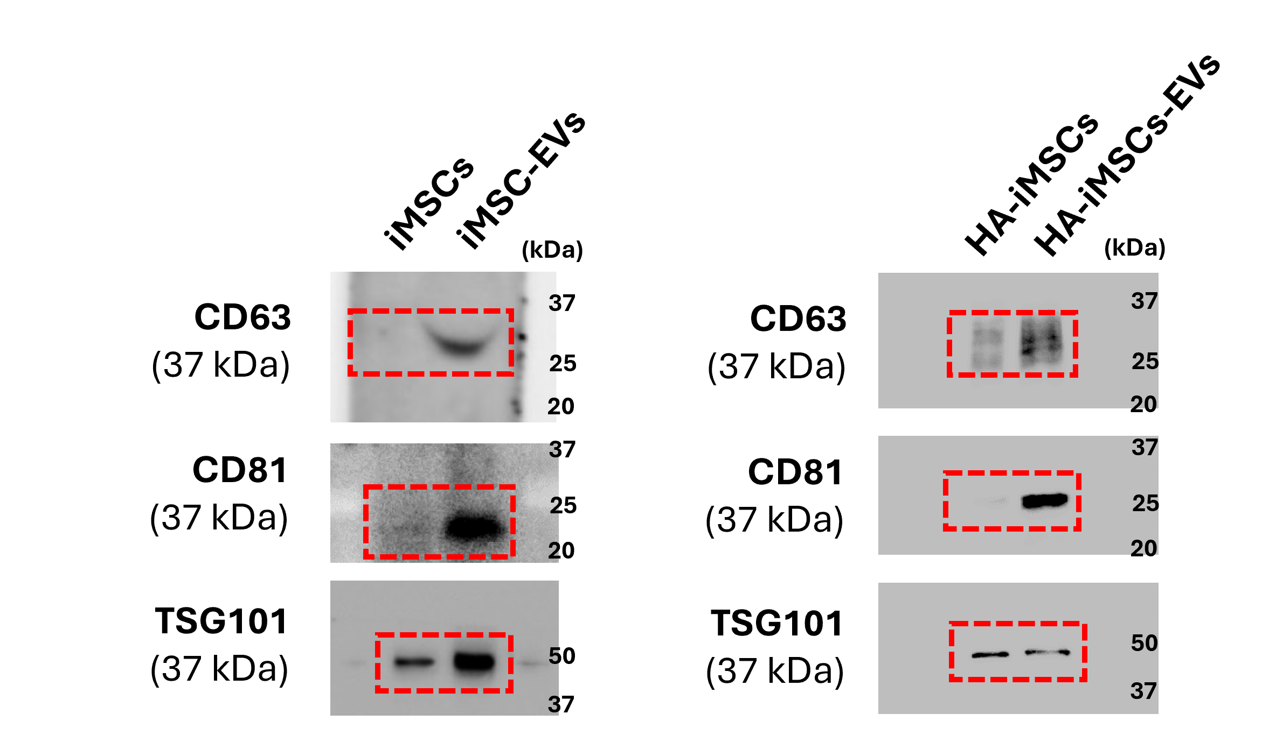
Figure S1. Uncropped images of western blotting for Figure 1 (B). The red boxes indicate the cropped images of western blotting shown in Figure 1 (B). Membranes were cut to enable blotting for multiple antibodies.

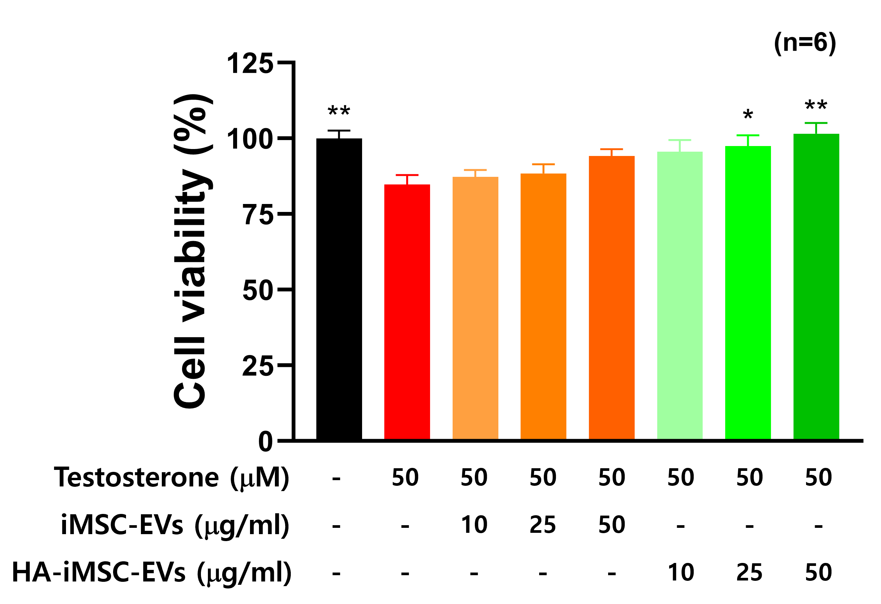
Figure S2. HA-iMSC-EVs recovered cell viability in testosterone-induced androgenic alopecia in vitro model. (A) The viability of HDFPC was measured after being cultured with 10, 25 and 50 μg/ml iMSC-EVs or HA-iMSC-EVs. *p<0.05, **p<0.01 vs. testosterone-treated group. EV, extracellular vesicle; HA, hyaluronic acid; HFDPC, hair follicle dermal papilla cell; iMSC, induced pluripotent stem cell-derived mesenchymal stem cell

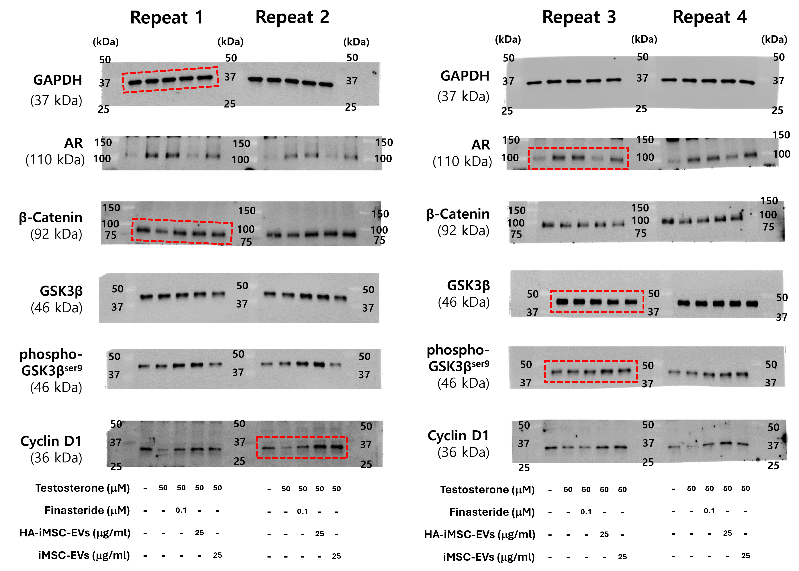

Figure S3. Uncropped images of western blotting for Figure 3 (A-E). The red boxes indicate the cropped images of western blotting shown in Figure 3 (A). Membranes were cut to enable blotting for multiple antibodies.

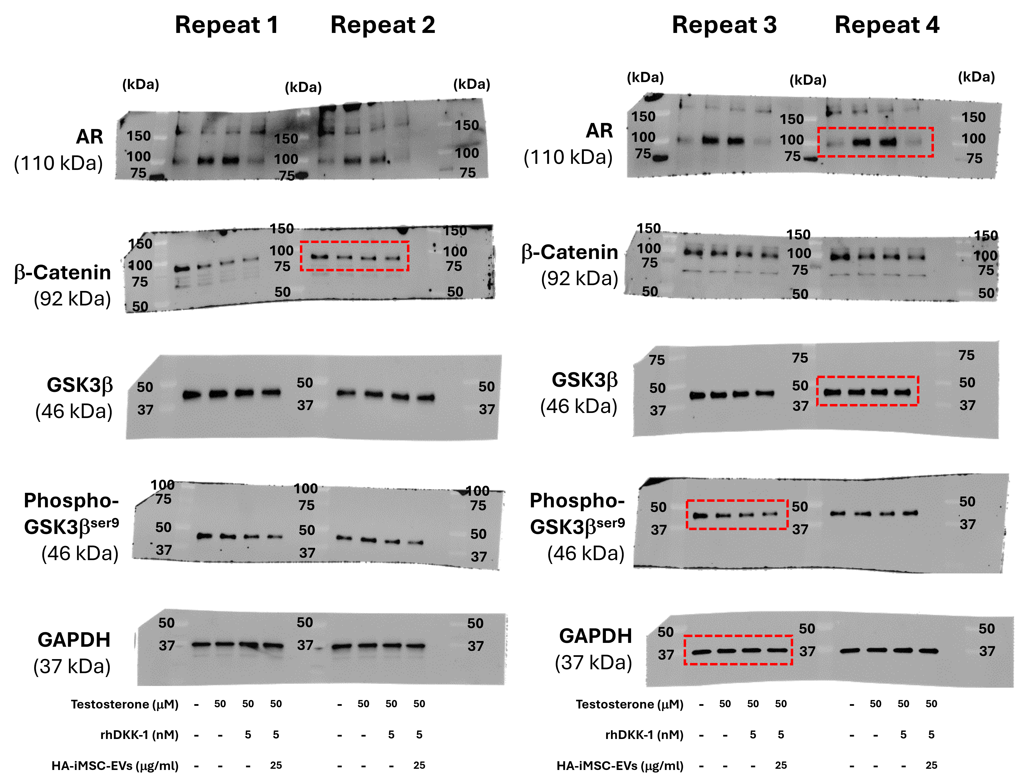

Figure S4. Uncropped images of western blotting for Figure 3 (F-I). The red boxes indicate the cropped images of western blotting shown in Figure 3 (F). Membranes were cut to enable blotting for multiple antibodies.

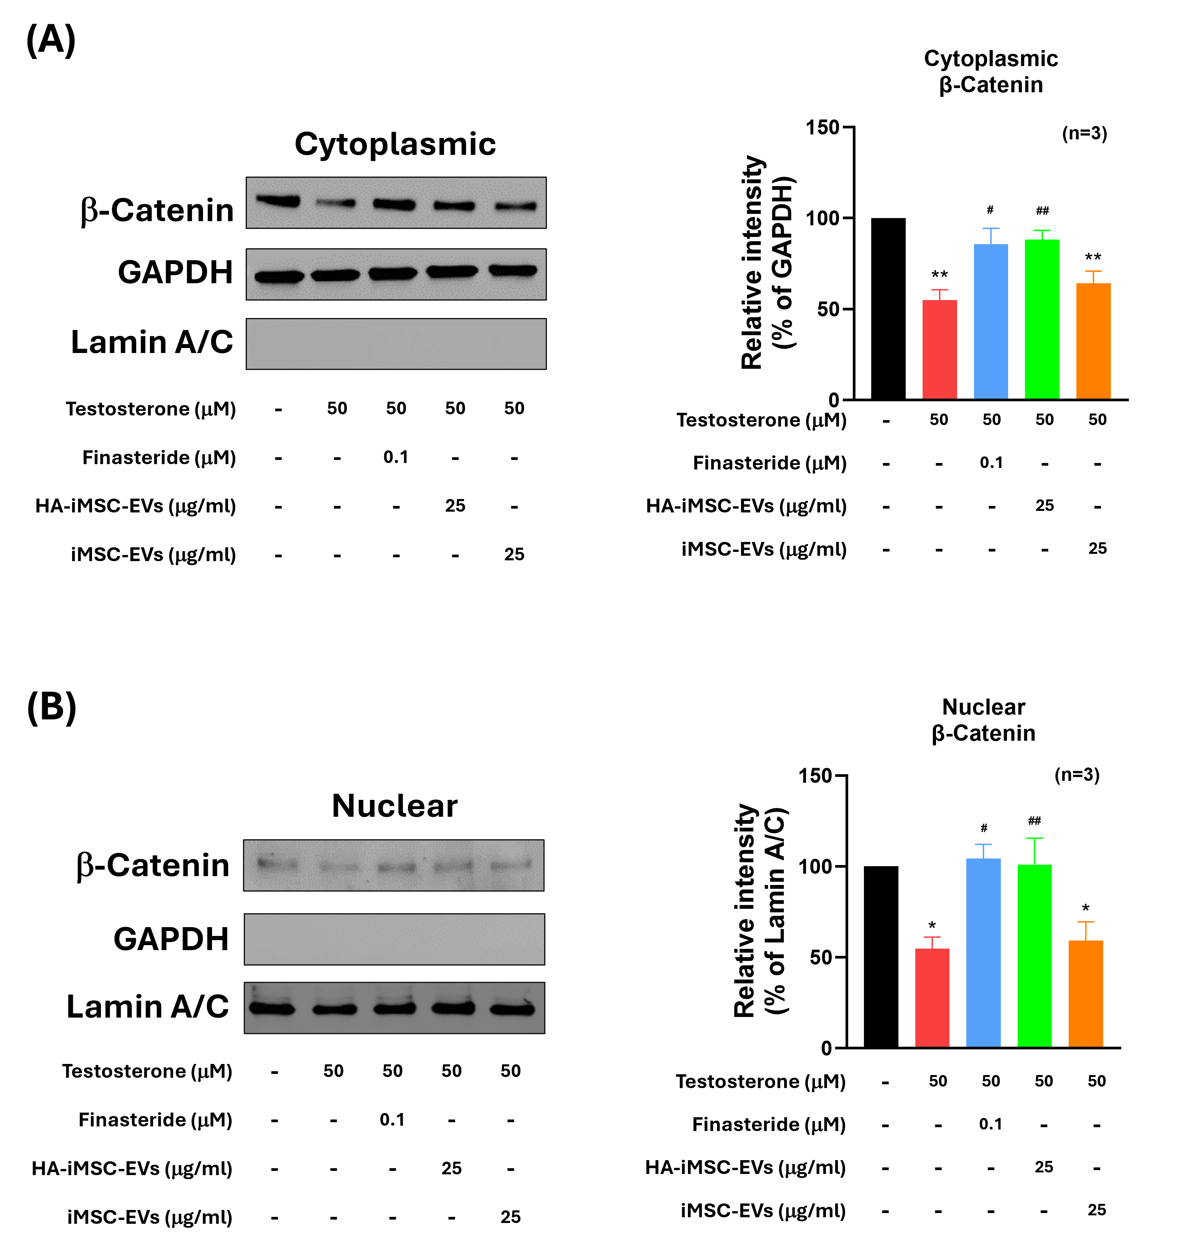
Figure S5. Translocation of testosterone-reduced β-catenin to the nucleus was restored by finasteride or HA-iMSC-EVs. The cytoplasmic β-catenin expression (A) and the nuclear β-catenin expression (B) were normalized to the loading control, GAPDH and Lamin A/C, respectively, and were replicated from three independent experiments. Uncropped western blot images are shown in Additional file 1: Figure S6. *p<0.05, **p<0.01 vs. control group. #p<0.05, ##p<0.01 vs. testosterone-only group. EV, extracellular vesicle; HA, hyaluronic acid; HFDPC, hair follicle dermal papilla cell; iMSC, induced pluripotent stem cell-derived mesenchymal stem cell

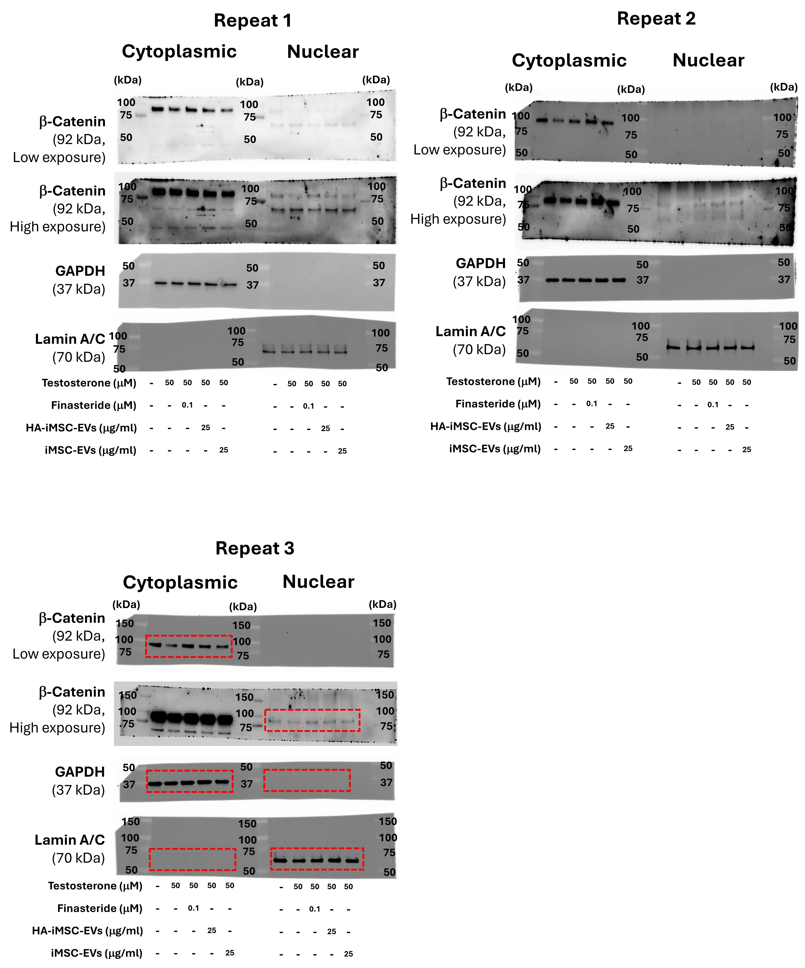
Figure S6. Uncropped images of western blotting for Figure S5 (A, B). The red boxes indicate the cropped images of western blotting shown in Figure S5 (A, B). Membranes were cut to enable blotting for multiple antibodies.

