Table S1. Donor information of the human primary hepatocytes.
Batch | Race | Gender | Age | Hepatitis B | Reason for liver resection
A123B | Asian | Male | 35 | - | Hepatic hemangioma
C567D | Asian | female | 42 | - | Hepatic hemangioma
E890F | Asian | Male | 1 | - | Propionic acidemia
G123H | Asian | Male | 5 | - | Propionic acidemia
I456J | Asian | Male | 51 | - | Hepatoma
KL78M | Asian | female | 66 | - | Cholangiocarcinoma
NO45P | Asian | Male | 48 | - | Cholangiocarcinoma
QR12S | Asian | female | 34 | - | Hepatoma
AZ17S | Asian | female | 55 | - | Hepatic echinococcosis
RS56A | Asian | female | 31 | - | Hepatic cystadenocarcinoma
H12AB | Asian | female | 50 | - | hilar cholangiocarcinoma
NR78B | Asian | female | 28 | - | Hepatoma

Table S2. Candidate small molecules for PHHs expansion.
No. | Name | Target | Working concentration (μM)
1 | SRT2104 | SIRT1 | 5
2 | SRT1720 | SIRT1 | 5
3 | SRT3025 | SIRT1 | 5
4 | Quercetin | SIRT1 and PI3K | 5
5 | XMU-MP-1 | MST | 5
6 | FPH1 | Reported for hepatocyte expansion | 5
7 | FPH2 | Reported for hepatocyte expansion | 5
8 | BAY K 8644 | LTCC | 5
9 | SR1 | AHR | 1
10 | UM171 | Reported for HSC self-renewal | 1
11 | JNK-IN-8 | JNK | 5
12 | SP600125 | JNK | 5
13 | TCSJNK60 | JNK | 5
14 | SB203580 | p38 MAPK | 5
15 | ID-8 | DYRK | 5
16 | PGE2 | a hormone | 5
17 | β-Estradiol 17-Acetate | a metabolite of estradiol | 5
18 | Estradiol | a steroid hormone | 5
19 | Progesterone | a steroid hormone | 5
20 | BIO | GSK-3α/β | 5
21 | 2-D08 | sumoylation | 5
22 | RA | RAR | 5
23 | MLN120B | IKKB | 5
24 | ACHP Hydrochloride | IKKB | 5
25 | 740 Y-P | PI3K | 5
26 | PIK-93 | PI3K | 5
27 | SC79 | AKT | 5
28 | MHY1485 | mTOR | 5
29 | Anisomycin | JNK | 5
30 | Hydrocortisone-acetate | NR3C1; NR3C2 | 5

Table S3. Media tested for PHHs expansion.
Components | Hep-Medium¹ | HM² | TEM³ | DCM⁴ | DTM⁵ | NHEM
DMEM/F-12 | / | / | / | / | / | 50%
Advanced DMEM/F-12 | 1× | 1× | 1× | 1× | 1× | /
William E medium | / | / | / | / | / | 50%
N2 supplement (100×) | 1× | 1× | 1× | / | / | /
B27 Supplement (50×, minus vitamin A) | 1× | 1× | 1× | / | / | 1×
Insulin-transferrin-selenium (100×) | / | / | / | 1× | / | /
Knockout-Serum Replacement | / | / | / | / | 10% | /
Fetal bovine serum | / | 1% | / | 1% | 5% | /
Penicillin-Streptomycin (100×) | 1× | 1× | / | 1× | 1× | 1×
NEAA (100×) | / | / | / | / | 1× | /
Sodium pyruvate | / | / | 1 mM | / | / | /
Glutamine (GlutaMax) (100×) | 1× | / | / | / | 1× | 1×
HEPES | / | / | / | / | 15 mM | /
Ascorbic acid | / | / | 10 μg/ml | / | / | 200 μM
N-acetyl-cysteine | 1.25 mM | 1 mM | / | / | / | /
Nicotinamide | 10 mM | 10 mM | / | 10 mM | / | /
Dexamethasone | / | / | / | 0.1 μM | / | /
Human [Leu15]-gastrin I | 10 nM | 10 nM | / | / | / | /
Hydrocortisone | / | / | / | / | / | 5 μM
EGF | 50 ng/mL | 50 ng/mL | 20 ng/mL | 20 ng/mL | 10 ng/mL | 50 ng/mL
FGF10 | 50 ng/ml | 2 ng/ml | / | / | / | /
FGF2 | / | / | / | / | 10 ng/mL | /
HGF | 25 ng/mL | 25 ng/mL | 20 ng/mL | 20 ng/mL | / | 20 ng/mL
Wnt3 | / | 50 ng/mL | / | / | / | /
TGFα | 20 ng/mL | / | / | / | / | /
FGF7 | 50 ng/mL | / | / | / | / | /
R-spondin 1 | 50 ng/mL | / | / | / | / | /
A 83-01 | 2 μM | 5 μM | 1 μM | 4 μM | / | /
CHIR99021 | 3 uM | / | 3 μM | 3 μM | 3 μM | 3 μM
Y-27632 | 10 μM | 10 μM | 10 μM | / | / | /
LPA | / | / | 5 μM | / | / | /
S1P | / | / | 1 μM | / | / | /

Table S4. Small Molecule Compounds and Cytokines.
No. | Full Name | Abbreviation | Working concentration | Molecular weight | Structure | Catalog Number
1 | Forskolin | FSK | 20 μM | 410.50 | 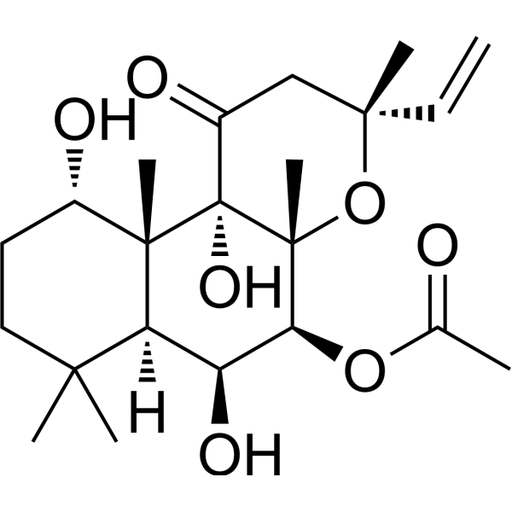 | HY-15371 (MCE)
2 | SB-431542 | SB43 | 5 μM for HEM/NHEM  10 μM for 5C/6C | 384.39 | 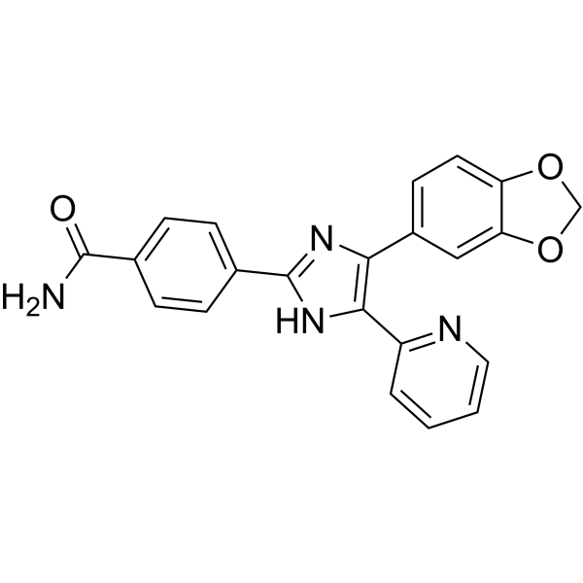 | SB-431542 (MCE)
3 | IWP-2 | / | 0.5 μM | 466.60 | 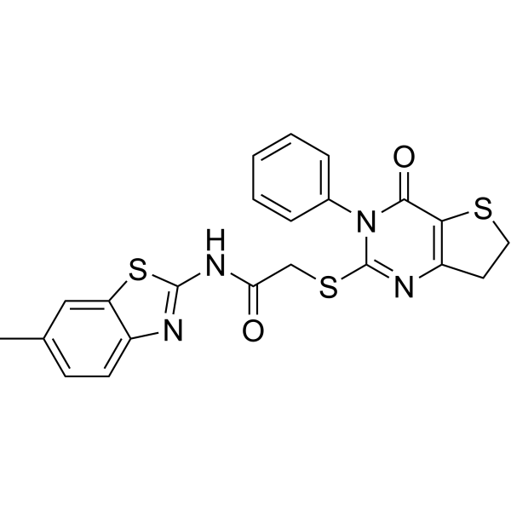 | IWP-2 (MCE)
4 | DAPT | / | 5 μM | 432.46 | 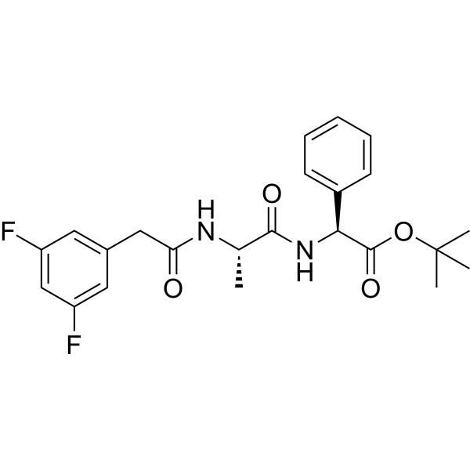 | DAPT (MCE)
5 | LDN193189 | LDN | 0.1 μM | 406.48 | 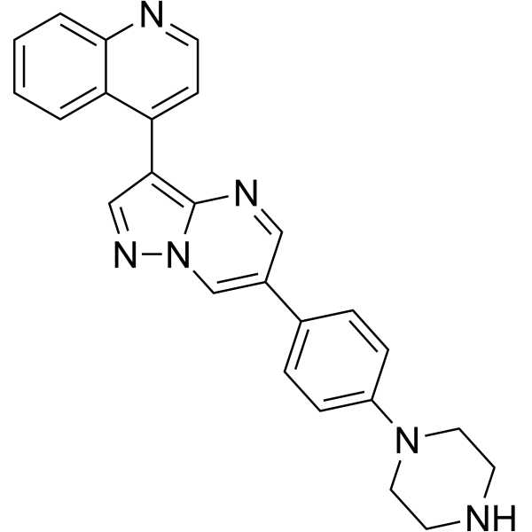 | LDN193189 (MCE)
6 | Nicotinamide | Nico | 5 μM | 122.12 | 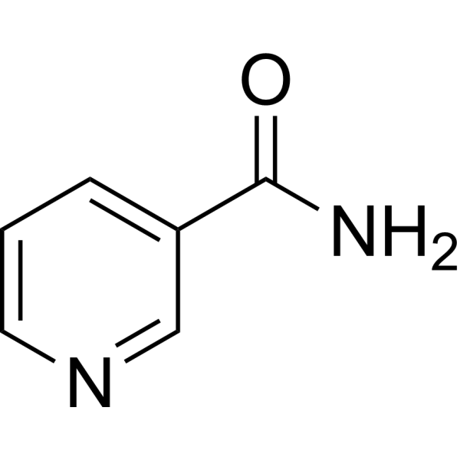 | HY-B0150 (MCE)
7 | CHIR-99021 | CHIR | 3 μM | 456.34 | 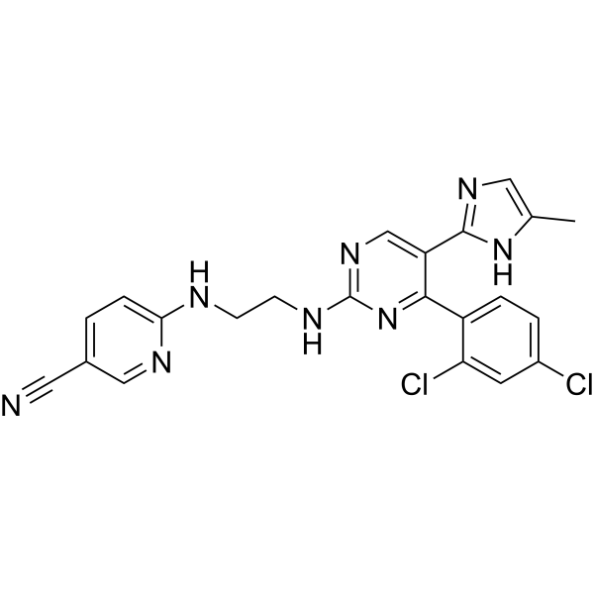 | HY-10182 (MCE)
8 | Sphingosine-1-phosphate | S1P | 0.5 μM | 379.47 | 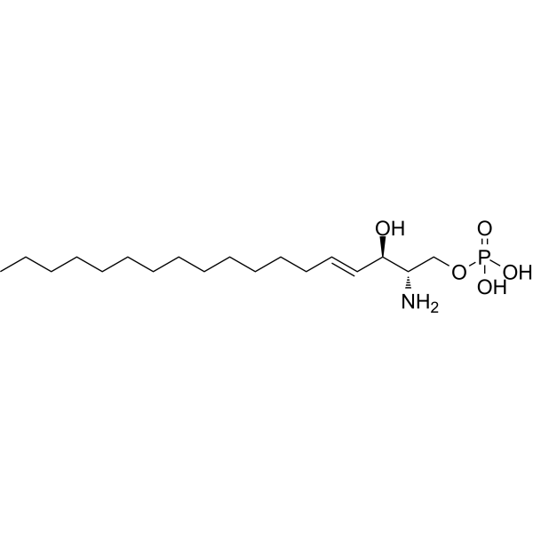 | S9666 (Sigma-Aldrich)
9 | Lysophosphatidic acid | LPA | 5 μM | 436.52 |  | L7260 (Sigma-Aldrich)
10 | 2-phospho-L-ascorbic acid | pVC | 200 μM | 332.05 | 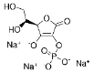 | 49752 (Sigma-Aldrich)
11 | Recombinant Human EGF | EGF | 50 ng/ml | / | / | AF-100-15 (Peprotech)
12 | Recombinant Human HGF | HGF | 20 ng/ml | / | / | 100-39H (Peprotech)
13 | Chroman 1 | CEPT | 0.05 μM | 436.5 | 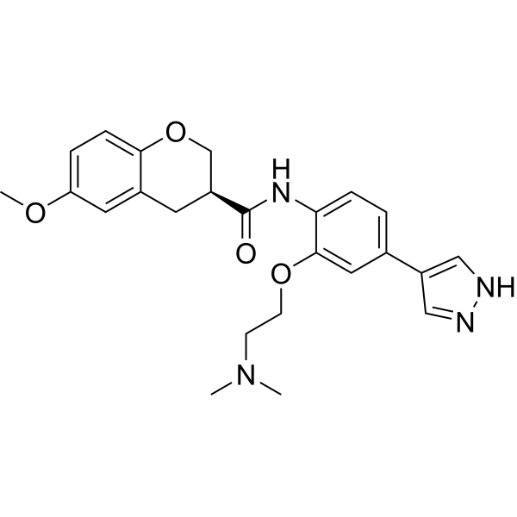 | HY-K1043 (MCE)
14 | Emricasan | CEPT | 5 μM | 569.5 | 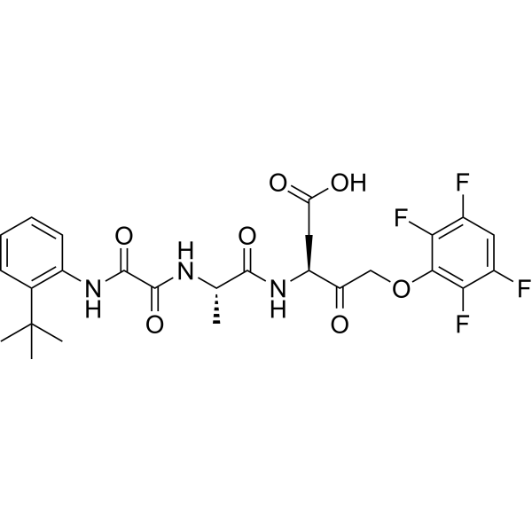 | HY-K1043(MCE)
15 | Polyamine supplement  (1000×, lyophilized) | CEPT | 1× | / | / | HY-K1043(MCE)
16 | Tran-ISRIB | CEPT | 0.7 μM | / | / | HY-K1043 (MCE)
17 | Dexamethasone | Dex | 0.2 μM | 392.46 | 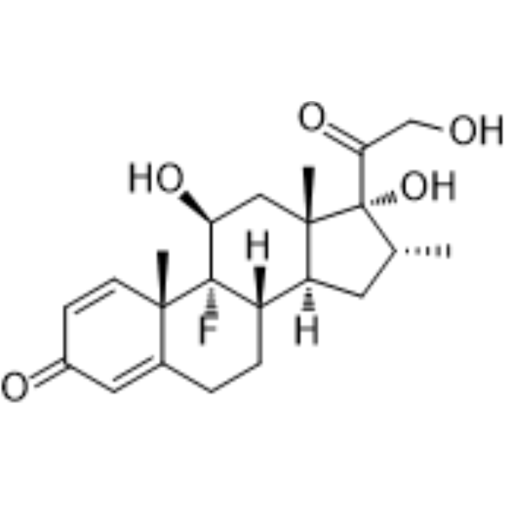 | HY-14648 (MCE)
18 | Hydrocortisone | / | 5 μM | 362.46 | 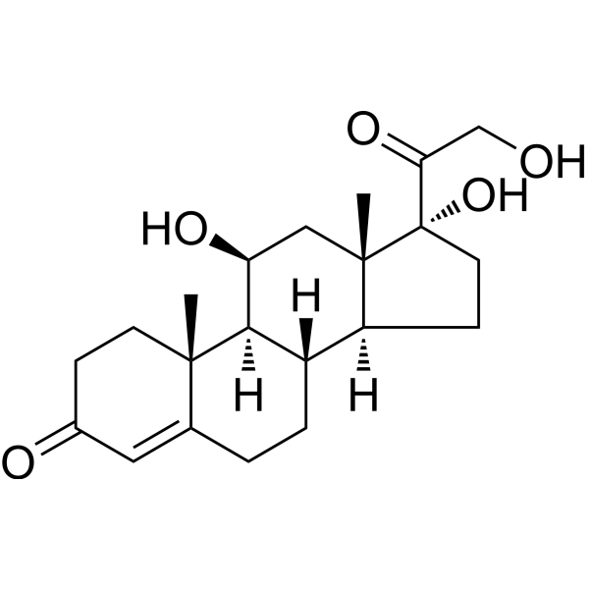 | HY-N0583 (MCE)
19 | Meprednisone | / | 1 μM | 372.45 | 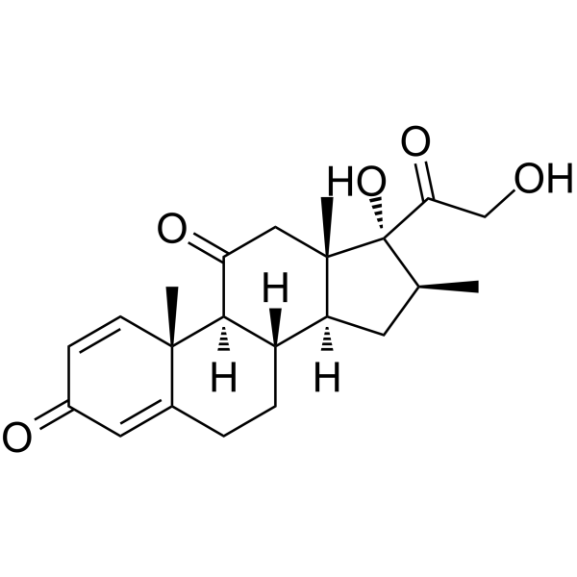 | HY-B0243 (MCE)
20 | GW9662 | / | 2 μM | 276.68 | 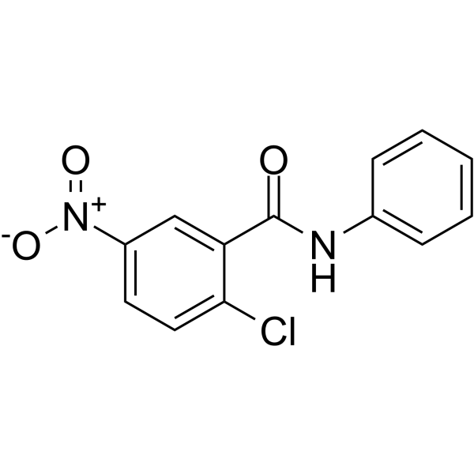 | HY-16578 (MCE)
21 | Troglitazone | / | 2 μM | 441.54 | 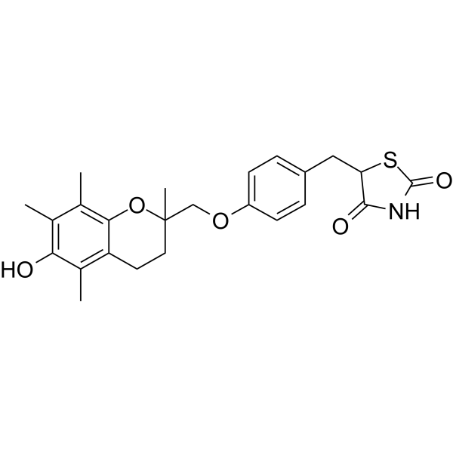 | HY-50935 (MCE)
22 | GW6471 | / | 2 μM | 619.67 | 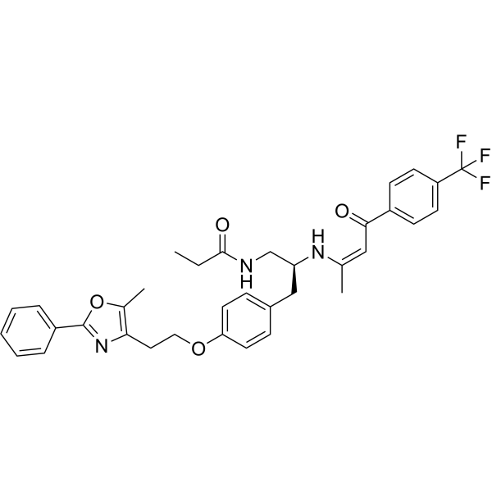 | HY-15372 (MCE)
23 | Fenofibrate | / | 2 μM | 360.83 | 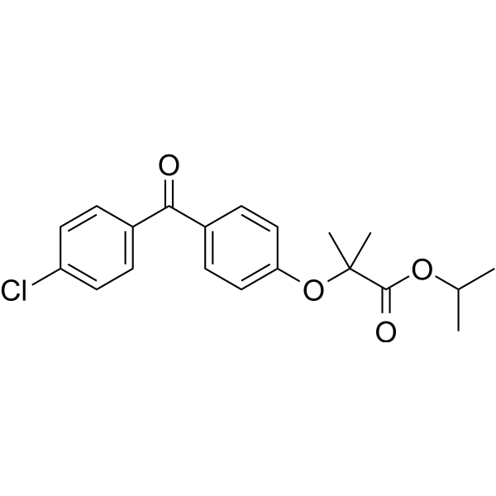 | HY-17356 (MCE)
24 | GW7647 | / | 5 μM | 502.75 | 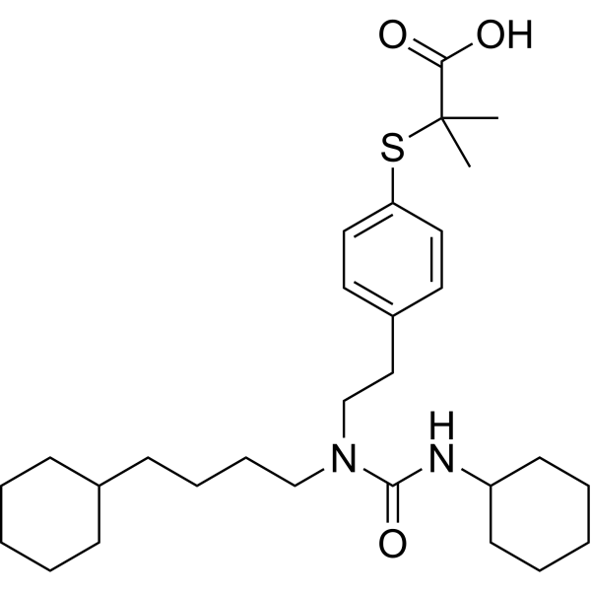 | HY-13861 (MCE)

Table S5. Primers used for RT-qPCR.
Gene | Forward Primer (5’ to 3’) | Reverse Primer (5’ to 3’)
RPL13A | AGATGGCGGAGGTGCAG | GGCCCAGCAGTACCTGTTTA
GAPDH | TGCACCACCAACTGCTTAGC | GGCATGGACTGTGGTCATGAG
AAT | ATGCTGCCCAGAAGACAGATA | CTGAAGGCGAACTCAGCCA
ALB | GAGACCAGAGGTTGATGTGATG | AGTTCCGGGGCATAAAAGTAAG
ARG1 | GTGGAAACTTGCATGGACAAC | AATCCTGGCACATCGGGAATC
CD24 | CTCCTACCCACGCAGATTTATTC | AGAGTGAGACCACGAAGAGAC
CDK2 | CCAGGAGTTACTTCTATGCCTGA | TTCATCCAGGGGAGGTACAAC
CDK4 | ATGGCTACCTCTCGATATGAGC | CATTGGGGACTCTCACACTCT
CK19 | TGAGCAGGTCCGAGGTTACTG | CAGTGTGTCTTCCAAGGCAGC
CPS1 | AATGAGGTGGGCTTAAAGCAAG | AGTTCCACTCCACAGTTCAGA
CYP1A2 | ATGCTCAGCCTCGTGAAGAAC | GTTAGGCAGGTAGCGAAGGAT
CYP2B6 | CCGGGGATATGGTGTGATCTT | CCGAAGTCCCTCATAGTGGTC
CYP2C9 | GCCTGAAACCCATAGTGGTG | GGGGCTGCTCAAAATCTTGATG
CYP2D6 | CCAACGGTCTCTTGGACAAAG | GGGTCGTCGTACTCGAAGC
CYP3A4 | CACGAGCAGTGTTCTCTCCTT | CACAGTATCATAGGTGGGTGGT
EPCAM | TGATCCTGACTGCGATGAGAG | CTTGTCTGTTCTTCTGACCCC
F10 | AGATGGCGACCAGTGTGAGA | GTGCAGGTGTATTCCCCGAG
F12 | CGATGGGGATACTGTTTGGAGC | CGCTTGGCATGTTCACACA
F2 | CTGAGGGTCTGGGTACGAACT | TGGGTAGCGACTCCTCCATAG
FMO3 | AATGGTTATCCTTGGGACATGC | AGATGGCTGTCGGTAAATTGTTC
FXR | TCCCATTTACCTACCACAGATGA | GCGAGTATGGTTCCACTTCCA
GATA4 | CCCGACACCCCAATCTC | CAGGCGTTGCACAGATAGTG
GLUL | TAAGGACCCTAACAAGCTGGT | CCGTTTACAGGTGTGCCTCAA
HNF1B | GCACCTCTCCCAGCATCTCA | GTCGGAGGATCTCTCGTTGC
HNF4A | CGTGGTGGACAAAGACAAGA | CATAGCTTGACCTTCGAGTGC
MAOA | GAATCAAGAGAAGGCGAGTATCG | GGCAGCAGATAGTCCTGAAATG
NTCP | GGCCGTCACAGTTCTCTCTG | GGTGGCAATCAAGAGTGGTGT
PROX1 | ACAGGGCTCTGAACATGCAC | GGCATTGAAAAACTCCCGTA
RXR | AAGCCCAGTGTCAACGCAG | GGGTCTTCCGGGTGATCTC
SOX9 | GTAATCCGGGTGGTCCTTCT | GACGCTGGGCAAGCTCT
TBX3 | GCCATGTACGTGTAGGGGTA | CTTCCACCTCCAGCAGCA
UGT2B15 | CCAACCAATGAAGCCCCTG | GTTGTGAGCTGCGACTCGAA
UGT2B7 | GATCCCAACAACTCATCCGCT | CAGCAGCTCACTACAGGGAA
NAGS | GTGGAAACTTGCATGGACAAC | AATCCTGGCACATCGGGAATC
ASL | CAGTGGACCCCATCATGGAGA | GGCTTTGCTGCCTTGAACATC

Table S6. Antibodies used for immunofluorescence staining.
Protein | Antibody | Catalog Number
ALB | Human Albumin Antibody | A80-129A (Bethyl Laboratories, Inc.)
AAT | AAT antibody | ZA-0007 (ZSGB-BIO)
AFP | Alpha-1-Fetoprotein | ZM-0009 (ZSGB-BIO)
CYP3A4 | CYTOCHROME P450 3A4 | AHP622Z (BIO-RAD)
CYP1A2 | CYTOCHROME P450 1A2 | AHP69Z (BIO-RAD)
CYP2C9 |  | AHP617Z (BIO-RAD)
  CYTOCHROME P450 2C9
CYP2C19 | CYTOCHROME P450 2C19 | AHP618Z (AbD Serotec)
CYP2E1 | CYTOCHROME P450 2E1 | AHP621Z (AbD Serotec)
CYP2C8 | CYTOCHROME P450 2C8 | AHP614Z (BIO-RAD)
CYP2D6 | Rabbit anti Human CYP2D6 | HPA045223 (Sigma)
CYP2C8 | Rabbit anti Human CYP2C8 | AHP614Z (AbD Serotec)
CK19 | Anti-Cytokeratin 19 antibody [A53-B/A2] | ab7754 (abcam)
EPCAM | Anti-EpCAM antibody [EPR20532-225] | ab223582 (abcam)
TBX3 | Anti-Tbx3 antibody | ab99302 (abcam)
SOX9 | Recombinant Anti-SOX9 antibody [EPR14335-78] | ab185966 (abcam)
Ki67 | Ki67 Rabbit pAb | A11390
HNF4A | HNF4A-Antibody-Polyclonal | PA5-82159(Thermofisher)
CEBPA | C/EBPα Antibody | #2295 (Cell Signaling technology)
PROX1 | PROX1 (D2J6J) Rabbit mAb | #14963 (Cell Signaling technology)

Table S7. Drugs used for measurements of CYP450 activity.
CYP450s isoforms | Standard substrate | Concentration of substrate | Internal standard | Product for detection | FDA concern
CYP3A4 | Testosterone | 200 μM | 6β-Hydroxytestosterone-[D7] | 6β-Hydroxytestosterone | concern
CYP2C9 | Difclofenac | 25 μM | 4′-Hydroxydiclofenac-[13C6] | 4'-Hydroxydiclofenac | concern
CYP1A2 | Phenacetin | 100 μM | Acetomidophenol-[13C2, 15N] | Acetaminophen | concern

Supplementary References
1. Hu H, Gehart H, Artegiani B, C LO-I, Dekkers F, Basak O, van Es J, Chuva de Sousa Lopes SM, Begthel H, Korving J, van den Born M, Zou C, Quirk C, Chiriboga L, Rice CM, Ma S, Rios A, Peters PJ, de Jong YP and Clevers H. Long-Term Expansion of Functional Mouse and Human Hepatocytes as 3D Organoids. Cell. 2018;175:1591-1606 e19.
2. Katsuda T, Kawamata M, Hagiwara K, Takahashi RU, Yamamoto Y, Camargo FD and Ochiya T. Conversion of Terminally Committed Hepatocytes to Culturable Bipotent Progenitor Cells with Regenerative Capacity. Cell Stem Cell. 2017;20:41-55.
3. Fu GB, Huang WJ, Zeng M, Zhou X, Wu HP, Liu CC, Wu H, Weng J, Zhang HD, Cai YC, Ashton C, Ding M, Tang D, Zhang BH, Gao Y, Yu WF, Zhai B, He ZY, Wang HY and Yan HX. Expansion and differentiation of human hepatocyte-derived liver progenitor-like cells and their use for the study of hepatotropic pathogens. Cell Res. 2019;29:8-22.
4. Kim Y, Kang K, Lee SB, Seo D, Yoon S, Kim SJ, Jang K, Jung YK, Lee KG, Factor VM, Jeong J and Choi D. Small molecule-mediated reprogramming of human hepatocytes into bipotent progenitor cells. J Hepatol. 2019;70:97-107.
5. Unzu C, Planet E, Brandenberg N, Fusil F, Cassano M, Perez-Vargas J, Friedli M, Cosset FL, Lutolf MP, Wildhaber BE and Trono D. Pharmacological Induction of a Progenitor State for the Efficient Expansion of Primary Human Hepatocytes. Hepatology. 2018.

