Supplementary material

Antibacterial periodontal ligament stem cells enhance periodontal regeneration and regulate the oral microbiome

Jiayi You^{1,2,3}, Qian Zhang⁴, Linjue Qian^{1,2,3}, Zihan Shi^{1,2,3}, Xinyue Wang^{1,2,3}, Lu Jia⁵, Yang Xia^{1,2,3*}
¹ The Affiliated Stomatological Hospital of Nanjing Medical University, Nanjing, Jiangsu 210029, People’s Republic of China
² State Key Laboratory Cultivation Base of Research, Prevention and Treatment for Oral Diseases, Nanjing Medical University, Nanjing, Jiangsu 210029, People’s Republic of China
³ Jiangsu Province Engineering Research Center of Stomatological Translational Medicine, Nanjing Medical University, Nanjing, Jiangsu 210029, People’s Republic of China
⁴ Suzhou Stomatological Hospital, Suzhou, Jiangsu, 215000, People’s Republic of China
⁵ Department of Emergency General Dentistry, Hebei Key Laboratory of Stomatology, Hebei Medical University, Shijiazhuang, Hebei, 050017, People’s Republic of China
* Corresponding author: email: xiayang@njmu.edu.cn. Fax: +86-25-86516414.

Table of contents
1. Details for Experimental Section
2. Fig. S1. The species accumulation curves.
3. Fig. S2. OTU rank curve.
4. Fig. S3. Analysis of α diversity.
5. Fig. S4. Linear discriminant analysis (LDA) analysis.
6. Fig. S5. Functional analysis at level 2 using the KEGG database.
7. Fig. S6. Functional analysis at level 3 using the KEGG database.
8. Table S1. Primer sequences used for quantitative real-time reverse transcription–polymerase chain reaction (qRT-PCR).
9. Table S2. Relative abundance of differential functions (Wilcox Test).

1. Details for Experimental Section
【1】Isolation of periodontal ligament stem cells (PDLSCs)
Briefly, periodontal ligament was scraped from root surface after washing the teeth with Hanks’ balanced salt solution (HBSS) containing penicillin/streptomycin (P/S, Gibco, USA). Then, it was digested in collagenase I (3 mg/mL; Sigma-Aldrich, USA) for 30min at 37°C, and centrifuged (1000 rpm, 5min). The cells were resuspended and cultured in α-minimum essential medium (α-MEM, Gibco, USA) with 10% fetal bovine serum (FBS, ScienCell, USA) and 1% P/S. Cells were maintained at 37°C in 5% CO₂ and subcultured when reaching 80~90% confluence.
【2】Microbial diversity analysis
(1) Extraction of chromosomal DNA.
The quantity and quality of the DNA was evaluated using a Qubit 2.0 Fluorometer (Invitrogen, Carlsbad, CA). 10 ng/ml each individual sample was prepared for PCR assays.
(2) Sequence processing
Bacterial 16S rRNA gene amplification, cloning, and sequencing of the polymerase chain reaction (PCR) products were performed at the laboratory of BGI (Huada Gene Institute). PCR amplification of the V4 region of bacterial 16S rRNA gene was performed using universal primers (V4 515F GTGCCAGCMGCCGCGGTAA PE250 806R GGACTACHVGGGTWTCTAAT) incorporating the FLX Titanium adapters and a sample barcode sequences.
(3) Deep Sequencing of 16S rRNA V4 Region
The PCR product was sequenced using paired-end sequencing using the 250 bp paired end strategy with an Illumina HISEQ 2500 platform. Clean data were generated after trimming and removing reads with low quality scores, and then, PE reads were overlapped to full V4 tags with a minimum overlap length of 15 bp. Tags with lengths less than 187bp were removed for further analysis. The redundant tags were deleted by Mothur v.1.11.0, and the unique tags were obtained. The unique tags were aligned against the Greengene_2013_5_99 database using the usearch software to OTU cluster. Sequences were classified using a Bayesian classifier with Greengene database. Chimeric sequences identified using UCHIME algorithm were then removed.
Taxonomic classification was performed using a limited value 0.6. 16S rRNA V4 database taxonomic information, most tags (>85%) of all the samples were classified into different orders and higher taxa, but a few tags were assigned to families and lower classifications. After obtaining the unique tags, they were clustered at 97% sequence similarity according to usearch software to acquire the target Operational Taxonomic Units (OTUs).
(4) Statistical Analysis.
To select significant OTUs between groups, wilcoxon test was performed based on the OTUs abundance. Wilcoxon test and PCA was performed by R statistical software (3.1.1). The UniFrac distance metrics analysis was performed based on OTUs phylogenetic tree and taxon abundance in each sample, and principal coordinate analysis (PCoA) was conducted according to the matrix of UniFrac distance. UniFrac distance, rarefaction and alpha-diversity were calculated by Qiime (v1.9.1). Linear discriminant analysis of Effect Size (LEfSe) was used to determine the biomarkers with LDA = 2.5. False Discovery Rate (FDR) was calculated according to Benjamini-Hochberg to evaluate the reliability of test results. Unless otherwise noted, the significance testing stated above used a value of 0.05.
【3】Isolation and purification of human gingival fibroblasts (hGFs)
The gingival tissue was cut into small pieces and digested with 3 g/L collagenase I (Sigma-Aldrich, USA) for 30 min at 37°C in a 5% CO₂ incubator. Tissue blocks were then cultured in Dulbecco’s modified Eagle’s medium (4.5. g/L D-Glucose, H-DMEM, Gibco, USA) containing 10% FBS and 2% P/S.
【4】Bacteria culture
Staphylococcus aureus (S. aureus, ATCC25923) and Escherichia coli (E. coli, ATCC25923) were grown in Luria-Bertani (LB) broth under aerobic conditions at 37 ℃. Fusobacterium nucleatum (F. nucleatum, ATCC25586) were grown in brain heart infusion (BHI, Oxoid, Basingstoke, UK) broth in an anaerobic chamber (5% H₂, 5%CO₂, 90% N₂, 37 °C). Single-colony cultures in LB or BHI broth were grown with 200 rpm shaking at 37 °C until they reached their exponential growth phase. After that, the bacterial cells were washed three times with PBS and adjusted to the desired bacterial concentration for further experimentation.
【5】Details for the antibacterial effect of PDLSCs
50 μL 10⁴ colony forming unit (CFU) /mL Staphylococcus aureus (S. aureus, ATCC25923) and Escherichia coli (E. coli, ATCC25923) was co-cultured with 2×10⁵ cells in α-MEM medium with 5% FBS for 24 h. Aliquots of culture medium were taken and serially diluted with LB broth, and plated on LB-agar plates. Colonies were counted after 24 h incubation at 37°C. α-MEM with 5% FBS was used as control.
The plates with 30-300 colonies per plate were counted automatically using a colony analyzer (Scan 1200, France), and the CFU was calculated as: number of colonies × 100× inverse dilution factor.
【6】Details for the antibacterial effect of PDLSCs CM
To evaluate the effect of CM on biofilms composition, confocal microscopy was performed. After seeding bacterial (5×10⁵ CFU for S.aureus and E.coli, 5×10⁶ CFU for F. nucleatum) in a 24-well plate for 24h, 500 μL CM was added and co-cultured for 24 h at 37 °C. The biofilms were stained using Live/Dead bacterial viability kits (Invitrogen, Carlsbad, California). Fluorescent images were acquired using a confocal laser scanning microscope (CLSM, Carl Zeiss, Germany) at 488 nm and 561 nm with a camera controlled by ZEN imaging software. Image J was used to analyze the mean fluorescence intensity (MFI) of live bacteria and dead bacteria.
To test the effect of CM on the viability, bacterial (500 CFU for S.aureus and E.coli, 25×104 CFU for F. nucleatum) were inoculated in 500 μL CM at 37 °C for 24 h. Then CFUs were counted as described earlier.
To observe the effect of CM on bacterial morphology, bacterial suspensions were adjusted to the final concentration of 2×108 CFU/mL and exposed to CM for 24 h. Then, the bacteria were harvested, washed with PBS, and fixed in 2.5% glutaraldehyde, and underwent dehydration with a series concentration of ethanol (30%, 50%, 70%, 90% and 100%), critical-point drying and gold coating before observation under scanning electron microscopy (SEM, JEOL JSM-7900F, Japan).
To test the impact of CM on inhibition of biofilm formation, crystal violet staining was used to quantify the effect of PDLSCs CM on S. aureus biofilm formation. 200 μL bacteria (1×106 CFU/mL for S.aureus and E.coli, 1×107 CFU/mL for F. nucleatum) was incubated at 37 °C for 24 h in triplicate wells of 96-well flat bottom cell culture plates. Then, the supernatants were removed and the bacteria biofilm was cultured with 100 μL CM for 48 h. After washing the nonadherent bacteria by PBS, the biofilms were stained with 0.1% crystal violet solution (Beyotime). Retained crystal violet was dissolved with ethanol and optical density (OD) readings were obtained at a wavelength of 595 nm using a microplate reader (Berthold, Stuttgart, Germany).
【7】Details for PCR
RNA was isolated using TRIzol reagent (Invitrogen, USA). After isolation, RNA quality was assessed and cDNA synthesis was reverse transcripted using PrimerScriptTM RT Master Mix (Takara, Japan). using the PowerUpTM SYBRTM Green Master Mix (Applied Biosystems, USA) with an ABI 7300 system (Applied Biosystems, USA). The results were normalized by the cycle threshold (Ct) of the housekeeping GAPDH gene.

2. Fig. S1. The species accumulation curves. It tended towards saturation, indicating that the amount of sample was sufficient.

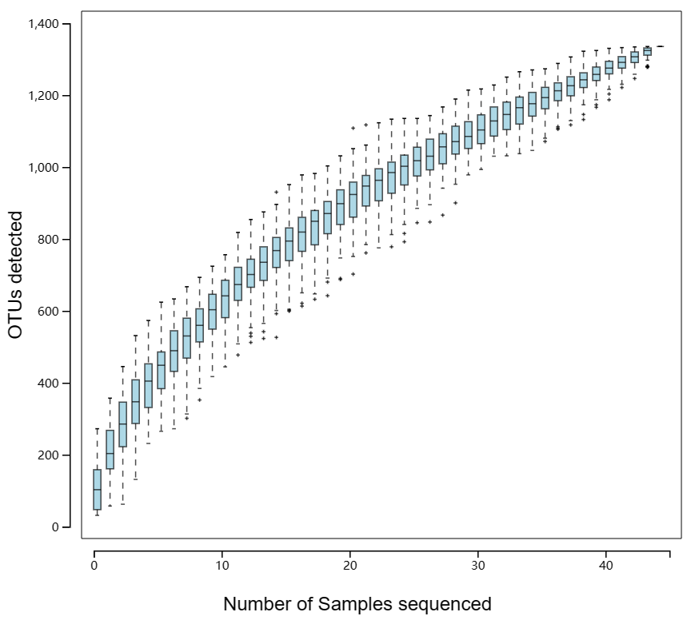

3. Fig. S2. OTU rank curve. The rank-abundance curves of PRE and Cell groups were similar, wide, and flat, indicating the rich and high evenness of species composition. However, the curve of Saline group was narrow and short.
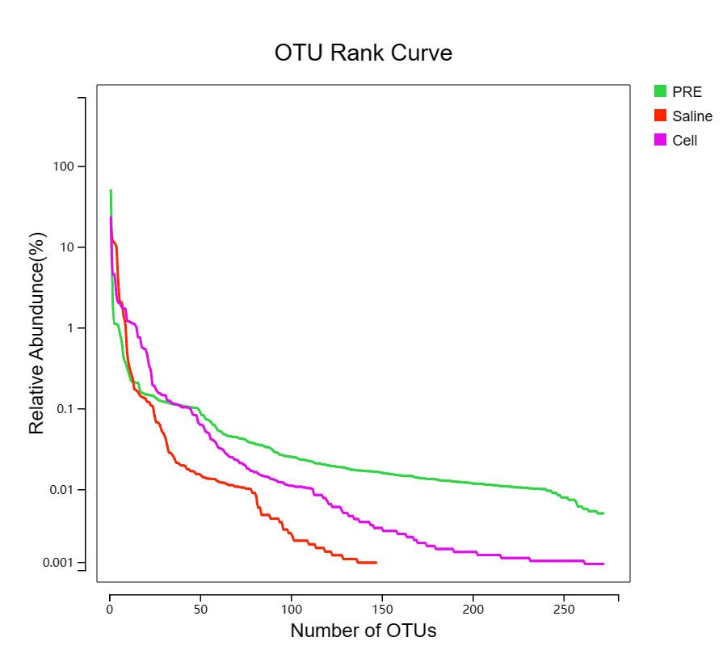

4. Fig. S3. Analysis of α diversity. (A) Observed species; (B) Chao; (C) ACE; (D) Shannon’s diversity; (E) Simpson’ diversity; (F) Good’s coverage. Good‘s coverage index was 100.0% for each group, indicating that the sequencing depth was sufficient to detect the bacterial diversity of the saliva samples.

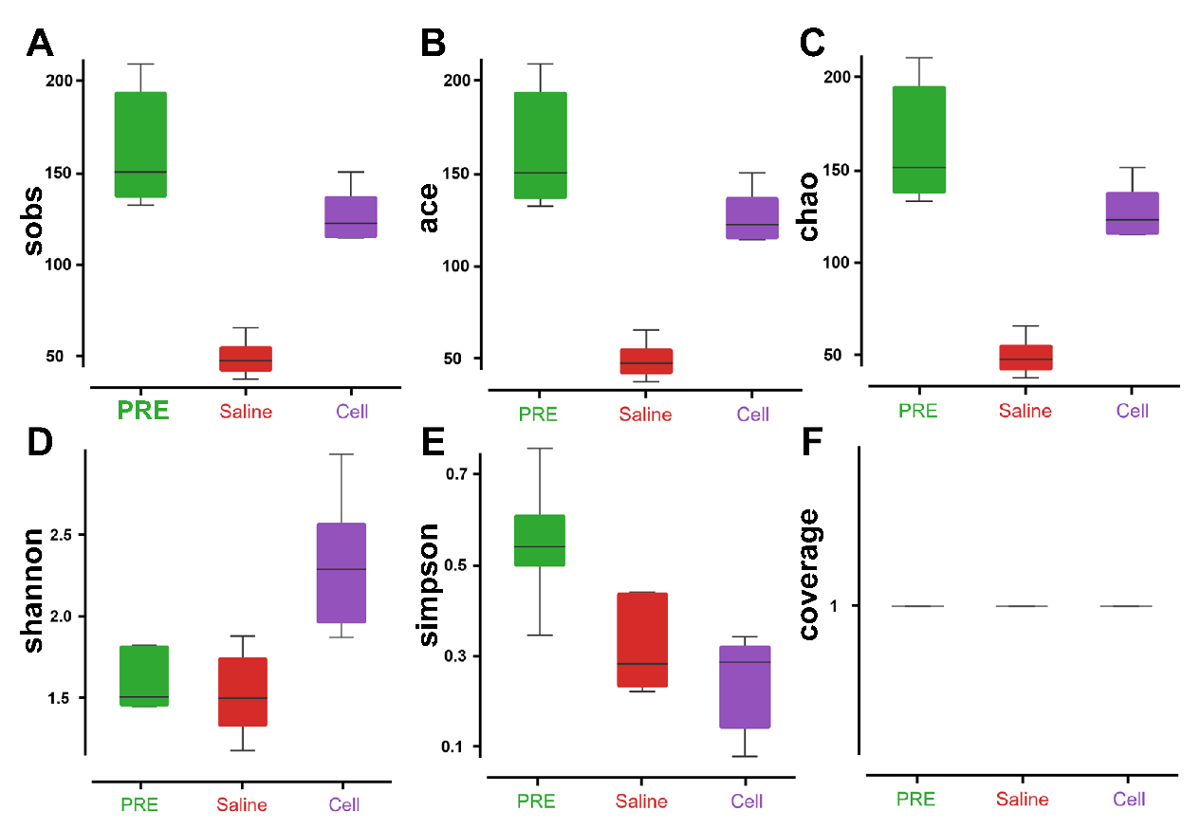

5. Fig. S4. Linear discriminant analysis (LDA) analysis.
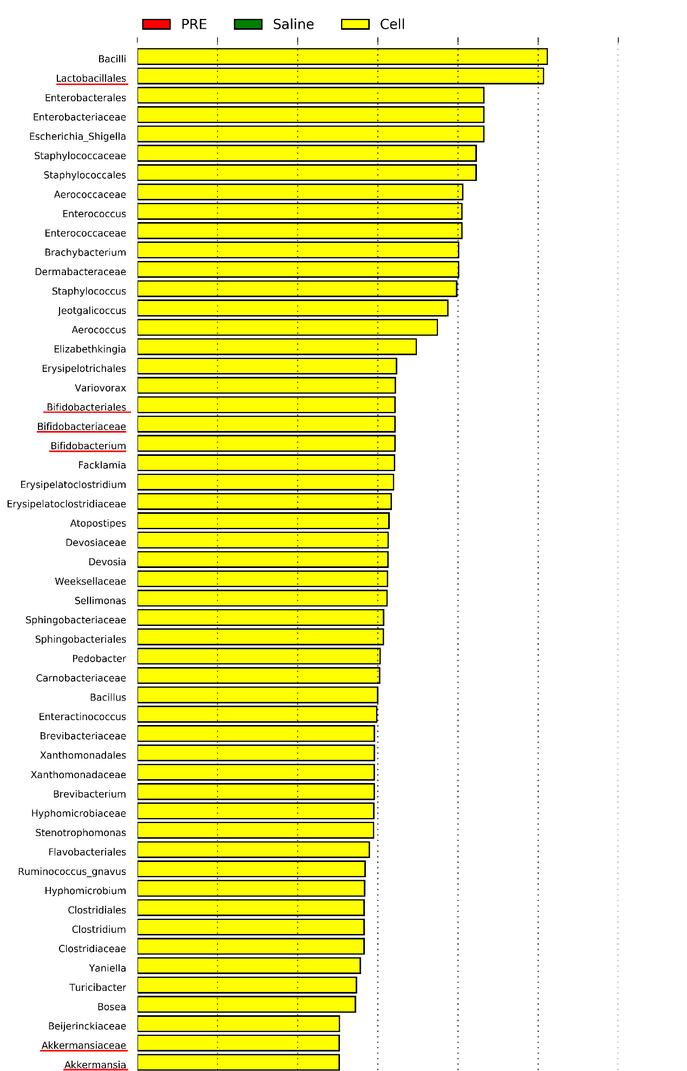

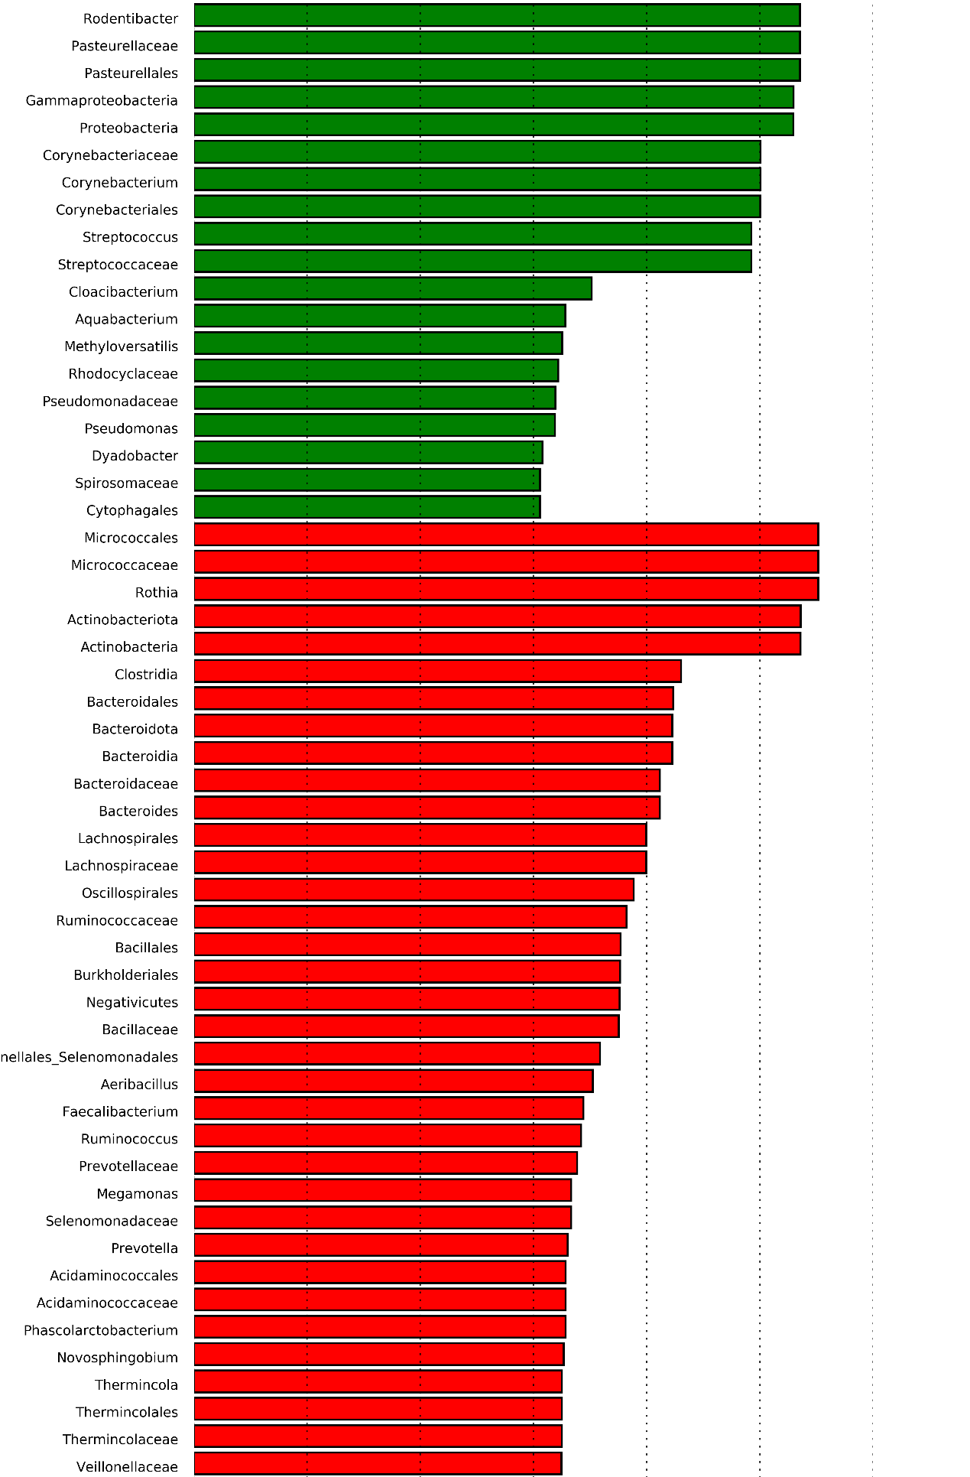

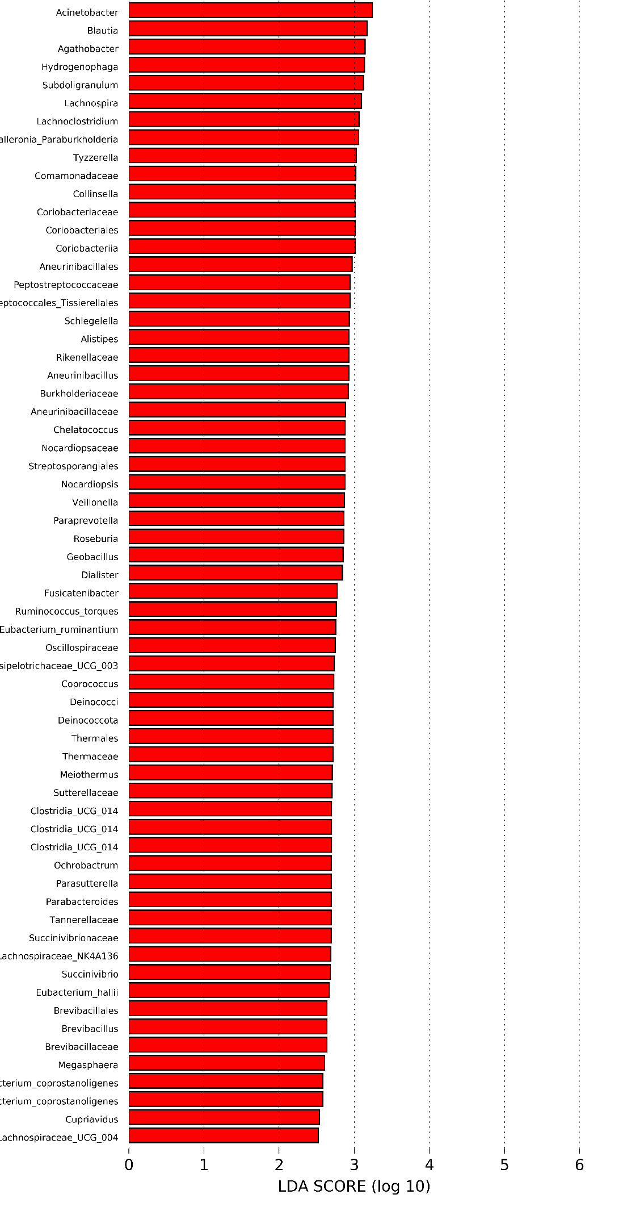
6. Fig. S5. Functional analysis at level 2 using the KEGG database.
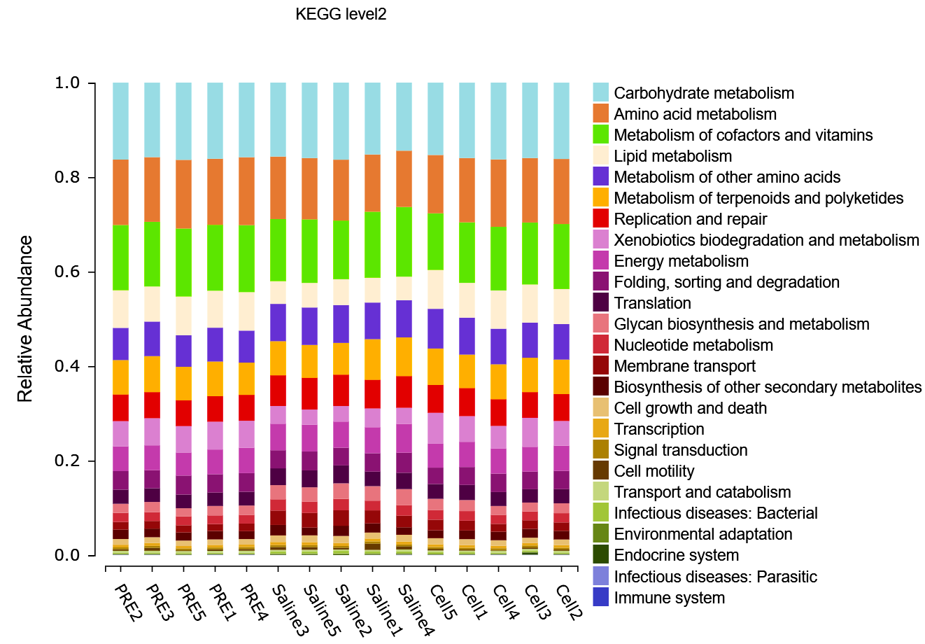

7. Fig. S6. Functional analysis at level 3 using the KEGG database.
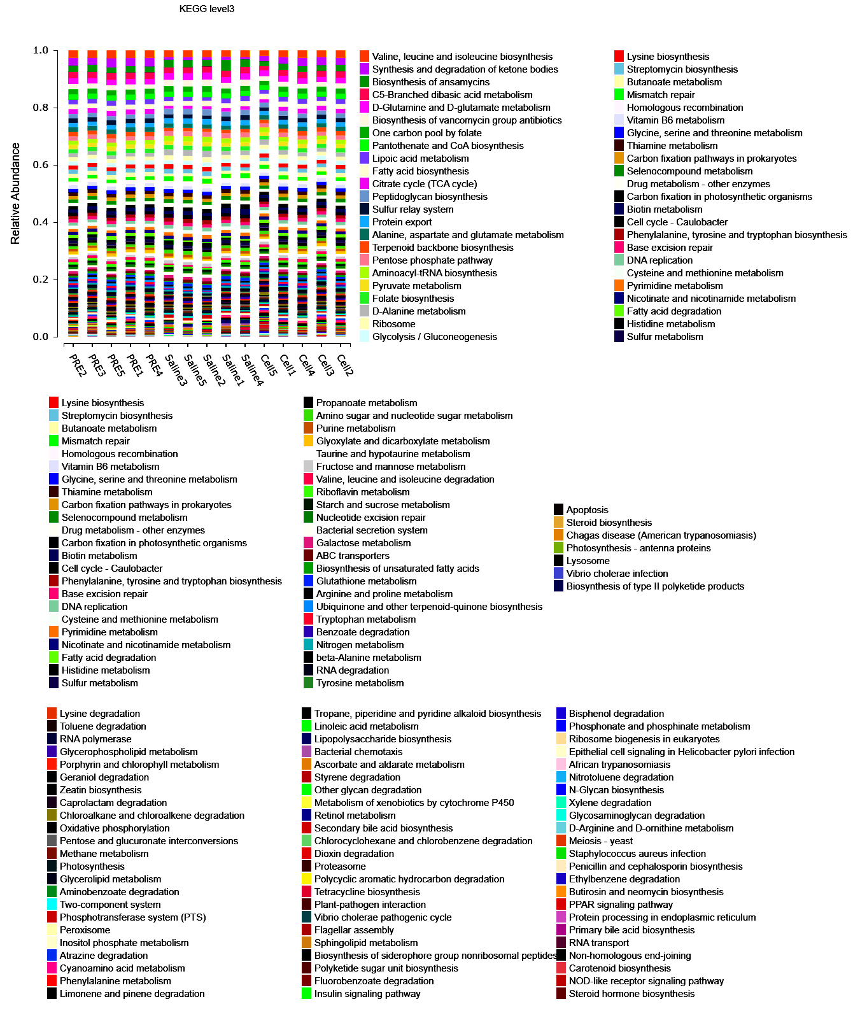

8. Table S1. Primer sequences used for quantitative real-time reverse transcription–polymerase chain reaction (qRT-PCR).
Gene | Forward primer (5’-3’) | Reverse primer (5’-3’)
GAPDH (human) | ACCACAGTCCATGCCATCAC | ACCACCCTGTTGCTGTA
LL-37 | GAAGACCCAAAGGAATGGCC | CAGAGCCCAGAAGCCT GAGC

9. Table S2. Relative abundance of differential functions (Wilcox Test).
Function | PRE(%) | Saline(%) | Cell(%)
Metabolism | 82.70 | 78.82 ↓ | 82.16 →
Organismal Systems | 0.23 | 0.32 ↑ | 0.30 →
Cellular Processes | 1.95 | 2.46 ↑ | 1.83 →
Environmental Information Processing | 1.96 | 3.33 ↑ | 2.31 ↑
Genetic Information Processing | 12.89 | 14.59 ↑ | 13.05 →
Human Diseases | 0.27 | 0.49 ↑ | 0.34 →
↓ represents downregulation (p < 0.05 compared with PRE group)
↑ represents upregulation (p < 0.05 compared with PRE group)
→ represents no significant difference (p > 0.05 compared with PRE group)

