Supporting Information
Advancing Wound Healing by Hydrogel-Based Dressings Loaded with Cell-Conditioned Medium: A Systematic Review
Galina Nifontova^{1†}, Sofia Safaryan^{1†}, Yana Khristidis¹, Olga Smirnova¹, Massoud Vosough², Anastasia Shpichka^{1*}, Peter Timashev^{1,3}
¹Institute for Regenerative Medicine, Sechenov University, 8-2 Trubetskaya St., Moscow 119991, Russia
²Department of Regenerative Medicine, Cell Science Research Center, Royan Institute for Stem Cell Biology and Technology, Academic Center for Education, Culture and Research, Tehran 1665666311, Iran
³World-Class Research Center “Digital Biodesign and Personalized Healthcare”, Sechenov University, 8-2 Trubetskaya St., Moscow 119991, Russia
†Galina Nifontova and Sofia Safaryan contributed equally to this work.
*Correspondence: ana-shpichka@yandex.ru

Table S1. The issues addressed within the selected articles
Reference | Journal title | Year | Hydrogel design and fabrication | CM production | CM profiling | Physicochemical characterization | In vitro studies using model cell lines | In vivo studies using wound models in animals
[1] | Biomaterials Research | 2023 | ++ | ++ | ++ | ++ | ++ | ++
[2] | Biomaterials Research | 2023 | ++ | ++ | ++ | ++ | ++ | ++
[3] | Advanced Healthсare Materials | 2023 | ++ | ++ | ++ | ++ | ++ | ++
[4] | Current Stem Cell Research & Therapy | 2023 | ++ | ++ | ++ | ++ | ++ | ++
[5] | Biomaterials | 2022 | ++ | ++ | ++ | + |  | ++
[6] | Carbohydrate Polymers | 2022 | ++ | ++ | + | ++ | ++ | ++
[7] | Burns | 2022 | ++ | ++ |  |  |  | ++
[8] | Stem Cells and Development | 2022 | ++ | ++ |  |  |  | ++
[9] | Materials & Design | 2022 | ++ | ++ |  | ++ | ++ | ++
[10] | Plastic and Reconstructive Surgery | 2021 | ++ | ++ |  |  |  | ++
[11] | Acta Biomaterialia | 2021 | ++ | ++ |  | ++ | ++ | ++
[12] | Journal of Tissue Viability | 2021 | ++ | ++ | + |  | ++ | ++
[13] | Pharmaceuticals | 2021 | ++ | ++ | ++ |  |  | ++
[14] | Tissue Engineering and Regenerative Medicine | 2021 | ++ | ++ | ++ |  |  | ++
[15] | Life Sciences | 2020 | ++ | ++ | + | ++ | ++ | ++
[16] | European Journal of Pharmaceutics and Biopharmaceutics | 2020 | ++ | ++ | + | ++ |  | ++
[17] | ACS Applied Materials and Interfaces | 2020 | ++ | ++ |  | ++ | ++ | ++
[18] | Drug Delivery and Translational Research | 2019 | ++ | ++ | + | + | + | ++
[19] | BioMed Research International | 2019 | ++ | ++ | + | + | + | ++
[20] | ACS Applied Bio Materials | 2019 | ++ | ++ | + | ++ | ++ | ++
[21] | Journal of Tissue Engineering | 2019 | ++ | ++ | ++ |  | ++ | ++
Total article number |  |  | 21 | 21 | 15 | 14 | 14 | 21
Notes: + the issue was partially or indirectly discussed; ++ the issue was fully discussed.
Table S2. Study quality assessment
Study | Major criteria |  |  |  |  |  |  |  |  |  | Score | Quality | Reference
Study | 1 | 2 | 3 | 4 | 5 | 6 | 7 | 8 | 9 | 10 | Score | Quality | Reference
Li 2023 | 1 | 1 | 1 | 0 | 1 | 1 | 0 | 1 | 1 | 1 | 8 | Low risk | [1]
Theocharidis 2022 | 1 | 0 | 1 | 0 | 1 | 1 | 0 | 1 | 1 | 1 | 7 | Low risk | [5]
Kwon 2023 | 1 | 1 | 1 | 0 | 1 | 1 | 0 | 1 | 1 | 1 | 8 | Low risk | [2]
Sabzevari 2020 | 1 | 1 | 1 | 0 | 1 | 1 | 1 | 1 | 1 | 1 | 9 | Low risk | [15]
Maarof 2019 | 1 | 0 | 1 | 0 | 1 | 1 | 0 | 1 | 1 | 1 | 7 | Low risk | [18]
Zhou 2019 | 1 | 1 | 1 | 1 | 1 | 1 | 1 | 1 | 1 | 1 | 10 | Low risk | [19]
Zhang 2021 | 1 | 1 | 1 | 0 | 1 | 1 | 0 | 1 | 1 | 1 | 8 | Low risk | [6]
Bari 2020 | 0 | 0 | 1 | 0 | 1 | 1 | 0 | 1 | 1 | 0 | 5 | Medium risk | [16]
Takahashi 2021 | 1 | 0 | 1 | 0 | 1 | 1 | 1 | 1 | 1 | 0 | 7 | Low risk | [10]
Ma 2020 | 1 | 0 | 1 | 0 | 1 | 0 | 0 | 1 | 1 | 1 | 6 | Medium risk | [17]
Hiew 2021 | 1 | 0 | 1 | 0 | 1 | 1 | 0 | 1 | 1 | 1 | 7 | Low risk | [11]
Sabzevari 2021 | 1 | 0 | 1 | 0 | 1 | 1 | 1 | 1 | 1 | 1 | 8 | Low risk | [12]
Subramaniam 2022 | 1 | 0 | 1 | 0 | 1 | 1 | 0 | 1 | 1 | 1 | 7 | Low risk | [7]
Vriend 2022 | 1 | 0 | 1 | 1 | 1 | 1 | 1 | 1 | 1 | 0 | 8 | Low risk | [8]
Kudinov 2021 | 0 | 1 | 1 | 0 | 1 | 1 | 1 | 1 | 1 | 1 | 8 | Low risk | [13]
Li 2019 | 1 | 1 | 1 | 0 | 1 | 1 | 0 | 1 | 1 | 1 | 8 | Low risk | [20]
Koh 2022 | 1 | 0 | 1 | 0 | 1 | 1 | 0 | 1 | 1 | 1 | 7 | Low risk | [3]
Zhang 2024 | 1 | 0 | 1 | 0 | 1 | 1 | 0 | 1 | 1 | 1 | 7 | Low risk | [4]
Robert 2019 | 1 | 0 | 1 | 0 | 1 | 1 | 0 | 1 | 1 | 1 | 7 | Low risk | [21]
Savitri 2021 | 1 | 1 | 1 | 0 | 1 | 1 | 0 | 1 | 1 | 1 | 8 | Low risk | [14]
Wu 2022 | 1 | 0 | 1 | 0 | 1 | 1 | 0 | 1 | 1 | 1 | 7 | Low risk | [9]
Notes. Criteria used for the analysis: (1) wound size calculation; (2) random allocation to treatment or control; (3) appropriate control; (4) blinded assessment of outcome; (5) appropriate animal defect model; (6) use of anesthetic on animal model where necessary throughout the study; (7) statement of control of temperature; (8) compliance with animal welfare regulations; (9) peer-reviewed publication; (10) statement of no potential conflict of interests. Response options applied: “Yes” = 1 score; “No and unclear” = 0 score. Scores and study quality type (out of 10): 7 to 10 - low risk; 4 to 6 - medium risk; 1 to 3 - high risk.

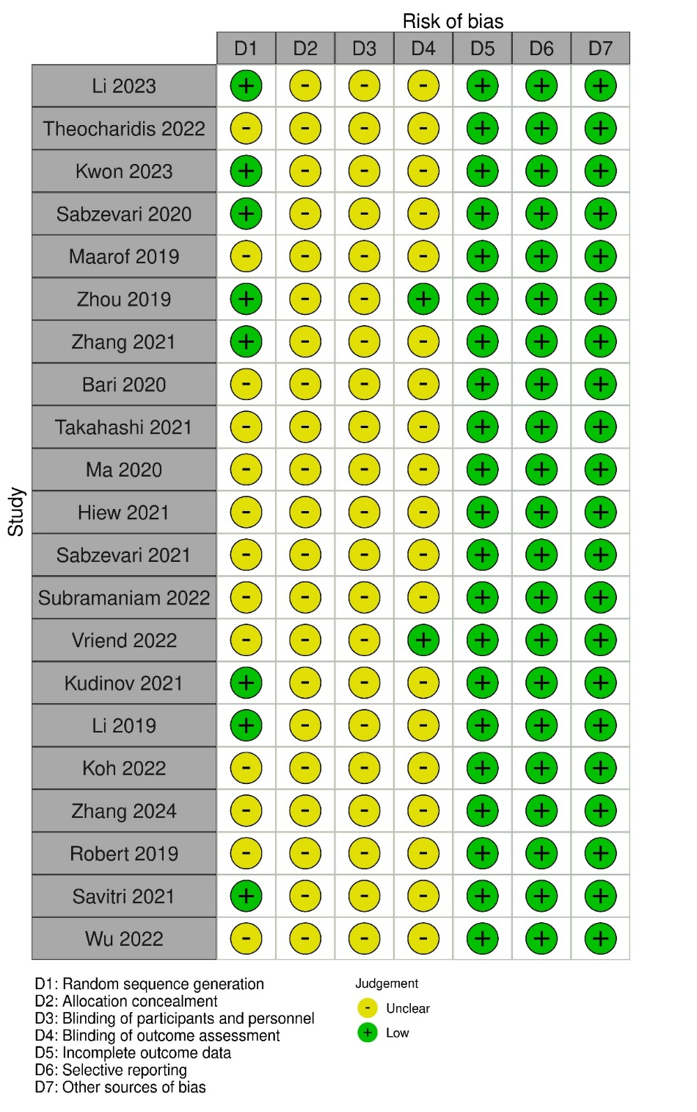
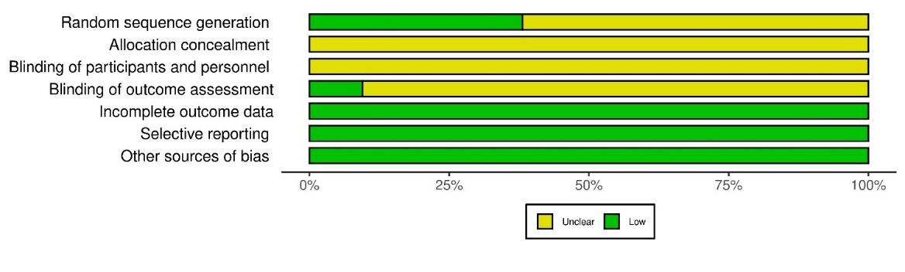
Figure S1. Risk of bias assessment for each selected experimental study using Robvis tool.
Table S3. Design of hydrogel-based dressings and the induced cellular and molecular responses as reported in selected articles
Dressing design and its composition | Molecular pathways activated due to exposition of the cells to CM-containing dressings | Cellular responses  and resultant /expected effects | Wound healing biomarkers detected in regenerated tissue | Reference
Gelatin methacryloyl hydrogel loaded with concentrated hypoxic/normoxic CM obtained from pretreated adipose-derived MSCs | VEGF-stimulated activation of the Akt/mTOR and MAPK signaling pathways due to application of GelMA+hypo-CM | GelMA+hypo-CM induced cell proliferation and migration of endothelial cells; wound re-epithelialization and collagen deposition | CD31 | [1]
Alginate/extracellular matrix hydrogel patch loaded with MSC-derived CM | Secretome components such as VEGF, HGF, IGF, inflammatory cytokines were discussed to participate in wound re-epithelialization, granulation, tissue formation, and angiogenesis; IL-6 and IL-8 are closely related to re-epithelialization and keratinocyte migration; IL-8, IGFBP are involved in collagen synthesis | Induced cellular proliferation, collagen deposition, keratinocyte migration, provided a self-assembled, elongated cell morphology (angiogenesis) | CD31, cytokeratin 10, α-SMA | [2]
Squid suckerin-spider silk fusion protein hydrogel containing adipose-derived MSC-CM | Transforming growth factor beta signaling, and the coagulation regulatory pathway | Induced immune cell migration, extracellular matrix organization, increased migration of endothelial cells within wound tissue (angiogenesis) | CD31, cytokeratin pan type I/II, Ly6C^{hi}MHCII^{hi} and Ly6C^{lo}MHCII^{hi} (monocytes/macrophages) | [3]
Composite skin patches of fibrin, with nasal mucosa-derived EMSC-CM | - | Promoted cell migration, cell proliferation, and differentiation of the intrinsic epidermal stem cells | Cytokeratin-pan, cytokeratin-14, P63 | [4]
Calcium-crosslinked alginate bandages containing macrophage -derived CM | - | Upregulation of keratinization, anchoring junction and keratinocyte and epidermal cell differentiation; glutamatergic synapse, axonogenesis, synapse and extracellular structure organization | α-SMA, CD31, Ki67, MMP3, sPECAM-1, TGFb1 | [5]
In situ forming hydrogel based on hyaluronic acid-grafted with methacrylic anhydride and N-(2-aminoethyl)-4-[4-(hydroxymethyl)-2-methoxy-5-nitrophenoxy]-butanamide (NB) groups and loaded with amnion-derived CM | - | Greatly increased cell migration and proliferation; promoted polarization of macrophages to M2 type | CD31, VEGF, IL-1β, TNF-α, TGF-β1, F4/80, CD206 (M2 macrophages) | [6]
Collagen I hydrogel containing dermal fibroblast-derived CM | - | Cell proliferation, collagen deposition | Cytokeratin 10 | [7]
ECM hydrogels  with ASC-derived CM | - | Promotes cell proliferation | Ki-67, CD68 | [8]
Dopamine grafted aldehyded chondroitin sulfate and carboxymethyl chitosan based hydrogel with embedded MSC-CM | - | Promotes cell proliferation, pro-vascularization/angiogenesis | CD31 | [9]
Carboxymethyl cellulose hydrogel loaded with human amnion-derived MSC-CM prepared under normoxic and hypoxic conditions | Hypoxic CM downregulated the expression levels of IL-1β, IL-6, CXCL-1, and CXCL-2 encoding proinflammatory factors that determine macrophage/neutrophil response | Induced cell proliferation, epithelization, angiogenesis; decreased inflammatory response | CD31, Ki-67, F4/80, MPO, CD3 and FOXP | [10]
Self-assembled short bioinspired GV8 octapeptide hydrogel containing hTERT immortalized adipose-derived MCS-CM | - | Promoted cell doubling and growth, angiogenesis, cell migration | - | [11]
Sodium alginate/gelatin hydrogel containing NRF2-engineered HEK-293-derived CM | Translocation of active form of NRF2 into the nucleus ensured realization of a NRF2/ARE pathway | Stimulated epithelialization, infiltration, fibroplasia, neovascularization, collagen density, and collagen arrangement | HO-1, SOD-1, SOD-2, VEGF | [12]
Chitosan hydrogel containing multipotent MSC-CM | - | Stimulated fibroblast and keratinocyte migration, cell proliferation, angiogenesis; secreting factors such as PGE2, IL-6, IL-8, or IFN-γ, IL-10, growth factors, and chemokines affected immunological properties of macrophages and neutrophils | - | [13]
Alginate membranes with embedded macrophage-derived CM | - | Promoted collagen deposition, cell proliferation, neovascularization, collagen maturation, and keratinocyte maturation | Cytokeratin 10, α-SMA, CD11b, CD206 (M2 macrophages) | [14]
Sodium alginate/gelatin hydrogel containing LL-37-engineered WJ-MSC-CM | - | Induced cell proliferation, epithelialization, keratinocytes migration and proliferation, angiogenesis | - | [15]
Sodium alginate sponge-like dressings containing AD-MSC lyo-secretome | Fga, Fgg, F13a1, Tnc, Arg1, Anxa5, Col1a1, Dcn, EGFR, decorin and tenascin were found up-regulated after treatment with lyo-secretome; PPI network analysis demonstrated a proteasome-mediated ubiquitin-dependent protein catabolic process (Edem3, Nedd4, Ppp2cb) to be activated due to lyo-secretome treatment, complement and coagulation cascades, proteolysis, epidermal growth factor stimulus and collagen-containing extracellular matrix, microtubule cytoskeleton, chaperone-mediated protein folding, ER membrane system, lipid metabolism and protein ubiquitination PPI modules were detected to be up-regulated | Pronounced vascularization, evident collagen deposition, numerous and mature fibroblasts, collagen deposition, inflammation response (eosinophil necrosis) | 4-3-3 protein zeta/delta (YWHAZ), Decorin (DCN), Tenascin (TNC) and Glyceraldehyde-3-phosphate dehydrogenase 1 (GADPH) | [16]
Sodium alginate/bioglass composite hydrogel functionalized with sodium alginate microparticles with encapsulated CM of RAW 264.7 murine macrophages, and with embedded PLGA-pirfenidone microspheres | Expression of genes related to vascularization/angiogenesis, including KDR, NRP-1 (upregulated), eNOS, bFGF (upregulated), and TGF-β1, was detected in co-cultured mouse aortic endothelial cells and areolar-derived fibroblast L929 cells | Induced cell proliferation, angiogenesis, promoted the ECM protein synthesis and vascularization by regulating the paracrine effects | iNOS (M1 marker), ARG (M2 marker), collagen I, collagen III, cytokeratin, CD206, α-SMA, CD31 | [17]
Ovine collagen hydrogel skin patch with human dermal fibroblast CM | - | Promoted cellular proliferation, collagen deposition, keratinocyte migration | Cytokeratin 14, collagen I | [18]
Chitosan/collagen/β-glycerophosphate thermosensitive hydrogel human umbilical cord MSC-CM | - | Promoted cell proliferation and epithelization, reduced inflammation | Ki-67 | [19]
Silk nanofiber hydrogel loaded with concentrated MSC-CM | - | Promoted proliferation of dermal fibroblasts and HUVECs, enhanced migration of fibroblasts and HUVECs in dose-dependent manner, inhibited TGF-β1-induced fibroblast differentiation | α-SMA | [20]
Natural (carrageenan gum) or a synthetic (PVA) polymer-based hydrogel containing human skin-derived MSC-CM | p38 Mitogen Activated Protein Kinase (MAPK) signaling pathway; IL-6, IL-8, and CXCL-1 | Stimulated cell proliferation and pro-angiogenic activity; both hydrogels exhibited a higher inflammation response and dense to moderate leukocyte infiltration | - | [21]
Abbreviations: CM, conditioned medium; GelMA+hypo-CM, gelatin methacryloyl hydrogel loaded with concentrated hypoxic conditioned medium; MSC, mesenchymal stromal cell; VEGF, vascular endothelial growth factor; HGF, hepatocyte growth factor; IGF, insulin-like growth factor; IL-6, interleukin-6; IL-8, interleukin-8; IL-10, interleukin-10; IGFBP, insulin-like growth factor-binding protein; ECM, extracellular matrix; ASC, adipose stromal cell; hTERT, human telomerase reverse transcriptase; NRF2, nuclear factor erythroid 2-related factor 2; PGE2, prostaglandin E2; IFN-γ, interferon gamma; WJ-MSC, Wharton jelly-derived mesenchymal stromal cell; PPI, protein−protein interaction; PLGA, poly(lactic-co-glycolic acid); HUVEC, human umbilical vein endothelial cells; PVA, poly(vinyl alcohol); MAPK, mitogen activated protein kinase.

References
1. Li S, Sun J, Yang J, Yang Y, Ding H, Yu B, et al. Gelatin Methacryloyl (GelMA) loaded with concentrated hypoxic pretreated adipose-derived mesenchymal stem cells (ADSCs) conditioned medium promotes wound healing and vascular regeneration in aged skin. Biomater Res. 2023;27:11.
2. Kwon JW, Savitri C, An B, Yang SW, Park K. Mesenchymal stem cell-derived secretomes-enriched alginate/extracellular matrix hydrogel patch accelerates skin wound healing. Biomater Res. 2023;27:107.
3. Koh K, Wang JK, Chen JXY, Hiew SH, Cheng HS, Gabryelczyk B, et al. Squid suckerin-spider silk fusion protein hydrogel for delivery of mesenchymal stem cell secretome to chronic wounds. Adv Healthc Mater. 2023;12:2201900.
4. Zhang X, Shi W, Wang X, Zou Y, Xiang W, Lu N. Evaluation of the composite skin patch loaded with bioactive functional factors derived from multicellular spheres of EMSCs for regeneration of full-thickness skin defects in rats. Curr Stem Cell Res Ther. 2024;19:1142–1152.
5. Theocharidis G, Rahmani S, Lee S, Li Z, Lobao A, Kounas K, et al. Murine macrophages or their secretome delivered in alginate dressings enhance impaired wound healing in diabetic mice. Biomaterials. 2022;288:121692.
6. Zhang Y, Zheng Y, Shu F, Zhou R, Bao B, Xiao S, et al. In situ-formed adhesive hyaluronic acid hydrogel with prolonged amnion-derived conditioned medium release for diabetic wound repair. Carbohydr Polym. 2022;276:118752.
7. Subramaniam T, Shaiful Hadi N, Sulaiman S, Fauzi MB, Hj Idrus RB, Chowdhury SR, et al. Comparison of three different skin substitutes in promoting wound healing in an ovine model. Burns. 2022;48:1198–1208.
8. Vriend L, Van Dongen JA, Sinkunas V, Brouwer LA, Buikema HJ, Moreira LF, et al. Limited efficacy of adipose stromal cell secretome-loaded skin-derived hydrogels to augment skin flap regeneration in rats. Stem Cells Dev. 2022;31:630–640.
9. Wu S, Zhang Z, Xu R, Wei S, Xiong F, Cui W, et al. A spray-filming, tissue-adhesive, and bioactive polysaccharide self-healing hydrogel for skin regeneration. Mater Des. 2022;217:110669.
10. Takahashi H, Ohnishi S, Yamamoto Y, Hayashi T, Murao N, Osawa M, et al. Topical application of conditioned medium from hypoxically cultured amnion-derived mesenchymal stem cells promotes wound healing in diabetic mice. Plast Reconstr Surg. 2021;147:1342.
11. Hiew SH, Wang JK, Koh K, Yang H, Bacha A, Lin J, et al. Bioinspired short peptide hydrogel for versatile encapsulation and controlled release of growth factor therapeutics. Acta Biomater. 2021;136:111–123.
12. Sabzevari R, Mohammadi Roushandeh A, Alijani -Ghazyani Z, Jahanian-Najafabadi A, Habibi Roudkenar M. SA/G hydrogel containing NRF2-engineered HEK-293-derived CM improves wound healing efficacy of WJ-MSCs in a rat model of excision injury. J Tissue Viability. 2021;30:527–536.
13. Kudinov VA, Artyushev RI, Zurina IM, Lapshin RD, Snopova LB, Mukhina IV, et al. Antimicrobial and regenerative effects of placental multipotent mesenchymal stromal cell secretome-based chitosan gel on infected burns in rats. Pharmaceuticals. 2021;14:1263.
14. Savitri C, Kwon JW, Drobyshava V, Ha SS, Park K. M2 macrophage-derived concentrated conditioned media significantly improves skin wound healing. Tissue Eng Regen Med. 2022;19:617–628.
15. Sabzevari R, Roushandeh AM, Mehdipour A, Alini M, Roudkenar MH. SA/G hydrogel containing hCAP-18/LL-37-engineered WJ-MSCs-derived conditioned medium promoted wound healing in rat model of excision injury. Life Sci. 2020;261:118381.
16. Bari E, Di Silvestre D, Mastracci L, Grillo F, Grisoli P, Marrubini G, et al. GMP-compliant sponge-like dressing containing MSC lyo-secretome: Proteomic network of healing in a murine wound model. Eur J Pharm Biopharm. 2020;155:37–48.
17. Ma Z, Song W, He Y, Li H. Multilayer injectable hydrogel system sequentially delivers bioactive substances for each wound healing stage. ACS Appl Mater Interfaces. 2020;12:29787–29806.
18. Maarof M, Mh Busra MF, Lokanathan Y, Bt Hj Idrus R, Rajab NF, Chowdhury SR. Safety and efficacy of dermal fibroblast conditioned medium (DFCM) fortified collagen hydrogel as acellular 3D skin patch. Drug Deliv Transl Res. 2019;9:144–161.
19. Zhou P, Li X, Zhang B, Shi Q, Li D, Ju X. A human umbilical cord mesenchymal stem cell-conditioned medium/chitosan/collagen/β-glycerophosphate thermosensitive hydrogel promotes burn injury healing in mice. BioMed Res Int. 2019;1:5768285.
20. Li M, Zhong L, He W, Ding Z, Hou Q, Zhao Y, et al. Concentrated conditioned medium-loaded silk nanofiber hydrogels with sustained release of bioactive factors to improve skin regeneration. ACS Appl Bio Mater. 2019;2:4397–4407.
21. Robert AW, Azevedo Gomes F, Rode MP, Marques da Silva M, Veleirinho MBDR, Maraschin M, et al. The skin regeneration potential of a pro-angiogenic secretome from human skin-derived multipotent stromal cells. J Tissue Eng. 2019;10:2041731419833391.

