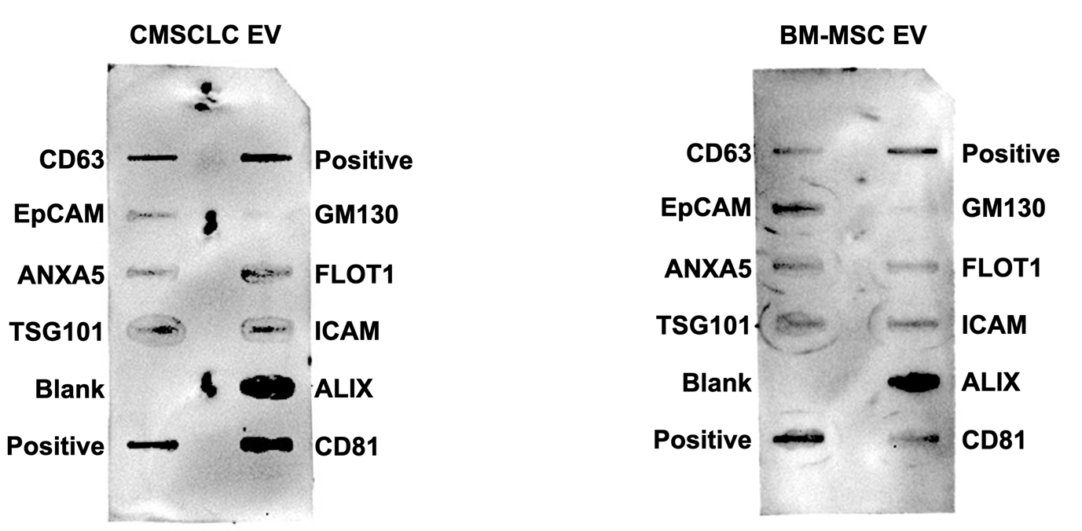

Original uncropped antibody array membrane images, from Figure 2D

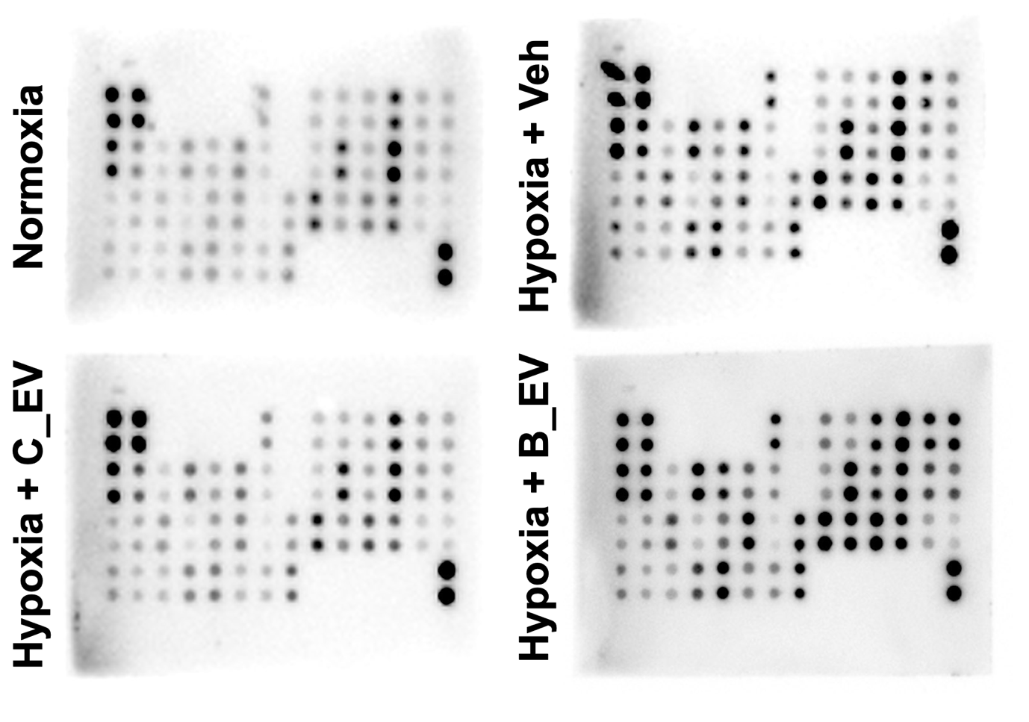

Uncropped antibody arrays from Figure 3D

