The renoprotective efficacy and safety of genetically-engineered human bone marrow-derived mesenchymal stromal cells expressing anti-fibrotic cargo
Yifang Li^{1,3}, Alex Hunter^{1,3}, Miqdad M. Wakeel^{1,3}, Guizhi Sun^{2,4}, Ricky W.K. Lau^{2,3}, Brad R.S. Broughton^{1,3}, Ivan E. Oyarce Pino^{1,3}, Zihao Deng⁵, Tingfang Zhang^{2,3}, Padma Murthi^{1,3}, Mark P. Del Borgo^{1,3}, Robert E. Widdop^{1,3}, Jose M. Polo^{2,4,6,7}, Sharon D. Ricardo^{2,3*} & Chrishan S. Samuel^{1,2,3,8*}

¹Cardiovascular Disease Program and ²Development and Stem Cells Program, Monash Biomedicine Discovery Institute, Monash University, Clayton, Victoria 3800, Australia. ³Department of Pharmacology and ⁴Department of Anatomy and Developmental Biology, Monash University, Clayton, Victoria 3800, Australia.
⁵Department of Medicine (Alfred Hospital), Central Clinical School, Monash University, Melbourne, Victoria 3004, Australia.
⁶Adelaide Centre for Epigenetics, School of Biomedicine and ⁷The South Australian Immunogenomics Cancer Institute, The University of Adelaide, South Australia 5005, Australia.
⁸Department of Biochemistry and Pharmacology, The University of Melbourne, Parkville 3010, Victoria, Australia.

*Correspondence: Professor Chrishan S. Samuel, PhD
Tel: +61 3 9902 0152 / E-mail: chrishan.samuel@monash.edu
Professor Sharon D. Ricardo, PhD
E-mail: sharon.ricardo@monash.edu
Department of Pharmacology, Monash University, Clayton, Victoria 3800, Australia
Supplementary Table 1 The relative cytokine/chemokine intensity from the Proteome Profiler Human XL Cytokine Array analysis of naïve BM-MSCs vs BM-MSCs-eRLX+GFP
 | Naïve BM-MSC-  secreted cytokine intensity | BM-MSC-eRLX+GFP-  secreted cytokine intensity
Immunomodulatory
MCP-3 | 0.055 + 0.010 | 0.079 + 0.014
IL-8 | 0.323 + 0.071 | 0.610 + 0.077*
IL-17A | 0.156 + 0.014 | 0.201 + 0.030
VCAM-1 | 0.577 + 0.062 | 0.662 + 0.065
Angiogenic
Relaxin-2 | 0.050 + 0.020 | 2.319 + 0.456**
VEGF | 1.623 + 0.291 | 1.404 + 0.305
Endoglin | 0.177 + 0.030 | 0.265 + 0.057
Angiopoietin 1 | 0.132 + 0.050 | 1.449 + 0.312**
Angiopoietin 2 | 0.116 + 0.017 | 0.164 + 0.012
Angiogenin | 0.518 + 0.076 | 0.664 + 0.045
IGFPB-3 | 0.913 + 0.069 | 0.817 + 0.091
IGFPB-2 | 0.295 + 0.035 | 0.130 + 0.018*
ECM remodelling and cell proliferative
CD147 | 0.254 + 0.030 | 0.331 + 0.030
Serpin E1 | 0.984 + 0.071 | 0.858 + 0.116
uPAR | 0.274 + 0.036 | 0.227 + 0.086
PDGF-AA | 0.123 + 0.018 | 0.088 + 0.010
Others detected
FGF-19 | 0.178 + 0.009 | 0.198 + 0.011
Thrombospondin-1 | 0.505 + 0.039 | 0.496 + 0.070
SDF-1a | 0.276 + 0.021 | 0.299 + 0.020
Osteopontin | 0.303 + 0.063 | 0.332 + 0.074
GDF-15 | 0.606 + 0.061 | 0.655 + 0.066
Cystatin C | 0.208 + 0.059 | 0.228 + 0.090
IL-11 | 0.122 + 0.013 | 0.117 + 0.010
The mean ± SEM OD intensity of the cytokine/chemokines detected from naïve BM-MSCs vs BM-MSC-eRLX+GFP; from n=4 separate assays. *p<0.01, **p<0.01 vs corresponding levels from naïve BM-MSCs.
Supplementary Table 2 List of antibodies used for flow cytometry
Antigen | Host/Isotype | Clone | Tag | Dilution | Company
CD45 | Rat IgG2b, κ | 30-F11 | PECY5 | 1:200 | BioLegend,USA
CD11C | Armenian Hamster IgG1, λ2 | Clone HL3 | BUV395 | 1:100 | BD Biosciences, USA
F4/80 | Rat IgG2a, κ | BM8 | APC-Fire 750 | 1:100 | BioLegend, USA
CD206 | Rat IgG2a, κ | C068C2 | AF647 | 1:100 | BioLegend, USA

Supplementary Table 3 The effects of IRI or HS and the respective treatments investigated on animal body weight (BW), kidney weight (KW) and KW to BW ratio
Parameter measured | BW  (g) | Left KW  (mg) | LKW:  BW ratio  (mg/g) | Right KW  (mg) | RKW:  BW ratio (mg/g)
Sham [8] | 29 ± 1 | 181 ± 4 | 6.3 ± 0.1 | 196 ± 4 | 6.8 ± 0.1
IRI [8] | 28 ± 1 | 190 ± 5 | 6.8 ± 0.2 | 199 ± 7 | 7.2 ± 0.3
IRI+BM-MSCs-eGFP [8] | 27 ± 1 | 190 ± 6 | 7.0 ± 0.2 | 202 ± 6 | 7.4 ± 0.2
IRI+BM-MSCs-RLX+GFP [8] | 27 ± 1 | 188 ± 6 | 6.9 ± 0.2 | 187 ± 6 | 6.8 ± 0.3
IRI+Pump RLX+BM-MSCs [8] | 28 ± 1 | 189 ± 4 | 6.7 ± 0.1 | 198 ± 5 | 7.0 ± 0.2
NDW [8] | 35 ± 1 | 284 ± 9 | 8.3 ± 0.3 | 287 ± 9 | 8.4 ± 0.3
HS [8] | 30 ± 1* | 273 ± 11 | 9.0 ± 0.3 | 272 ± 13 | 9.0 ± 0.4
HS+BM-MSCs-eGFP (x2) [8] | 32 ± 1 | 290 ± 14 | 9.0 ± 0.3 | 290 ± 17 | 9.0 ± 0.4
HS+BM-MSCs-eRLX+eGFP (x1) [7] | 32 ± 1 | 282 ± 11 | 8.8 ± 0.2 | 290 ± 14 | 9.1 ± 0.3
HS+BM-MSCs-eRLX+eGFP (x2) [7] | 33 ± 1 | 268 ± 6 | 8.2 ± 0.1 | 254 ± 8 | 7.7 ± 0.2
HS+Pump RLX+BM-MSCs [8] | 32 ± 1 | 265 ± 6 | 8.3 ± 0.2 | 271 ± 10 | 8.4 ± 0.3
HS+Perindopril [8] | 32 ± 1 | 269 ± 19 | 8.1 ± 0.4 | 285 ± 19 | 8.6 ± 0.4
All data are expressed as the mean+SEM; from n=6-8 mice per group (as denoted by the numbers in the square brackets). *p<0.05 vs NDW control group.

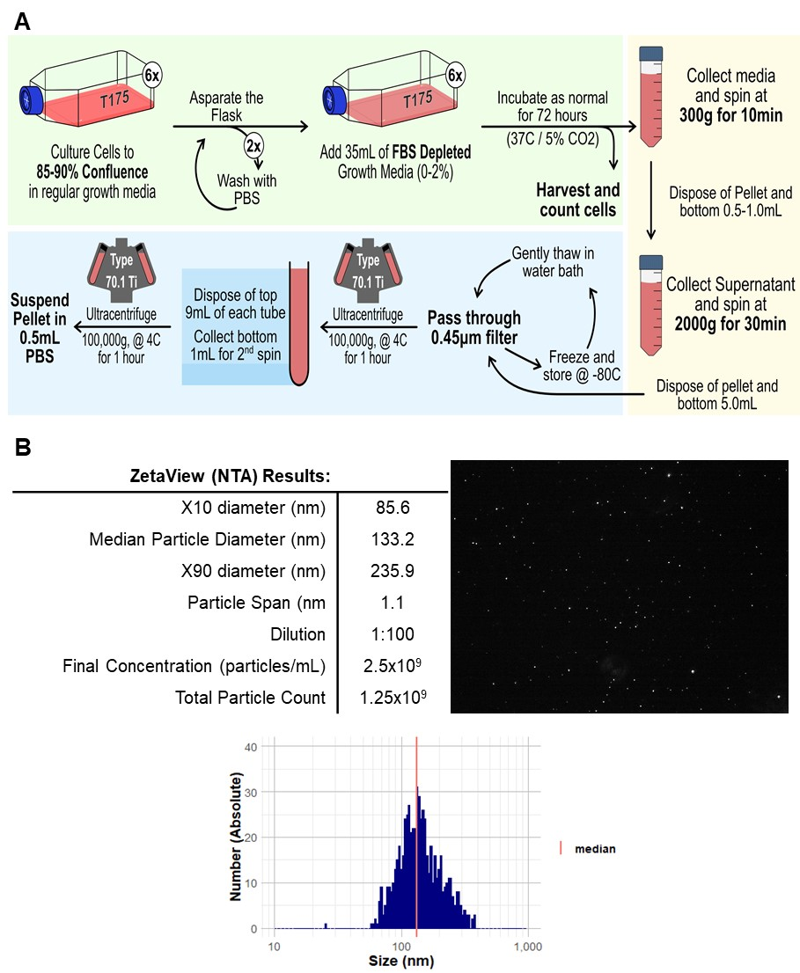
Supplementary Fig. 1 Extraction and characterisation of BM-MSCs-eRLX+GFP-derived exosomes. (A) Shown is a flowchart outlining how exosomes were harvested and isolated from BM-MSCs-eRLX+GFP (completed once). (B) BM-MSCs-eRLX+GFP-derived exosomes were characterised using the Zetaview® PMX-120 Nanoparticle Tracking Analyzer (NTA), using a 1:100 dilution. A total of 1.25x10⁹ particles were isolated, with a median diameter of 133.2nm (X10 = 85.6nm, X90 = 235.9nm, span = 1.1).
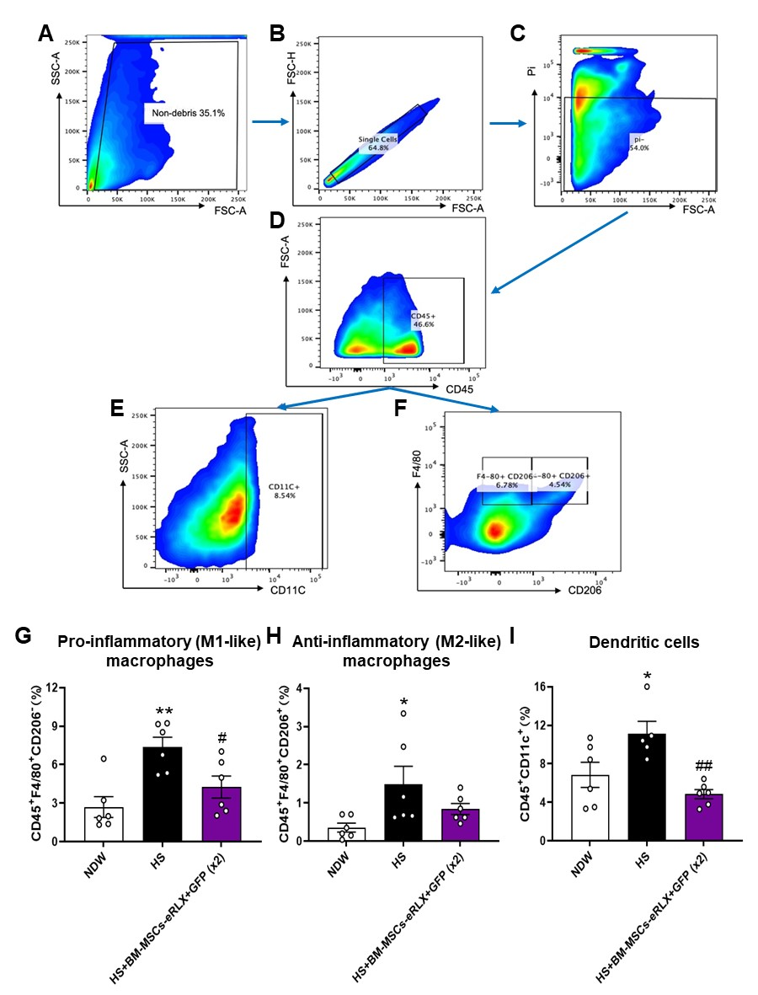
Supplementary Fig. 2 Flow cytometric analysis of the effects of HS and BM-MSCs-eRLX+GFP on macrophage subsets and dendritic infiltration within the kidney. (A) Total non-cellular debris (including all monocytes, lymphocytes and granulocytes) was gated by forward scatter area (FSC-A) vs side scatter area (SSC-A). (B) Live leukocyte singlets were then gated by forward scatter-height (FSC-H) vs FSC-A, followed by (C) exclusion of dead cells (PI stain), and (D) gated as CD45⁺ populations against FSC-A. These leukocytes were then divided into (E) dendritic cells (CD45⁺CD11c⁺) or (F) CD45⁺F4/80⁺CD206⁻ pro-inflammatory (M1-like) macrophages and CD45⁺F4/80⁺CD206⁺ anti-inflammatory (M2-like) macrophages. (G) Also shown are the mean + SEM % CD45⁺F4/80⁺CD206⁻ pro-inflammatory (M1-like) macrophage, CD45⁺F4/80⁺CD206⁺ anti-inflammatory (M2-like) macrophage (H) and CD45⁺CD11c⁺ dendritic cell infiltration (I) in the kidneys of NDW controls (n=6), HS-fed mice (n=6) and HS-fed mice treated with BM-MSCs-eRLX+GFP (x2) (n=6), as determined by flow cytometry analysis. *p<0.05, **p<0.01 vs the NDW control group; #p<0.05, ##p<0.01 vs the HS alone group; as determined using a one-way ANOVA and Tukey’s post-hoc test.
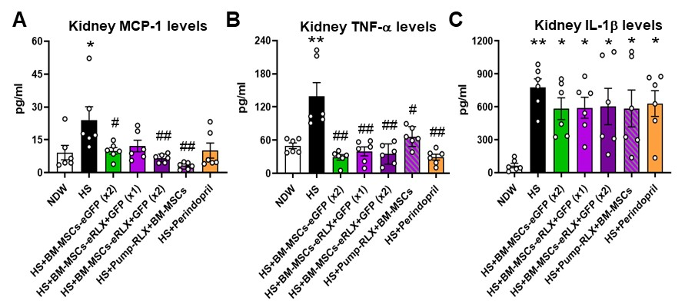

Supplementary Fig. 3 The effects of HS and the treatments evaluated on pro-inflammatory cytokine expression levels within the kidney. (A-C) Shown are the mean ± SEM levels of (A) monocyte chemoattractant protein (MCP)-1, (B) tumour necrosis factor (TNF)-α and (C) interleukin (IL)-1β within the kidney, as determined by ELISA analysis of kidney protein extracts; from n=6 mice per group evaluated. *p<0.05, **p<0.01 vs the NDW control group; #p<0.05, ##p<0.01 vs the HS alone group; as determined using a one-way ANOVA and Tukey’s post-hoc test.

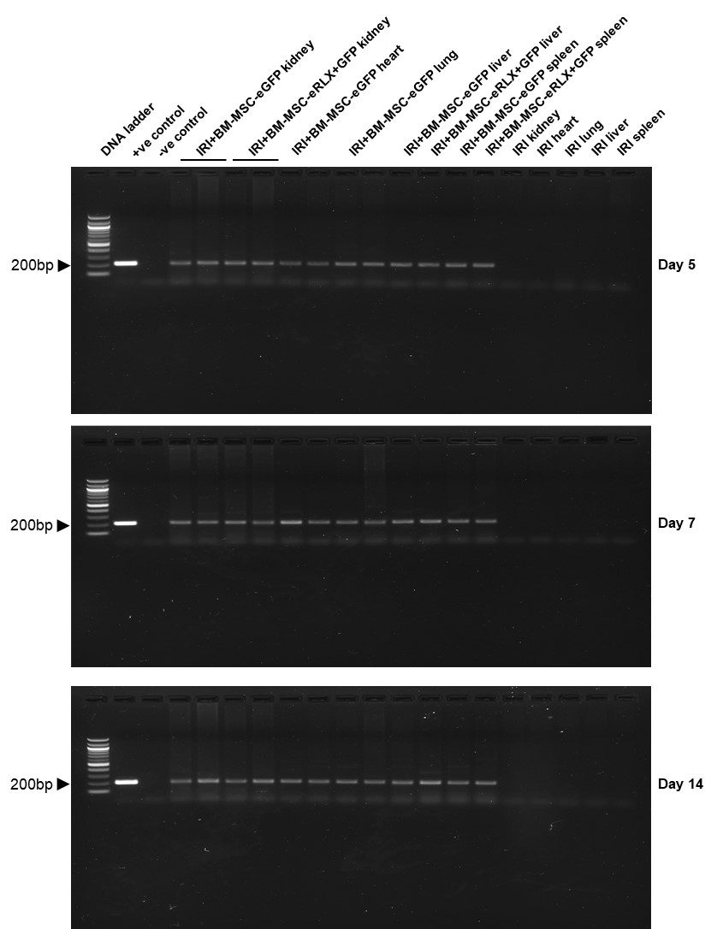
Supplementary Fig. 4 The full-length agarose gel blots that were cropped to create Fig. 3A.
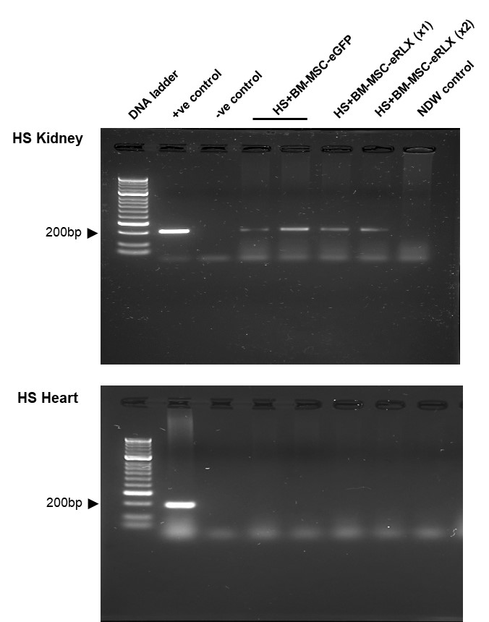
Supplementary Fig. 5 The full-length agarose gel blots that were cropped to create Fig. 3D.

