Supplementary Figure S1.
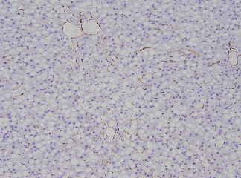
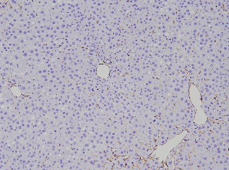
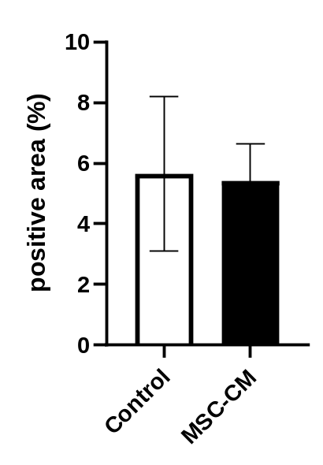
A
Control
MSC-CM
CD31 positive area
B

(A) Representative liver sections stained by CD31 at 30h after hepatectomy.
(B) Quantification of CD31 positive area at 30h after hepatectomy (n = 4-5/group).

Supplementary Figure S2.

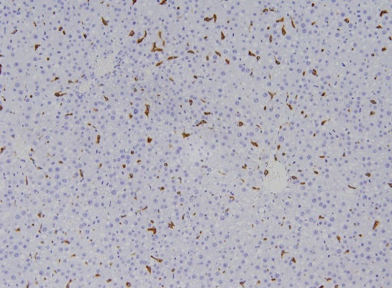
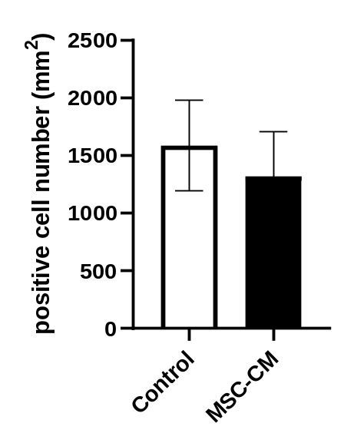
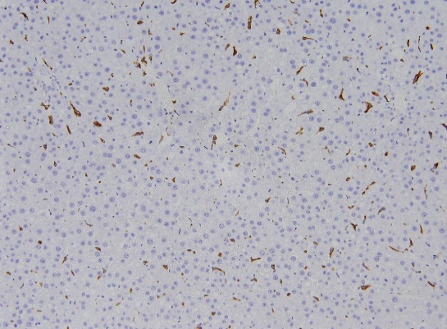
A
Control
CD163-positive cell
MSC-CM
B

(A) Representative liver sections stained by CD163 at 30h after hepatectomy.
(B) Quantification of CD163-positive nuclei (%) at 30h after hepatectomy (n = 4-5/group).

Supplementary Figure S3.

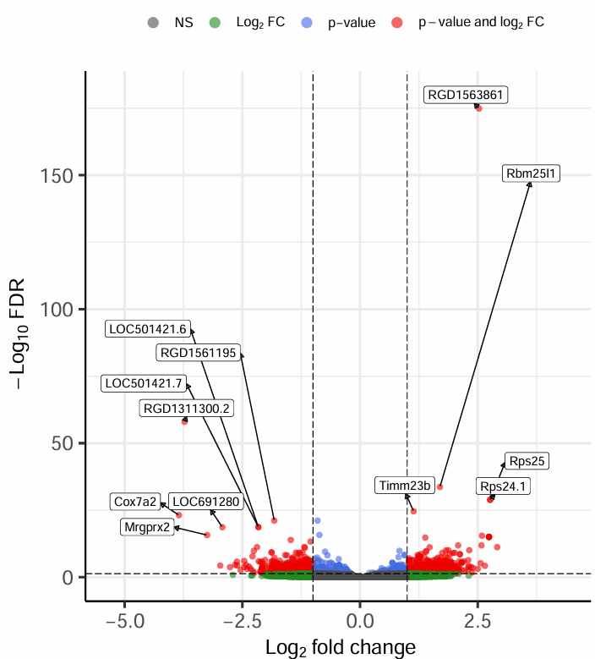

Differential expression analysis of liver tissue mRNA expression at 9h for control group versus MSC-CM group. Volcano plots showing all the DEGs.

Supplementary Table S1.

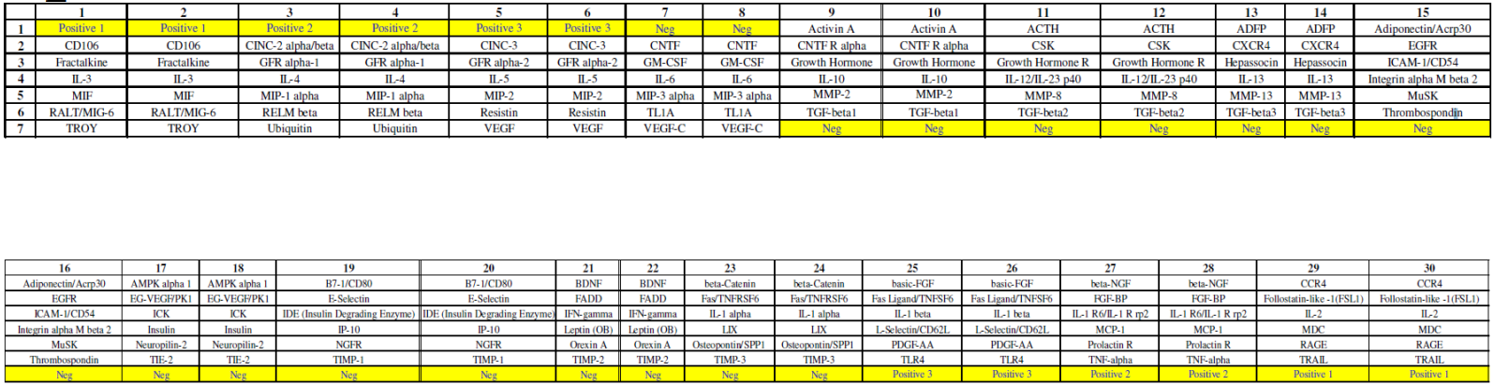
Supplementary Table S2. Differential gene expression analysis of Standard diet group versus MCD diet group. Top 10 DEGs in ascending order of FDRs.

Symbol | logFC | logSIGNAL | P value | FDR
LOC100360095 | -7.44 | 9.87 | 0 | 0
Cyp7a1 | 5.08 | 8.76 | 0 | 0
Igfbp1 | 4.15 | 9.09 | 0 | 0
Mt1m | -1.74 | 10.0 | 0 | 0
Hamp | 1.19 | 10.8 | 6.51E-319 | 2.94E-315
Cyp2c11 | -1.67 | 9.70 | 1.20E-276 | 4.53E-273
Mt1a.1 | -1.53 | 9.88 | 1.54E-264 | 4.96E-261
Hsd17b2 | -2.67 | 8.69 | 2.19E-254 | 6.18E-251
Dhrs7 | -4.00 | 7.95 | 3.13E-240 | 7.87E-237
G6pc | 2.03 | 9.21 | 2.29E-239 | 5.17E-236

Supplementary Table S3. Differential gene expression analysis of MCD diet group versus control group. Top 10 DEGs in ascending order of FDRs.

Symbol | logFC | logSIGNAL | P value | FDR
Mt2A | 5.88 | 10.2 | 1.14E-64 | 2.58E-60
Mir770 | 5.98 | 9.50 | 2.49E-62 | 2.82E-58
Cyp7a1 | -6.24 | 8.73 | 8.13E-52 | 6.13E-48
Fads1 | -5.20 | 9.20 | 1.23E-47 | 6.94E-44
Rnase4 | -5.16 | 9.00 | 6.29E-46 | 2.65E-42
Hmgcs1 | -5.11 | 9.09 | 7.03E-46 | 2.65E-42
Cth | -4.87 | 9.33 | 6.16E-45 | 1.99E-41
Cyp3a23.3a1.1 | -6.14 | 7.98 | 1.05E-43 | 2.97E-40
Vom2r70 | 5.90 | 7.08 | 7.68E-42 | 1.93E-38
Pkib.1 | 4.52 | 8.78 | 8.57E-42 | 1.94E-38

Supplementary Table S4. GO Biological Processes that are enriched in DEGs in Standard diet group versus MCD diet group. Top 10 GO biological processes in ascending order of P values.

GO.ID | Term | Annotated | Significant | Expected | P value
GO:0044281 | small molecule metabolic process | 1620 | 99 | 39.4 | 1.30E-18
GO:0043436 | oxoacid metabolic process | 900 | 66 | 21.9 | 4.50E-16
GO:0006082 | organic acid metabolic process | 910 | 66 | 22.1 | 7.80E-16
GO:0006629 | lipid metabolic process | 1303 | 81 | 31.7 | 1.70E-15
GO:0019752 | carboxylic acid metabolic process | 887 | 63 | 21.6 | 1.10E-14
GO:0008202 | steroid metabolic process | 310 | 35 | 7.56 | 3.50E-14
GO:0009410 | response to xenobiotic stimulus | 679 | 53 | 16.5 | 4.40E-14
GO:0014070 | response to organic cyclic compound | 1386 | 79 | 33.7 | 4.30E-13
GO:0032787 | monocarboxylic acid metabolic process | 626 | 48 | 15.2 | 1.50E-12
GO:0044283 | small molecule biosynthetic process | 536 | 43 | 13.0 | 5.70E-12

Supplementary Table S5. GO Biological Processes that are enriched in DEGs in MCD diet group versus control group. Top 10 GO biological processes in ascending order of P values.

GO.ID | Term | Annotated | Significant | Expected | Fisher’s Test
GO:0050877 | nervous system process | 1351 | 1133 | 921 | < 1e-30
GO:0007186 | G protein-coupled receptor signaling pathway | 981 | 839 | 668 | < 1e-30
GO:0007600 | sensory perception | 755 | 663 | 514 | < 1e-30
GO:0003008 | system process | 2031 | 1612 | 1384 | < 1e-30
GO:0032501 | multicellular organismal process | 7090 | 5148 | 4833 | 1.40E-28
GO:0007606 | sensory perception of chemical stimulus | 262 | 249 | 178 | 2.20E-27
GO:0051606 | detection of stimulus | 311 | 276 | 212 | 8.00E-18
GO:0050906 | detection of stimulus involved in sensory perception | 219 | 201 | 149 | 3.40E-17
GO:0007268 | chemical synaptic transmission | 864 | 695 | 589 | 7.00E-17
GO:0098916 | anterograde trans-synaptic signaling | 864 | 695 | 589 | 7.00E-17

