Fig. S1 Expression and characterization of surface markers on human umbilical cord mesenchymal stromal cells (hUC-MSCs). At passage 3, hUC-MSCs were analyzed via flow cytometry, and their osteogenic and adipogenic differentiation capabilities were assessed via Alizarin red and Oil Red O staining. Flow cytometry was used to analyze surface markers (A. CD73, B. CD90, C. CD105, D. CD11b, E. CD19, F. CD34, G. CD45, H. HLA-DR), I. MSCs with a fibroblast-like appearance. J. Osteogenic differentiation was identified by Alizarin red staining, and K. Adipogenic differentiation was detected by Oil Red O staining.
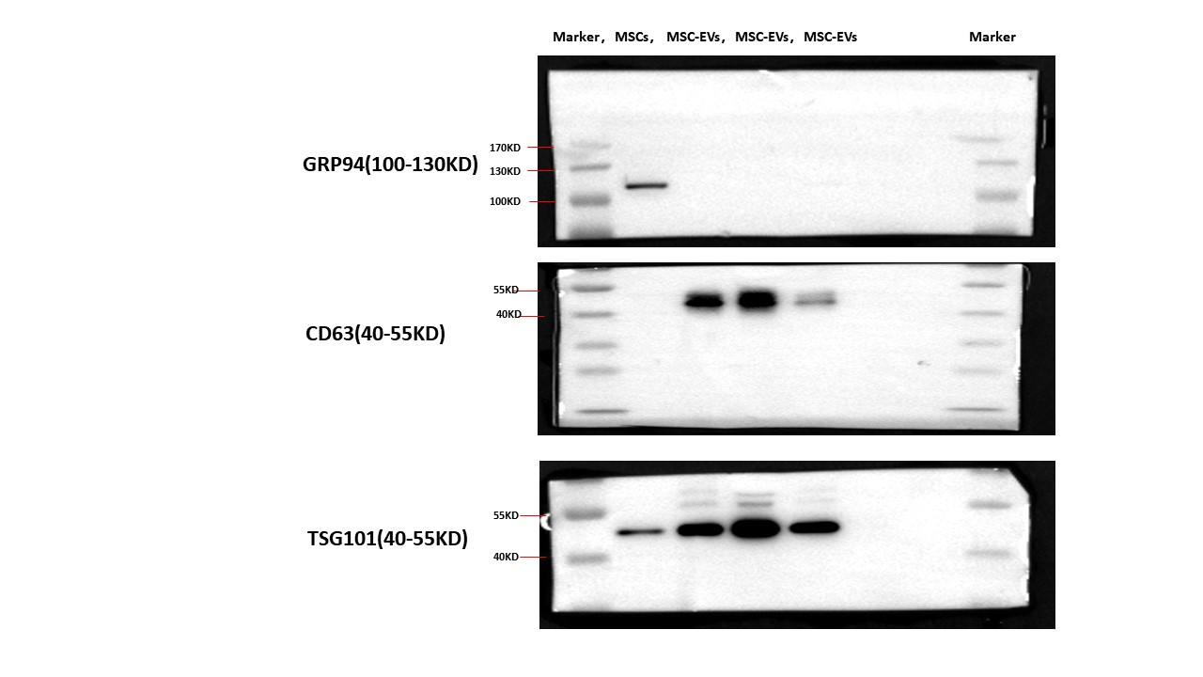
Fig. S2
Fig. S3 Pearson’s rank correlation analysis was conducted on the top 10 enriched bacterial genera and therapeutic outcomes (AST and ALT). The heatmap illustrates a close association between microbial taxa and clinical indicators (AST and ALT). Colors represent the Pearson rank correlation coefficients, with red indicating a positive correlation and blue indicating a negative correlation. Additionally, *P < 0.05 and **P < 0.01 indicate statistically significant differences between bacterial taxa and therapeutic outcomes.

