Supplementary Information

Supplementary Figures

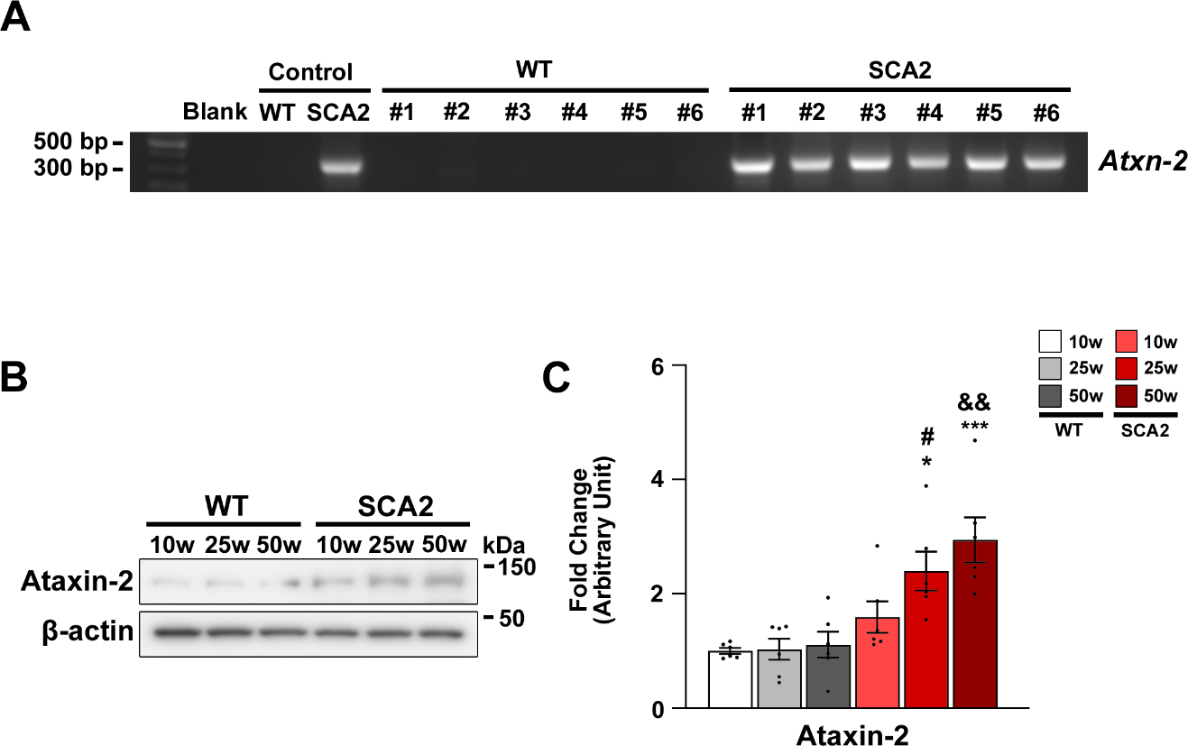
Supplementary Fig. 1. Confirmation of SCA2 mice. (A) Genotyping was employed to validate the existence of the human Ataxin-2 gene. Full-length gels are presented in supplymentary Fig. 5: Suppl. 1A. An internal mouse control (WT, SCA2) was presented for verification to confirm genotyping. (B, C) The levels of Ataxin-2 in cerebellum tissues from WT and SCA2 mice at 10, 25, and 50 weeks of age were examined using Western blot. A significant difference (*p < 0.05 and ***p < 0.001) was observed when compared to 10-week-old WT mice, as determined by a two-way ANOVA with Tukey’s post hoc analysis (n = 6 for each group). Significant differences (#p < 0.05 and &&p < 0.01) were observed when compared to 25-week-old WT mice and 50-week-old WT mice, respectively, as determined by a two-way ANOVA with Tukey’s post hoc analysis (n = 6 for each group). Full-length blots are presented in supplymentary Fig. 5: Supplementary Fig. 1B.
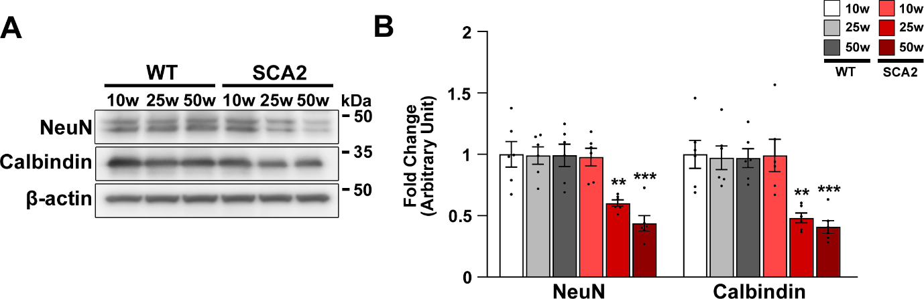
Supplementary Fig. 2. Decrease in the protein levels of NeuN and Calbindin in the cerebellum of SCA2 mice. (A, B) Western blot analysis of NeuN and Calbindin in cerebellum tissues obtained from 10-, 25-, and 50-week-old WT and SCA2 mice. **p < 0.01 and ***p < 0.001 vs. 10-week-old WT mice [two-way analysis of variance (ANOVA) with Tukey’s post hoc analysis; n = 6 for each group]. Full-length blots are presented in supplymentary Fig. 5: Supplementary Fig. 2A.

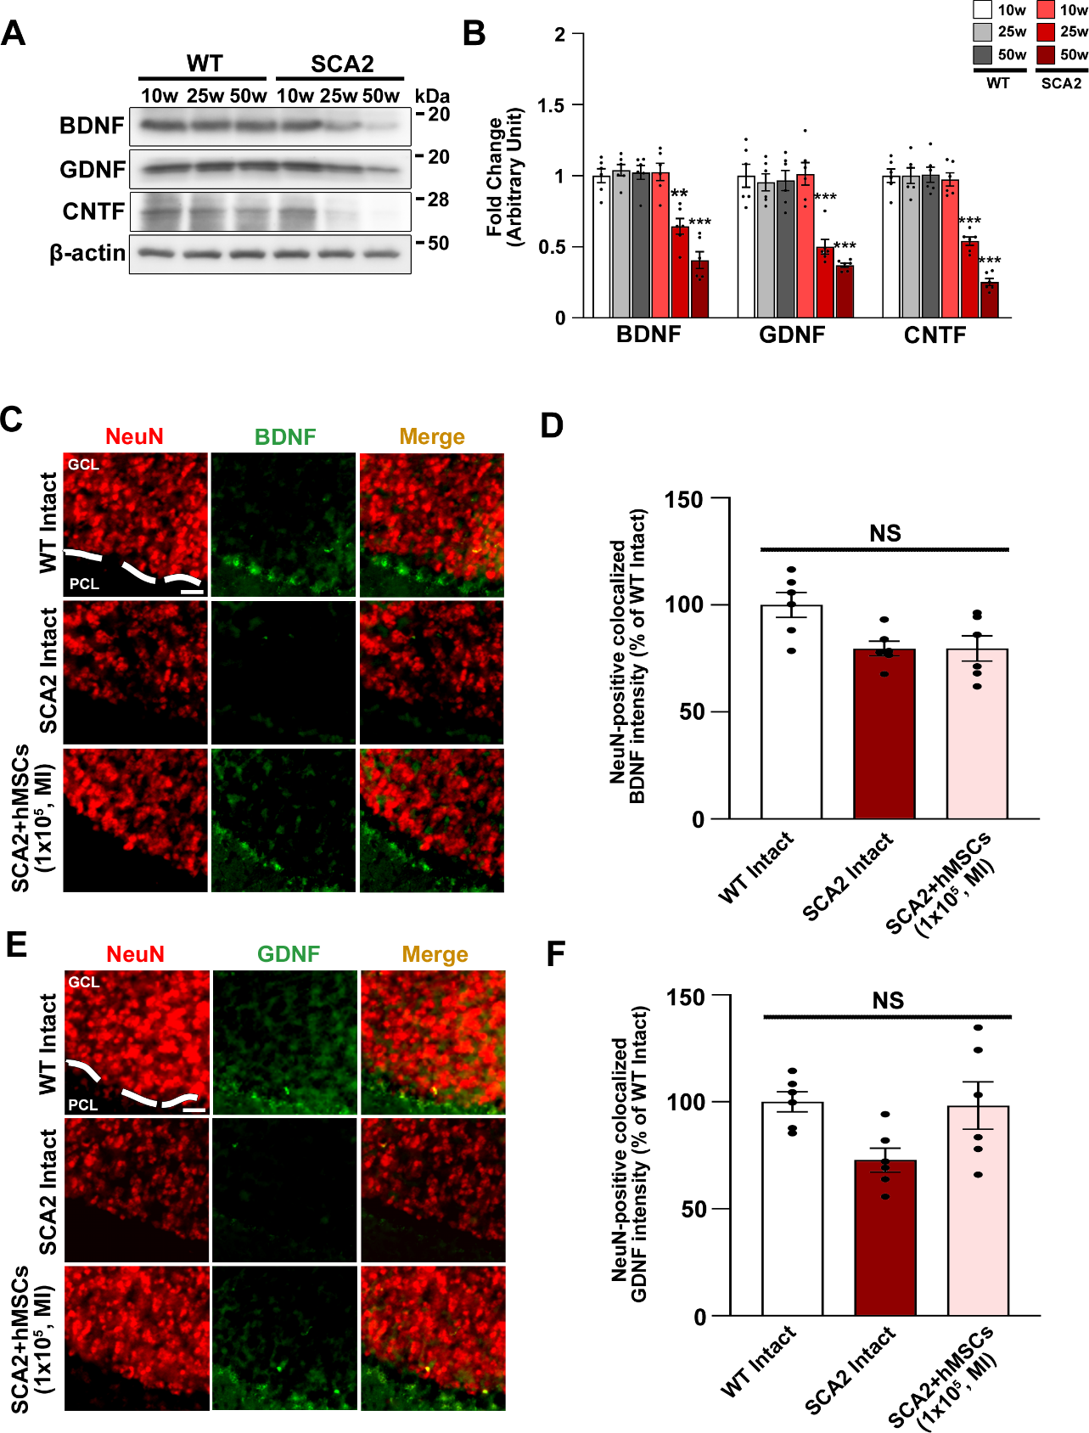
Supplementary Fig. 3. Decrease in the protein levels of neurotrophic factors in the cerebellum of SCA2 mice. (A, B) Western blot analysis of BDNF, GDNF, and CNTF in cerebellum tissues obtained from 10-, 25-, and 50-week-old WT and SCA2 mice. **p < 0.01 and ***p < 0.001 vs. 10-week-old WT mice (two-way ANOVA with Tukey’s post hoc analysis; n = 6 for each group). Full-length blots are presented in supplymentary Fig. 5: Supplementary Fig. 3A. (C) Double immunofluorescence staining was conducted for NeuN and BDNF, and NeuN and GDNF, in the cerebellum of 50-week-old WT, SCA2, and SCA2 + hMSCs (MI, 1 × 10⁵ cells)-treated mice. The scale bar represents 20 μm. A dashed line is used to differentiate between the granule cell layer (GCL) and the Purkinje cell layer (PCL). (D) The fluorescence intensity for the quantitative co-localization of NeuN with BDNF was measured. NS, no significance (one-way ANOVA with Tukey’s post-hoc analysis). (E) Double immunofluorescence staining was conducted for NeuN and GDNF, in the cerebellum of 50-week-old WT, SCA2, and SCA2 + hMSCs (MI, 1 × 10⁵ cells)-treated mice. The scale bar represents 20 μm. A dashed line is used to differentiate between the GCL and the PCL. (F) The fluorescence intensity for the quantitative co-localization of NeuN with GDNF was measured. NS, no significance (one-way ANOVA with Tukey’s post-hoc analysis).

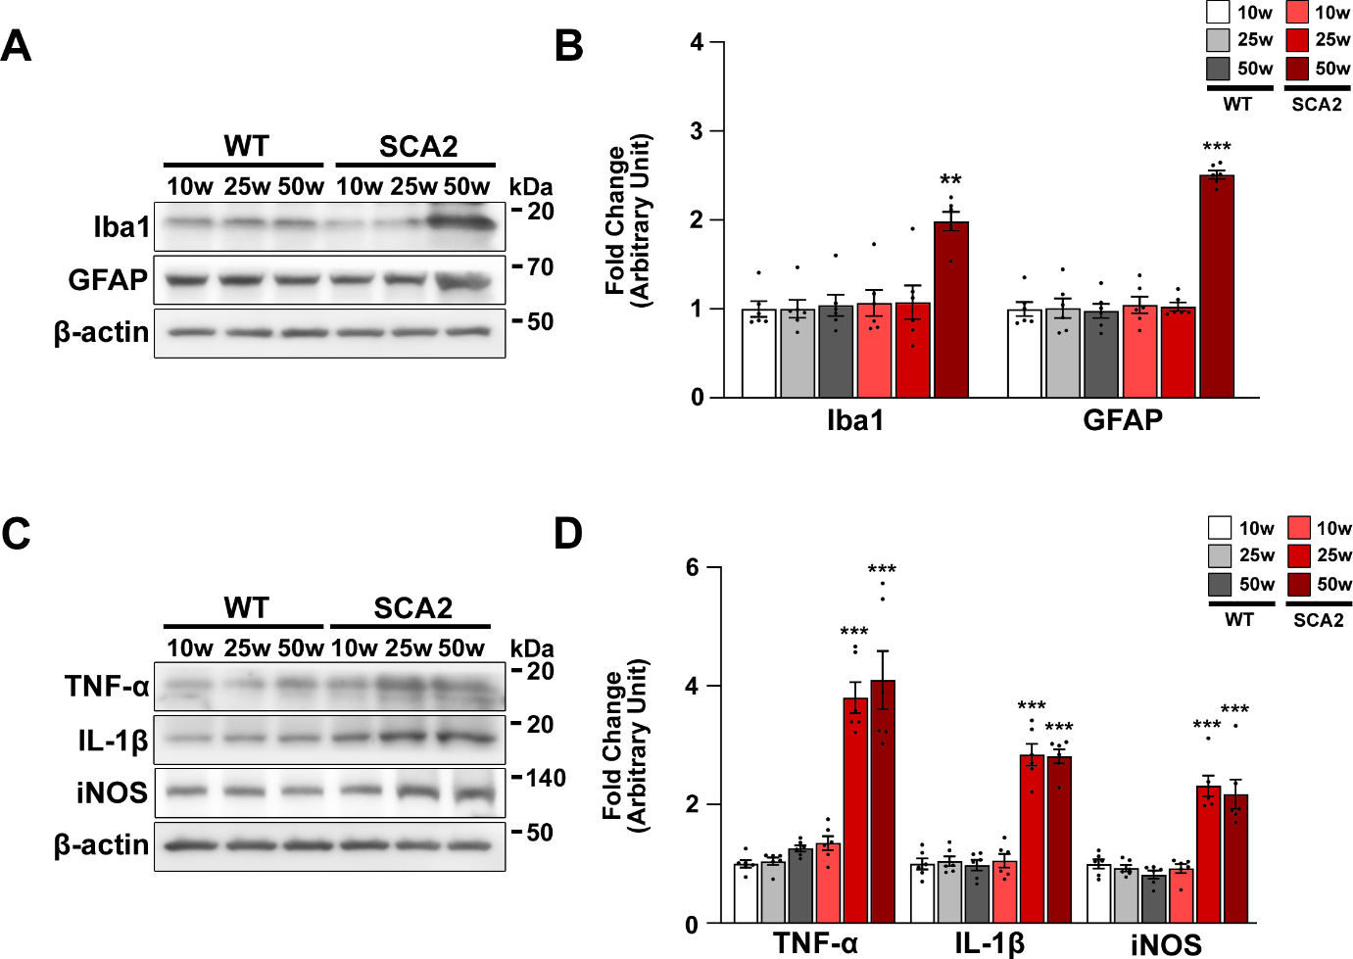
Supplementary Fig. 4. Upregulation of neurotoxic cytokines in the cerebellum of SCA2 mice. (A, B) Western blot analysis of Iba1 and GFAP in cerebellum tissues obtained from 10-, 25-, and 50-week-old WT and SCA2 mice. **p < 0.01 and ***p < 0.001 vs. 10-week-old WT mice (two-way ANOVA with Tukey’s post hoc analysis; n = 6 for each group). Full-length blots are presented in supplymentary Fig. 5: Supplementary Fig. 4A. (C, D) Western blot analysis of TNF-α, IL-1β, and iNOS in cerebellum tissues obtained from 10-, 25-, and 50-week-old WT and SCA2 mice. ***p < 0.001 vs. 10-week-old WT mice (two-way ANOVA with Tukey’s post hoc analysis; n = 6 for each group). Full-length blots are presented in supplymentary Fig. 5: Supplementary Fig. 4C.

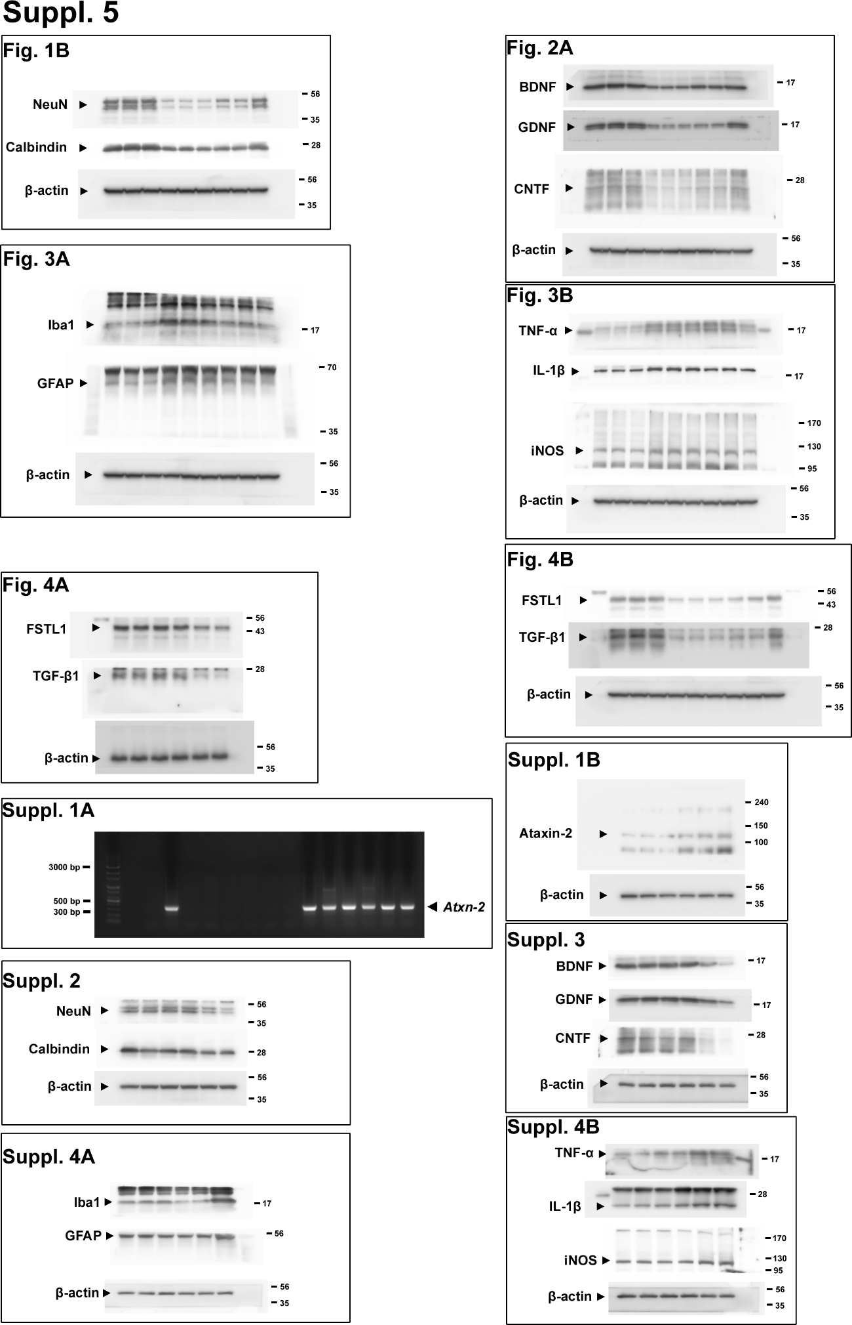
Supplementary Fig. 5. Images of full-length blots/gels
Supplementary Table

WT vs. SCA2 |  | Figure | Protein |  | Type of test |  | p-value
10w |  | S2  S2  S3A  S3A  S3A  S4A  S4A  S4B  S4B  S4B  4A  4A  S1B | NeuN  Calbindin  BDNF  GDNF  CNTF  Iba1  GFAP  TNF-α  IL-1β  iNOS  FSTL1  TGF-β1  Ataxin-2 |  | Two-way ANOVA |  | ns  ns  ns  ns  ns  ns  ns  ns  ns  ns  ns  ns  ns
25w |  | S2  S2  S3A  S3A  S3A  S4A  S4A  S4B  S4B  S4B  4A  4A  S1B | NeuN  Calbindin  BDNF  GDNF  CNTF  Iba1  GFAP  TNF-α  IL-1β  iNOS  FSTL1  TGF-β1  Ataxin-2 |  | Two-way ANOVA |  | P < 0.05  P < 0.01  P < 0.01  P < 0.01  P < 0.001  ns  ns  P < 0.001  P < 0.001  P < 0.001  P < 0.001  P < 0.01  P < 0.05
50w |  | S2  S2  S3A  S3A  S3A  S4A  S4A  S4B  S4B  S4B  4A  4A  S1B | NeuN  Calbindin  BDNF  GDNF  CNTF  Iba1  GFAP  TNF-α  IL-1β  iNOS  FSTL1  TGF-β1  Ataxin-2 |  | Two-way ANOVA |  | P < 0.01  P < 0.01  P < 0.001  P < 0.001  P < 0.001  P < 0.01  P < 0.001  P < 0.001  P < 0.001  P < 0.001  P < 0.001  P < 0.001  P < 0.01
Table 1: Comparative statistical analysis of 10-, 25-, and 50-week-old WT and SCA2 mice.

Figure |  | Protein/behavior test |  | Type of test |  | p-value
1B, C  1B, C  1D  1E  1F  2A, B  2A, B  2A, B  2D  2D  3A, B  3A, B  3C, D  3C, D  3C, D  4A, B  4A, B  4C  4C  4D  4D  4E, F  4E, F |  | NeuN  Calbindin  Rota-rod test  Open field test  Phenotypic Scoring test  BDNF  GDNF  CNTF  Calbindin/BDNF  Calbindin/GDNF  Iba1  GFAP  TNF-α  IL-1β  iNOS  FSTL1  TGF-β1  Calbindin/FSTL1  Calbindin/TGF-β1  NeuN/FSTL1  NeuN /TGF-β1  FSTL1  TGF-β1 |  | Two-way ANOVA  Two-way ANOVA  One-way ANOVA  One-way ANOVA  One-way ANOVA  Two-way ANOVA  Two-way ANOVA  Two-way ANOVA  One-way ANOVA  One-way ANOVA  Two-way ANOVA  Two-way ANOVA  Two-way ANOVA  Two-way ANOVA  Two-way ANOVA  Two-way ANOVA  Two-way ANOVA  t-test  t-test  t-test  t-test  Two-way ANOVA  Two-way ANOVA |  | ***p <0.0001, ###p<0.0001  **p =0.0017, #p=0.0374  ***p <0.0001, ###p<0.0001  *p =0.0257, ###p<0.0001  *p =0.0244, #p=0.0401  ***p <0.0001, ###p<0.0001  ***p <0.0001, ###p<0.0001  ***p <0.0001, ###p<0.0001  ***p <0.0001, ###p=0.0002  ***p <0.0001, ###p<0.0001  ***p <0.0001, ###p<0.0001  ***p <0.0001, ###p<0.0001  ***p <0.0001, ##p=0.0012  ***p <0.0001, ###p<0.0001  ***p <0.0001, ###p<0.0001  **p =0.003, ***p<0.0001  ***p <0.0001  ***p =0.0001  ***p <0.0001  ***p =0.0001  ***p <0.0001  ***p <0.0001, ###p<0.0001  ***p <0.0001, ###p<0.0001
S1B, C  S2A, B  S2A, B  S3A, B  S3A, B  S3A, B  S4A, B  S4A, B  S4C, D  S4C, D  S4C, D |  | Ataxin-2  NeuN  Calbindin  BDNF  GDNF  CNTF  Iba1  GFAP  TNF-α  IL-1β  iNOS |  | Two-way ANOVA  Two-way ANOVA  Two-way ANOVA  Two-way ANOVA  Two-way ANOVA  Two-way ANOVA  Two-way ANOVA  Two-way ANOVA  Two-way ANOVA  Two-way ANOVA  Two-way ANOVA |  | *p =0.0109, ***p=0.0002, #p=0.0132, &&p=0.005  **p =0.0091, ***p=0.0001  **p =0.0044, ***p=0.0009  **p =0.006, ***p <0.0001  ***p <0.0001, ***p<0.0001  ***p <0.0001, ***p<0.0001  ***p=0.0009  ***p<0.0001  ***p <0.0001, ***p<0.0001  ***p <0.0001, ***p<0.0001  ***p <0.0001, ***p<0.0001
Table 2: Comprehensive statistical analysis summary of all figures

