Supplementary Material

Methods
1. Cell proliferation analysis
Cell proliferation was measured using a real-time cellular analysis system. MSCs were seeded at a density of 2000 cells/well in 96-well plates for 24 h and then the medium was replaced with different concentrations of AST (0, 5, 10, 20, 40, 80μg/ml). Cells were counted every 12 h and monitored continuously for up to 84 hours. Each sample was repeated three times.
2. CCK-8 cell viability assay
MSCs were seeded in 96-well plates and treated with 20μg/ml for 48 h. Cell viability was measured using the Cell Counting Kit-8 (Dojindo, Kumamoto, Japan) in accordance with the manufacturer's instructions.

Results

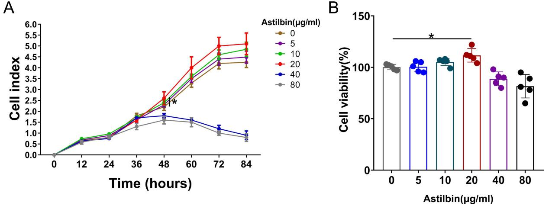
Figure S1 Depicts the impact of astilbin on the proliferation and viability of MSC cells. After prolonged treatment with various concentrations of astilbin, the results were obtained by measuring the proliferation of MSCs using a real-time cellular analysis system(A) and by detecting cell viability using the CCK8 assay(B). (*p< 0.05 compared to astilbin concentrations of 0 μg/ml)

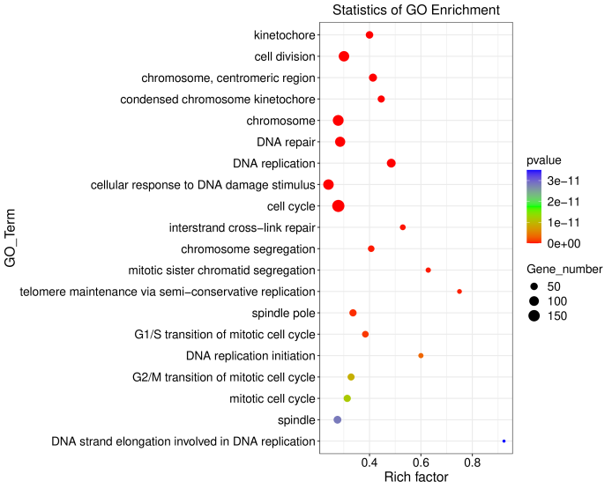
Figure S2 GO enrichment analysis of the differentially expressed genes (DEGs). Different colors reflect different p values, while different circle sizes represent different gene counts.

