Supplementary Information

Figure S1. Activation of astrocyte and microglia 7 days after HIE surgery.
(A) Whole mount view of injured brain with 30 min hypoxia at 7 days after HIE operation. Scale bars: 5mm. (B and C) Immunostaining of GFAP and IBA1 showed astrocytosis (B) and microgliosis (C) in the ipsilateral cortex of HIE-injured brain. The boxed area was magnified on the right in (a) and (b) Scale bars: 500μm (B and C), 100μm (a and b). (related to figure 1)

Figure S2. Characterization of human NPCs by DAPT treatment.
(A and B) Immunofluorescent staining and quantification of FOXG1 in the CON, DAPT treatment for 3d and 7d groups. Scale bars: 100μm. (C and D) Immunofluorescent staining and quantification of MEIS2 in the CON, DAPT treatment for 3d and 7d groups. Scale bars: 100μm. (E and F) Immunofluorescent staining and quantification of NKX2.1 in the CON, DAPT treatment for 3d, and 7d groups. Scale bars: 100μm. Data are presented as the mean ± SEM. (related to figure 2)

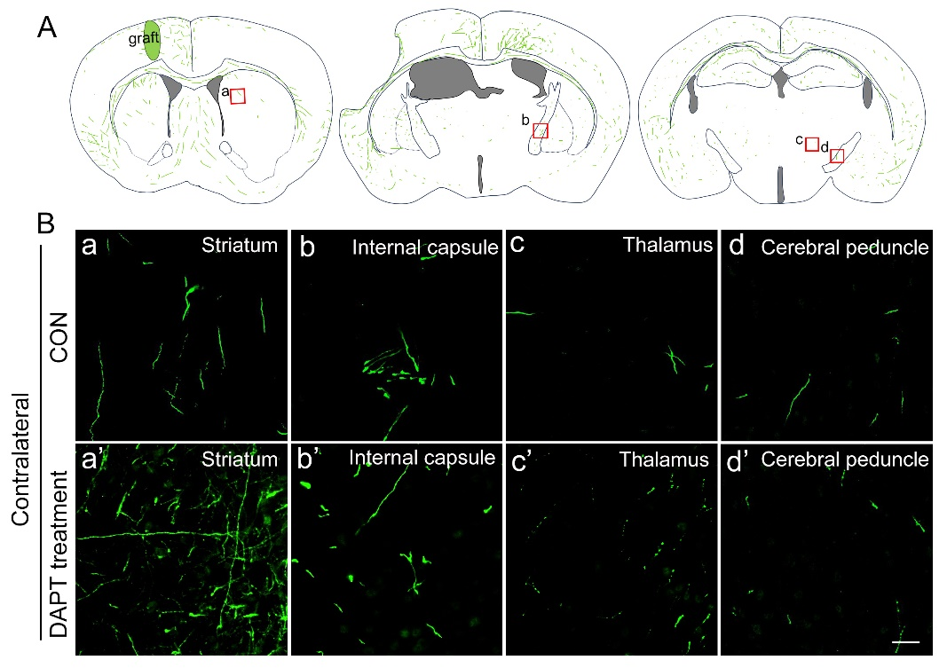
Figure S3. Human neuron fibers from the graft project to the contralateral of HIE-injured brain.
A. Schematic showing the GFP+ fibers in three representative planes. B. Images from CON and DAPT-treated groups showing graft-derived projections in the contralateral striatum (a, a’), internal capsule (b, b’), thalamus (c, c’), and cerebral peduncle (d, d’) in the HIE-injured brain. Scale bars: 25μm. (related to figure 5).

Figure S4. Electrophysiological properties of grafted human cortical neurons at 5 MPT in HIE-injured mice.
(A-C) Statistical data showing resting membrane potential (RMP), threshold of action potential (Threshold) (A), action potential peak amplitude (Peak Amp), half-width (B), rise and decay slope (C) from grafted human neurons with DAPT-treatment at 5 MPT. (D) Typical traces of sEPSCs and sIPSCs in grafted neurons without DAPT-treatment at 5 MPT. (E-F) The frequency (E), amplitude (F) of sEPSCs and sIPSCs in grafted human neurons without DAPT-treatment. Data are presented as the mean ± SEM. (related to figure 6).

Supplementary Table 1. Antibodies used for all immunofluorescence assays
Type | Target | Cat. No | Manufacturer | Host Species | Conjugate | Dilution
Primary | FOXG1 | ab18259 | Abcam | Rabbit |  | 1 in 800
Primary | PAX6 | 901301 | Biolegend | Rabbit |  | 1 in 800
Primary | EMX1 | ab15067-I | Sigma-Aldrich | Rabbit |  | 1 in 800
Primary | MEIS2 | Sc-101850 | Santa Cruz | mouse |  | 1 in 500
Primary | NKX2.1 | MAB5460 | Millipore | Rabbit |  | 1 in 1000
Primary | SATB2 | ab92446 | Abcam | Rabbit |  | 1 in 800
Primary | CTIP2 | ab18465 | Abcam | Rat |  | 1 in 1000
Primary | CTIP2 | ab28448 | Abcam | Rabbit |  | 1 in 1000
Primary | TBR1 | ab31940 | Abcam | Rabbit |  | 1 in 800
Primary | GLUTAMATE | G6642 | Sigma-Aldrich | Rabbit |  | 1 in 5000
Primary | GABA | A2052 | Sigma-Aldrich | Rabbit |  | 1 in 4000
Primary | NEUN | ABN78 | Sigma-Aldrich | Rabbit |  | 1 in 500
Primary | GFP | ab13970 | Abcam | Chicken |  | 1 in 1000
Primary | SOX2 | AF2018 | R&D Systems | Goat |  | 1 in 500
Primary | KI67 | ab15580 | Abcam | Rabbit |  | 1 in 500
Primary | TUJ1 | T2200 | Sigma-Aldrich | Rabbit |  | 1 in 2000
Primary | MAP2 | M1406 | Sigma-Aldrich | Mouse |  | 1 in 1000
Primary | Caspase-3 | #9662 | CST | Rabbit |  | 1 in 1000
Primary | Synaptophysin | NBP1-19222 | Novus | Mouse |  | 1 in 1000
Primary | PSD-95 | ab12093 | Abcam | Goat |  | 1 in 1000
Primary | GFAP | Z0334 | DAKO | Rabbit |  | 1 in 5000
Primary | Iba1 | Ab178846 | Abcam | Rabbit |  | 1 in 1000
Secondary | Chicken IgG | 703-545-155 | Jackson | Donkey | AlexaFluor 488 | 1 in 800
Secondary | Mouse IgG | A21202 | Invitrogen | Donkey | AlexaFluor 488 | 1 in 800
Secondary | Rabbit IgG | A10042 | Invitrogen | Donkey | AlexaFluor 568 | 1 in 800
Secondary | Mouse IgG | A10037 | Invitrogen | Donkey | AlexaFluor 568 | 1 in 800
Secondary | Rat IgG | A21209 | Invitrogen | Donkey | AlexaFluor 594 | 1 in 800
Secondary | Goat IgG | A11057 | Invitrogen | Donkey | AlexaFluor 568 | 1 in 800
Secondary | Rabbit IgG | A31573 | Invitrogen | Donkey | AlexaFluor 647 | 1 in 800
Secondary | Mouse IgG | A31571 | Invitrogen | Donkey | AlexaFluor 647 | 1 in 800
Secondary | Goat IgG | A21447 | Invitrogen | Donkey | AlexaFluor 647 | 1 in 800
Secondary | Rat IgG | 712-605-153 | Jackson | Donkey | AlexaFluor 647 | 1 in 800
Secondary | Biotin | 016-600-084 | Jackson |  | AlexaFluor 647 | 1 in 800
Hoechst 33342 |  | 14533 | Sigma-Aldrich |  |  | 1 in 2000

