Additional file 1
Uncropped image of the western blot showing expression of CX43 and GADPH.

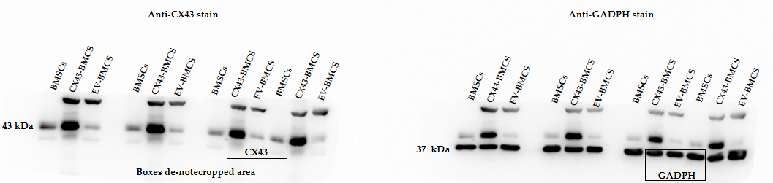

The above bands all originate from the same protein group and were loaded equally (10μg). To maintain consistency with other experiments, the bands within the box were selected for use after being flipped as depicted in the figure.

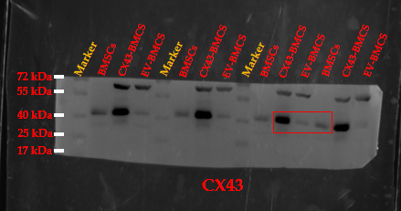
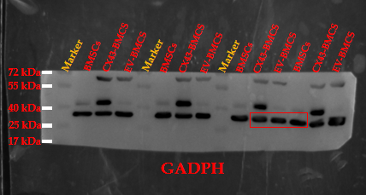

Experimental Method in Appendix:
Firstly, we incubated with CX43 antibody and visualized CX43 bands. Then, we used neutral stripping buffer (Western antibody stripping buffer P0025N) to remove the antibody complexes, and subsequently re-incubated with GADPH antibody to visualize GADPH bands. There might have been residual staining from the CX43 antibody due to tight binding with the detection reagent, but this did not affect the visualization of GADPH bands.

