The Inconclusive Superiority Debate of Allogeneic Vs. Autologous MSCs in Treating Patients with HFrEF: A Systematic Review and Meta-Analysis of RCTs
Omar T. Ahmed^{1Ω}, Ziyad T. Ahmed^{1Ω}, Abdulrahman W. Dairi¹, Maha Saad Zain Al-Abeden¹, Mohammed H. Alkahlot¹, Rana H. Alkahlot¹, Ghazi I. Al Jowf ^{2,3,5} Lars M. T. Eijssen ^{3,4,5}, and Khawaja Husnain Haider¹*
Appendix 1. Supplements to statistical analysis and results supporting information.

Meta-Analysis for safety and efficacy parameters
Supplementary Table 1. Death:
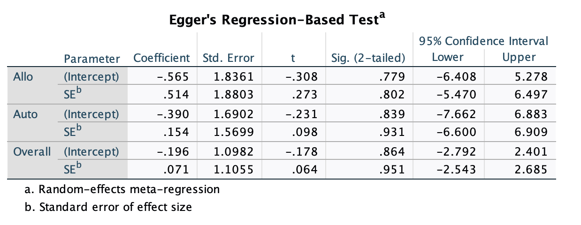

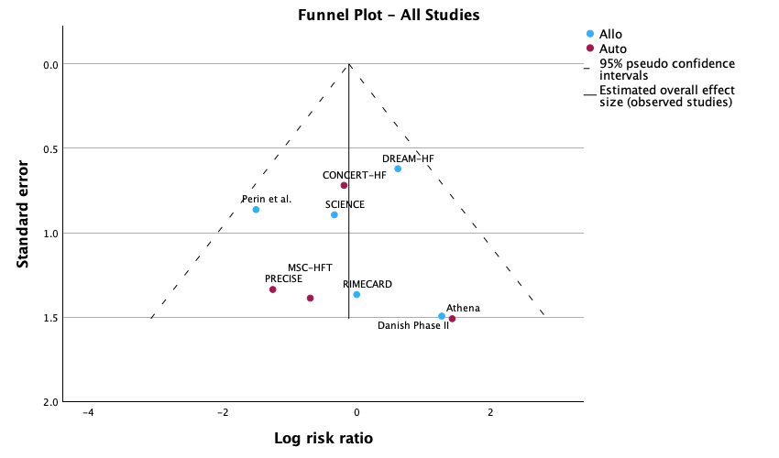
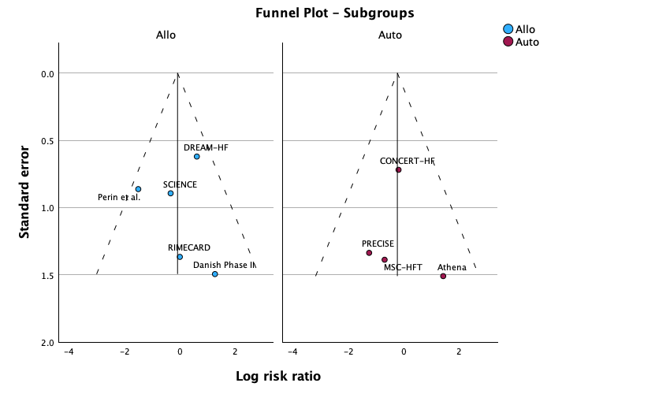
Supplementary Figure 1. Funnel plot overall and for subgroups for death parameter.

Supplementary Table 2. Hospitalization.

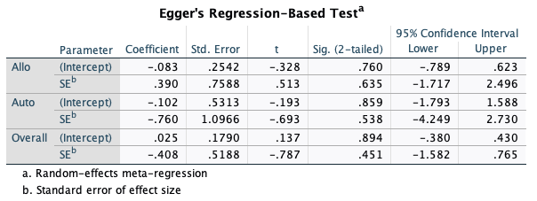

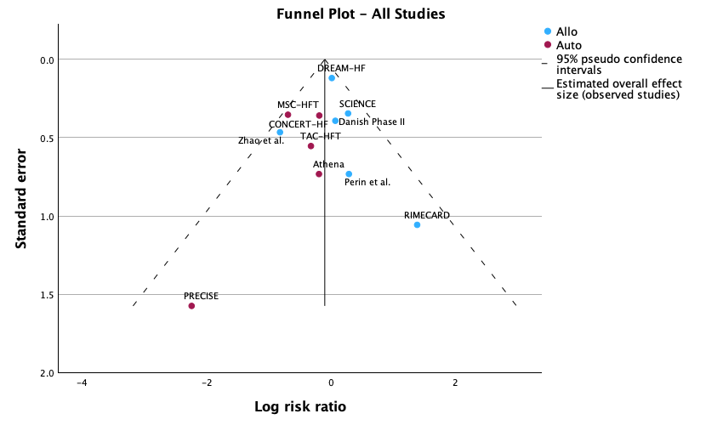
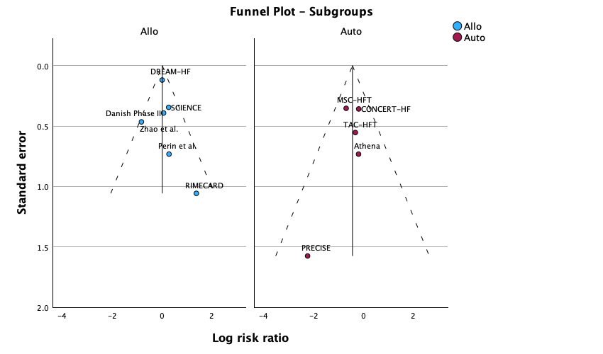
Supplementary Figure 2. Funnel plot overall and for subgroups for hospitalization parameter.

Supplementary Table 3. MACE:

Heterogeneity Measures
Allo | Tau-squared | .000
Allo | H-squared | 1.000
Allo | I-squared (%) | .0
Auto | Tau-squared | .000
Auto | H-squared | 1.001
Auto | I-squared (%) | .1
Overall | Tau-squared | .000
Overall | H-squared | 1.000
Overall | I-squared (%) | .0

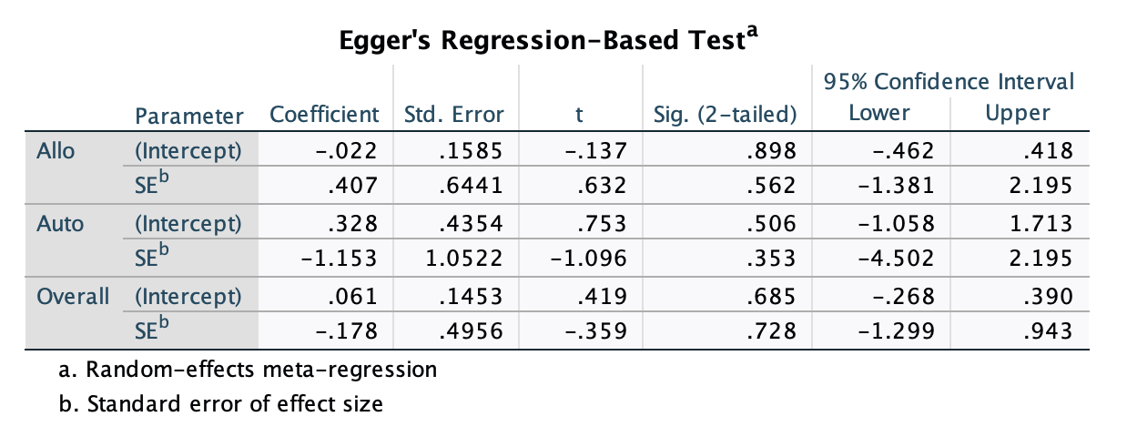
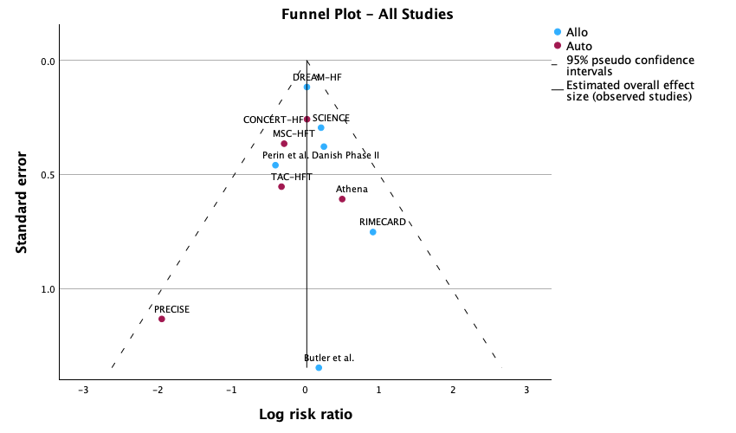
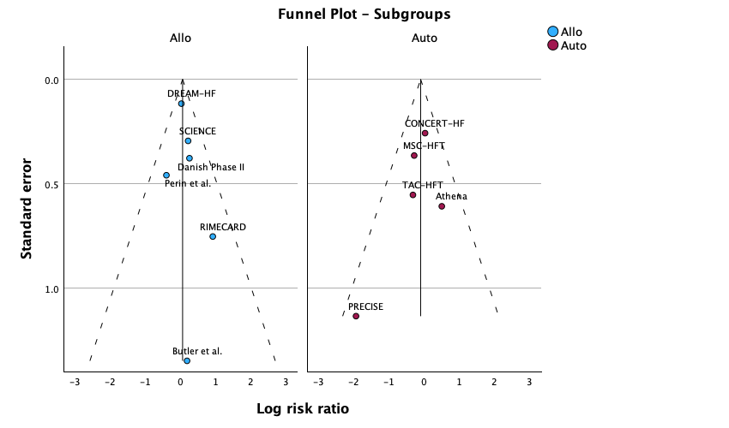
Supplementary Figure 3. Funnel plot overall and for subgroups for MACE parameter.

Supplementary Table 4: LVEF.

Heterogeneity Measures
Allo | Tau-squared | 4.951
Allo | H-squared | 9.483
Allo | I-squared (%) | 89.5
Auto | Tau-squared | 8.786
Auto | H-squared | 5.027
Auto | I-squared (%) | 80.1
Overall | Tau-squared | 6.458
Overall | H-squared | 10.128
Overall | I-squared (%) | 90.1

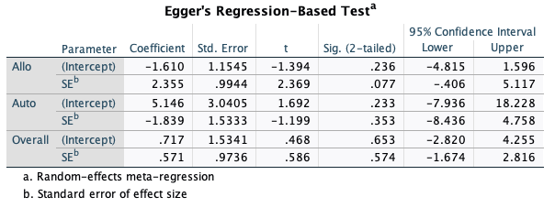

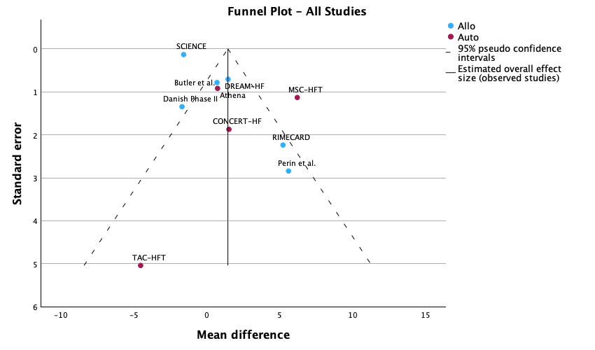
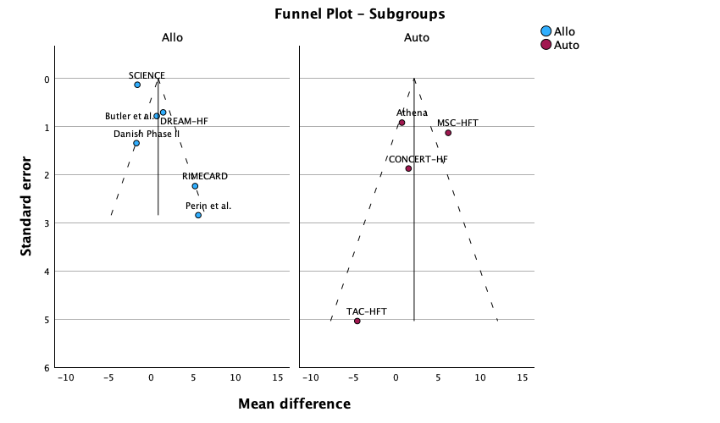
Supplementary Figure 4. Funnel plot overall and for subgroups for LVEF parameter

Supplementary Table 5: LVESv.

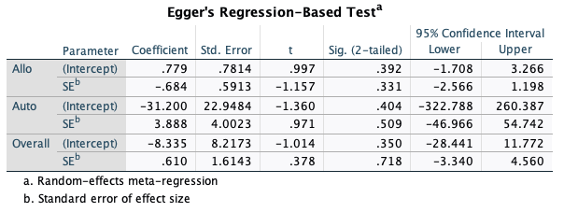

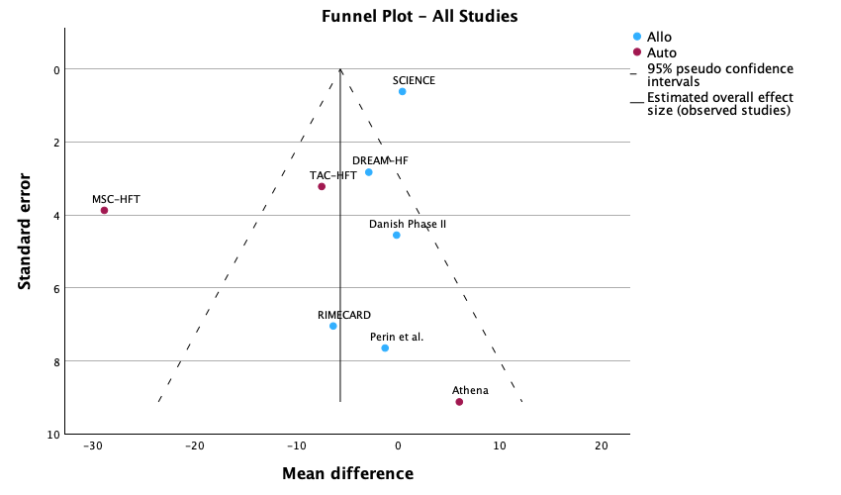
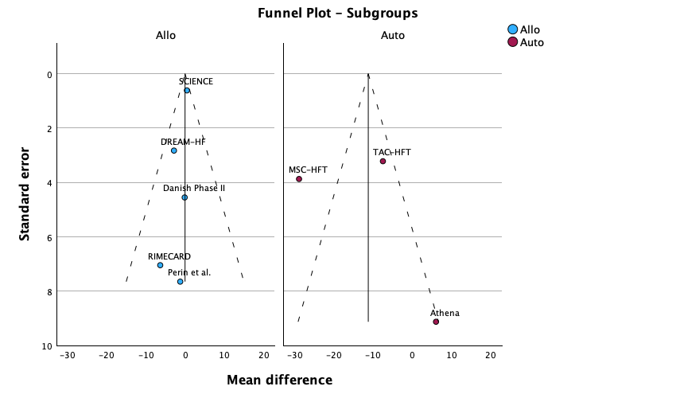
Supplementary Figure 5. Funnel plot overall and for subgroups for LVESv parameter

Supplementary Table 6: LVEDv.

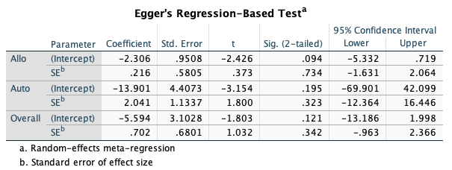

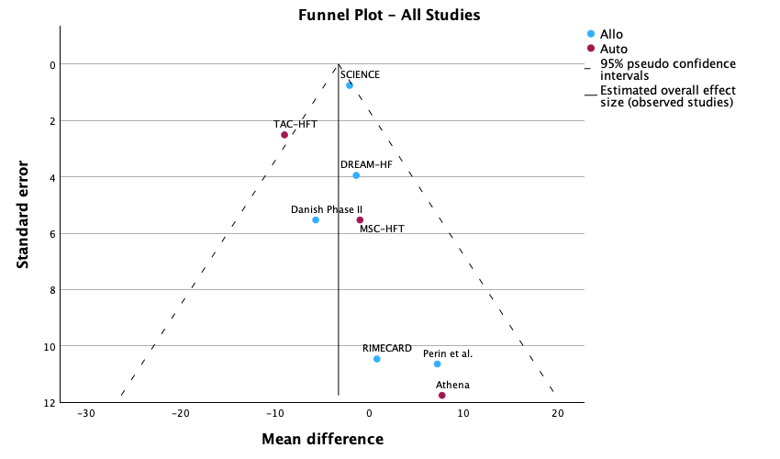
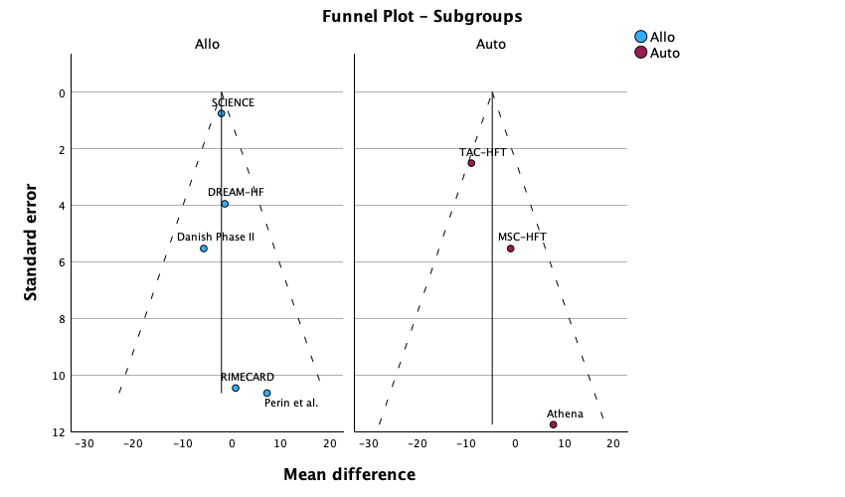
Supplementary Figure 6. Funnel plot overall and for subgroups for LVEDv parameter

Supplementary Table 7: 6MWD:

Heterogeneity Measures
Allo | Tau-squared | .000
Allo | H-squared | 1.000
Allo | I-squared (%) | .0
Auto | Tau-squared | 362.831
Auto | H-squared | 1.642
Auto | I-squared (%) | 39.1
Overall | Tau-squared | .000
Overall | H-squared | 1.000
Overall | I-squared (%) | .0

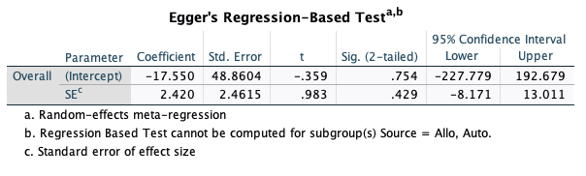

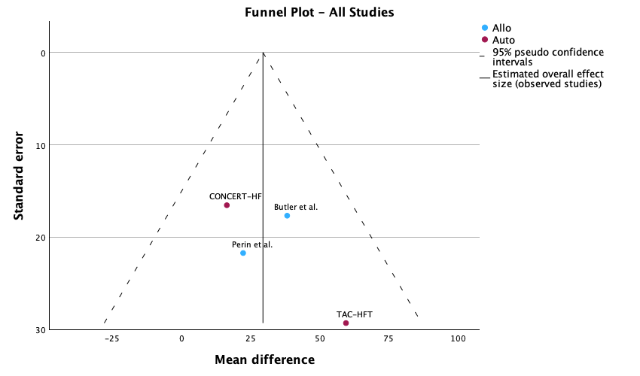
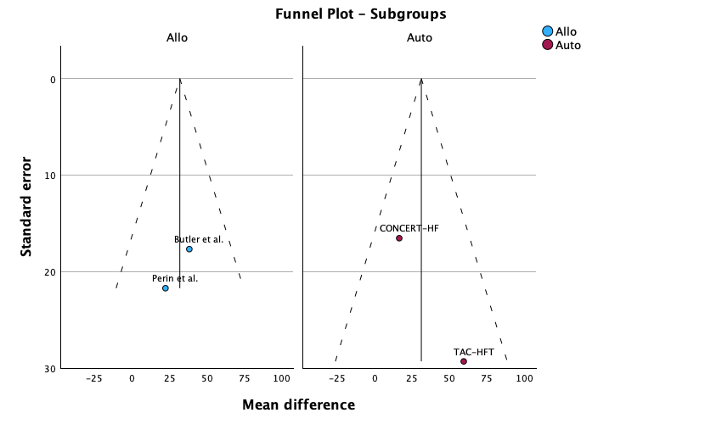
Supplementary Figure 7. Funnel plot overall and for subgroups for 6-MWD parameter

Supplementary Table 8: LVEF with exclusion of ADRCs trials
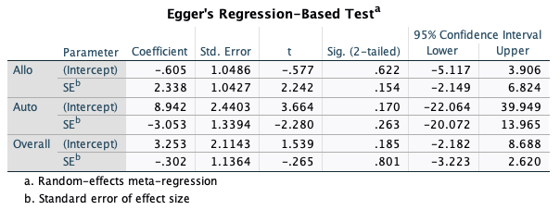

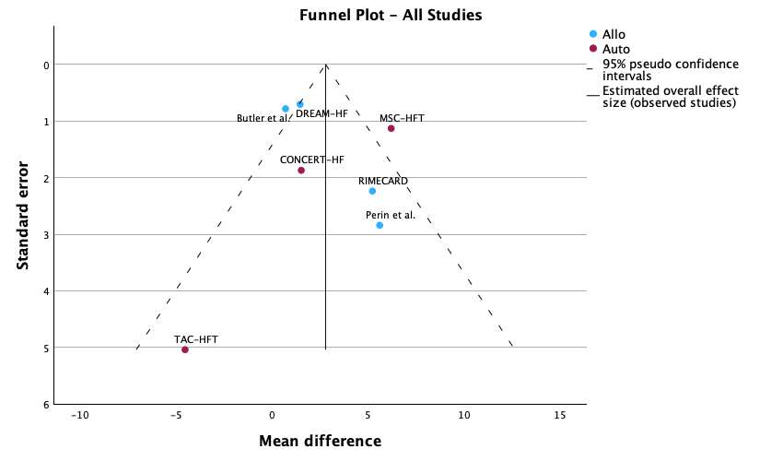
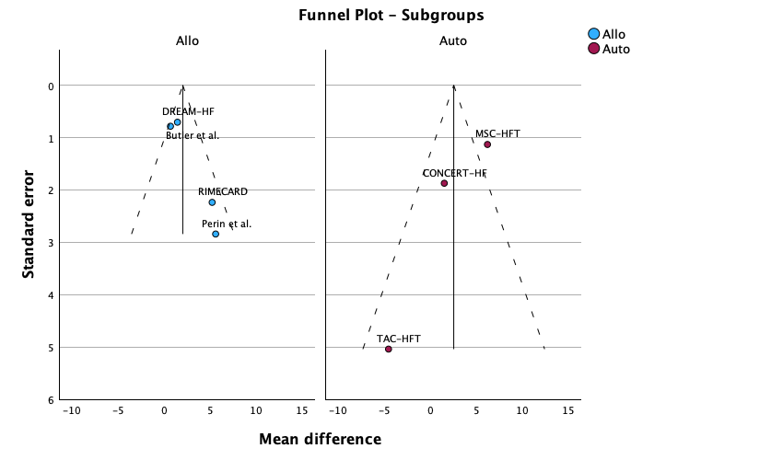
Supplementary Figure 8.

Supplementary Table 9. Meta-regression analysis for LVEF.
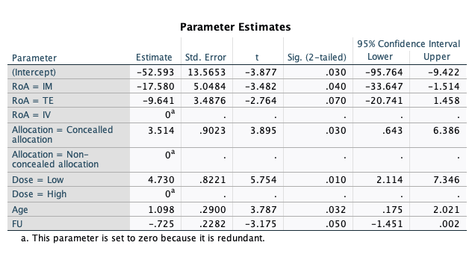

Appendix 2. Definition of Major Adverse Cardiac Events (MACE).
We defined major adverse cardiac events (MACE) as the occurrence of any of the following:
- death or,
- hospitalization due to adverse events including:
  - worsening heart failure,
  - ischemic heart disease,
  - cardiac arrest,
  - arrhythmias (i.e., A-Fib, A-Flut, V-Fib, V-Tach, 3rd-degree block, and LBBB),
  - cardiogenic shock,
  - cardiac tamponade,
  - revascularization procedures,
  - and ICD/CRT implantation/revision

Appendix 3. Analysis protocol.
This meta-analysis strictly follows the guidelines of the Cochrane Handbook for Systematic Reviews of Interventions.

The analysis was conducted using the statistical package of SPSS version 28 (SPSS Inc., Chicago, IL, USA).

The protocol for the analysis will be as follows:
- Data needed for the analysis were extracted and plotted in (Data Table 1). All the available data from the papers and their supplementary material were extracted.

- The corresponding authors of papers that did not provide the needed data in the original article or the supplementary material were contacted to provide the data. Reminders were sent in case the authors forgot to respond.

- In case the corresponding authors did not respond, data feasible for imputation were imputed following the Cochrane Handbook for Systematic Reviews of Interventions guidelines. However, one-step imputation was followed to avoid inaccurate weighting, meaning that if data needed to be imputed multiple times to produce the data needed, they were not included in the analysis.

- If data needed to impute values were not available, the study was excluded from the respective analysis.

- In case authors presented the data in figure form instead of text or tables, corresponding authors were first contacted, and in case of no response, the webplotdigitizer (https://automeris.io/WebPlotDigitizer/) was used to extract the data, only if the figure offered the final data needed in complete form (i.e, mean difference ± standard deviation). If data was in a form that requires further imputation, the study was excluded from the respective analysis.

- Low quality studies were excluded from the analysis to avoid bias.

- An unstandardized mean difference meta-analysis using a restricted maximum likelihood inference with the intention to treat protocol.

Left Ventricular Ejection Fraction (LVEF) analysis:
- The MSC-HFT, Perin et al., Athena, RIMECARD, TAC-HFT, CONCERT-HF, SCIENCE and DREAM-HF trials provided all the data needed in the form of mean difference ± standard deviation.

- Butler et al. provided the mean difference without its standard deviation. The corresponding authors were contacted with no response. The standard deviation was calculated as demonstrated in the Cochrane Handbook for Systematic Reviews of Interventions, section 6.5.2.3 (https://training.cochrane.org/handbook/current/chapter-06#section-6-5-2-3)

- The Danish Phase II trial offered the mean difference and standard deviation in a figure form. The corresponding authors were contacted with no response. the webplotdigitizer was used to extract the data.

- Xiao et al. and Zhao et al. provided the mean difference without its standard deviation. The corresponding authors were contacted with no response. The standard deviation was calculated as demonstrated in the Cochrane Handbook for Systematic Reviews of Interventions, section 6.5.2.8 (https://training.cochrane.org/handbook/current/chapter-06#section-6-5-2-8). However, the study was not included due to low quality.

6 minutes walking distance (6-MWD):

- Only CONCERT-HF, Perin et al., TAC-HFT and Butler et al. trials provided the mean difference for the 6-MWD. Of those, only CONCERT-HF and TAC-HFT trials provided the standard deviation with the mean difference.

- Butler et al. and Perin et al. provided the mean difference without its standard deviation. The corresponding authors were contacted with no response. The standard deviation was calculated as demonstrated in the Cochrane Handbook for Systematic Reviews of Interventions, section 6.5.2.3 (https://training.cochrane.org/handbook/current/chapter-06#section-6-5-2-3)

Left Ventricular End Systolic Volume (LVESV):
- The MSC-HFT, Perin et al., Athena, RIMECARD, SCIENCE, Danish Phase II, and DREAM-HF trials provided LVESV measurements.

- Only MSC-HFT, Perin et al., Athena SCIENCE, and Danish Phase II trials reported the mean difference with its standard deviation.

- RIMECARD and DREAM-HF provided the mean difference without its standard deviation. The corresponding authors were contacted with no response. The standard deviation was calculated as demonstrated in the Cochrane Handbook for Systematic Reviews of Interventions, section 6.5.2.3 (https://training.cochrane.org/handbook/current/chapter-06#section-6-5-2-3)

Left Ventricular End Diastolic Volume (LVEDV):
- The MSC-HFT, Perin et al., Athena, RIMECARD, SCIENCE, Danish Phase II, and DREAM-HF trials provided LVEDV measurements.

- Only MSC-HFT, Perin et al., Athena SCIENCE, and Danish Phase II trials reported the mean difference with its standard deviation.

- RIMECARD and DREAM-HF provided the mean difference without its standard deviation. The corresponding authors were contacted with no response. The standard deviation was calculated as demonstrated in the Cochrane Handbook for Systematic Reviews of Interventions, section 6.5.2.3 (https://training.cochrane.org/handbook/current/chapter-06#section-6-5-2-3)

ITEMIZED RESPONSE TO THE REVIEWERS’ COMMENTS
Reviewer #1 [REV #1 responses]:
Comment #1. The language needs revision by a native speaker, accompanied by a certificate of language editing service and a manuscript with tracked editing records as a Suppl.
Author’s Response: We thank the reviewer for their meticulous review and attention to language. We have extensively reviewed and revised the manuscript for language, typos, and syntax. We have also consulted an academic English native to revise the manuscript.
Comment #2. For a better understanding of the Introduction and Discussion, please cite the following literature in the appropriate site (PMID): Methodology of meta-analysis/systematic review: 33516224, 37666311, 35032305, 35345532
Authors’ Response: We thank the reviewer for the valuable insight; we have cited these papers in the introduction and discussion sections for a better understanding as follows:
Line 135: 35345532, 33516224 (HF remains incurable and irreversible, causing a significant global health burden besides steadily impairing the affected population's physiological capacity and negatively impacting their quality of life. (Uygur and Lee et al., 2016, Li et al., 2021, Ning et al., 2022).
Line 160: 37666311 (Also, xenogenic MSCs from intractable interspecies differences are common reasons xenogeneic MSC treatment fails (Jiang et al., 2021; Chen et al., 2023).
Line 401: 35032305 (Different mechanisms contribute to HFpEF than those of HFrEF; hence, the mechanisms by which cell therapy exerts its effects in both states appear to differ (Domaszk et al., 2023, Li et al., 2022).
Comment #3. Similar studies were found in PubMed. The authors shall cite some of them and discuss what is new and different from this article.
Authors’ Response: We thank you for your detailed literature search. Clinical trials have compared autologous and allogeneic MSCs, as can be seen in lines 418-425 (The POSEIDON trial, a phase 1/2 study in 30 patients, is the only one that directly compared AutoMSCs to AlloMSCs (Hare et al., 2012). It is also a dose-escalation study in which 20 million, 100 million, or 200 million cells were delivered through trans-endocardial injection. The results indicated that AutoMSCs and AlloMSCs were safe and exhibited potential regenerative bioactivity. However, it was excluded from our analysis due to lacking a control group (Hare et al., 2012). One systematic review and meta-analysis, including 82 studies from large animal models of ischemic heart disease, showed significant improvement in LVEF irrespective of the cells’ origin (Lorkeers et al., 2015).
Although similar studies on MSCs' efficacy in HF are cited in the paper, no systematic review and meta-analysis have compared the efficacy of autologous vs. allogeneic MSCs in clinical trials, which forms the basis of our paper's novelty.
Comment #4. Prepare a paragraph on the limitations of this article in the Section discussion. The discussion is not in-depth, limitations are lacking, and the clinical implications shall also be added.
Author’s Response: Limitations and clinical implications have been added in the Discussion section. Please see lines 454-480 as follows:

“Despite promising results, the lack of comprehensive cost-effectiveness analyses hinders informed decision-making regarding their adoption. Future research must prioritize economic evaluations to assess the feasibility of MSC-based therapies in real-world settings, ensuring they deliver both clinical benefits and sustainable value for healthcare systems. When writing this revised version of the manuscript, no new advanced phase clinical study has been reported providing a head-to-head comparison of AutoMSCs vs. AlloMSCs. This lack of direct comparison evidence has already hindered a definitive conclusion about the superiority of one over the other. The use of AutoMSCs faces several potential limitations. Firstly, sourcing sufficient quantities of AutoMSCs from patients is challenging, particularly in cases where the source is compromised, such as in thin individuals or patients with myelofibrosis. Secondly, the biological activity and stemness of AutoMSCs decrease with age and the morbid health status of the donor, thus making it a challenge to acquire enough healthy and therapeutically effective AutoMSCs. (Jung et al., 2014), Therefore, it is challenging to acquire enough healthy and therapeutically effective AutoMSCs (Cianfarani et al., 2013; Nie et al., 2010). Moreover, AutoMSCs are logistically time-intensive, requiring longer waiting to isolate, purify, and expand the cells to achieve the required cell number, rendering their emergency room utility very difficult to treat acute conditions, i.e., stroke and myocardial infarction. On the contrary, AlloMSCs provide an off-the-shelf, ready-to-use availability of cells to overcome logistic issues. Also, their use may help avoid donor age and health-related issues. Although most in vitro studies have highlighted the immunosuppressive properties of AlloMSCs, several studies have evidenced their immunogenicity, which is accentuated in the proinflammatory milieu (Ankrum et al., 2014). Preclinical investigations showed alloantibodies after AlloMSCs delivery (Poncelet et al., 2007; Schu et al., 2012) besides an increased number of neutrophils, monocytes, and T cells at the site of intracranial injection of AlloMSCs (Camp et al., 2009). There is evidence of productive allorecognition by B cells and anti-donor T-cell and NK-cell responses to AlloMSCs delivery in immuno-competent rhesus macaques (Isakova et al., 2014). The magnitude of the host allo-response was influenced by the degree of MHC class I and II mismatch between the donor and host.”
Also, new insights into limitations have been introduced in lines 490-498 as follows:
“Although the study demonstrated promising safety and efficacy data with improved functional outcomes, such as the 6-MWD, it has certain limitations. For instance, inconsistencies in reporting functional parameters, including the 6-MWD and New York Heart Association (NYHA) class during follow-up, hindered the accurate assessment of valuable clinical outcomes. Furthermore, trials exploring head-to-head comparison of AutoMSCs vs. AlloMSCs via multi-arm comparison were excluded, primarily due to the absence of a control arm. Additionally, variability in clinical design elements, such as the administration route, source, sampling site, and follow-up duration, may introduce bias and impact result reliability. Nonetheless, the findings offer initial insights into the dose-response relationship to inform future clinical trial designs.”
Comment #5. The reference style may be incorrect. Please refer to the author's guidelines carefully.
Author’s Response: We have revisited the reference section and corrected the reference style using the Vancouver style per the author's guidelines.
Reviewer #1 [Rev 2 Comments]:
Comments #1: The author shall re-read the previous questions carefully and resubmit this manuscript + response letter.
Authors’ response:
The manuscript has been revised, and the reviewer's comments have been responded to and provided as a separate file (itemized response in blue text). The changes have also been highlighted in the manuscript.
Comments #2: Please upload the response letter as a PDF file in the Supplementary materials in the online submission system.
Authors’ response:
The itemized response has been included in the Supplementary materials per the reviewer's suggestion.
Comments #3: Please give a detailed response. Please write down what changes have been made in the response letter rather than reading the manuscript to find what has been revised. Please avoid using Microsoft Office's revisions mode. Please mark this revised font as blue only. And please note that any uncompleted or improper corrections by the authors during
Authors’ response:
A detailed response has been provided as an “Itemized response to the reviewer’s comments” in blue font, as suggested by the reviewer. For the ease of the reviewers, the responses to the comments for Rev1 and Rev2 have been consolidated in one file. Also, the changes have been highlighted in blue underlined text in the manuscript per the reviewer's suggestion.
Reviewer #2 [Rev 1 Comments]:
This manuscript presents a systematic review and meta-analysis comparing allogeneic and autologous mesenchymal stem cells (AlloMSCs vs. AutoMSCs) in the treatment of heart failure with reduced ejection fraction (HFrEF). While comparative analyses of MSC therapies have been previously conducted, the focus on the head-to-head comparison of AlloMSCs and AutoMSCs in cardiovascular applications is novel and timely. However, several points must be further addressed to support the conclusion fully.
Major points:
Comment #1. The authors report a systematic literature search across four major databases and registers, adhering to PRISMA guidelines. However, the selection of only 13 RCTs raises concerns about whether potentially relevant studies were excluded prematurely, especially given the large initial pool of articles retrieved. Please provide more details about the inclusion/exclusion process, particularly for excluded articles after full-text review.

Authors’ Response: We thank you for the valid observation. A critical factor for study exclusion was adjunct interventions alongside MSC-based therapy. We intended to eliminate any confounder effect of the adjunct interventions that might render the actual impact of MSCs unclear. Second, the proposed use of MSCs in clinical settings so far is of cell therapy injection (regardless of the route of administration), and other accompanying interventions to MSC treatment might not be feasible for clinical utility in differing clinical settings. In addition, as we are directly comparing two different sources of MSCs, it would be more advisable to compare them as sole-treatment modalities. A second reason for the exclusion was the lack of control groups in those trials, which hindered their inclusion in a meta-analysis.
This information has been included in the inclusion and exclusion criteria.
Comment #2. The exploration of heterogeneity sources is limited. Subgroup analyses based on cell source, delivery method, and follow-up duration are presented but lack sufficient discussion. Please conduct additional subgroup analyses or meta-regression to identify the impact of variables like baseline patient characteristics or differences in trial design on heterogeneity.
Author’s Response: We thank you for your valuable suggestion. To include continuous and categorical variables, we have conducted a meta-regression analysis for the primary parameter, LVEF, showing significant prediction and sources of heterogeneity. Please see lines 268-271 and 361-366 and Supplementary Table 9.
Comment #3. Please provide more details on the quality assessment criteria (Jadad scale) and their implications for the meta-analysis outcomes. Elaborate on the selection rationale for excluding specific trials.
Author’s Response: We have added an explanation of applying the Jadad score and the exclusion process (lines 235-245).
Comment #4. For the discussion section, please emphasize the practical challenges of translating MSC therapies into clinical practice and highlight the need for cost-effectiveness analyses in future research.
Author’s Response: We have incorporated the suggested information in the discussion sections. Please refer to lines 469-500
Comment #5. The statistical methods are rigorous, but the interpretation of results could be more nuanced. Explain how small effect sizes, such as LVEF improvements, translate to clinical outcomes. Could a 1-2% change in LVEF justify the adoption of MSC therapy?
Author’s Response: As suggested, we have implemented this into our discussion; kindly check lines 452-466.
Minor points:
Minor Comment #1. Pooled effect sizes are scattered across multiple forest plots, making it difficult to summarize the findings. Please add a summary table consolidating key effect sizes (e.g., LVEF, 6-MWD, LVEDV) with 95% CI and p-values. Divide the table into columns for "AutoMSCs" and "AlloMSCs," with an additional column for "Comparison Results" to indicate differences.
Author’s Response: We thank you for the suggestion. Please refer to Table 3.
Minor Comment #2. Sources of heterogeneity (I²) are not adequately visualized, and their impact on the results is only discussed in the text. Please create a bar chart or scatter plot to display I² values for each study and their effects on pooled estimates, helping readers quickly identify key contributors to heterogeneity.
Author’s Response: We thank you for the valuable suggestion. We added a Galbraith scatter plot demonstrating outlier studies raising the heterogeneity (Figure 7).
Minor Comment #3. The literature search concluded in March 2024, which ensures recent studies are included. However, the review would benefit from a brief discussion on whether any significant trials published after the search period could alter the findings.
Authors’ Response: Thank you for pointing this out. We added an annotation to it; please see lines 476-80.
Minor Comment #4. In the methods section of the abstract, you mentioned that the results of MACEs and death are also key findings of this study. Please report these results accordingly in the results section.
Author’s Response: Refer to lines 325-340 and figures 2 & 4.
Minor Comment #5. Introduction, paragraph 3: Most of the sentences describe the advantages of AutoMSCs themselves. Please compare the controversial points that AutoMSCs and AlloMSCs treat HFrEF.
Author’s Response: This information is included in the introduction and Discussion section.
Minor Comment #6. Introduction, paragraph 4: please report the means of evaluating safety.
Author’s Response: Amended accordingly; kindly check lines 174-177.
Minor Comment #7. Inclusion and Exclusion Criteria: what are the reference points for setting these criteria? Please explain why trials without a clear statement about the number of cells administered to the intervention group should be excluded.
Author’s Response: The number of cells used has been mentioned sporadically in the studies. Given that this would impact the study's primary aim and better account for heterogeneity, we excluded cell dose as a parameter for the inclusion or exclusion of a study. Also, we have already published a meta-analysis regarding the effect of cell dose effect. The sentence noted here was mistakenly a remnant of the first draft.
Minor Comment #8. Safety reports are not displayed in the results section; safety evaluation should at least include adverse events.
Author’s Response: We assessed safety using death, hospitalization, and major adverse cardiac events (MACE). We reported those accordingly in subsection 3.4.1. Kindly see Figure 4.
Minor Comment #9. Page 9, lines 226 to 227: in my opinion, MACE, hospitalization, and death should be considered as part of the efficacy. It should not be viewed as a safety evaluation standard. Please carefully check the statements included in your manuscript.
Authors’ Response: Thank you for the annotation. When deciding the parameters used for safety assessment, we screened clinical trials of stem cells in disorders of the cardiovascular system. Major adverse cardiac events (MACE) are a specific safety outcome in this type of trial. Additionally, death as a parameter assessed in our study is that of a cardiac cause, which can be an endpoint of the named treatment. Given that trials do not report other means that can be used to assess the safety of the intervention. Since safety is an even more critical parameter than efficacy for a used intervention, we decided to go with death and hospitalization (both of which are of cardiac origin in our study) and MACE for safety assessment.

Minor Comment #10. All forest plots do not show heterogeneity within subgroups. Please demonstrate heterogeneity within subgroups and explain why subgroups based on other variables are not conducted.
Author’s Response: We have added that to the text accordingly, with detailed statistics in the supplementary materials.
Reviewer #3 [Rev 1 Comments]:
This systematic review and meta-analysis highlight the safety and potential efficacy of MSC therapy for heart failure with reduced ejection fraction (HFrEF), demonstrating that both autologous (AutoMSCs) and allogeneic (AlloMSCs) sources show similar outcomes, with AlloMSCs showing some advantages in improving functional parameters like 6-minute walk distance (6-MWD). Although this research may provide new insights into the effect of both AutoMSCs and AlloMSCs) treating HFrEF, many limitations need to be improved.
Comment #1. The full names of abbreviated terms in an article should be provided when they first appear. For example, RCTs (Randomized controlled trials), PRISMA (Preferred Reporting Items for Systematic Reviews and Meta-Analyses), CABG (Coronary artery bypass grafting), etc. In addition, the full name is generally required in the abstract.
Author’s Response: Thank you for the meticulous review; we modified it accordingly.
Comment #2. Why are phase I and II trials included, given their potential for bias and lack of conclusive evidence compared to phase III trials?
Author’s Response: Phase I and II trials have the potential for bias compared with Phase III trials. However, given the current lack of trials, only a few phase III trials exist, which would produce much weaker evidence alone. Additionally, no phase I trial was included in the meta-analysis, as both trials were of poor quality.
Comment #3. How were variations in the MSC treatment protocols (e.g., cell type, dosage, delivery method) handled?
Author’s Response: We conducted a meta-regression analysis for the primary parameter, LVEF, to include continuous and categorical variables. The analysis showed significant prediction and sources of heterogeneity. Please refer to lines 253-258 and 342-347 and Supplementary Table 9.
Comment #4. Can you explain the rationale behind the Boolean operators used in the search? Were there any variations in how these operators might affect the search results across different databases?
Authors’ Response: They were used during the PubMed search to ensure a broader search and screening and to avoid missing any potential candidate papers.
Comment #5. Why was the search limited to studies published between January and March 2024? Could this time window have excluded critical earlier studies?
Authors’ Response: This was the window during the literature search. Given the extensive database, it took some time. However, this is not a date range for the included studies, as we had no specific date for studies to be included or excluded.
Comment #6. How did the two authors ensure consistency when extracting data? Was there any inter-rater reliability testing or discussion between authors to address discrepancies?

Authors’ Response: After data extraction was completed, the co-authors responsible for data extraction discussed each derived data from the individual study and concluded their extraction mutually. A meeting was held to discuss the final extracted data with the analysis specialist to validate the extraction process and numbers.
Comment #7. Can you provide more information on the protocol for dealing with missing data, especially if the corresponding author did not respond? How might this impact the validity of the extracted data?
Authors’ Response: Thank you for the note. This is vital for the validity of the results, so we have provided details in the supplementary materials. We tried contacting the authors multiple times to provide the missing information, but unfortunately, we failed. Further extraction, imputation, and estimation methods were followed to compensate for as much data as possible, per the supplementary material appendix.
Comment #8. Did you consider other quality assessment tools (e.g., the Cochrane Risk of Bias tool), and if not, why was the Jadad scale chosen as the most appropriate? Any limitations?
Author’s Response: While the Cochrane risk of bias tool was the first choice, most co-authors were more comfortable and confident using the Jadad scale. Therefore, we decided that the Jadad scale would be a suitable alternative, although it is more limited (e.g., lack of allocation concealment assessment). However, we conducted a preliminary evaluation with the Cochrane tool and found that trials received similar quality levels overall.
Comment #9. The I-square value assesses heterogeneity, but the text does not discuss how heterogeneity was managed or whether sensitivity analyses were conducted. In meta-analyses, high heterogeneity can distort results, and it would be essential to examine whether any studies were excluded due to high heterogeneity or how this was accounted for in the analysis. Without addressing this, the conclusions may be misleading.
Authors’ Response: Thank you for the vital comment; we agree and have made extensive modifications. We have conducted a meta-regression to account for heterogeneity. Additionally, we provided a Galbraith scatter plot to help readers identify studies that contributed the most to the heterogeneity between studies. Given the small number of studies following exclusion, we thought excluding those studies would provide non-reliable evidence.
Comment #10. While the study uses WMD for clinical effectiveness and RR for safety, the rationale for choosing these specific statistical methods needs further explanation.
Author’s Response: We used WMD because we dealt with raw data, and the named variables were continuous. Additionally, a weighted mean difference would make clinical interpretation easier. RR was used due to its clinical relevance. This information has been included in the text and supplementary material.
Comment #11. Funnel plots and Egger's regression are used to assess publication bias. Still, the method section does not specify how these analyses were interpreted or what threshold was used to determine bias. Moreover, if significant asymmetry or bias is detected in the funnel plots or regression, the study should discuss how it impacts the results or if adjustments were made. This is crucial for evaluating the robustness of the findings.
Author’s Response: We understand the importance of this comment and have added a brief explanation in the text. Also, no significant publication bias was found across parameters for the included trials. We have added this, as you suggested, to the appendix.
Comment #12. The authors indicate that most trials used echocardiography to assess LVEF, while others used cardiac CT or MRI. The choice of imaging modality could introduce variability in outcomes. The text could benefit from discussing the potential impact of using different diagnostic tools and whether there are any known discrepancies in LVEF measurement between these methods. This is crucial to understand how heterogeneity in assessment might influence the interpretation of the results.
Author’s Response: This is a valid observation, and we addressed it accordingly. We have added the meta-regression data in the results section and discussed potential effects in the discussion section.
Comment #13. The term "mock injection technique" needs further clarification. Is this considered a placebo or a sham? The terminology here is inconsistent and could lead to confusion. It would be helpful to clearly define the difference between placebo, sham, and mock injections in the context of these trials.
Author’s Response: The mock injection is a sham control. We used this term to be similar to the author's, but as you stated, it might create confusion, so we removed it.
Comment #14. The subgroup analysis shows a more significant improvement with autologous MSCs (2.17%) compared to allogeneic MSCs (0.86%), but both results were non-significant. What is the clinical relevance of this difference, and should autologous MSCs be preferred despite the lack of statistical significance?
Author’s Response: The analysis shows that allogeneic MSCs are non-inferior to autologous. This supports the use of allogeneic in cases where autologous MSC availability is limited, which is the main advantage of allogeneic MSCs (of the shelf-ready-to-use availability from young donors). We have added a summary table to elaborate on this (Table 3). Regarding overall MSC efficacy in HF, other studies have investigated this topic, so we avoided repetition.
Comment #15. Excluding studies using ADRCs significantly improved allogeneic MSC treatment outcomes (2.03%). Could ADRCs be a confounding factor, and how should their impact be further evaluated in future trials?
Author’s Response: We did this further sensitivity analysis to test for this, and apparently, the source of MSC (either bone marrow or adipose tissue) is a confounding factor. We have added some discussion points regarding this accordingly; kindly see lines 495-503. Thank you for the valuable comment.
Comment #16. Several trials (RIMECARD, Athena, PRECISE, DREAM-HF) did not report changes in 6-MWD, even though baseline and follow-up measurements were taken. Clarification is needed on why these trials were excluded and whether this impacts the validity of the overall findings.
Author’s Response: Unfortunately, these studies did not take 6-MWD as an endpoint in their analysis, nor did they report on or measure it. Some of these studies measured 6-MWD at baseline but did not follow up for some reason. Accordingly, we added these studies to our discussion to address this point, as improvement in 6-MWD should be interpreted with caution. Kindly see lines 452-456.
Comment #17. While the study suggests the non-inferiority of AlloMSCs compared to AutoMSCs, the overall clinical evidence for AlloMSCs remains modest. Is this because of the smaller sample sizes? In addition, despite claims of immunosuppressive properties, evidence of immunogenic responses (alloantibodies, T cell activation) challenges the perceived safety of AlloMSCs, particularly in inflammatory environments.
Author’s Response: This is an interesting point, so we added it to the discussion sections. We thank you for pointing this out.
Comment #18. Some sentences are not concise; please remove the repetition of words; for example, remove "release of" in this sentence: "These effects have been ascribed to the release of soluble and insoluble factors released by MSCs as part of their paracrine activity."
Author’s Response: We have extensively revised the manuscript and made many modifications accordingly, including the suggested change.
Reviewer #3 [Rev 2 Comments]
Comments #1: Further refinement of the sentences is needed to highlight the key points.
Author Response: The following text has been added as the First paragraph of the Discussion section.
With the rapid emergence of regenerative medicine, various types of stem cells have progressed to the final phases of clinical trials. Notably, some of these cell types, particularly mesenchymal stem cells (MSCs), have already received clinical approval for use as living biodrugs, such as Prochymal (Osiris Therapeutics, Canada), Cartistem (Medipost Co Ltd, Korea), Stempeucel (Stempeutics Research), and Cellgram-AMI (FCB Pharmicell, South Korea) (Alliance for Regenerative Medicine; https://alliancerm.org/available-products/). However, their performance continues to be monitored closely. Our systematic review of published randomized controlled trials (RCTs) and meta-analysis aims to compare the clinical safety and efficacy of autologous (^{Auto}MSCs) and allogeneic MSCs (^{Allo}MSCs). The key findings of our study include: (1) this is the first systematic review and meta-analysis to compare ^{Auto}MSCs with ^{Allo}MSCs for cardiovascular applications directly; (2) while autologous cells are generally regarded as a safer and more practical choice, most reported clinical trials have focused on ^{Auto}MSCs, resulting in limited evidence regarding efficacy based on the source; (3) both ^{Allo}MSCs and ^{Auto}MSCs exhibited similar safety profiles; and (4) our analysis demonstrated the non-inferiority of ^{Allo}MSCs compared to their autologous counterparts.

