Section and Topic | Item # | Checklist item | Location where item is reported
TITLE
Title | 1 | Identify the report as a systematic review. | 1
ABSTRACT
Abstract | 2 | See the PRISMA 2020 for Abstracts checklist. | 3
INTRODUCTION
Rationale | 3 | Describe the rationale for the review in the context of existing knowledge. | 4
Objectives | 4 | Provide an explicit statement of the objective(s) or question(s) the review addresses. | 4
METHODS
Eligibility criteria | 5 | Specify the inclusion and exclusion criteria for the review and how studies were grouped for the syntheses. | 5
Information sources | 6 | Specify all databases, registers, websites, organisations, reference lists and other sources searched or consulted to identify studies. Specify the date when each source was last searched or consulted. | 6
Search strategy | 7 | Present the full search strategies for all databases, registers and websites, including any filters and limits used. | 6
Selection process | 8 | Specify the methods used to decide whether a study met the inclusion criteria of the review, including how many reviewers screened each record and each report retrieved, whether they worked independently, and if applicable, details of automation tools used in the process. | 5
Data collection process | 9 | Specify the methods used to collect data from reports, including how many reviewers collected data from each report, whether they worked independently, any processes for obtaining or confirming data from study investigators, and if applicable, details of automation tools used in the process. | 6
Data items | 10a | List and define all outcomes for which data were sought. Specify whether all results that were compatible with each outcome domain in each study were sought (e.g. for all measures, time points, analyses), and if not, the methods used to decide which results to collect. | 6
Data items | 10b | List and define all other variables for which data were sought (e.g. participant and intervention characteristics, funding sources). Describe any assumptions made about any missing or unclear information. | 6
Study risk of bias assessment | 11 | Specify the methods used to assess risk of bias in the included studies, including details of the tool(s) used, how many reviewers assessed each study and whether they worked independently, and if applicable, details of automation tools used in the process. | 6
Effect measures | 12 | Specify for each outcome the effect measure(s) (e.g. risk ratio, mean difference) used in the synthesis or presentation of results. | 7
Synthesis methods | 13a | Describe the processes used to decide which studies were eligible for each synthesis (e.g. tabulating the study intervention characteristics and comparing against the planned groups for each synthesis (item #5)). | 7
Synthesis methods | 13b | Describe any methods required to prepare the data for presentation or synthesis, such as handling of missing summary statistics, or data conversions. | 7
Synthesis methods | 13c | Describe any methods used to tabulate or visually display results of individual studies and syntheses. | 7
Synthesis methods | 13d | Describe any methods used to synthesize results and provide a rationale for the choice(s). If meta-analysis was performed, describe the model(s), method(s) to identify the presence and extent of statistical heterogeneity, and software package(s) used. | 7-8
Synthesis methods | 13e | Describe any methods used to explore possible causes of heterogeneity among study results (e.g. subgroup analysis, meta-regression). | 7-8
Synthesis methods | 13f | Describe any sensitivity analyses conducted to assess robustness of the synthesized results. | 7-8
Reporting bias assessment | 14 | Describe any methods used to assess risk of bias due to missing results in a synthesis (arising from reporting biases). | 6
Certainty assessment | 15 | Describe any methods used to assess certainty (or confidence) in the body of evidence for an outcome. | 6-7
RESULTS
Study selection | 16a | Describe the results of the search and selection process, from the number of records identified in the search to the number of studies included in the review, ideally using a flow diagram. | 8-9
Study selection | 16b | Cite studies that might appear to meet the inclusion criteria, but which were excluded, and explain why they were excluded. | 9
Study characteristics | 17 | Cite each included study and present its characteristics. | 9
Risk of bias in studies | 18 | Present assessments of risk of bias for each included study. | 9
Results of individual studies | 19 | For all outcomes, present, for each study: (a) summary statistics for each group (where appropriate) and (b) an effect estimate and its precision (e.g. confidence/credible interval), ideally using structured tables or plots. | 9
Results of syntheses | 20a | For each synthesis, briefly summarise the characteristics and risk of bias among contributing studies. | 9
Results of syntheses | 20b | Present results of all statistical syntheses conducted. If meta-analysis was done, present for each the summary estimate and its precision (e.g. confidence/credible interval) and measures of statistical heterogeneity. If comparing groups, describe the direction of the effect. | 9-11
Results of syntheses | 20c | Present results of all investigations of possible causes of heterogeneity among study results. | 9-11
Results of syntheses | 20d | Present results of all sensitivity analyses conducted to assess the robustness of the synthesized results. | 9-11
Reporting biases | 21 | Present assessments of risk of bias due to missing results (arising from reporting biases) for each synthesis assessed. | 9-11
Certainty of evidence | 22 | Present assessments of certainty (or confidence) in the body of evidence for each outcome assessed. | 9-11
DISCUSSION
Discussion | 23a | Provide a general interpretation of the results in the context of other evidence. | 11-14
Discussion | 23b | Discuss any limitations of the evidence included in the review. | 11-14
Discussion | 23c | Discuss any limitations of the review processes used. | 11-14
Discussion | 23d | Discuss implications of the results for practice, policy, and future research. | 11-14
OTHER INFORMATION
Registration and protocol | 24a | Provide registration information for the review, including register name and registration number, or state that the review was not registered. | 5
Registration and protocol | 24b | Indicate where the review protocol can be accessed, or state that a protocol was not prepared. | 5
Registration and protocol | 24c | Describe and explain any amendments to information provided at registration or in the protocol. | 5
Support | 25 | Describe sources of financial or non-financial support for the review, and the role of the funders or sponsors in the review. | 2
Competing interests | 26 | Declare any competing interests of review authors. | 2
Availability of data, code and other materials | 27 | Report which of the following are publicly available and where they can be found: template data collection forms; data extracted from included studies; data used for all analyses; analytic code; any other materials used in the review. | 2
From: Page MJ, McKenzie JE, Bossuyt PM, Boutron I, Hoffmann TC, Mulrow CD, et al. The PRISMA 2020 statement: an updated guideline for reporting systematic reviews. BMJ 2021;372:n71. doi: 10.1136/bmj.n71

Supplementary Table 1: Quality of non-randomized studies included in the meta-analysis according to the Newcastle-Ottawa Scale

Study | Item 1 | Item 2 | Item 3 | Item 4 | Item 5 | Item 6 | Item 7 | Item 8 | Score
Serrero et al. 2019 | ★ |  | ★ | ★ |  | ★ | ★ | ★ | 6
Sørensen et al. 2022 | ★ |  | ★ | ★ |  | ★ | ★ | ★ | 6
Arkenbosch et al. 2023 | ★ |  | ★ | ★ |  | ★ | ★ | ★ | 6
Dige et al. 2019 | ★ |  | ★ | ★ |  | ★ | ★ | ★ | 6
Laureti et al. 2020 | ★ |  | ★ | ★ |  | ★ | ★ | ★ | 6
Cho et al. 2013 | ★ |  | ★ | ★ |  |  | ★ | ★ | 5
Lee et al. 2013 | ★ |  | ★ | ★ |  | ★ | ★ | ★ | 6
Cho et al. 2021 | ★ |  | ★ | ★ |  | ★ | ★ | ★ | 6
Dozois et al. 2023 | ★ |  | ★ | ★ |  | ★ | ★ | ★ | 6
De la Portilla et al. 2013 | ★ |  | ★ | ★ |  | ★ | ★ | ★ | 6
Furukawa et al. 2023 | ★ |  | ★ | ★ |  | ★ | ★ | ★ | 6
Fathallah et al. 2023 | ★ |  | ★ | ★ |  | ★ | ★ | ★ | 6
Schwandner 2021 | ★ |  | ★ | ★ |  |  | ★ | ★ | 5
Reenaers et al. 2023 | ★ |  | ★ | ★ |  | ★ | ★ | ★ | 6
Ciccocioppo et al. 2011 | ★ |  | ★ | ★ |  | ★ | ★ | ★ | 6
Lightner et al. 2023 | ★ |  | ★ | ★ |  | ★ | ★ | ★ | 6
Vosough et al. 2022 | ★ |  | ★ | ★ |  | ★ | ★ | ★ | 6
Nazari et al. 2022 | ★ |  | ★ | ★ |  | ★ | ★ | ★ | 6
Wei et al. 2023 | ★ |  | ★ | ★ |  | ★ | ★ | ★ | 6
Swaroop et al. 2024 | ★ |  | ★ | ★ |  | ★ | ★ | ★ | 6
Hadizadeh et al. 2024 | ★ |  | ★ | ★ |  | ★ | ★ | ★ | 6

Items: 1/ representativeness of the exposed cohort; 2/ selection of the non-exposed cohort; 3/ ascertainment of exposure; 4/ demonstration that outcome of interest was not present at start of study; 5/ comparability of cohorts on the basis of the design or analysis; 6/ assessment of outcome; 7/ follow-up was long enough for outcomes to occur; 8/ adequacy of follow-up (>75% follow-up, or description for those lost).

Supplementary Table 2: Sensitivity analyses

Outcomes | Meta-analysis with RCT | Number of studies with RCT | Meta-analysis without RCT | Number of studies without RCT
All therapies  Clinical response M3  Clinical response M6  Clinical remission M3  Clinical remission M6  Combined remission M3  Combined remission M6  Combined remission M12 | 77.0 (61.3 - 87.6)  76.1 (69.2 - 81.9)  41.2 (22.8 - 62.4)  61.7 (49.9 - 72.3)  40.9 (25.9 - 57.9)  57.9 (51.3 - 64.2)  52.0 (38.8 - 64.8) | 9  13  6  12  7  15  7 | 73.5 (57.6 - 85.0)  78.7 (70.5 – 85.0)  41.5 (19.8 - 67.1)  59.9 (44.7 - 73.4)  31.5 (16.1 - 52.5)  57.7 (49.1 - 65.9)  50.4 (36.1 - 64.7) | 8  11  5  10  4  11  6
According to therapy  Clinical remission M6 with ASCs | 56.0 (47.9 - 63.7) | 5 | 52.8 (28.9 - 75.6) | 4

ASC, adipose-derived stem cell; RCT, randomized controlled trial;
Meta-analyses for sensitivity analyses were carried out without removing any outlying studies.

Supplementary Table 3: GRADE for MSC-based therapies for combined remission
Patient or population: Crohn's disease
Setting: Perianal fistulizing Crohn's disease
Intervention: MSC-based therapies
Outcomes | № of participants  (studies)  Follow-up | Certainty of the evidence  (GRADE) | Relative effect  (95% CI) | Anticipated absolute effects
 |  |  |  | Risk with | Risk difference with MSC-based therapies
Combined remission  Follow-up: 3 months | 90  (4 non-randomized studies and 2 RCTs) | ⨁◯◯◯  Very low | Not estimable | Not estimable | Not estimable
Combined remission  Follow-up: 6 months | 259  (9 non-randomized studies and 4 RCTs) | ⨁◯◯◯  Very low | Not estimable | Not estimable | Not estimable
Combined remission  Follow-up: 12 months | 115  (6 non-randomized studies and 1 RCT) | ⨁◯◯◯  Very low | Not estimable | Not estimable | Not estimable
Combined remission subgroup RCT  Follow-up: 3 months | 66  (3 RCTs) | ⨁⨁◯◯  Low | RR 1.6  (1.0 to 2.8) | 409 per 1 000 | 245 more per 1 000  (0 fewer to 736 more)
Combined remission subgroup RCT  Follow-up: 6 months | 270  (4 RCTs) | ⨁⨁◯◯  Low | RR 1.5  (1.1 to 1.9) | 374 per 1 000 | 187 more per 1 000  (37 more to 337 more)
*The risk in the intervention group (and its 95% confidence interval) is based on the assumed risk in the comparison group and the relative effect of the intervention (and its 95% CI).
CI: confidence interval; MSC: mensenchymal stem cell; RCT: randomized controlled trial; RR: risk ratio;
GRADE Working Group grades of evidence
High certainty: we are very confident that the true effect lies close to that of the estimate of the effect.
Moderate certainty: we are moderately confident in the effect estimate: the true effect is likely to be close to the estimate of the effect, but there is a possibility that it is substantially different.
Low certainty: our confidence in the effect estimate is limited: the true effect may be substantially different from the estimate of the effect.
Very low certainty: we have very little confidence in the effect estimate: the true effect is likely to be substantially different from the estimate of effect.

Allogeneic ASC |  | 1.44  (1.05 - 1.99)
0.74  (0.31 - 1.77) | Allogeneic BMSC | 1.95  (0.87 - 4.38)
NA* | NA* | Placebo
Supplementary Table 4: League table for achieving combined remission at 6 months

Relative risk with 95% confidence intervals in parentheses. Comparisons, column versus row, should be read from left to right, and are ordered relative to their overall efficacy. The intervention in the top left position is ranked as the most effective after the network meta-analysis of direct and indirect effects. Direct comparisons are provided above the therapies used, and indirect comparisons are below. Boxes shaded green denote a statistically significant difference.
NA*: Not available, indirect comparison could not be calculated.

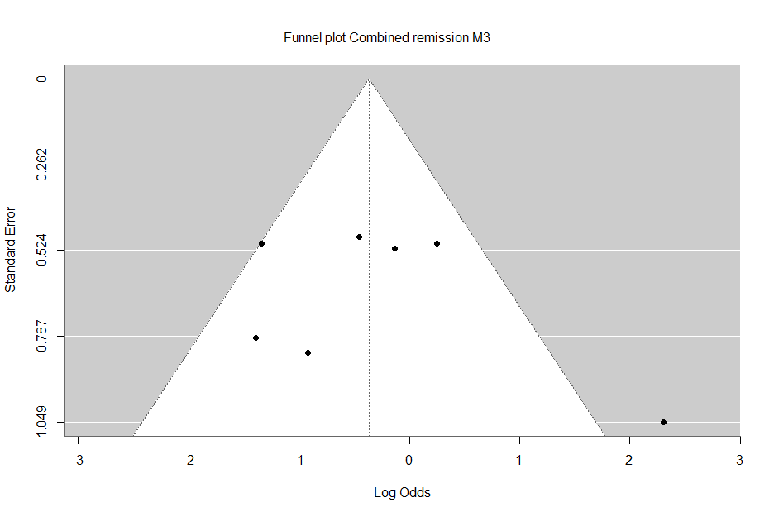
Egger’s regression test: p=0.3226

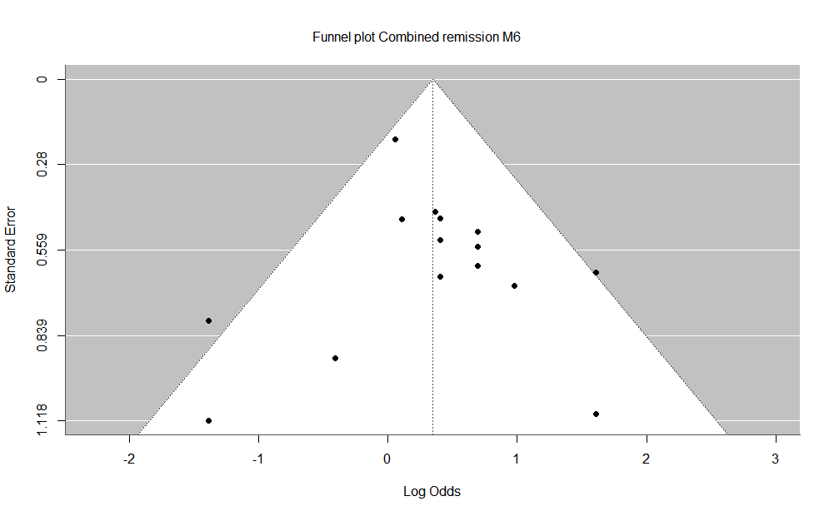

Egger’s regression test: p=0.9298

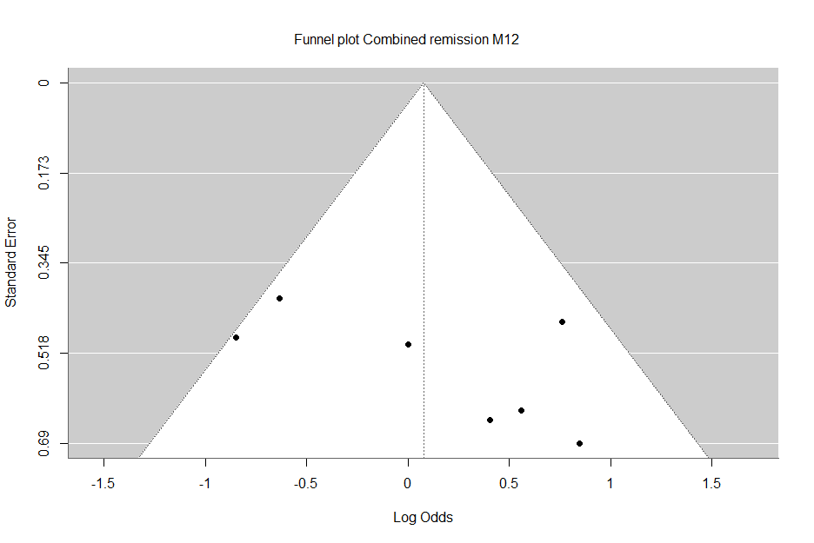

Egger’s regression test: p=0.1205

Supplementary Figure 1: Egger’s regression test and funnel plots of combined remission rate
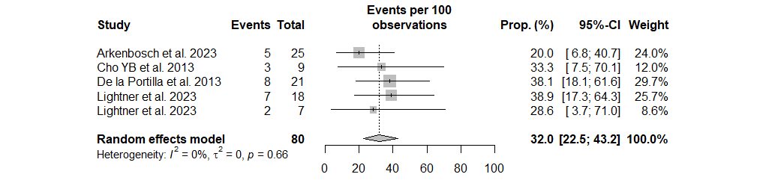
Clinical remission at 3 months
A
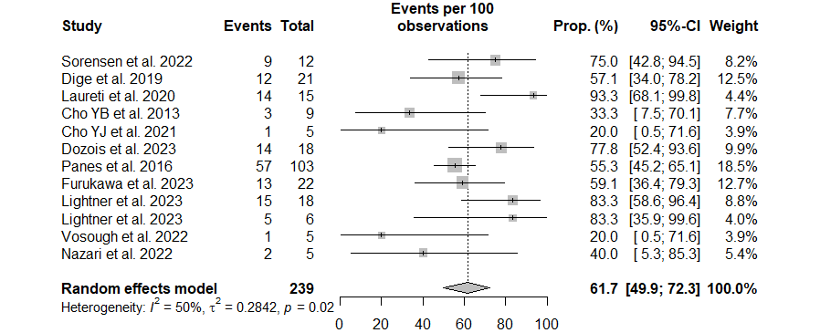
B
Clinical remission at 6 months

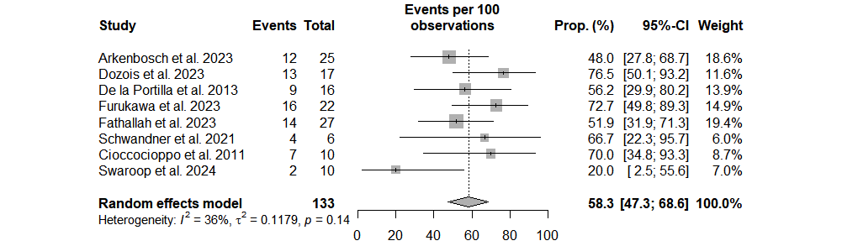
Clinical remission at 12 months
C

Supplementary Figure 2: Forest plot comparing the fistula clinical remission rate after treatment with MSC-based therapy
A/ Clinical remission at 3 months
B/ Clinical remission at 6 months
C/ Clinical remission at 12 months

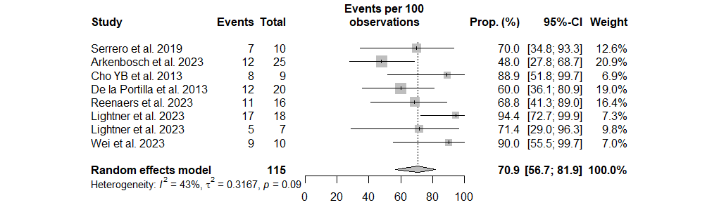
A
Clinical response at 3 months
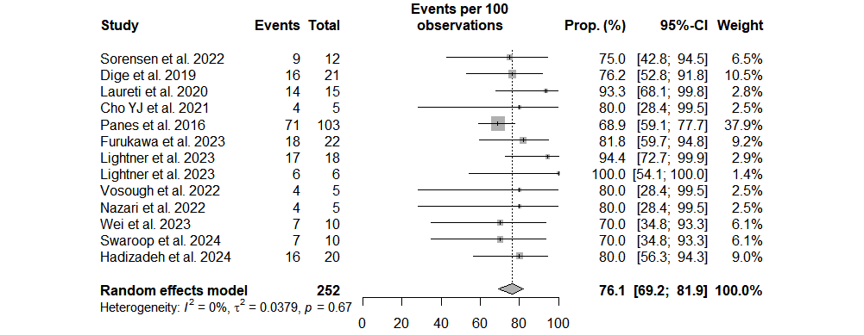
Clinical response at 6 months
B

C
Clinical response at 12 months
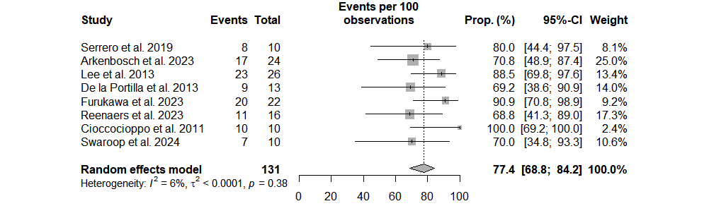

Supplementary Figure 3: Forest plot comparing the fistula clinical response rate after treatment with MSC-based therapy
A/ Clinical response at 3 months
B/ Clinical response at 6 months
C/ Clinical response at 12 months

