Human dental pulp stem cells attenuate airway inflammation in mice with PM2.5-induced asthma exacerbation by inhibiting the pyroptosis pathway

Jianling Liu1,2#, Yuehua Chen2,3#, Zhongpeng Li2,3, Zhangwen Li1,2, Fengjuan Lyu4,5, Fang Wang1,2,6, Aili Wang2,3, Zhangquan Liu2,3, Xiaoyang Liao2,3, Jian Wu2,1*
Corresponding Author:
Dr. Jian Wu, MD, Ph.D., Second Department of Elderly Respiratory, Guangdong Provincial People's Hospital, Guangdong Academy of Medical Sciences, Southern Medical University, Guangzhou, Guangdong, China.
Email address: sywujian@scut.edu.cn
1 School of Medicine, South China University of Technology, Guangzhou, Guangdong, China.
2 Second Department of Elderly Respiratory, Guangdong Provincial People’s Hospital, Southern Medical University, Guangzhou 510080, China.
3 Graduate School, The Second School of Clinical Medicine, Southern Medical University, Guangzhou, Guangdong, China.
4 Joint Center for Regenerative Medicine Research of South China University of Technology and the University of Western Australia, School of Medicine, South China University of Technology, Guangzhou 515000, P.R. China.
5 The Sixth Affiliated Hospital, School of Medicine, South China University of Technology, Guangzhou, 510000, P.R. China.
6 Department of Pulmonary Medicine, Zhongshan Hospital, Fudan University, Shanghai, China.
#These authors contributed equally to this work as co-first authors.

Full-length blots of Figure 7A

NLRP3
OVA
OVA+PM2.5+MCC950
control
OVA+PM_{2.5}+hDPSCs
OVA+PM_{2.5}
GSDMD
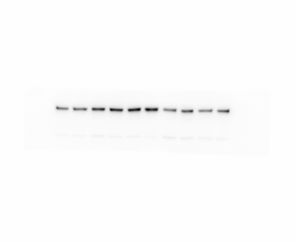
control
OVA+PM_{2.5}+hDPSCs
OVA+PM2.5+MCC950
OVA+PM_{2.5}
OVA
GAPDH
OVA
OVA+PM_{2.5}
OVA+PM2.5+MCC950
OVA+PM_{2.5}+hDPSCs
control

NLRP3
control
OVA+PM_{2.5}+hDPSCs
OVA+PM2.5+MCC950
OVA+PM_{2.5}
OVA
GAPDH
control
OVA+PM_{2.5}+hDPSCs
OVA+PM2.5+MCC950
OVA+PM_{2.5}
OVA

NLRP3
OVA
OVA+PM_{2.5}
OVA+PM2.5+MCC950
OVA+PM_{2.5}+hDPSCs
control
GAPDH
OVA
OVA+PM_{2.5}
OVA+PM2.5+MCC950
OVA+PM_{2.5}+hDPSCs
control

GSDMD
OVA+PM2.5+MCC950
OVA+PM_{2.5}
OVA+PM_{2.5}+hDPSCs
OVA
control
GAPDH
OVA
OVA+PM_{2.5}
OVA+PM2.5+MCC950
OVA+PM_{2.5}+hDPSCs
control

caspase-1
OVA
OVA+PM_{2.5}
OVA+PM2.5+MCC950
OVA+PM_{2.5}+hDPSCs
control
GAPDH
control
OVA+PM_{2.5}+hDPSCs
OVA+PM2.5+MCC950
OVA+PM_{2.5}
OVA

caspase-1
control
OVA+PM_{2.5}+hDPSCs
OVA+PM2.5+MCC950
OVA+PM_{2.5}
OVA
GAPDH
control
OVA+PM_{2.5}+hDPSCs
OVA+PM2.5+MCC950
OVA+PM_{2.5}
OVA

Cleaved caspase-1
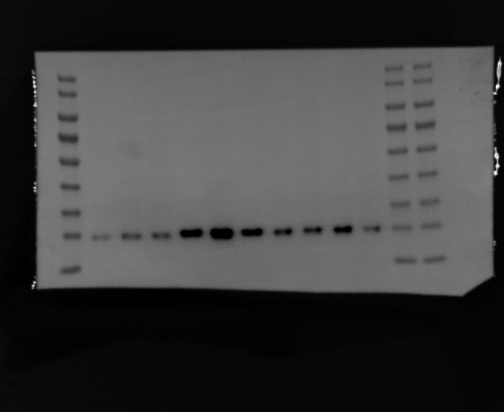
control
OVA+PM_{2.5}+hDPSCs
OVA+PM2.5+MCC950
OVA+PM_{2.5}
OVA
GAPDH
control
OVA+PM_{2.5}+hDPSCs
OVA+PM2.5+MCC950
OVA+PM_{2.5}
OVA

Caspase-1
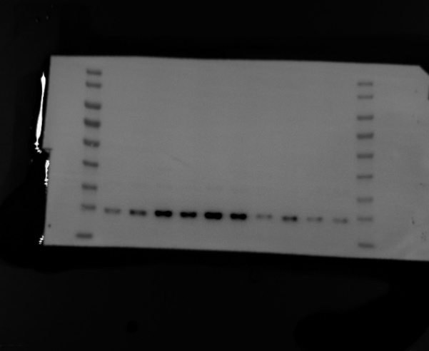
OVA+PM_{2.5}+hDPSCs
OVA+PM2.5+MCC950
control
OVA+PM_{2.5}
OVA
GAPDH
control
OVA+PM_{2.5}+hDPSCs
OVA+PM2.5+MCC950
OVA+PM_{2.5}
OVA
Cleaved caspase-1
control
OVA
OVA+PM_{2.5}
OVA+PM2.5+MCC950
OVA+PM_{2.5}+hDPSCs
GAPDH
OVA+PM_{2.5}+hDPSCs
OVA+PM2.5+MCC950
OVA+PM_{2.5}
control
OVA

