Supplementary Figures
Figure S1. Biological characteristics of hucMSCs. A. Morphology of primary and 2nd generation hucMSCs under inverted light microscope (scale bar = 500 μm); B. Inverted microscope view of hucMSCs osteogenic (scale bar = 200 μm) and lipogenic staining (scale bar = 200 μm); C. Flow cytometry detection of positive markers CD105, CD73, and CD166 as well as negative markers CD34, CD45 and CD11b of hucMSCs.

Figure S2. HPLC assay for encapsulation rate and drug loading of NMN-sEVs. A. Prepared a series of NMN standards at different concentrations of 12.5, 25, 50, 100, 200, and 500 μg/ml for HPLC determination; B. Determined the peak areas of NMN standards at different concentrations; C. Ploted a standard curve based on the concentrations and peak areas of NMN standards; D. NMN-sEVs were subjected to HPLC for determination of peak area.

Figure S3. Effectiveness of NMN-sEVs obtained by electroporation of different concentrations of NMN in delaying the senescence of DFs. A. β-galactosidase activity assay (scale bar = 200 μm); B. Fluorescence intensity of ROS (scale bar = 200 μm).

Figure S4. Safety evaluation of NMN-sEVs. A. Changes in body weight of mice; B. Changes in liver and kidney function detected by serology; C. Structural changes in major organs detected by HE staining in mice (scale bar = 100 μm).

Figure S5. Construction of a model of D-gal-induced senescence in DFs. A. Morphology of primary and 1st generation DFs under an inverted light microscope (scale bar = 500 μm); B-C. Cellular immunofluorescence and western blotting detected the positive markers a-SMA and Vimentin, and negative marker CK10 of DFs (scale bar = 50 μm); D. Cellular morphology and number of DFs treated with D-gal (scale bar = 500 μm); E. β-galactosidase activity assay and its quantification plot (scale bar = 200 μm); F. ROS fluorescence intensity and its quantification plot (scale bar = 500 μm); G. Cell proliferation viability assay; H. Western blotting detected the senescence-related markers. Full-length blots are presented in Additional file: Original Images for Blots; I. Expression of Rbm39 and col1a1; J. LaminB1 deletion representative immunofluorescence images and their quantification maps (scale bar = 100 μm). Data are presented as mean±SD. n = 3, *P <0.05, **P <0.01, ***P < 0.001, ****P < 0.0001, ns: no significant difference.

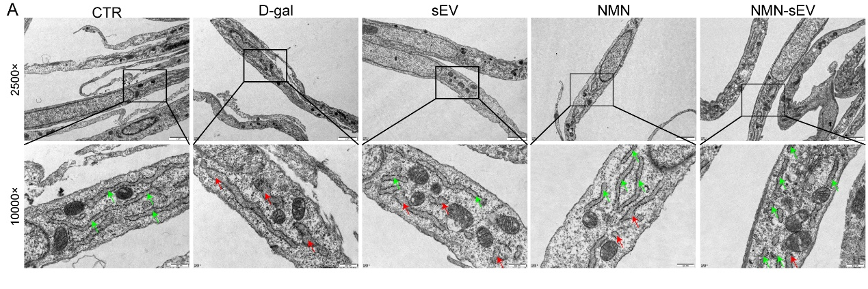
Figure S6. Representative TEM images of the endoplasmic reticulum. A. Representative TEM images of the endoplasmic reticulum of DFs after different treatments. The green arrow represents the normal endoplasmic reticulum, while the red arrow represents the damaged endoplasmic reticulum (scale bar in full view = 2μm; scale bar in magnified partial view = 500nm).

