Additional file 1
Supplementary Figure 1. Characterization of DFSCs and PDLSCs. A DFSCs and PDLSCs in primary culture under optical microscope. B DFSCs and PDLSCs in passaged culture under optical microscope. C Detection of DFSCs and PDLSCs surface markers CD105, CD44, CD90, CD34, CD45, CD11b and CD106 by flow cytometry.
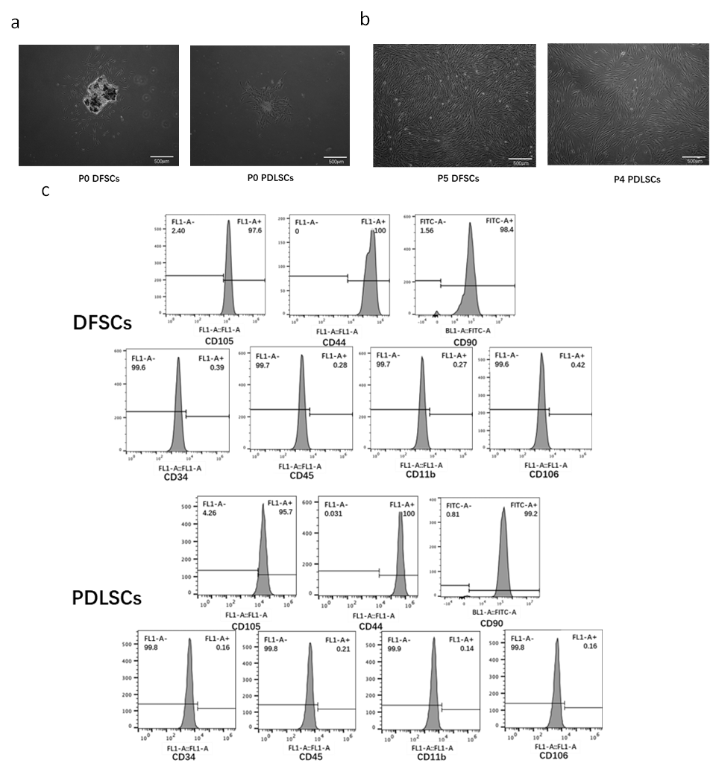
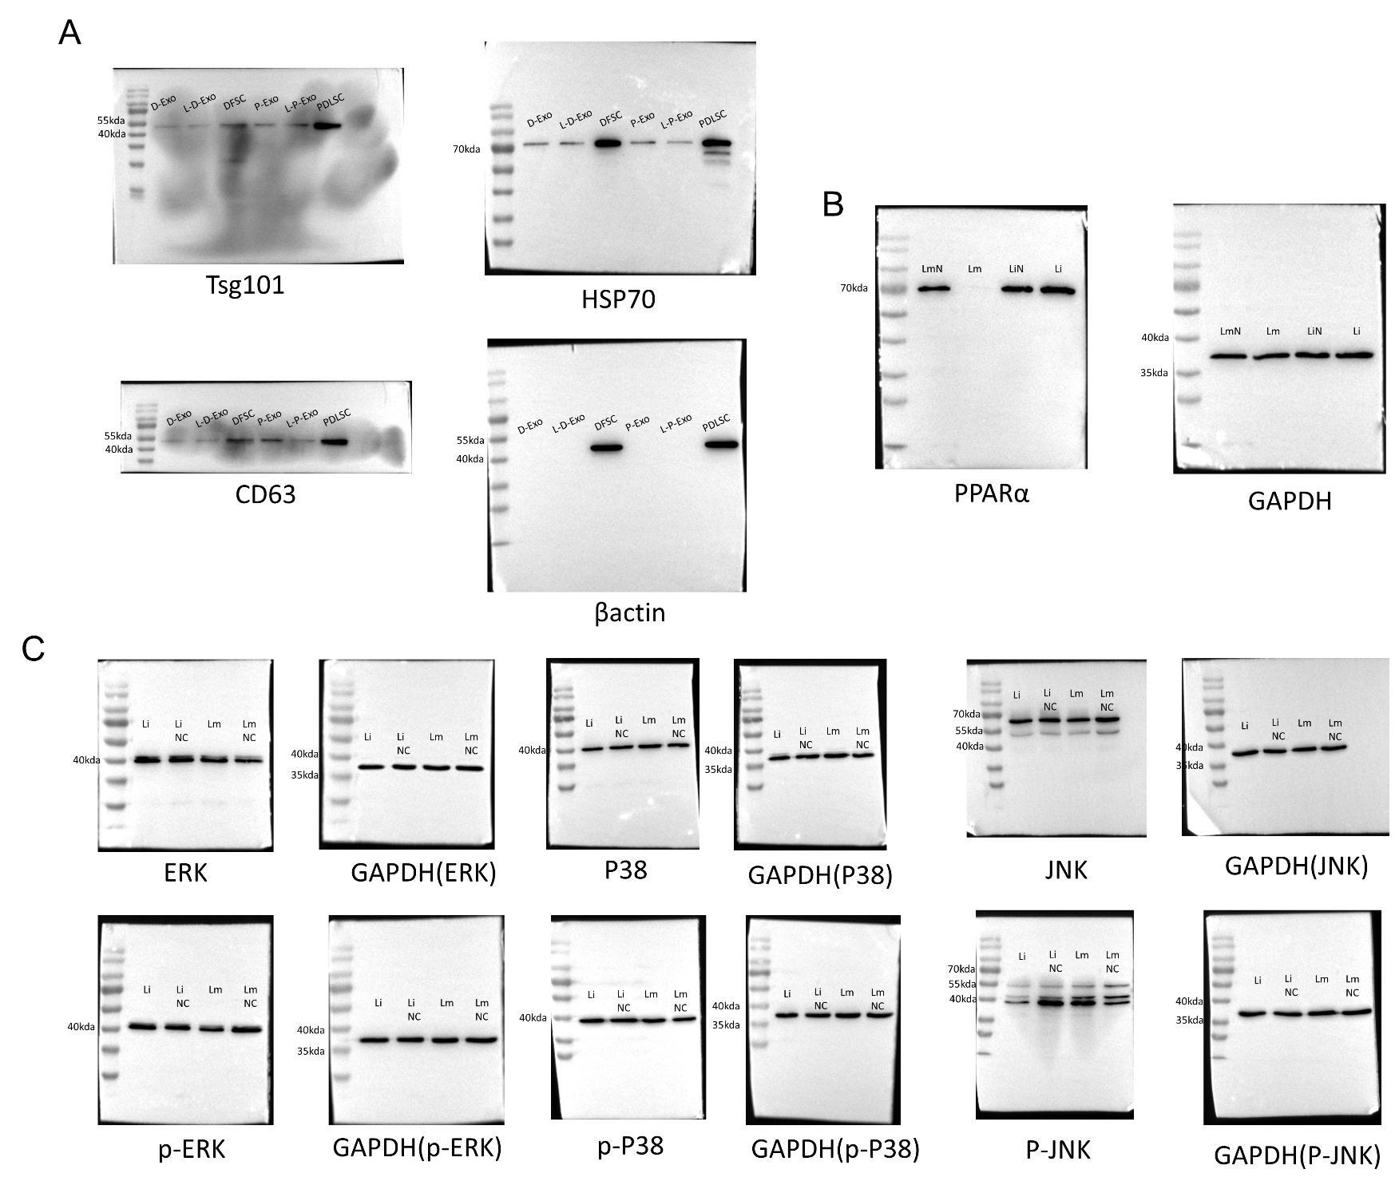
C
B
A
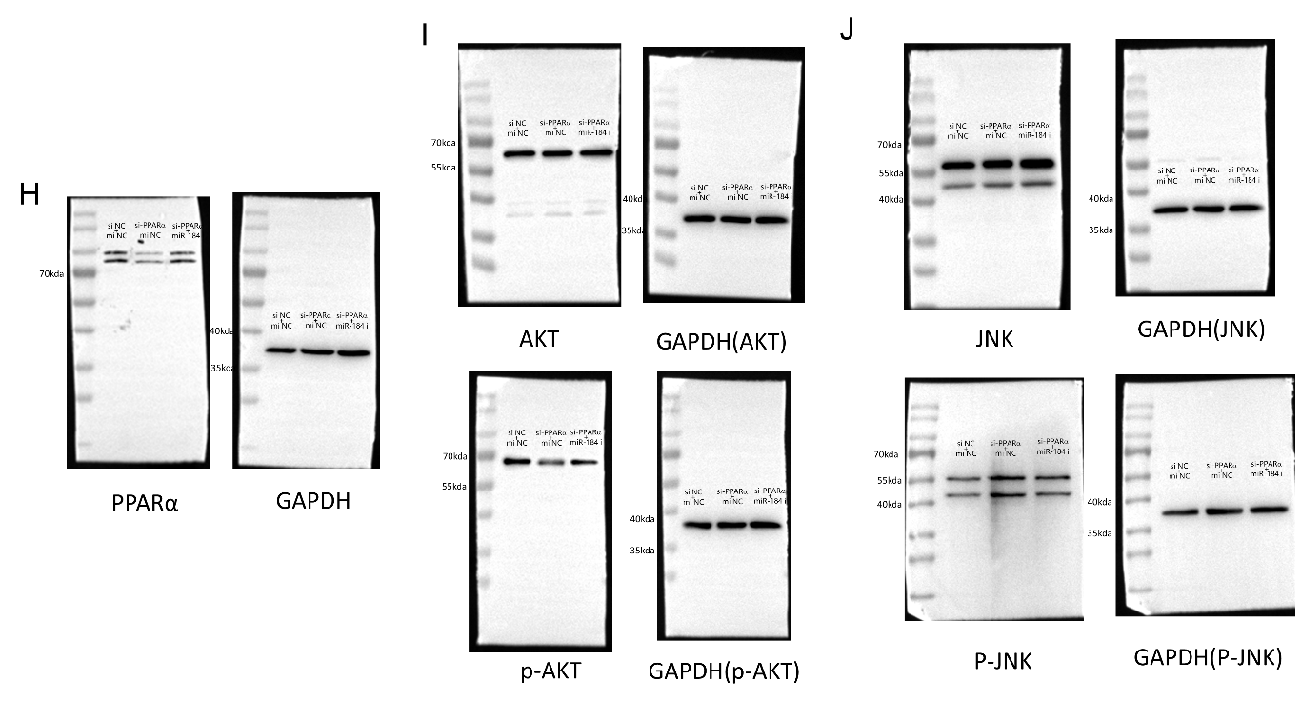
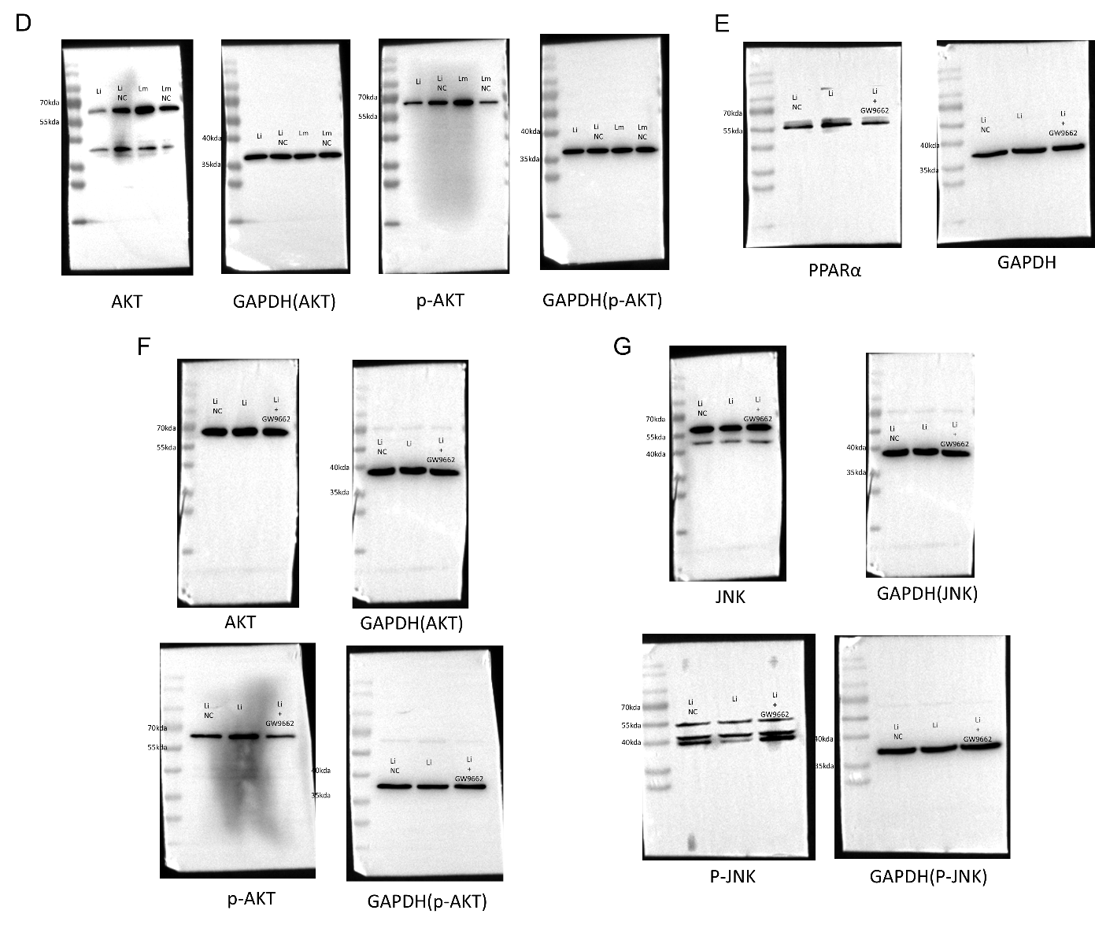
Supplementary Figure 2. Original Full-length blots. A Original image of Figure 1D. B Original image of Figure 5F. C Original image of Figure 6B. D Original image of Figure 6C. E Original image of Figure 6D. F Original image of Figure 6E. G Original image of Figure 6F. H Original image of Figure 6G. I Original image of Figure 6H. J Original image of Figure 6I.
Supplementary Table 1. List of primer sequences.
Primer name | Sequence
miR-454-3p | Forward:5’-AACACGCTAGTGCAATATTGCT-3’
miR-6529-5p | Forward:5’-AGATCGATGAGAGATCAGAGGC-3’
miR-136-3p | Forward:5’-AAGCTGAGCATCATCGTCTCA-3’
miR-184 | Forward:5’-AACCGGTGGACGGAGAACT-3’
miR-222-3p | Forward:5’-CCGAGCTACATCTGGCTACTGGGT-3’
miR-423-3p | Forward:5’-AGCTCGGTCTGAGGCCCCTCA-3’
miR-195-5p | Forward:5’-GCGCTAGCAGCACAGAAATATTGGC-3’
miR-139-5p | Forward:5’-CCGTCTACAGTGCACGTGTCTCCAGT-3’
U6 | Forward:5’-CTCGCTTCGGCAGCACA-3’
U6 | Reverse:5’-AACGCTTCACGAATTTGCGT-3’
IL-6 | Forward:5’- TGTGAAAGCAGCAAAGAGGC-3’
IL-6 | Reverse:5’- TGGGTCAGGGGTGGTTATT-3’
IL-1β | Forward:5’- CTTTGAAGCTGATGGCCCTAAA-3’
IL-1β | Reverse:5’- AGTGGTGGTCGGAGATTCGT-3’
TNF-α | Forward:5’- CCCAGGGACCTCTCTCTAATCA-3’
TNF-α | Reverse:5’- GCTTGAGGGTTTGCTACAACATG-3’
OCN | Forward:5’- CTCACACTCCTCGCCCTATT-3’
OCN | Reverse:5’- CCTCCTGCTTGGACACAAA-3’
ALP | Forward:5’- TAAGGACATCGCCTACCAGCTC-3’
ALP | Reverse:5’- TCTTCCAGGTGTCAACGAGGT-3’
POSTN | Forward:5’- CACTCTTTGCTCCCACCAATA-3’
POSTN | Reverse:5’- ATTTCCTTCCAGCGTCTCAA-3’
RUNX2 | Forward:5’- CCGCCTCAGTGATTTAGGGC-3’
RUNX2 | Reverse:5’- GGATCTGTAATCTGACTCTGTCC-3’
PPARA | Forward:5’- ATGGTGGACACGGAAAGCC-3’
PPARA | Reverse:5’- CGATGGATTGCGAAATCTCTTGG-3’
NPM1 | Forward:5’- GGAGGTGGTAGCAAGGTTCC-3’
NPM1 | Reverse:5’- TTCACTGGCGCTTTTTCTTCA-3’
MECP2 | Forward:5’- ACTCCCCAGAATACACCTTGCTT-3’
MECP2 | Reverse:5’- TGAGGCCCTGGAGGTCCT-3’
ELN | Forward:5’- AACTCTAGAGAATTCGCCACCATGGCGGGTCTGAC-3’
ELN | Reverse:5’- CTTCCATGGCTCGAGTCATTTTCTCTTCCGGCCAC-3’
CCNF | Forward:5’- CAGCTGCAGAGGACTCACAA-3’
CCNF | Reverse:5’- CCTCCTCAAACAGGTCATGG-3’
ACO2 | Forward:5’- TCAAGCTATGAAGATATGGGGC-3’
ACO2 | Reverse:5’- GATCCCTCAAGATCTGTGCATA-3’
GAPDH | Forward:5’- CTTTGGTATCGTGGAAGGACTC-3’
GAPDH | Reverse:5’- GTAGAGGCAGGGATGATGTTCT-3’

Supplementary Table 2. Predicted target genes of miR-184.
miRDB | TargetScan | mirDIP | References
SETD9 | EPB41L5 | PLPP3 | DLX1
NUS1 | SF1 | SF1 | TP63
CES2 | CRTC1 | NUS1 | Wnt3
PLPP3 | ALDH4A1 | FBXO28 | SOX1
GNB1 | SIDT2 | SIDT2 | BCL2L1
EPB41L5 | NUS1 | HAND2 | GAS1
FAM169B | FBXO28 | ZNF740 | WIG1
TNPO2 | ZNF865 | NCOR2 | EZR
CAMK2B | HAND2 | MLEC | FBXO28
IMP4 | SLC25A22 | TNRC6B | BCL-2
CCDC180 | ZNF740 | AGO2 | CX3CR1
S100A7A | PPAP2B | EPB41L5 | AKT2
SUSD1 | MFRP | ZNF865 | PRAS40(AKT1S1)
GBGT1 | REEP5 | NOL4L
FBXO28 | STC2 | REEP5
LOC100505549 | NCOR2 | LRRC8A
SIDT2 | C15orf37 | RUNX1
MRTFA | FCRLB | ALDH4A1
ADGRA2 | CARM1 | HIF1AN
ZNF740 | MLEC | STC2
SLA | CRISPLD2 | CBX6
JHY | HIF1AN | CARM1
PLEKHA1 | NFIC | CRTC1
HOMER2 | TNRC6B | CRISPLD2
MFSD13A | CBX6 | NFIC
CRLF2 | C20orf112 | PRKCB
LRRC8A | ZIC4 | GNB1
PPP6R1 | AGO2 | SLC25A22
DCSTAMP | DBNL | TNPO2
TLE1 |  | MFRP
FLAD1 |  | DGAT1
KIAA1211 |  | ATXN2L
AKR1C3 |  | ANKRD52
PLTP |  | ZFPM2
DGAT1 |  | DBNL
ADO |  | CES2
NCOR2 |  | ADO
DESI2 |  | FCRLB
SF1 |  | KIF1A
FOSB |  | SEMA6D
C21orf62 |  | CELF2
CREB3L1 |  | VAMP1
ADPRHL1 |  | ADPRHL1
KNOP1 |  | MECP2
NOL4L |  | ADD3
HAND2 |  | HPSE
CRISPLD2 |  | DAG1
STRA6 |  | NUFIP2
AGRN |  | FZD1
CCDC77 |  | MGAT4A
AGO2 |  | PCBP2
CRTC1 |  | ST20-AS1
TMC8 |  | TRIM27
ADAM22 |  | MAVS
BIN3 |  | KLF12
CLIC5 |  | SMAD5
ZFPM2 |  | VEZF1
ZNF865 |  | HOOK3
TMEM183A |  | PPP6R1
LEFTY2 |  | SUSD6
CTBP1 |  | MRTFA
IYD |  | TLE1
FSCN1 |  | CSF1
RUNX1 |  | FBXW11
ACO2 |  | SRC
SLC6A8 |  | SRGAP3
HPSE |  | KAT6A
PLXNA2 |  | TRAK1
POLL |  | ADGRA2
ELN |  | ONECUT2
 |  | USP42
 |  | ANKRD54
 |  | AKR1C3
 |  | TBC1D20
 |  | PAN3
 |  | IFFO2
 |  | FBXW7
 |  | PABPN1
 |  | AGAP3
 |  | FAM169B
 |  | PLTP
 |  | ACO2
 |  | GRK3
 |  | GSK3A
 |  | PLXNA2
 |  | RRP1B
 |  | CTDSP2
 |  | VPS53
 |  | SUSD1
 |  | BUB3
 |  | CREB3L2
 |  | MEX3C
 |  | PPARA
 |  | CDC25A
 |  | EHD2
 |  | ZIC4
 |  | TPM3
 |  | ARHGDIA
 |  | CCDC77
 |  | NDST1
 |  | DVL3
 |  | SLC6A9
 |  | CLINT1
 |  | PCSK6
 |  | MAPK1
 |  | RNMT
 |  | S100A16
 |  | LNPK
 |  | PDXK
 |  | SOGA1
 |  | URM1
 |  | EIF4E3
 |  | UBP1
 |  | TGFBRAP1
 |  | PITPNM2
 |  | CRACD
 |  | CSDE1
 |  | ORAI1
 |  | AGPAT1
 |  | GRSF1
 |  | SND1
 |  | PLAGL2
 |  | CCNF
 |  | PLEKHA1
 |  | AGO1
 |  | ZBTB5
 |  | CAMK2B
 |  | ELN
 |  | CREB3L1
 |  | KSR2
 |  | KLF13
 |  | PPP1R12B
 |  | PTBP3
 |  | AK2
 |  | BTBD9
 |  | STK40
 |  | SLC7A5
 |  | NPM1
 |  | GNL3L
 |  | MNT
 |  | PCDH10
 |  | ENC1
 |  | TRDMT1
 |  | ZNF512B
 |  | FN3K
 |  | NF2
 |  | POM121C
 |  | CACNB4
 |  | CTBP1
 |  | MKLN1
 |  | GOLGA7
 |  | PSMA4
 |  | RASAL2
 |  | TTC39C
 |  | KAZN
 |  | LEFTY2
 |  | ZBTB41
 |  | ZNF445
 |  | UBE3B
 |  | FAM72B
 |  | ERBB4
 |  | CLIC5
 |  | RNF165
 |  | PPM1H
 |  | SNX27
 |  | DESI2

Supplementary Table 3. Oxidative stress-related genes.
Gene Symbol
KIT | NR1H2 | SETX | ENO1 | CYGB
NDUFA13 | HBEGF | ADAMTS13 | LAMP2 | CCND1
MAPK13 | AKAP9 | GHRL | ITGB1 | PDHA1
TNFSF4 | MIR34C | KCNMA1 | SERPINA1 | ASS1
LEPQTL1 | MSR1 | MIR125A | S100B | LRRK2
MIR185 | RPA1 | H2AX | LOC110973015 | HTR2A
ALS3 | RCAN1 | FOXP3 | REST | DRD2
ALS7 | FTH1 | KRT8 | PIK3R1 | SLC6A3
OXTR | CYP11A1 | PLA2G2A | CDC42 | MAPKAPK2
DHFR | CHGA | BRF2 | CXCL12 | ARG1
ACACA | PLCB1 | MIR200B | DAO | GGT1
GPX8 | SENP3 | FKRP | BAK1 | SLC25A4
BGLAP | RRM2B | ADPRS | HCRT | NPY
TAZ | PDK1 | H4-16 | ADORA2A | GBA
MAPK12 | SNCB | ALAD | MTHFR | BMP6
YBX1 | MIR107 | MIR181A1 | CSF3 | HSPD1
SFXN4 | MIR181C | MT-ND4 | BRCA1 | CYP1B1
SLC4A1 | CAPN3 | NDUFB9 | GNAS | NOX1
HPSE | RNASE3 | IGF2 | SIGMAR1 | HP
RPTOR | PRPH | ACTN2 | IREB2 | LEP
MTA1 | CFI | ISCU | TGFBR1 | BLVRB
CD274 | LAMP1 | XIAP | CARS2 | NOS1AP
ENDOG | BLOC1S1 | CFLAR | CALM3 | FARS2
BMP4 | PML | GSTA2 | MAP2 | HRAS
MTTP | CCK | NLRP3 | MIF | CALCA
TCF7L2 | TIMP2 | QDPR | CTSD | RAC1
TLR6 | TRAF2 | CASP2 | MAPKAPK3 | SNAP25
VDR | STIP1 | SRF | PAH | PRKAA2
CPQ | NOSTRIN | PKLR | OXR1 | PRKAA1
NFU1 | MYLK | TYMP | CACNB4 | EPO
GADD45G | GSTM5 | SCO1 | PXN | MSRB2
FMO4 | TPK1 | PTS | HTR3A | LOX
BBC3 | SLC2A4 | THBS1 | IGF2R | NDUFB8
AREG | HLA-A | SYP | CASP7 | PDE5A
HK1 | UNG | TYK2 | GSTO2 | CRYAB
PIK3R2 | IL3 | GRN | ANG | EGFR
ATG5 | RORA | OPTN | EPHA3 | RPS27A
POU5F1 | MDH1 | GRIA1 | PTPN22 | MDM2
SIRT6 | RUNX2 | PIK3CB | MRPS16 | THBD
MIR214 | SCARA3 | IKBKB | GLUD2 | NDUFV1
JAZF1 | PDIA3 | CEBPB | CREBBP | CTLA4
FADD | DDC | CD80 | SLC25A13 | MIR22
BCL2A1 | GSTM4 | C4B | SIRT3 | MAPK9
IL11 | PIGA | PPP1R15A | GSTA4 | NGF
SELENOT | BRCA2 | ACSL4 | IDH2 | IL2
MAP3K11 | UNC13A | EIF2B3 | TOR1A | SRC
CYP4F2 | VPS13C | PLA2G4A | DCTN1 | CREB1
MIR24-2 | TNFSF11 | TUBA1B | MIR17 | ATF6
ASPA | CYP2C8 | STK11 | C12orf65 | MIR146A
ROCK1 | SERPINF1 | MMP3 | EPHX1 | TLR2
NEDD8 | DYSF | GRM5 | TGFBR2 | ATM
GAA | PSIP1 | DRD3 | BCHE | SDHD
ATP5PD | TPI1 | SMARCA4 | ERCC6 | IL1A
PEPD | PDGFRB | NTRK1 | NFE2L1 | NDUFS3
CAPN2 | CAMK2G | ECE1 | EIF2AK2 | MT-ATP6
PTPRC | EPHX2 | LYN | ADM | MT-CYB
CYP20A1 | CR1 | ELK1 | H2AC18 | CDKN1A
MKI67 | CYP3A5 | ALDH3A1 | COL2A1 | OSGIN1
SORL1 | AGRN | PDCD1 | TRPV1 | SLC1A3
MIR210 | NR2C2 | CCS | VIP | ATF4
SORD | XRCC6 | SIL1 | SYK | GTPBP3
MUC5AC | PPP3CA | IL5 | A2M | RHOA
ALDH3A2 | UBQLN1 | PSEN2 | ALOX5 | PPARA
CHCHD2 | FOXO4 | ARG2 | CD44 | ABL1
PLD1 | MAPK7 | IDO1 | IAPP | KDR
C5 | NES | DYNLL1 | PRKCA | SPP1
MIR222 | FTL | MTR | SNCAIP | ACAD9
TNFRSF11B | BACH1 | PDIA2 | S100A8 | AGT
TNFRSF10A | SCGB1A1 | SLPI | NAGS | TRPM2
FABP1 | FMO2 | SLC1A1 | HNRNPA1 | GSTT1
PFKM | APC | EIF2B4 | ATP13A2 | PIK3CA
PYCR2 | MYD88 | ADAM17 | SLC25A3 | PRDX1
IL6R | HERPUD1 | CAMP | DAPK1 | HMGB1
SUMO1 | CYP17A1 | CYP2A6 | TTR | CLU
TEK | TYRP1 | HDAC1 | EIF4E | PIK3CG
SLC7A1 | XRCC5 | CD79A | DLST | CDKN3
FIG4 | FKBP1B | CYP27A1 | CRYAA | HBB
GLT8D1 | MMP14 | RXRA | UBE2L3 | NDUFA12
LBR | TMEM161A | PTPN1 | NEFH | SELP
CXCL16 | ALOX15 | EP300 | G3BP1 | ATP5F1A
OSM | SOX2 | CXCR3 | ADH1C | SERPINE1
GRIN1 | ASL | NAT2 | DNMT1 | C1QBP
DYRK1A | CCNF | EDNRA | MRPS22 | PRDX3
MIR181A2 | DIABLO | PFN1 | TFAM | TXNRD1
DNM2 | MMP7 | MT-ND3 | OSGIN2 | SLC22A5
TACO1 | TRPV4 | NTHL1 | CCL3 | MSRB1
GIGYF2 | PGK1 | KCNJ2 | SCN4A | AGER
C5AR1 | NDUFA1 | NRG1 | UCHL1 | PRL
ALDH3B1 | IL23A | CHCHD10 | MIR195 | LDLR
CCR7 | ATXN1 | BECN1 | FGFR1 | CTNNB1
MUC1 | JUNB | CLEC4A | OXT | TRDN
CANX | HSPA14 | COQ2 | MIR34A | CASQ2
ADH1A | CD86 | EIF4EBP1 | AKR1A1 | PC
FRZB | GAL | SGK1 | OPA1 | CALM1
EEF2 | FGF7 | ANGPT1 | VARS2 | ETFB
ZFAND1 | SCP2 | SOCS3 | SLC1A2 | SHC1
UBQLN4 | BCL6 | UCP1 | CRHR1 | COMT
PKD1 | SULT1A3 | MIR93 | POR | ANXA5
MIR200C | GADD45A | AIF1 | PRKG1 | MMP2
TNIP1 | GSN | IL15 | TGFB3 | TH
SCN4B | MDH2 | TRIM21 | KCNJ5 | SELE
IL16 | IL2RB | LTA | BACE1 | STAT3
H3C14 | ABCC8 | NAMPT | SNTA1 | NUDT1
ARNT | PPIG | MIR29A | DRD5 | MT-CO1
CYP19A1 | MCU | MFN2 | SERPINA3 | MIR21
SDC1 | MLYCD | CALM2 | HSPA9 | EIF2S1
CACNA2D1 | CHMP2B | TIA1 | SCN2A | EIF2AK3
AQP1 | UBC | RELA | AMPD1 | TNFRSF1A
CDC25C | MSN | NGFR | TNFRSF1B | TERT
ACTN4 | PTPN3 | TRAP1 | ITPR1 | IL13
BSG | NTF4 | HGF | TSFM | GDNF
LYRM4 | SLC19A3 | GAP43 | MT-TK | SLC2A1
KL | CCNB1 | MIR433 | MIR223 | FAS
ANXA11 | FMR1 | SLC6A2 | TGFB2 | SOD3
AVP | HSPA6 | CD4 | UCP3 | MB
ABCC3 | HK2 | MYO9A | IDH1 | MT-ND1
MRAP | SELL | PENK | CSF1 | SDHA
FANCD2 | PRKCZ | EPRS1 | DNM1L | CYP1A2
FIS1 | PTGIS | CDH1 | MET | SDHB
PGAM5 | ZC3H12A | CFTR | TSC2 | NR3C1
CAMKK2 | AHR | RPS6KA5 | PLA2G6 | MMP9
CFAP410 | GLS | PVALB | PGD | TXN2
VIPR1 | PPOX | MRPL44 | KCNH2 | OXSR1
ADRB3 | NCAM1 | CTSB | HMOX2 | HSPA8
RTN4 | RETN | NTS | PPIF | C9orf72
MIR19A | B2M | ERBB4 | EHHADH | GFAP
FAAH | CD55 | EIF4G1 | TXNRD2 | IGF1
GLA | VKORC1L1 | KLF4 | AKR1B1 | TPO
PDE4A | SLC25A27 | CYP2B6 | GSTM2 | EGF
TARS2 | EDNRB | ACE2 | MAP2K3 | MYH7
CX3CR1 | PF4 | SESN1 | NGB | MSRA
NOD2 | SMAD2 | NRF1 | MMP1 | CYP2E1
SFTPB | SOCS1 | PECAM1 | NCF1 | GCH1
LANCL1 | BLK | KLF2 | MECP2 | ELAC2
CD38 | PYGM | GSS | NPPB | MAOB
FECH | CDK6 | EIF2AK1 | SIRT2 | PRDX6
TPPP3 | MICB | FLT1 | STAT1 | CYP1A1
IL1RAPL2 | PPARD | RPS6KB1 | ECHS1 | PINK1
TP53INP1 | UBQLN2 | OXA1L | AOC3 | GPX3
ENC1 | HYOU1 | ATXN3 | H6PD | ACADL
PEX5 | TACR1 | HLA-B | FGF2 | SP1
IKBKG | BDKRB2 | ATF3 | GPX2 | NOX4
FYN | ADRB1 | RAF1 | GLRX2 | CASP9
ABCG2 | CTTN | MALAT1 | OSER1 | F2
MIR199A1 | DEPDC5 | ADA | GSTM3 | ETFA
UCN2 | MIR106B | MAPK11 | KRIT1 | PPARG
CD46 | NQO2 | GRIN2B | SDHAF1 | HTRA2
KIAA0319L | ABCC2 | ANXA2 | OPRM1 | ADIPOQ
MIR184 | SREBF1 | COX6B1 | SESN2 | CYP3A4
CXCL2 | SERPINH1 | HMGCL | APOH | ALDH2
GPX5 | H2BC21 | CXCR4 | VDAC1 | FOXO3
CD28 | LPA | CXCL10 | REN | COX5A
YAP1 | VCL | MMP13 | SST | SELENON
GADD45B | MIR145 | MIR122 | ADRB2 | OGG1
EIF2AK4 | MIR143 | STK39 | NR3C2 | KNG1
NEK1 | FASN | GCLM | GSK3B | MTOR
HDAC9 | CASP4 | TLR3 | KRAS | CHAT
ACAD8 | CD34 | BAD | MYC | ABCD1
MIR203A | KRT18 | TBP | ADH5 | MTO1
ADAM10 | CTSG | CCN2 | HTR1A | TLR4
MT-CO3 | SLC11A2 | TJP1 | FXN | BAX
RAG2 | ODC1 | ALDH9A1 | NPPA | PRDX2
C3 | TNFRSF10B | BIRC5 | PTK2 | POLG
HRH2 | CHEK1 | FCGR3B | CPT1B | MAPK3
VEGFC | SFTPD | PDGFRL | HLA-DRA | VCAM1
SLC8A1 | CD69 | NLRP1 | UGT1A1 | HSF1
MRPS34 | PDLIM4 | KCNE1 | PRKD1 | NCF2
FCGR3A | GH1 | GAD1 | CYB5R3 | PRNP
IL12B | LPL | ENO2 | GPX4 | FOS
CIITA | HNF1A | PEX12 | GPT | MAOA
SIAH1 | SCARB1 | CDKN1B | FMO3 | APOE
MIR23B | PTX3 | GJA1 | F3 | HIF1A
SET | RAD51 | HSPA1B | TFRC | CACNA1C
MIR92A1 | EZH2 | LOC111365141 | JAK2 | CASP8
MMD | COX15 | FGF1 | MT-TL1 | LMNA
ITGA2 | LGALS1 | DRD4 | IL1R1 | XBP1
TLR5 | GRIN2A | IRF1 | MAP2K1 | CRH
PHYH | VAPB | ATF2 | MT-CO2 | PPARGC1A
HSPG2 | ELAVL1 | CDK1 | ATP2A2 | CAV1
PRDM10 | HRH1 | RNF112 | PLA2G7 | PON2
RBP4 | ATR | HMGCR | CD40 | BCL2
DYNC1H1 | PNKP | DHCR24 | MAP2K4 | TARDBP
HPRT1 | GFER | NTRK2 | GSTO1 | MAPK10
SPARC | CDH5 | CXCL1 | TPH1 | HSPA1A
SELENOK | MIR24-1 | AHSP | BCL2L1 | ACE
MAPK8IP1 | ABCA1 | NDUFA6 | ACHE | APEX1
TFEB | DAXX | PLCG1 | CRAT | OLR1
TAT | CDH2 | IRAK1 | GCLC | ESR1
HDAC2 | GZMB | FMO1 | NFKBIA | MAP3K5
VNN1 | CALB2 | HSP90AB1 | SGCB | VCP
MIR142 | MUTYH | ITGAL | IL4 | AIFM1
GDF15 | ERCC8 | AKT2 | UCP2 | ICAM1
SORCS2 | DDAH1 | FDXR | NR4A2 | CP
MIR152 | NDUFS7 | MIR126 | EGR1 | SCN5A
SELENOP | NDUFS6 | CCR6 | IL17A | HSPB1
ADSL | ERO1A | KIF1B | EGR1 | BDNF
NEFL | DSP | DSPP | LOC110806262 | NFKB1
HPX | NDUFA10 | CCNA2 | TRMT10C | PRDX5
OTC | SUMO2 | CPOX | PNPT1 | HBG2
LCAT | NRAS | ALDH1A1 | CDKN2A | CAV3
RYR3 | IGF2BP1 | HSPB2 | PTK2B | TYR
ISG15 | CXCL9 | CNTF | CCL5 | KEAP1
MAP3K1 | SLC18A2 | MT3 | NPM1 | GSTM1
BCR | PIK3C2A | SDHAF2 | ETS1 | AARS2
SLC25A1 | BCL2L11 | EPAS1 | PRODH | FOXO1
EPHA4 | STK4 | LONP1 | ACO1 | PSEN1
MAPKAPK5 | HNF4A | ABCC1 | EEF1A1 | DDIT3
ACTG1 | ALOX12 | SETD2 | OGDH | GSTP1
CLIC1 | GLS2 | E2F1 | TAC1 | CPT1A
SLC7A11 | CFH | MTFMT | CASP1 | SLC25A20
TLR8 | F8 | CALB1 | CYP11B2 | GPX1
NCF4 | DNAJB1 | MBP | NDUFAF2 | SQSTM1
DGKQ | TBK1 | S100A9 | PRKCD | ETFDH
IFNAR1 | ITIH4 | NDUFS1 | SLC5A7 | HSPA5
MMP8 | LRPPRC | IGF1R | SMAD3 | ACOX1
CDKN2B | XRCC1 | CHUK | ENG | CYP2D6
TOP1 | TP73 | DNASE1 | GLUL | VWF
ACO2 | ANGPT2 | IFNB1 | HSD17B4 | NDUFS4
MIR25 | AOX1 | VIM | RAC2 | GAPDH
CUL3 | NEAT1 | ANK2 | MT-ND2 | MAPT
DUOX1 | NME1 | MAP2K7 | PON3 | PARP1
CAMK4 | DES | CR2 | ATXN2 | VEGFA
CUL1 | TRPA1 | DLG4 | PTEN | RYR2
CYB5A | TGFA | DRD1 | TSPO | CCL2
IGF2BP2 | MAP3K7 | PCNA | ELANE | HADHB
UBE2D2 | EPX | ADCY10 | SDHC | RYR1
FAM120A | PLG | PLAT | TUFM | CYBB
AQP4 | INSR | TSC1 | ERN1 | GFM1
PDGFB | RHOD | ELN | POMC | HSPA4
MIR27A | GP1BA | MBL2 | DBH | PTGS2
KCNE2 | LGALS3 | BMP2 | CYP2C9 | SNCA
HAMP | CYC1 | LCN2 | GPX7 | IFNG
BACH2 | BAG3 | GLUD1 | P4HB | NQO1
PPP5C | PARK12 | TNFSF10 | FUS | HSP90AA1
AURKA | STAT4 | DMD | MT-ND5 | EDN1
TLR7 | NR1H4 | MCL1 | FASLG | TGFB1
PTPA | DNAH8 | NOL3 | HLA-DRB1 | JUN
WRN | MT-ND6 | CST3 | MIR155 | CYBA
TTPA | NDUFA9 | CBS | TF | CXCL8
RARA | FCGR2B | NDUFS8 | CHKB | CRP
UCN | CSK | CHKA | CDK2 | ALB
PKP2 | STK24 | DDAH2 | CD36 | SIRT1
KCNT1 | AR | NTF3 | HFE | ACADS
ATXN8OS | GYG1 | ACTB | ACP1 | HADH
PARK10 | PRKD2 | PRKAB1 | GSTA1 | AKT1
PARK16 | PPIA | STUB1 | NOTCH1 | INS
PARK21 | CDK4 | FCGR2A | DUSP1 | IL10
MGMT | TPT1 | ITGB2 | PRDX4 | ACADVL
LIN28B | COA8 | MATR3 | PTPN11 | TXN
SMPD1 | IRF5 | APOB | AGTR1 | CASP3
GRM1 | F5 | STK25 | HSP90B1 | G6PD
DMPK | SCO2 | TLR9 | SLC18A3 | MAPK1
PYCR1 | PKM | CSF2 | FN1 | SLC6A4
UTRN | GLO1 | APAF1 | PRKCB | ACADM
MIR148B | MYH6 | PDYN | CNR1 | IL1B
FOXJ1 | MME | OPRD1 | TREM2 | CYCS
MIR144 | FOXM1 | TNFAIP3 | NDUFV2 | MAPK8
CCR5 | ACOX2 | ABCB1 | GLRX | HADHA
SLC40A1 | JAK1 | TGM2 | ITGAM | PRKN
ITGB3 | H19 | ACTA1 | TECRL | IL6
CCL11 | NDRG1 | MIR23A | IL1RN | PON1
MECOM | PEX11B | GRB2 | CACNA1S | PARK7
MIR20A | ERBB2 | HSD17B10 | HTT | GSR
DUSP19 | FKBP5 | MRPS14 | PLAU | XDH
VASP | MIR133B | MIR132 | TIMP1 | APP
HAO1 | TPM1 | LTF | CDK5 | MAPK14
MIR9-1 | MIR221 | CCL4 | CALR | MPO
FH | VHL | NDUFS2 | MGST1 | SOD2
CYP21A2 | IL2RA | BTD | SUOX | CPT2
CACNA1A | MSH2 | IFNA1 | PTGS1 | NFE2L2
BRAF | C4A | RB1 | CYP2C19 | TP53
NOSIP | RAB5A | SMAD4 | TREX1 | NOS1
KLRK1 | PLAUR | MAP2K6 | TTN | HMOX1
ESR2 | NEIL1 | SRXN1 | DLD | TNF
PIK3C3 | SPR | LPO | ADCYAP1 | CAT
VTN | LCK | HBA1 | CS | NOS2
IL33 | MSRB3 | IRS1 | TXNIP | SOD1
CXCR1 | GLE1 | SLC17A5 | IL18 | NOS3
PRKCG | TAF15 | KCNQ1 | GCDH
TALDO1 | GFM2 | HTR2C | APOA1

