Therapeutic effects of adipose tissue-derived mesenchymal stem cells on ER stress in a murine model of metabolic dysfunction-associated steatohepatitis: An in vivo and in vitro study

Norihiko Ogawa¹, Akihiro Seki^{1*}, Alessandro Nasti², Ho Yagi², Masatoshi Yamato^{1,3}, Hiiro Inui¹, Hiroki Nomura¹, Takuya Komura^{1,4}, Hidetoshi Nakagawa¹, Kouki Nio¹, Hajime Takatori¹, Tetsuro Shimakami¹, Masao Honda¹, Shuichi Kaneko², Yoshio Sakai^{1,5}, Taro Yamashita¹
Affiliations
¹Department of Gastroenterology, Kanazawa University Hospital, Kanazawa, Japan
²Information-Based Medicine Development, Kanazawa University, Kanazawa, Japan
³Marukawa Hospital, Nyuzen, Japan
⁴National hospital organization Kanazawa medical center, Kanazawa, Japan
⁵Sakai Clinic, Nonoichi, Japan
*Correspondence:
Akihiro Seki, MD, Ph.D.
Department of Gastroenterology, Kanazawa University Hospital
13-1, Takara-machi, Kanazawa-shi, Ishikawa, 920-8641, Japan
Email: Seki0510@gmail.com
TEL:+81-76(265)2235

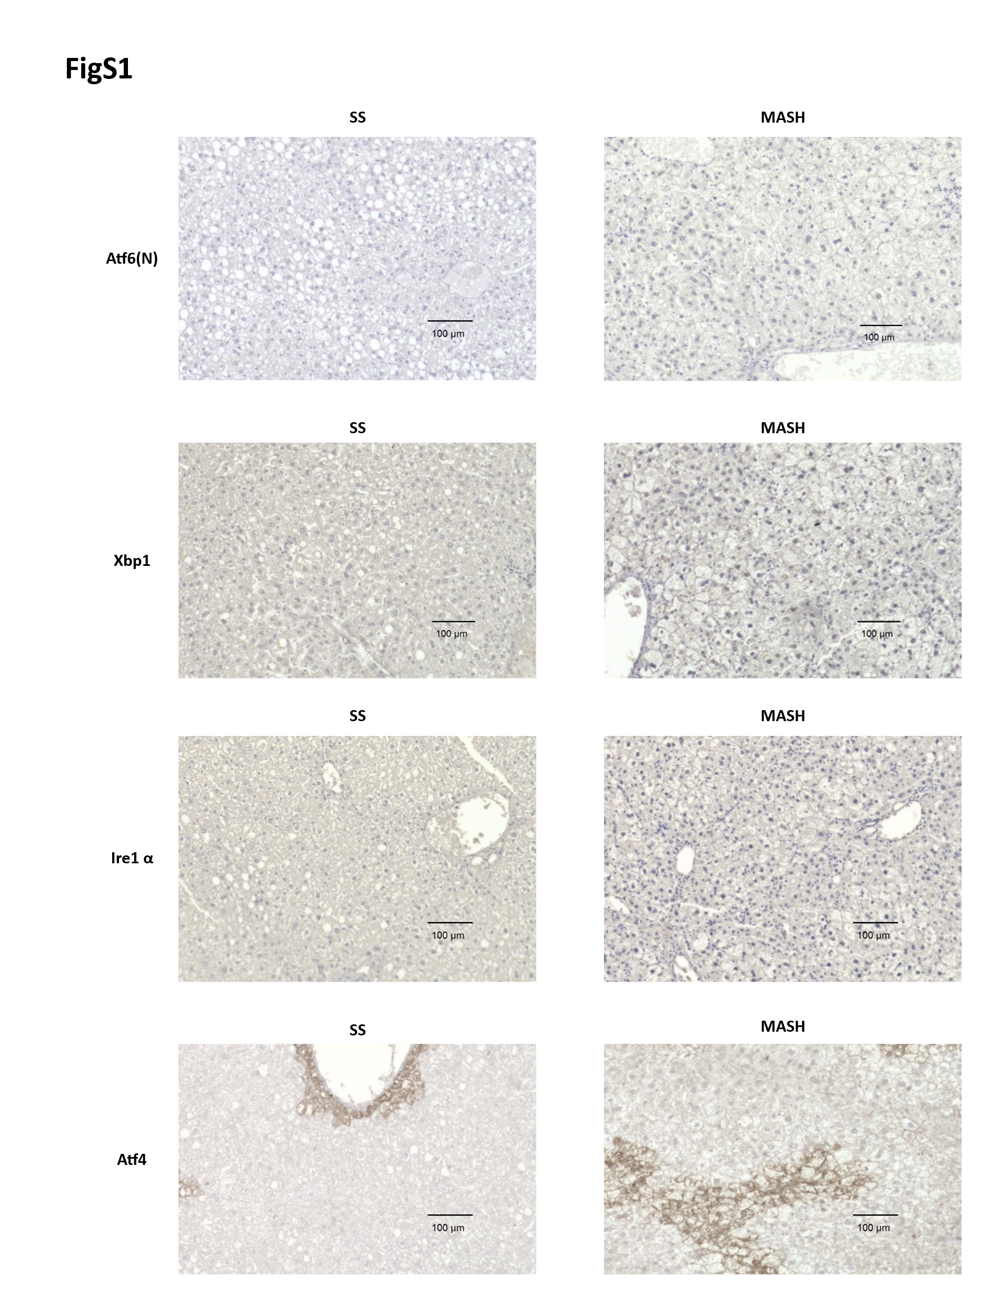

Figure S1. Immunohistochemical analysis of UPR markers in liver tissues from MASH and SS mice.
MASH and simple steatosis (SS) mouse models were established by feeding an atherogenic high-fat diet or HFD-60, respectively, for 12 weeks. Liver tissues were then collected for further analysis. Each dietary group included five mice. Liver sections were immunostained with antibodies against Atf6, Xbp1, Ire1α, and Atf4. Scale bars represent 100 μm.

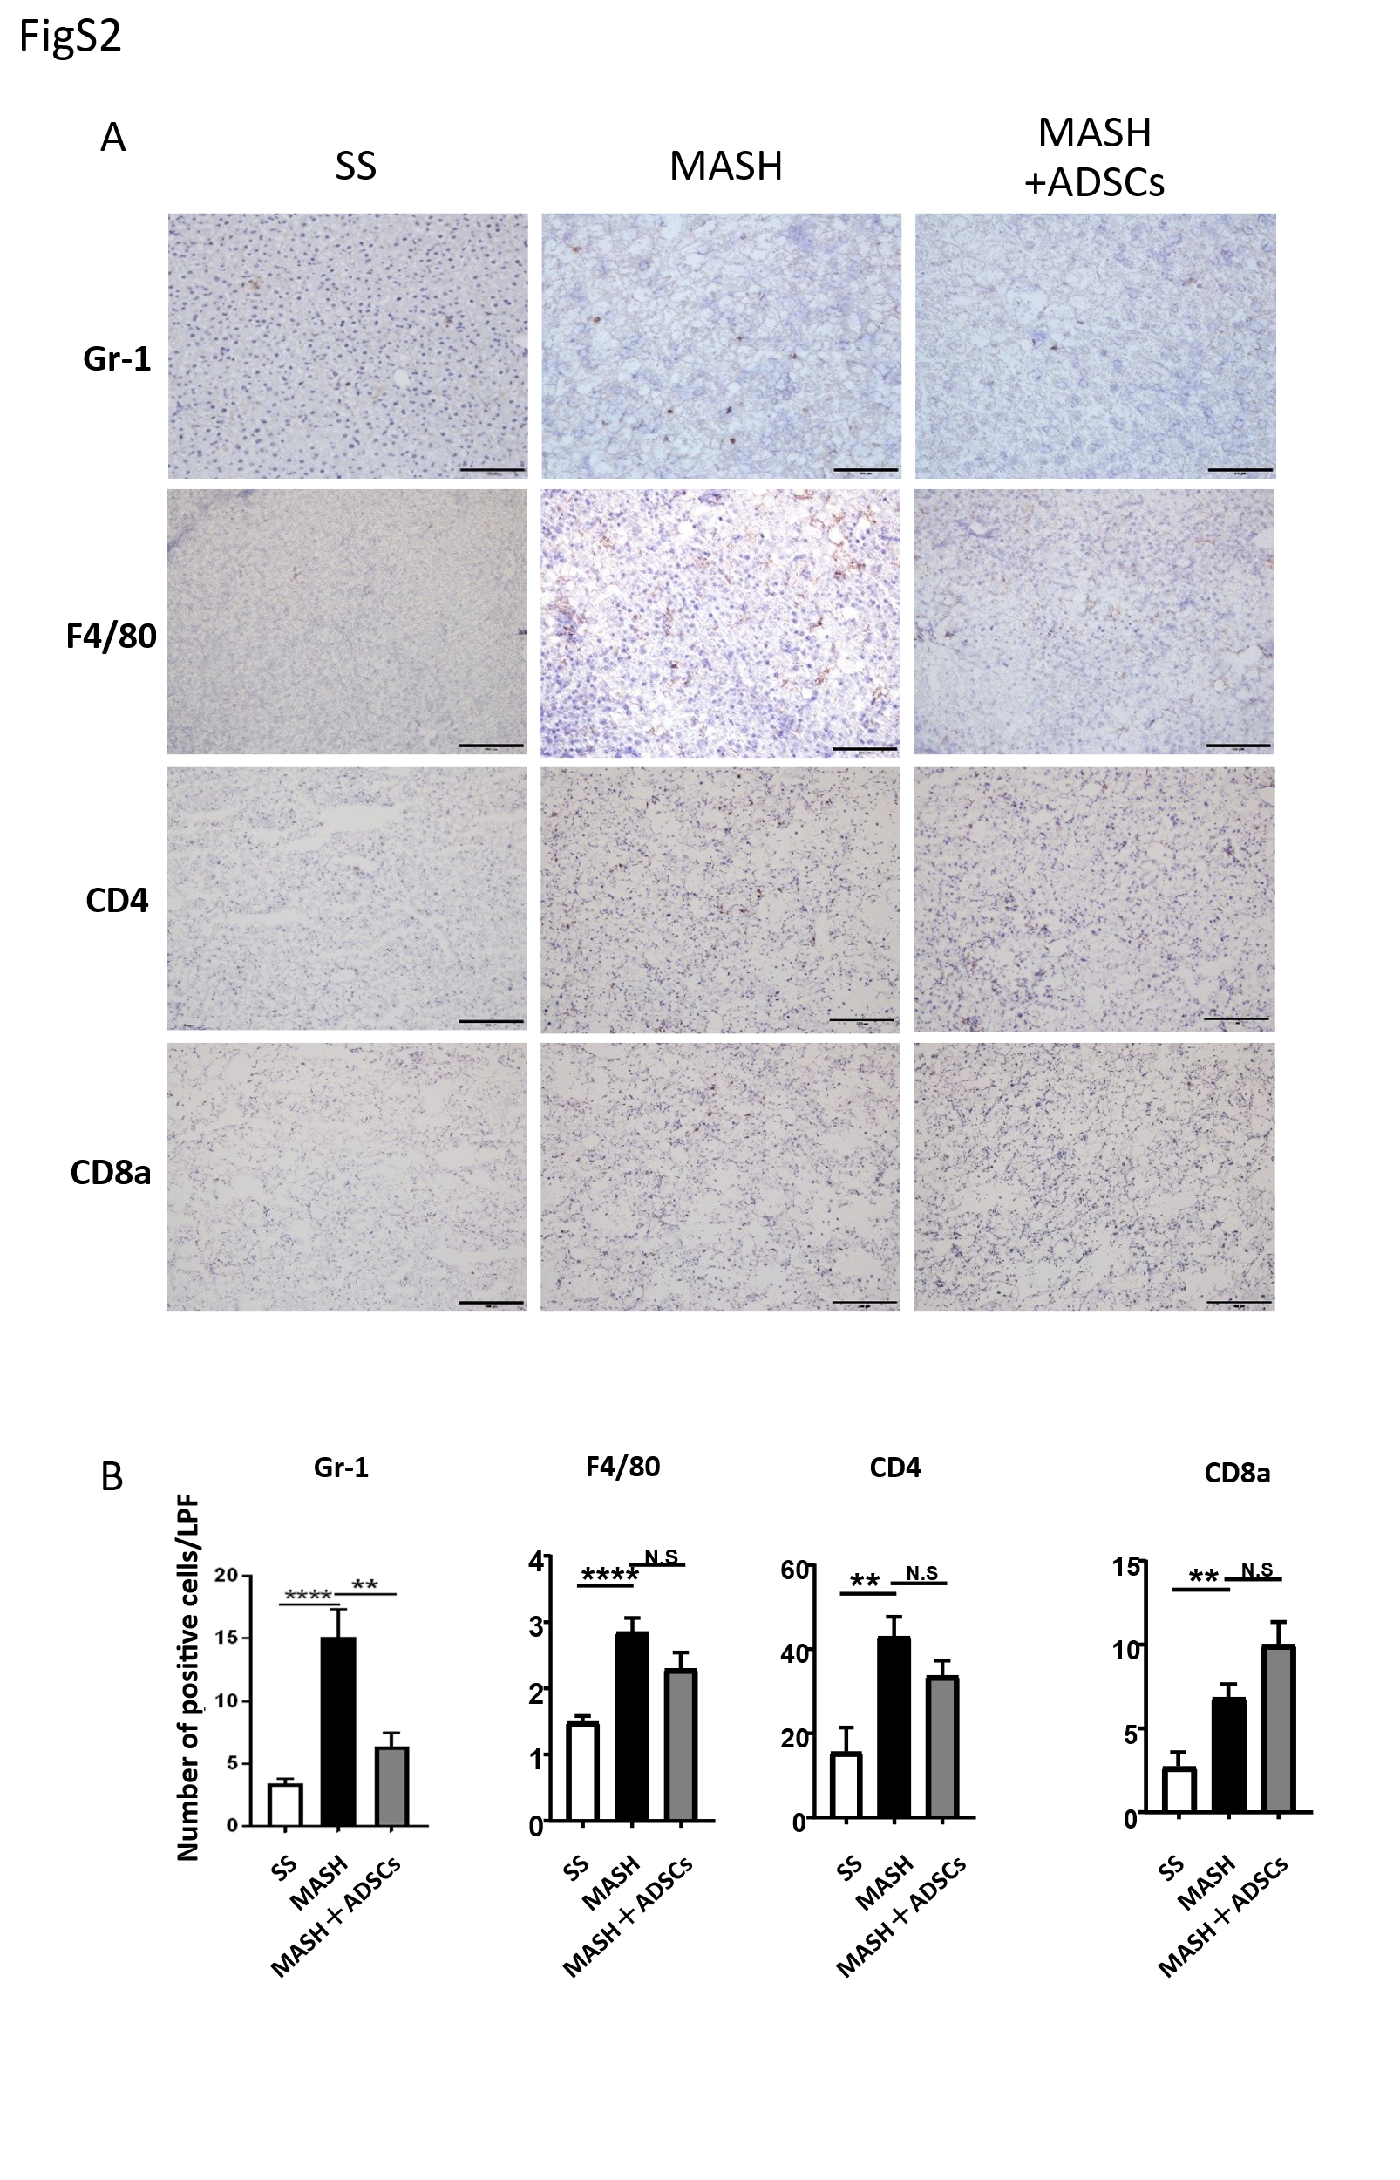
Figure S2. ADSC treatment reduces hepatic immune cell infiltration in MASH mice.
ADSCs (2×10⁵ cells) were administered into the splenic subcapsule at weeks 8 and 10 from the initiation of AT+HF feeding. Liver tissues were collected two weeks after the final injection for immunohistochemical analysis. (A) Liver sections were stained with antibodies against α-SMA, Gr-1 (neutrophils), F4/80 (macrophages), CD4, or CD8a (T cells). Each scale bar: 200 μm. (B) Quantification of positive cell number or staining area was performed using ImageJ. Data represent mean ± SEM, n=3 per group, **P<0.01, ****P<0.001

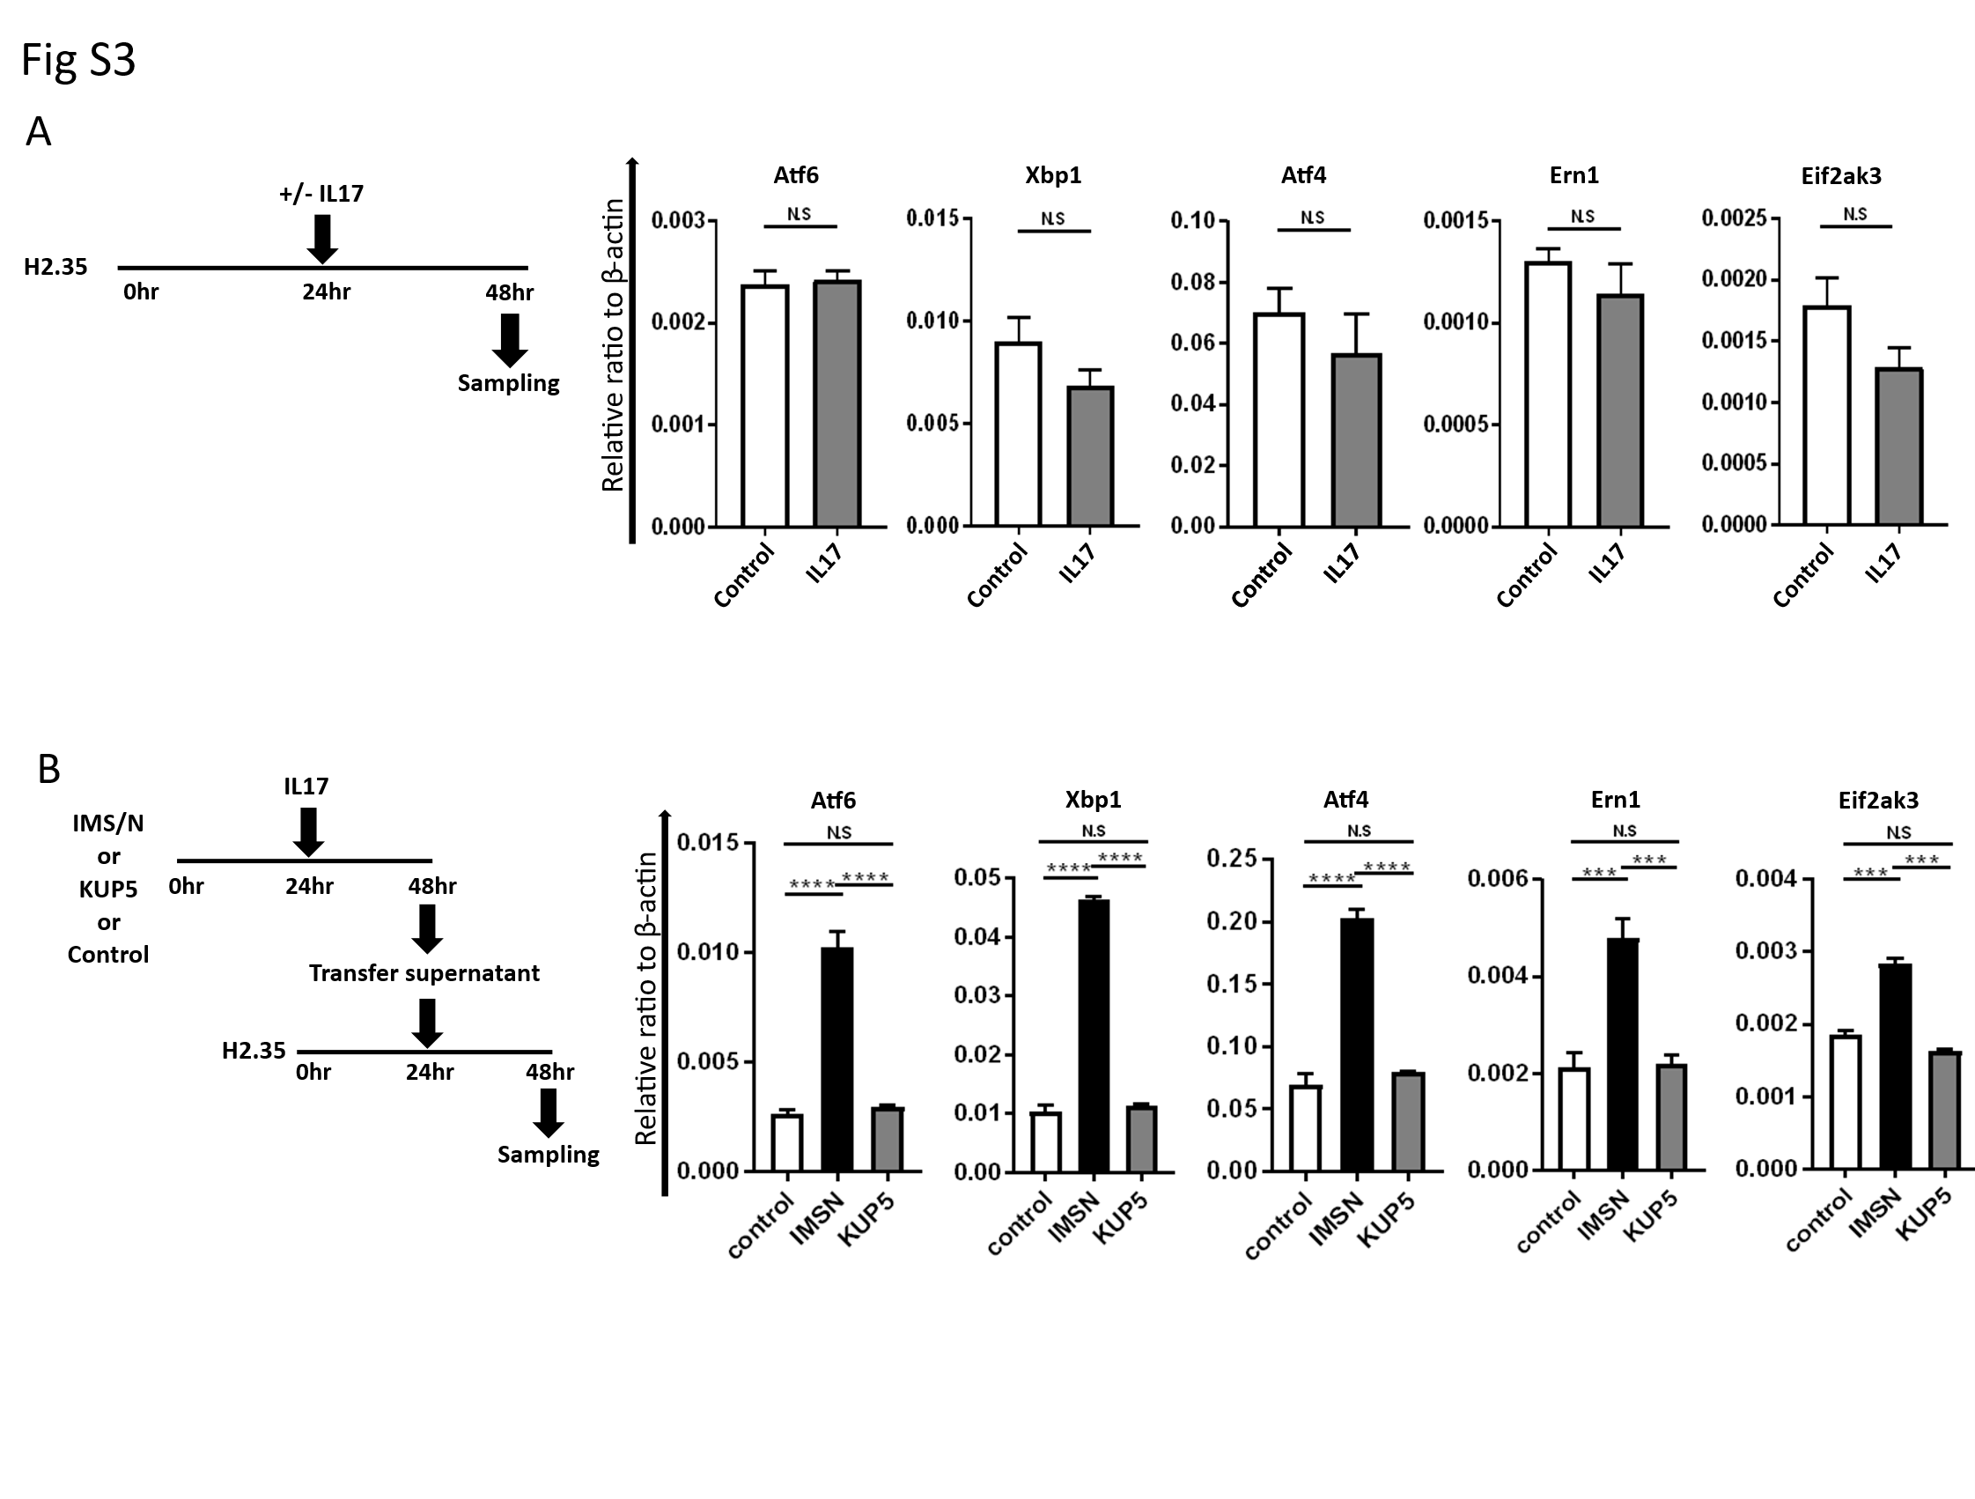
Figure S3. The UPR-related gene expression analysis of H2.35 cells.
(A) H2.35 cells were directly treated with IL-17, and UPR-related gene expression was analyzed by Quantitative real-time PCR (qRT-PCR). n=3; results show no significant difference (N.S. = not significant). (B) H2.35 cells were cultured in conditioned media from IMS/N or KUP5 cells pre-treated with IL-17.UPR-related gene expression was analyzed by qRT-PCR. n=3 per group. ***P<0.005, ****P<0.001.

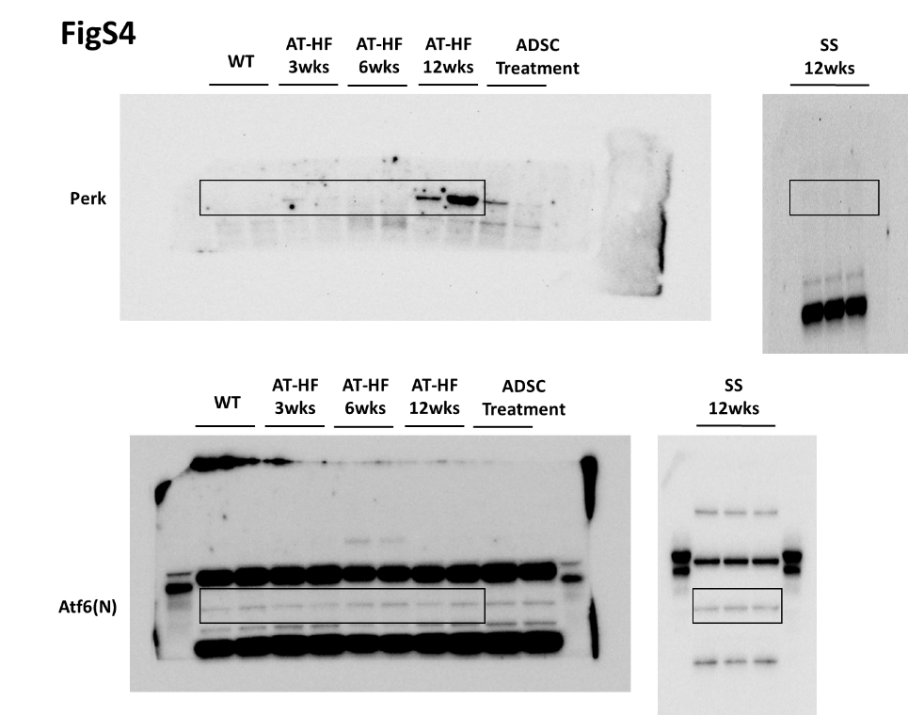
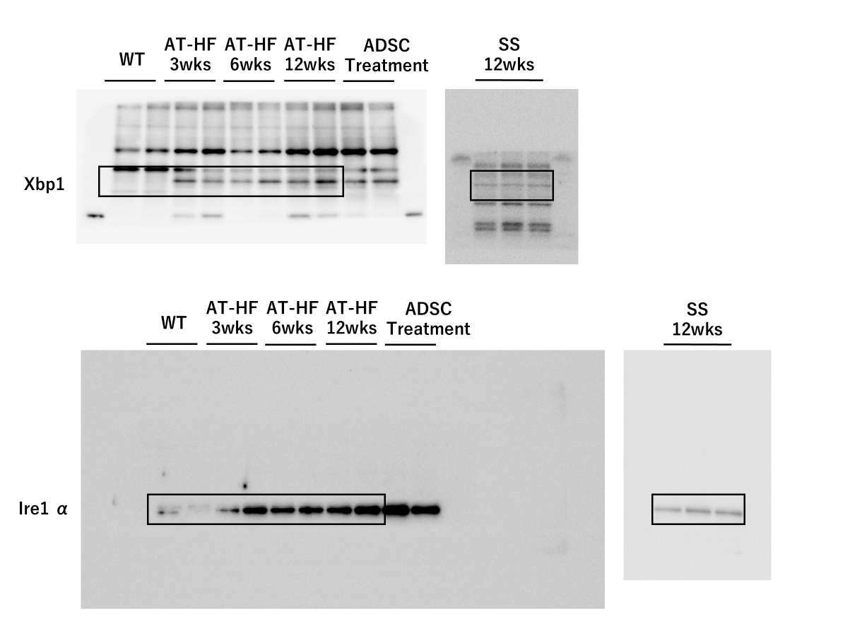

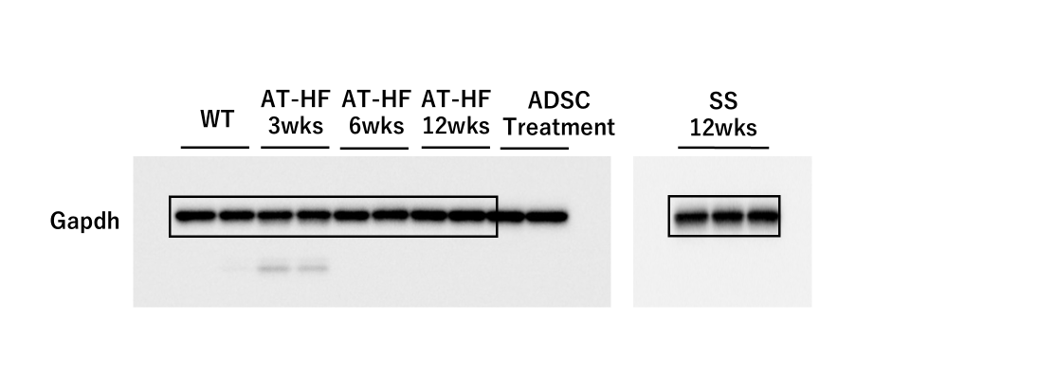

Figure S4. Full Western blot images for figure 1G. Uncropped immunoblots of UPR-related proteins from liver tissues of MASH and SS mice.
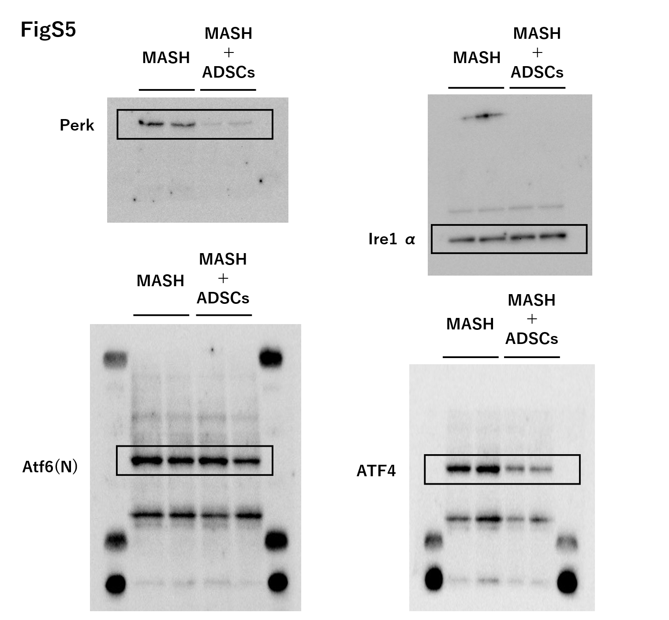

Figure S5. Full Western blot images for figure 2A. Uncropped blots showing UPR protein expression in MASH mice with or without ADSC treatment.

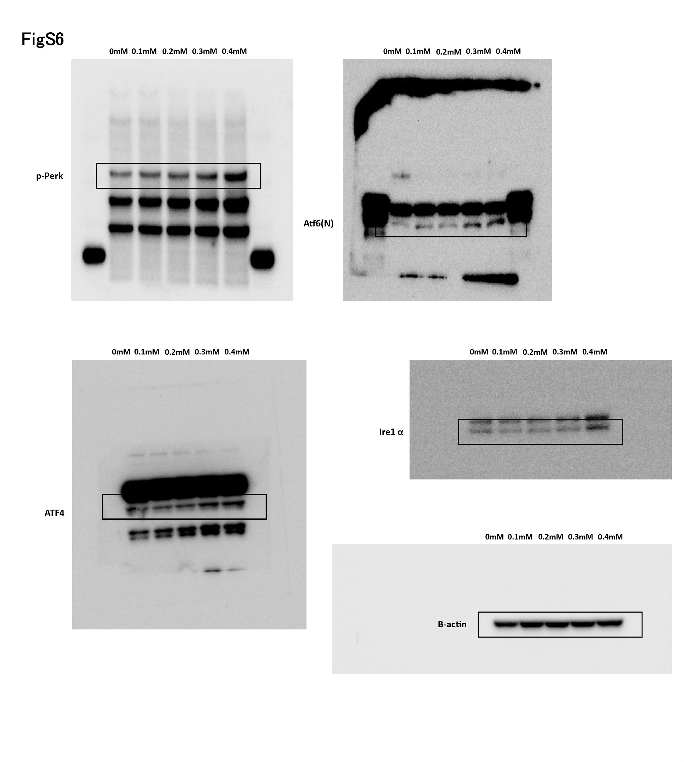
Figure S6. Full Western blot images for figure 3B. Uncropped blots of UPR-related proteins in H2.35 steatohepatitis model with or without ADSC co-culture.
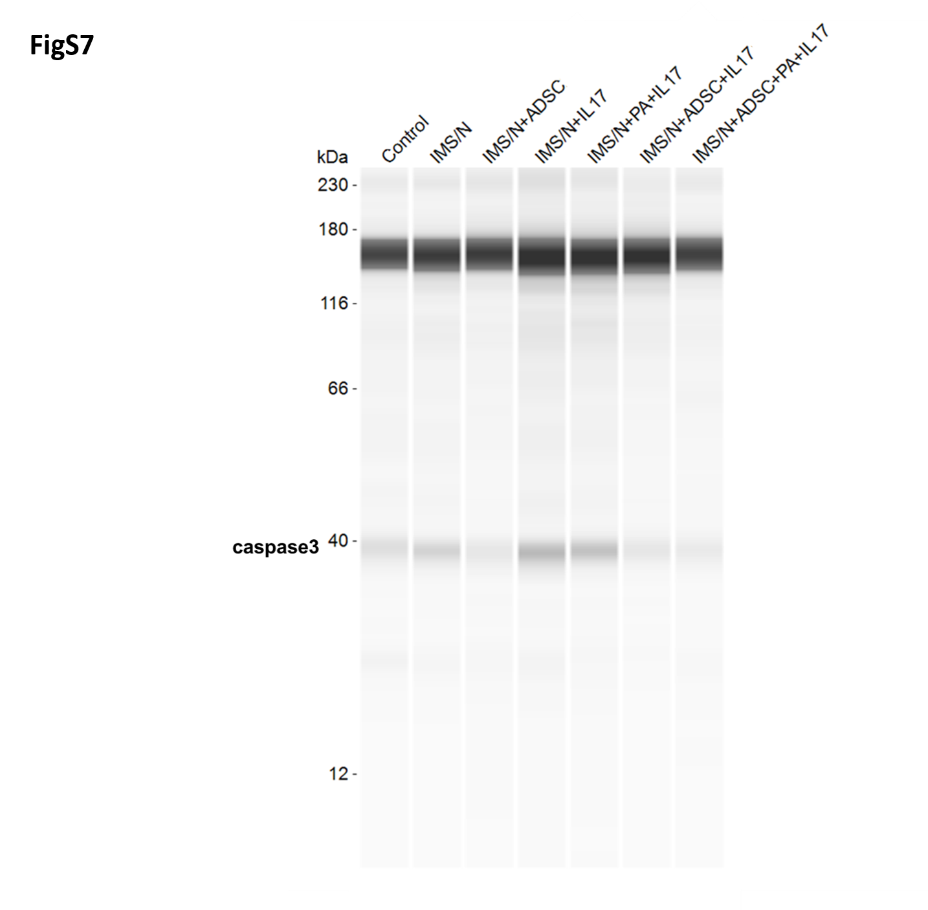

Figure S7. Full Western blot images for figure 5D. Uncropped western blot showing caspase-3 expression in hepatocytes treated with supernatants from IL-17 or PA-stimulated IMS/N with or without ADSC co-culture.

Table S1. Antibodies and probes used in the analysis
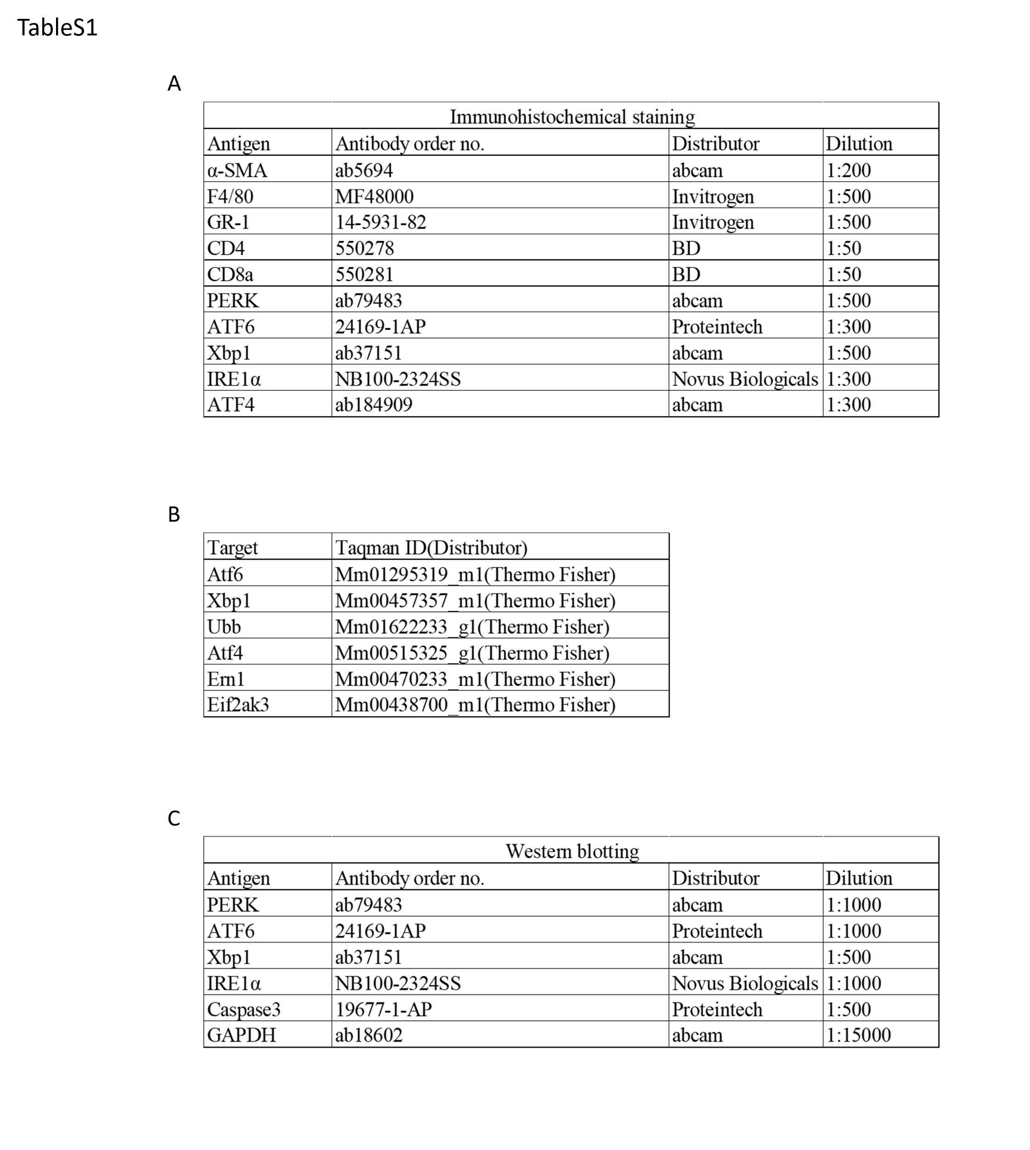

Table S2. MetaCore pathway enrichment of upregulated genes (1580; FC≥1.5) in IMSN+PA and downregulated in IMSN.
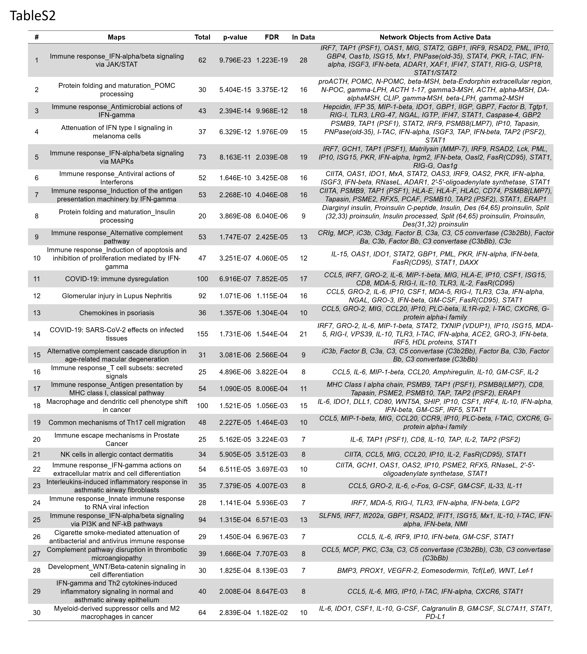

Table S3. MetaCore pathway enrichment of upregulated genes (861; FC≥1.5) in IMSN+IL17A and downregulated in IMSN.
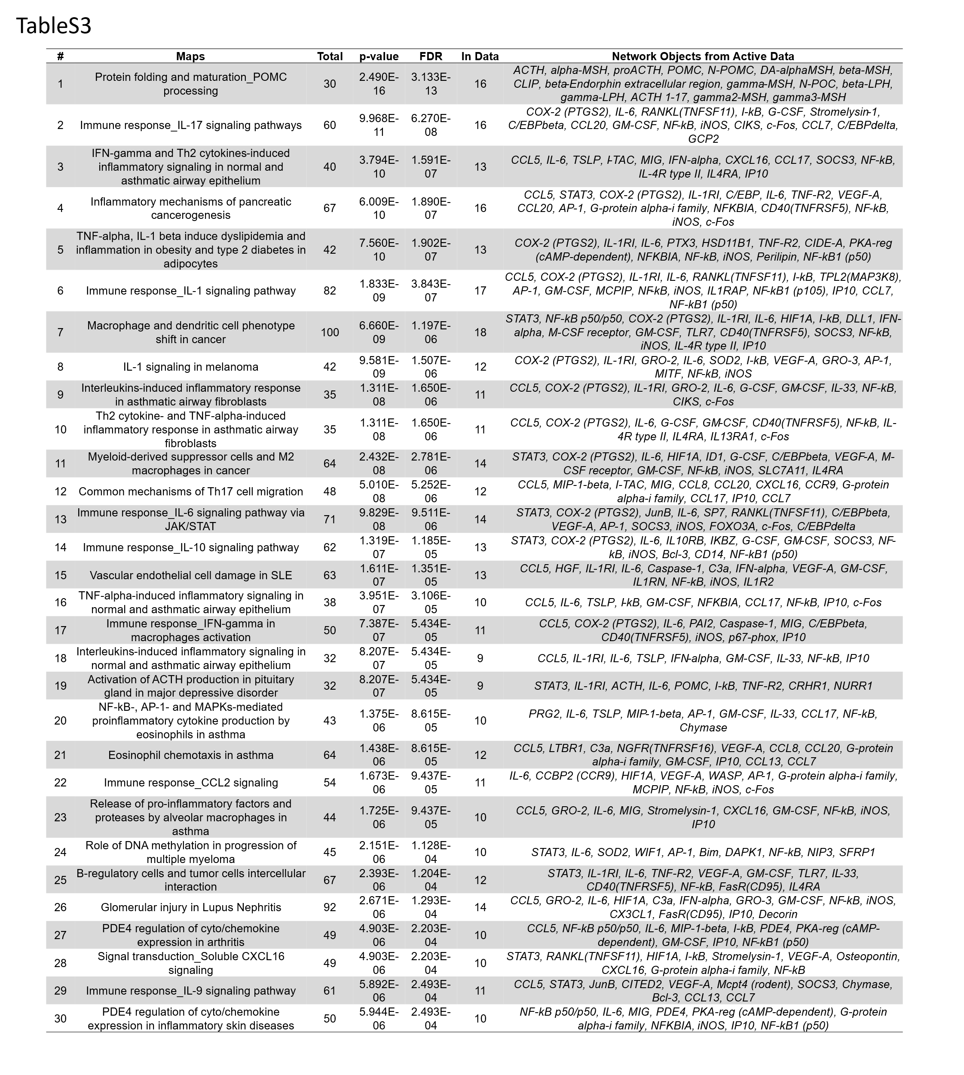

Table S4. MetaCore enrichment analysis of upregulated genes (920; FC≥1.5) in IMSN+PA and downregulated in IMSN+PA+ADSC media.
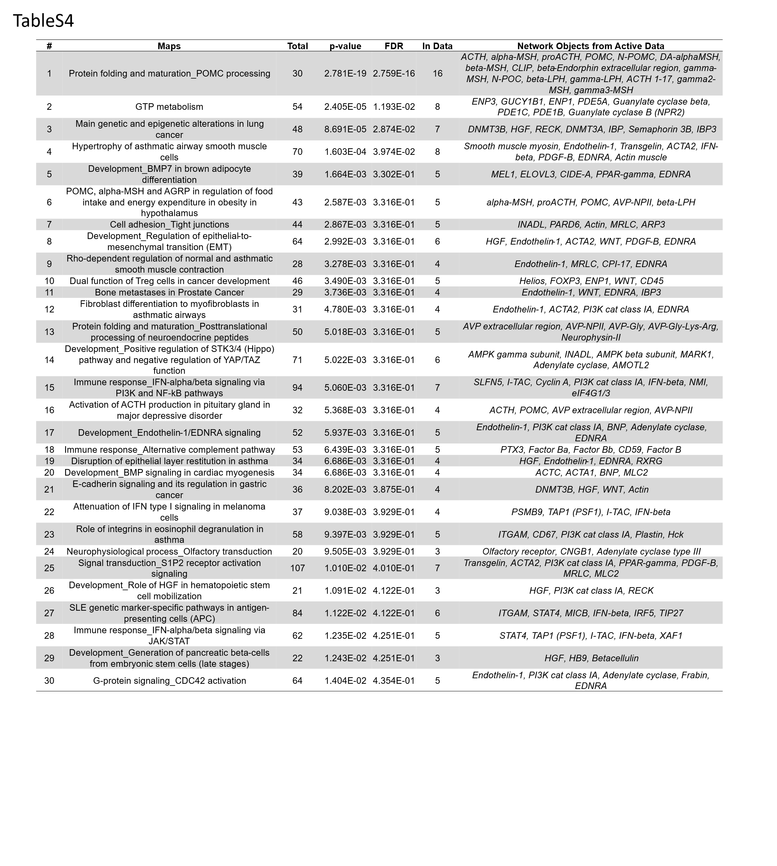

Table S5. MetaCore enrichment of genes (1193; FC≥1.5) in IMSN+IL17A and downregulated in IMSN+IL17A+ADSC media.
