Supplementary material
Human umbilical cord mesenchymal stem cell-derived exosomes enhance follicular regeneration in androgenetic alopecia via activation of Wnt/β-catenin pathway
Aiqing Yu ^{1,2,3#}, Yujun Zhang^{4*#}, Saifeng Zhong^{1,2}, Zhizhen Yang⁴ and Mingming Xie⁴
¹Department of Clinical Laboratory, Hunan Provincial People’s Hospital, The First-Affiliated Hospital of Hunan Normal University, Changsha 410000, China.
²Department of Immunology, Hunan Normal University Health Science Center, Changsha 410000, China.
³Hubei Provincial Clinical Research Center for Umbilical Cord Blood Hematopoietic Stem Cells, Hubei Key Laboratory of Embryonic Stem Cell Research, Taihe Hospital, Hubei University of Medicine, Shiyan 442000, Hubei, China.
⁴Beijing Xinghui Stem Cell Technology Co., Ltd., Beijing100010, China
* This is the corresponding author, Email: 18474926866@163.com
#Co-first author
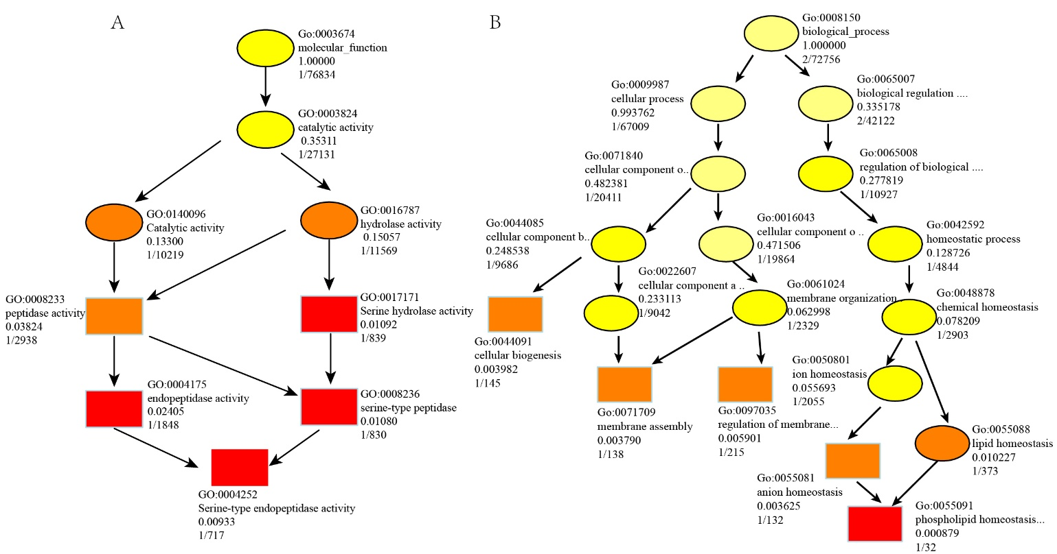
Figure S1 GO analysis of differentially expressed lncRNAs.
Directed acyclic graphs (DAGs) representing GO analysis of differentially expressed lncRNAs. Colors closer to red indicate more genes enriched in the corresponding pathway.

