Supporting Information for

Inflammatory cytokine-primed MSC-derived extracellular vesicles: a novel approach to combat COVID-19-induced ARDS

Jongwon Jeong^{1†}, Jun-Kook Park^{1†}, Jiwon Shin¹, Inseong Jung¹, Hyun-Woo Kim², Anyeseu Park³, Hanchae Cho⁴, Sung-Min Kang⁵, Sanghee Shin¹, Eunju Park¹, Jisuk Kim¹, Soojeong Noh¹, Yongdeok Ahn⁶, Do-Kyun Kim², Jeong Yoon Lee³, Daeha Seo⁶, Moon-Chang Baek^{5,*}, and Kyungmoo Yea^{1,7,*}
¹Department of New Biology, Daegu Gyeongbuk Institute of Science and Technology (DGIST), Daegu, 42988, Republic of Korea
²Korea Zoonosis Research Institute, Jeonbuk National University, Iksan 54531, South Korea. ³The Laboratory of Viromics and Evolution, Korea Zoonosis Research Institute, Jeonbuk National University, 820-120 Hana-ro, Iksan-si, Jeollabuk-do, 54531, Republic of Korea
⁴Department of Biomedical Science, School of Medicine, Kyungpook National University, Daegu, 41944, Republic of Korea
⁵Department of Molecular Medicine, Cell and Matrix Research Institute (CMRI), School of Medicine, Kyungpook National University, Daegu, 41944, Republic of Korea
⁶Department of Physics and Chemistry, Daegu Gyeongbuk Institute of Science and Technology (DGIST), Daegu, 42988, Republic of Korea
⁷New Biology Research Center, Daegu Gyeongbuk Institute of Science and Technology (DGIST), Daegu, 42988, Republic of Korea

†These authors contributed equally to this work.

Correspondence
Kyungmoo Yea, Department of New Biology and New Biology Research Center, Daegu Gyeongbuk Institute of Science and Technology (DGIST), Daegu, 42988, Republic of Korea
E-mail: ykm31@dgist.ac.kr
Moon-Chang Baek, Department of Molecular Medicine, Cell and Matrix Research Institute (CMRI), School of Medicine, Kyungpook National University, Daegu, 41944, Republic of Korea
E-mail: mcbaek@knu.ac.kr
Kyungmoo Yea and Moon-Chang Baek contributed equally to this work

Supporting Figures
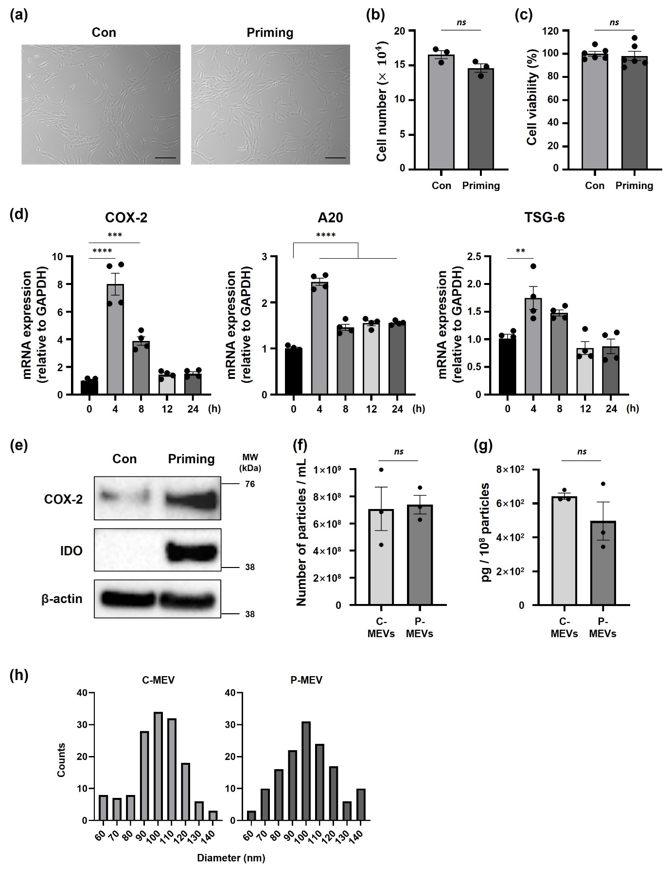
Supplementary figure 1. Characterization and immunomodulatory profiles of control and primed hADMSCs.
(a) Representative phase contrast images of control (Con) and primed (Priming) hADMSCs after 24 h incubation with IFN-γ (10 ng/mL) and TNF-α (15 ng/mL). Black bars represent 50 μm. (b) Cell proliferation determined by automated cell counting after 24 h of priming. n = 3. (c) Cell viability determined by MTS assay after 24 h of priming. n = 6. (d) mRNA expression levels of COX-2, A20, and TSG-6 over a given period of priming. n = 4. (e) Protein expression analysis of COX2, IDO, and β-actin after 24 h of priming (Full-length blots are presented in Supplementary Figure S8b). (f) The number of particles per curtured volume (mL). n = 3. (g) A bar graph measuring the protein content of C-MEVs and P-MEVs, presented as picograms (pg) of protein per 10⁸ particles. n = 3. (h) Histograms displaying the size distribution of C-MEVs and P-MEVs. n = 150. Data are presented as the mean ± standard error of the mean (SEM), analyzed by unpaired two-tailed Student's t-test for (b), (c), (f) and (g), and analyzed with a one-way ANOVA, followed by the Holm–Sidak multiple comparison test for (d). Statistical differences in post hoc tests are indicated as ns = not significant, **p < 0.01, ***p < 0.001, and ****p < 0.0001.

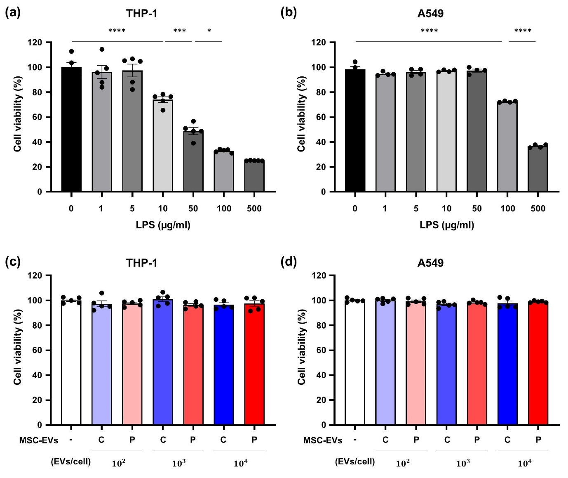
Supplementary figure 2. Effects of hADMSC-derived EVs and LPS on cell viability.
(a-d) Cell viability of THP-1 and A549 cells was evaluated by MTS assay. (a) THP-1 cells were treated with the indicated concentrations of LPS for 24 h. n = 5. (b) A549 cells were treated with the indicated concentrations of LPS for 24 h. n = 4. (c) THP-1 cells were treated with the indicated doses of C-MEVs or P-MEVs for 24 h. n = 5. (d) A549 cells were treated with the indicated doses of C-MEVs or P-MEVs for 24 h. n = 5. C, control; P, primed. Data are presented as the mean ± SEM, analyzed by one-way ANOVA, followed by the Holm–Sidak multiple comparison test. Statistical differences in post hoc tests are indicated as *p < 0.05, ***p < 0.001, and ****p < 0.0001.

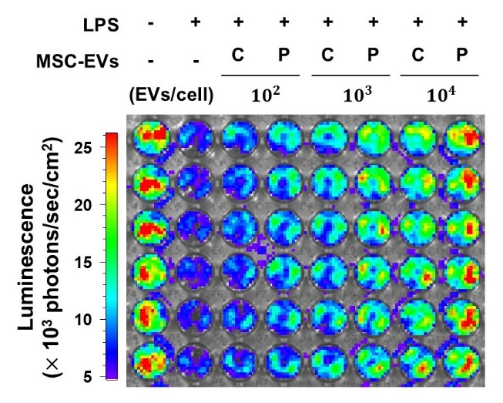
Supplementary figure 3. Evaluation of cell viability in lung epithelial cells.
A549 cells were pretreated with MSC-EVs (C-MEVs or P-MEVs) or PBS for 2 h, followed by exposure to LPS (500 μg/mL) for 24 h. Bioluminescence images of A549 cells were captured using an in vivo imaging system (IVIS). C, control; P, primed.

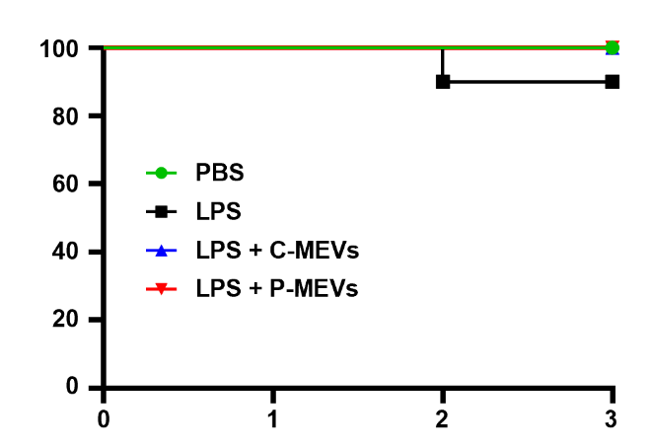
Supplementary figure 4.
Summary of survival outcomes during the 72-hour post-treatment period. One mouse (10%) in the LPS group died on day 2. All mice in the C-MEV and P-MEV groups survived throughout the observation period (n = 10 per group).

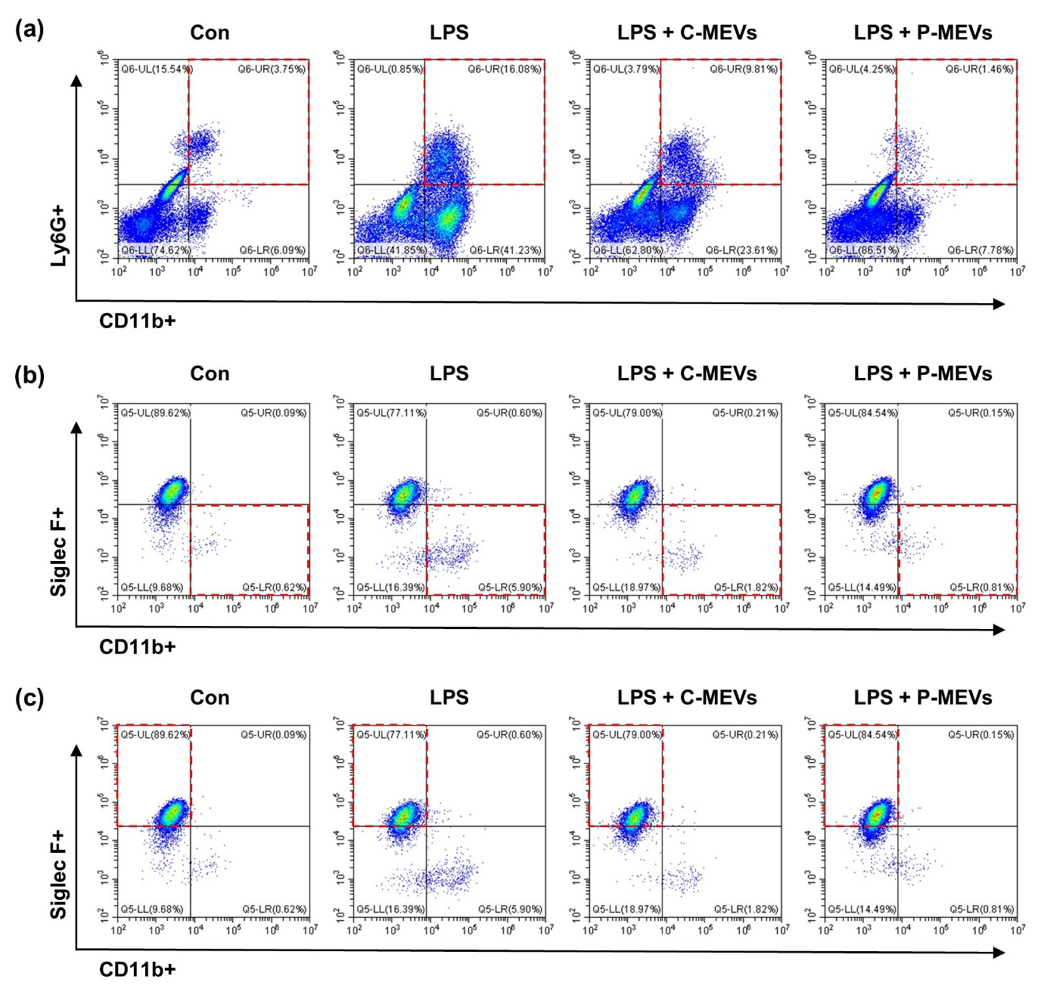
Supplementary figure 5. Flow cytometric analysis of immune cell accumulation in lung tissue.
C57BL/6 mice were challenged with LPS (5 mg/kg, intravenously), and then received daily injections of PBS or MSC-EVs (6 $×{10}^{9}$ particles, intravenously). Flow cytometric analysis of (a) neutrophils (CD11b+ Ly6G+), (b) monocyte-derived macrophages (Siglec F- CD11b+ on CD11c+ F4/80+), and (c) alveolar macrophages (Siglec F+ CD11b- on CD11c+ F4/80+) accumulation in lung tissue at 72 h after LPS injection. C-MEVs, control MSC-EVs; P-MEVs, primed MSC-EVs.

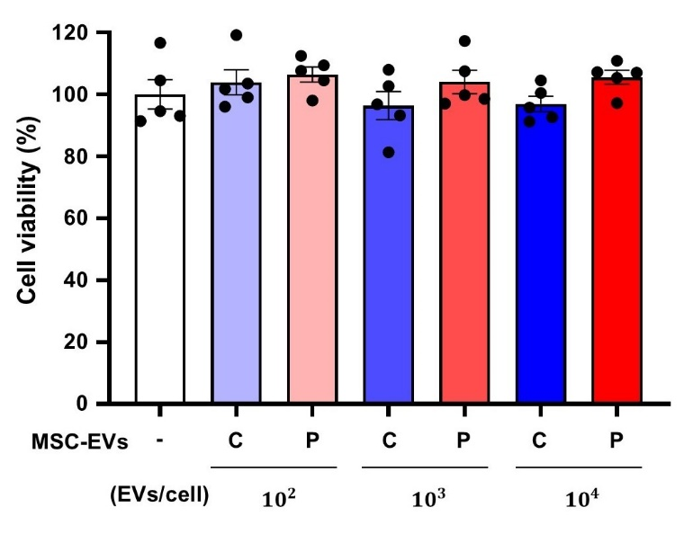
Supplementary figure 6. Effects of hADMSC-derived EVs on Vero E6 cell viability.
Cell viability of Vero E6 cells was assessed by the MTS assay. Cells were treated with the indicated doses of C-MEVs or P-MEVs for 48 h. n = 5. C, control; P, primed. Data are presented as the mean ± SEM.

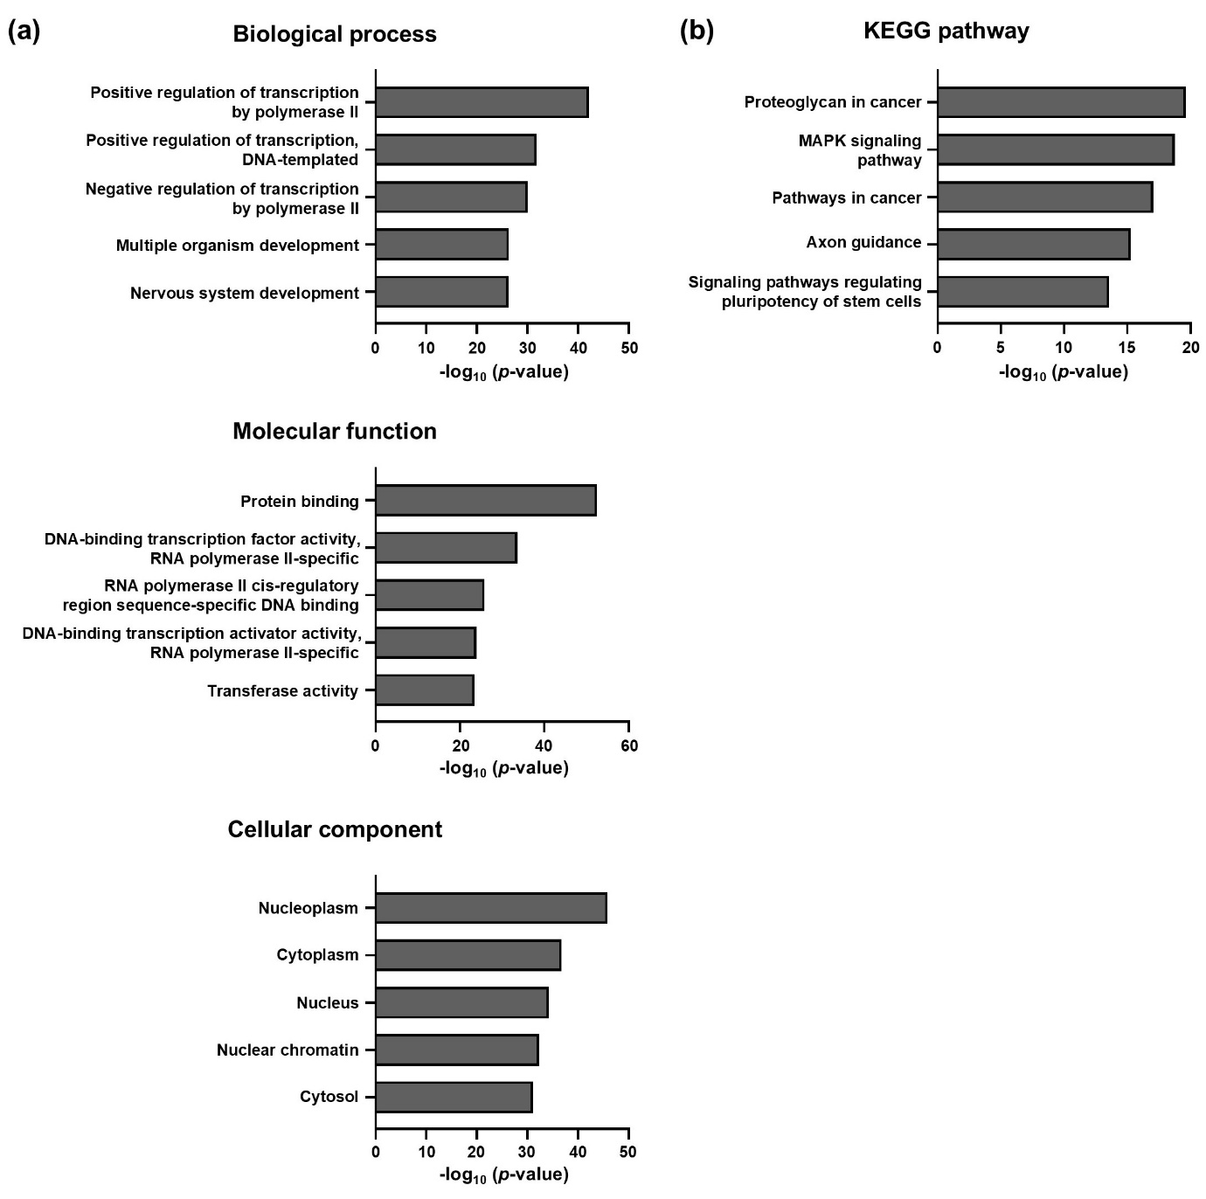
Supplementary figure 7. GO and KEGG pathway analysis of the 10 miRNAs highly expressed in P-MEVs.
(A) GO analysis of miRNA target genes. The top five enriched GO terms of the 10 miRNAs highly expressed in P-MEVs. (B) Top five canonical pathways of the 10 miRNAs highly expressed in P-MEVs. P-MEVs, primed MSC-EVs.

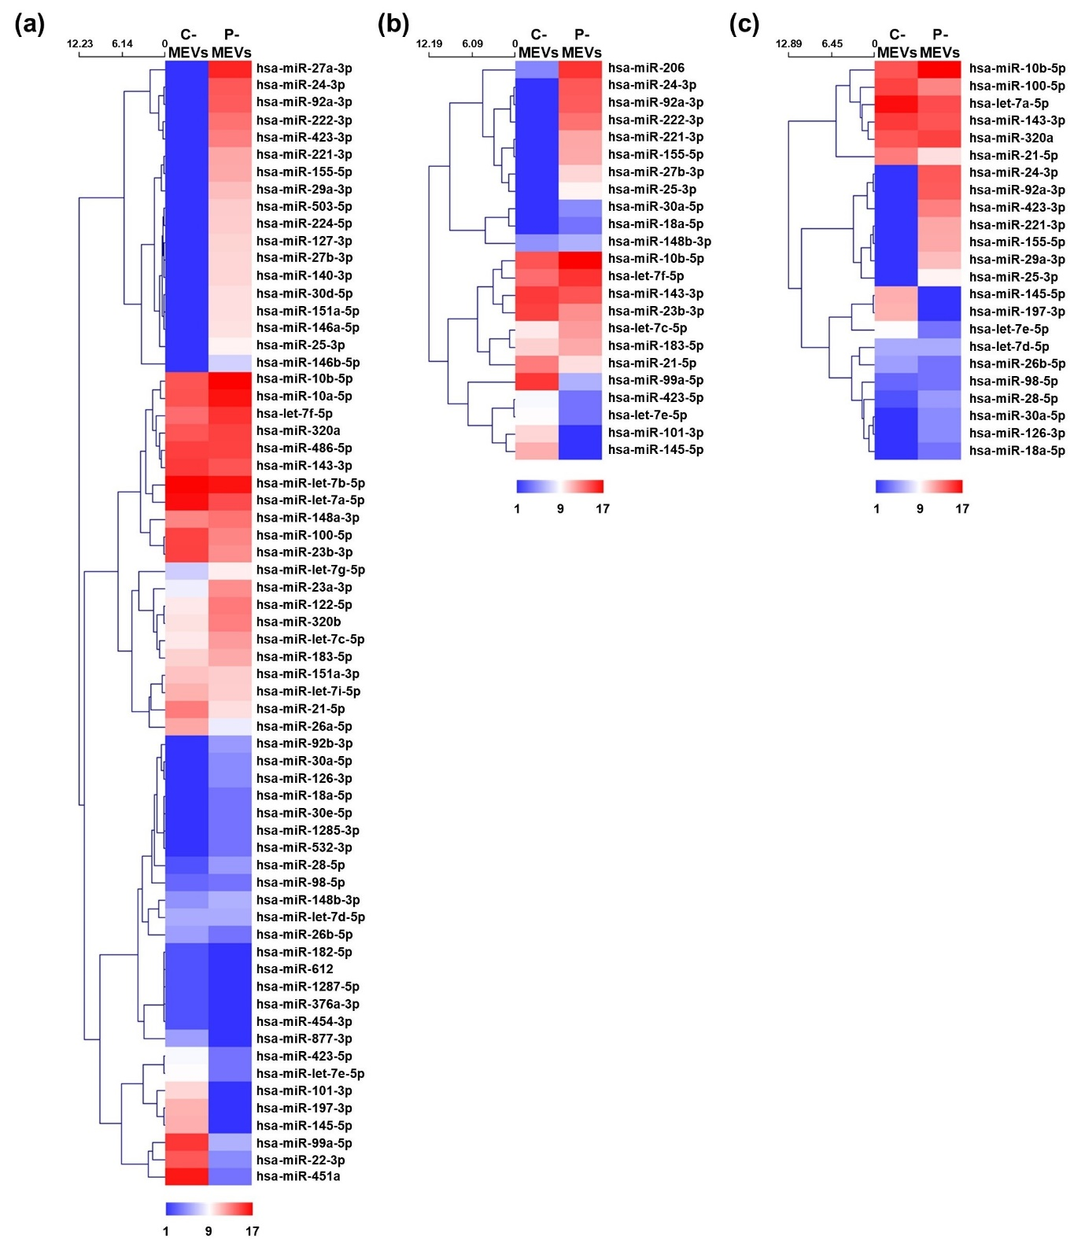
Supplementary figure 8. Heatmap analysis of miRNAs in C-MEVs and P-MEVs.
Heatmaps of immune response (A), tissue regeneration (B), and negative regulation of inflammation (C) in C-MEVs and P-MEVs. C-MEVs, control MSC-EVs; P-MEVs, primed MSC-EVs.

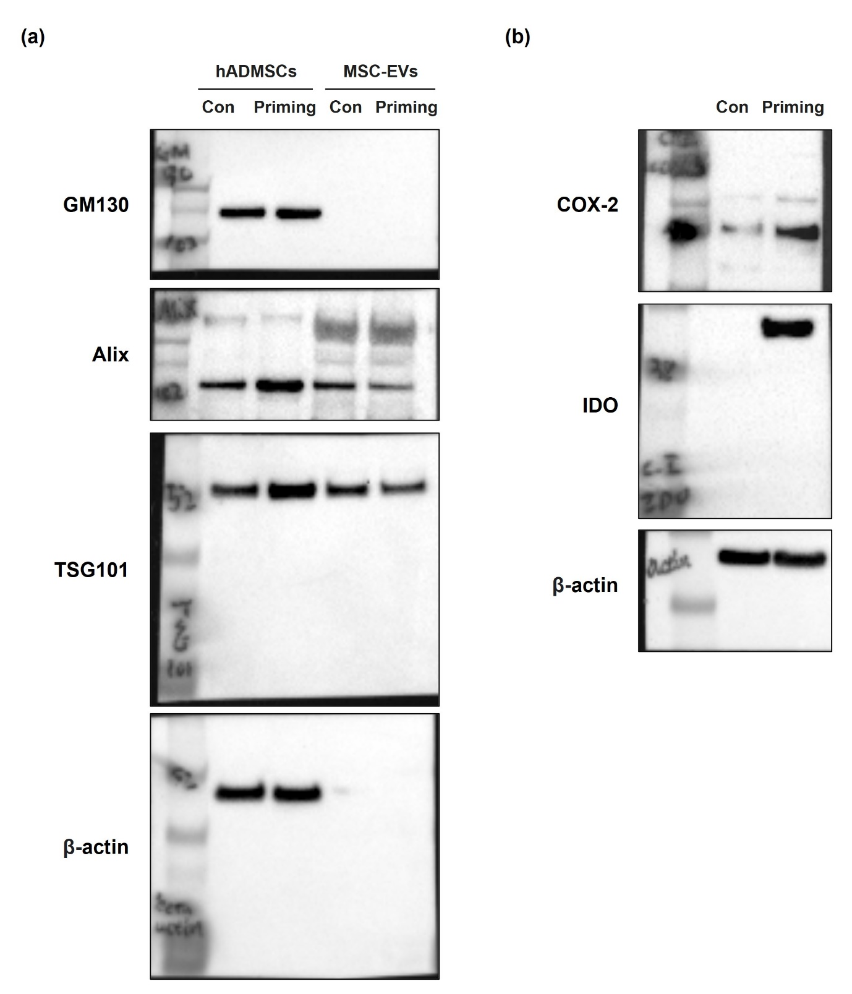
Supplementary figure 9. Full-length blots.
Full length blots of Figure 1e (A) and Supplementary Figure 1e (B).

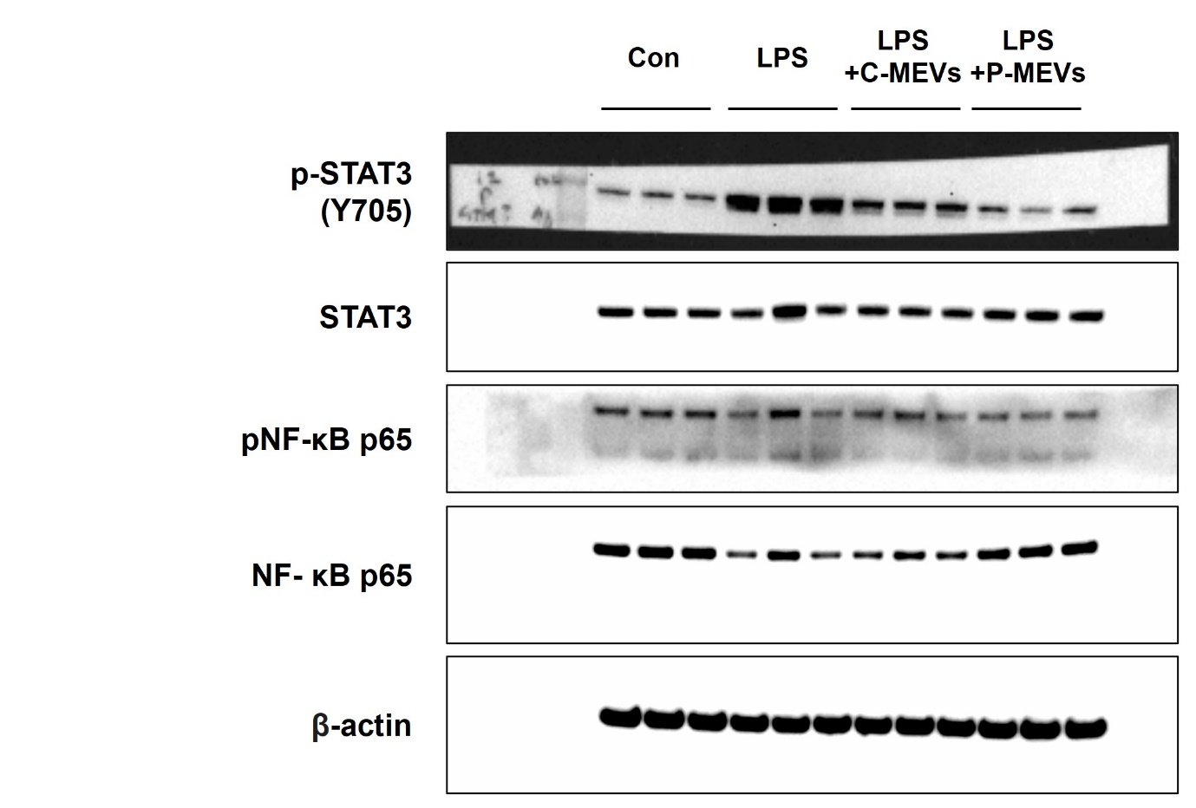
Supplementary figure 10. Full-length blots.
Full length blots of Figure 4e.

Table S1. List of primers and their sequences for qRT-PCR
Gene | Species | Forward | Reverse
TNF-α | Human | CTGCTGCACTTTGGAGTGAT | AGATGATCTGACTGCCTGGG
IL-1β | Human | GTGGCAATGAGGATGACTTGTTC | TAGTGGTGGTCGGAGATTCGTA
IL-6 | Human | AGCCACTCACCTCTTCAGAAC | GCCTCTTTGCTGCTTTCACAC
GAPDH | Human | TGCACCACCAACTGCTTAGC | GGCATGGACTGTGGTCATGAG
TNF-α | Mouse | GGTGCCTATGTCTCAGCCTCTT | GCCATAGAACTGATGAGAGGGAG
IL-1β | Mouse | CTTCAGGCAGGCAGTATCACTC | TTGTTGTTCATCTCGGAGCC
IL-6 | Mouse | TACCACTTCACAAGTCGGAGGC | CTGCAAGTGCATCATCGTTGTTC
GAPDH | Mouse | TCACCACCATGGAGAAGGC | GCTAAGCAGTTGGTGGTGCA
TNF-α | Monkey | CCTCTCTCTAATCAGCCCTCTG | GAGGACCTGGGAGTAGATGAG
IL-1β | Monkey | AGGTCCTGTGCTGAATGTCG | TGGGAGAGGTAAGAGAGGCC
IL-6 | Monkey | AAGGAGACATGTAACAGGAG | CTAGGTATACCTCAAACTCC
CCL2 | Monkey | CCCCTAGTTTTCCCCTGTTT | CATCCCAGGGATAGAACTGTGG
CXCL10 | Monkey | GTGGCATTCAAGGAGTACCTC | GCCTTCGATTCTGGATTCAGACA
GAPDH | Monkey | CATGACCACAGTCCACGCCATC | GATGACCTTGCCCACAGCCTTG

