Supplementary Materials

Supplementary Table S1. Search strategies in four databases (Search Cut-off Date: March 1, 2025).
Databases | No. | Query | Results
Pubmed | #1 | “Mesenchymal stromal cell” OR “Mesenchymal stem cell” OR “MSC” OR “Multipotent stromal cell” OR “Wharton Jelly Cells” OR “Bone Marrow Stromal Cells” OR “Multipotent Bone Marrow Stromal Cells” OR “Bone Marrow Stromal Stem Cells” OR “Mesenchymal Progenitor Cells” OR “Multipotent Mesenchymal Stromal Cells” OR “Bone Marrow Mesenchymal Stem Cells” OR “Adipose Derived Mesenchymal Stem Cells” | 79,346
Pubmed | #2 | “Osteoarthritis” OR “Osteoarthritides” OR “Degenerative Arthritides” OR “Degenerative Arthritis” OR “Osteoarthrosis” OR “Osteoarthroses” OR “Osteoarthrosis Deformans” OR “Arthrosis” OR “Arthroses” | 133,280
Pubmed | #3 | “controlled clinical trial” OR “randomized controlled trial” OR “RCT” | 809,627
Pubmed | #4 | #1 AND #2 AND #3 | 89
Cochrane Library | #5 | (Mesenchymal stromal cell):ab,ti,kw OR (Mesenchymal stem cell):ab,ti,kw OR (MSC):ab,ti,kw OR (Multipotent stromal cell):ab,ti,kw OR (Wharton Jelly Cells):ab,ti,kw OR (Bone Marrow Stromal Cells):ab,ti,kw OR (Multipotent Bone Marrow Stromal Cells):ab,ti,kw OR (Bone Marrow Stromal Stem Cells):ab,ti,kw OR (Mesenchymal Progenitor Cells):ab,ti,kw OR (Multipotent Mesenchymal Stromal Cells):ab,ti,kw OR (Bone Marrow Mesenchymal Stem Cells):ab,ti,kw OR (Adipose Derived Mesenchymal Stem Cells):ab,ti,kw | 2,755
Cochrane Library | #6 | (Osteoarthritis):ab,ti,kw OR (Osteoarthritides):ab,ti,kw OR (Degenerative Arthritides):ab,ti,kw OR (Degenerative Arthritis):ab,ti,kw OR (Osteoarthrosis):ab,ti,kw OR (Osteoarthroses):ab,ti,kw OR (Osteoarthrosis Deformans):ab,ti,kw OR (Arthrosis):ab,ti,kw OR (Arthroses):ab,ti,kw | 26,186
Cochrane Library | #7 | (controlled clinical trial):ab,ti,kw OR (randomized controlled trial):ab,ti,kw OR (RCT):ab,ti,kw | 846,997
Cochrane Library | #8 | #5 AND #6 AND #7 | 144
Web of Science | #9 | TS=(Mesenchymal stromal cell OR Mesenchymal stem cell OR MSC OR Multipotent stromal cell OR Wharton Jelly Cells OR Bone Marrow Stromal Cells OR Multipotent Bone Marrow Stromal Cells OR Bone Marrow Stromal Stem Cells OR Mesenchymal Progenitor Cells OR Multipotent Mesenchymal Stromal Cells OR Bone Marrow Mesenchymal Stem Cells OR Adipose Derived Mesenchymal Stem Cells) | 81,698
Web of Science | #10 | TS=(Osteoarthritis OR Osteoarthritides OR Degenerative Arthritides OR Degenerative Arthritis OR Osteoarthrosis OR Osteoarthroses OR Osteoarthrosis Deformans OR Arthrosis OR Arthroses) | 57,880
Web of Science | #11 | TS=(controlled clinical trial OR randomized controlled trial OR RCT) | 282,851
Web of Science | #12 | #9 AND #10 AND #11 | 250
Embase | #13 | ('Mesenchymal stromal cell':ab,ti,kw OR 'Mesenchymal stem cell':ab,ti,kw OR 'MSC':ab,ti,kw OR 'Multipotent stromal cell':ab,ti,kw OR 'Wharton Jelly Cells':ab,ti,kw OR 'Bone Marrow Stromal Cells':ab,ti,kw OR 'Multipotent Bone Marrow Stromal Cells':ab,ti,kw OR 'Bone Marrow Stromal Stem Cells':ab,ti,kw OR 'Mesenchymal Progenitor Cells':ab,ti,kw OR 'Mesenchymal Stromal Cells':ab,ti,kw OR 'Bone Marrow Mesenchymal Stem Cells':ab,ti,kw OR 'Adipose Derived Mesenchymal Stem Cells':ab,ti,kw) | 87,557
Embase | #14 | ('Osteoarthritis':ab,ti,kw OR 'Osteoarthritides':ab,ti,kw OR 'Degenerative Arthritides':ab,ti,kw OR 'Degenerative Arthritis':ab,ti,kw OR 'Osteoarthrosis':ab,ti,kw OR 'Osteoarthroses':ab,ti,kw OR 'Osteoarthrosis Deformans':ab,ti,kw OR 'Arthrosis':ab,ti,kw OR 'Arthroses':ab,ti,kw) | 153,312
Embase | #15 | ('controlled clinical trial':ab,ti,kw OR 'randomized controlled trial':ab,ti,kw OR 'RCT':ab,ti,kw) | 244,296
Embase | #16 | #13 AND #14 AND #15 | 44
Total | #13 | #4 AND #8 AND #12 AND #16 | 527

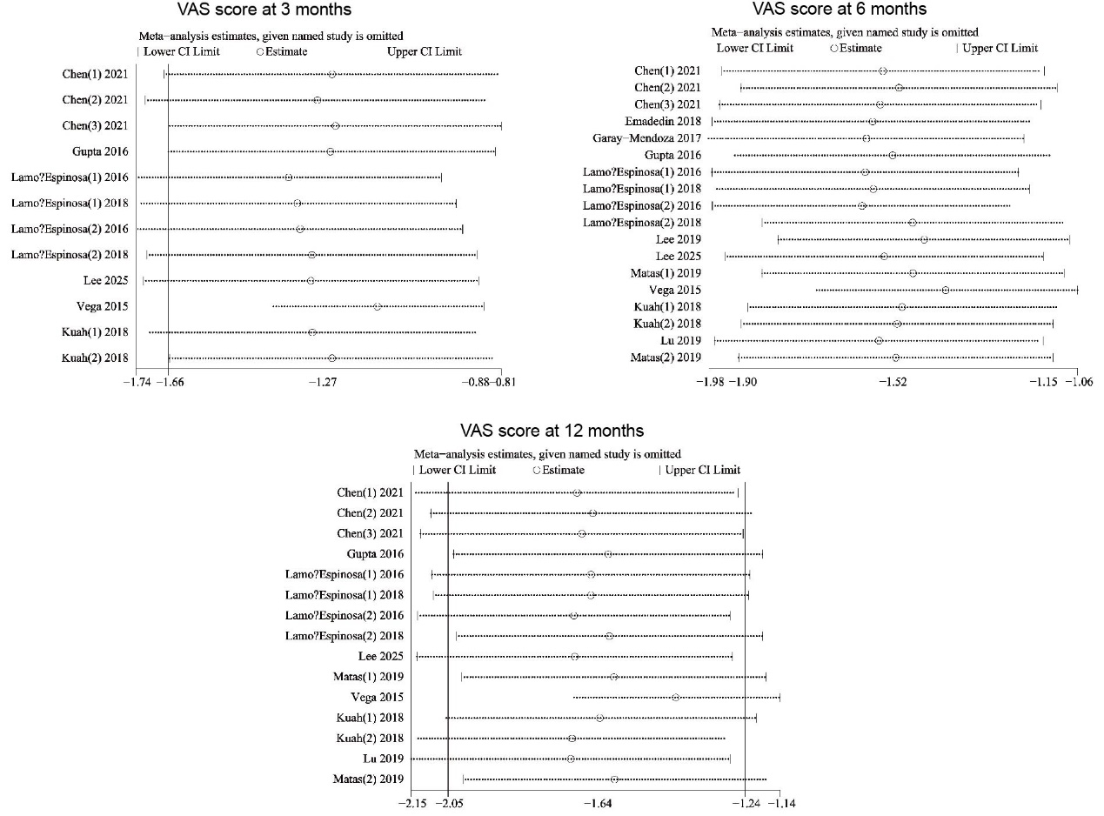
Supplementary Figure S1. Sensitivity analysis of VAS score at 3, 6, and 12 months in traditional meta-analysis.
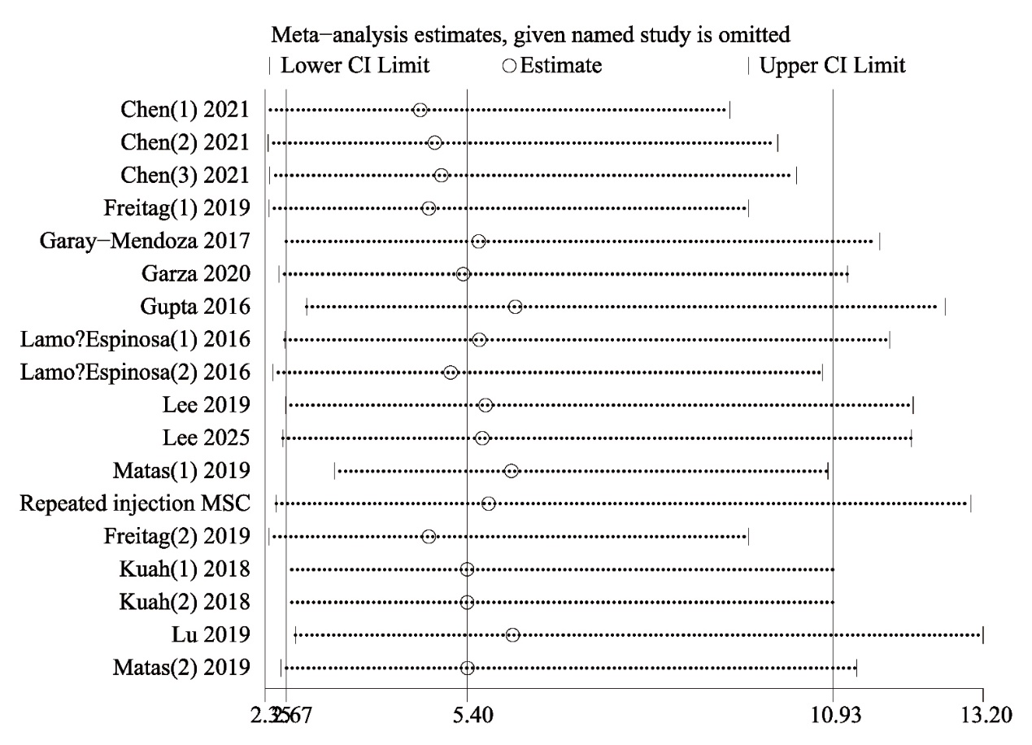
Supplementary Figure S2. Sensitivity analysis of adverse events in traditional meta-analysis.

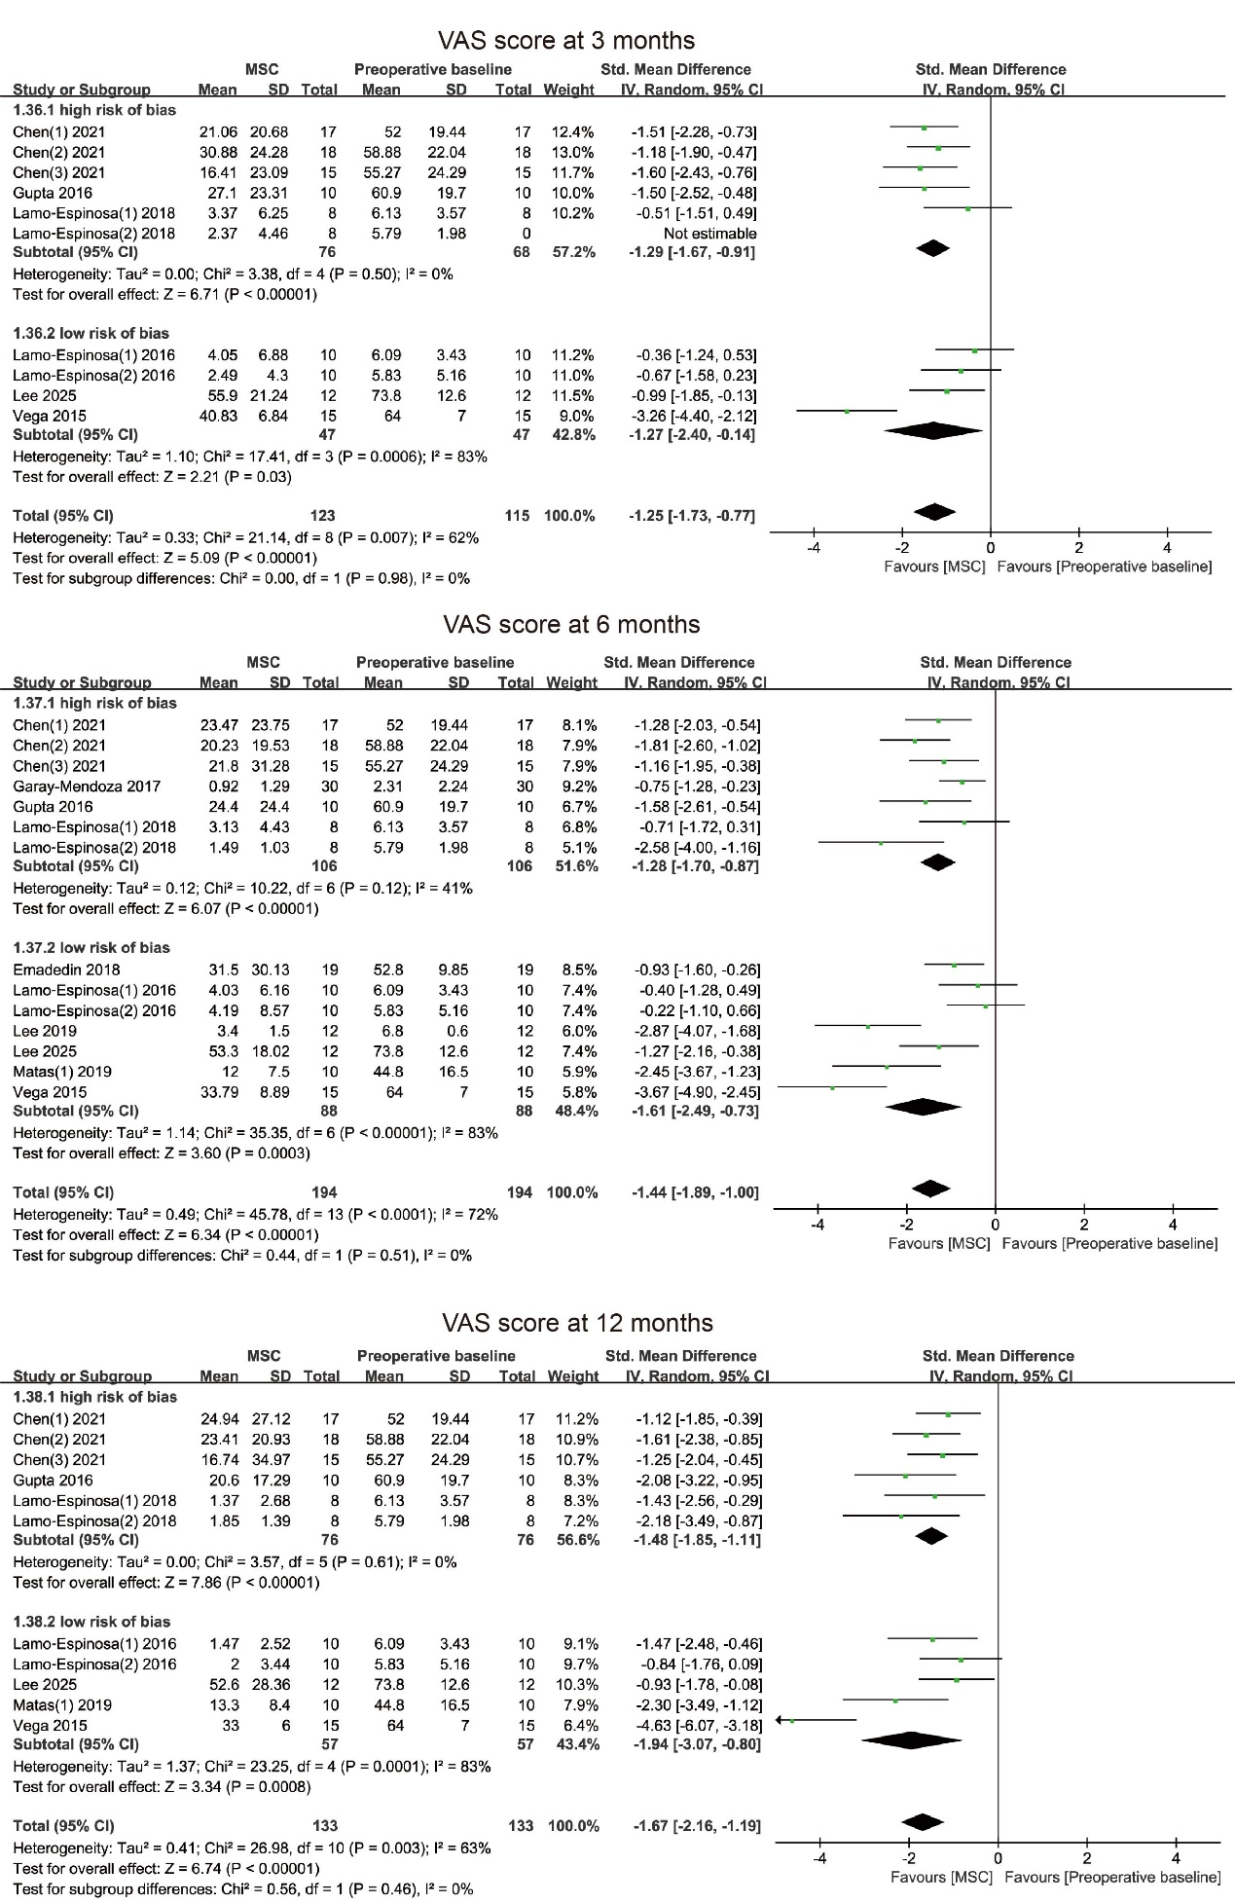
Supplementary Figure S3. Subgroup analysis of VAS score after single injection MSC at 3, 6, and 12 months based on different risk of bias.
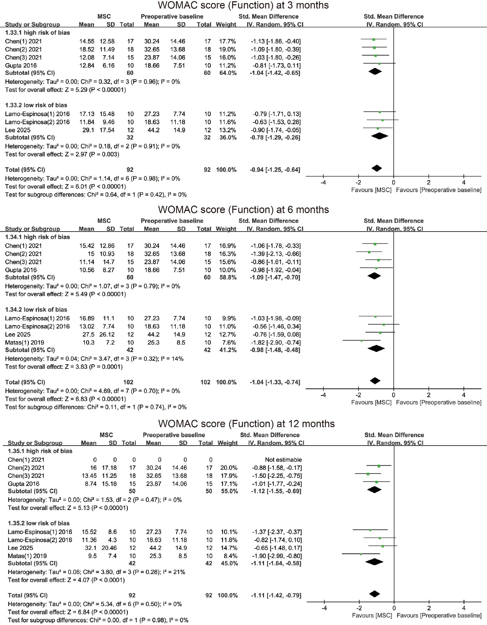
Supplementary Figure S4. Subgroup analysis of WOMAC Score (Function) after single injection MSC at 3, 6, and 12 months based on different risk of bias.

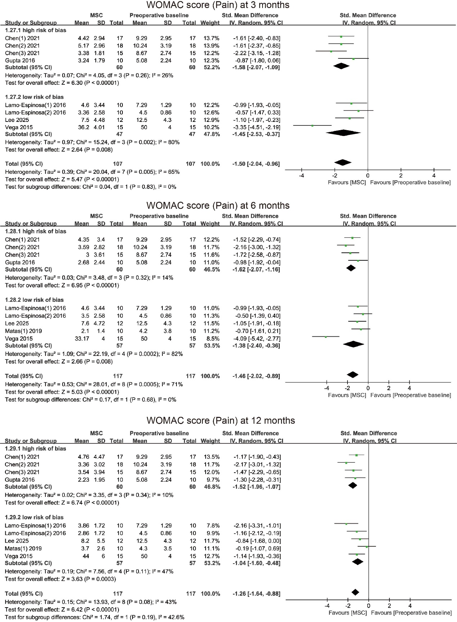
Supplementary Figure S5. Subgroup analysis of WOMAC Score (Pain) after single injection MSC at 3, 6, and 12 months based on different risk of bias.

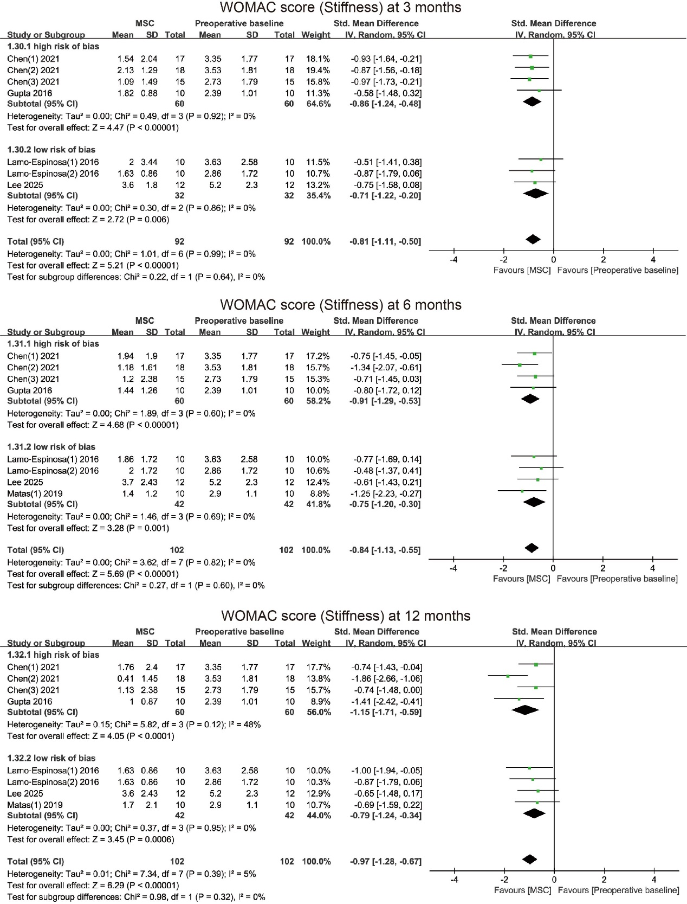
Supplementary Figure S6. Subgroup analysis of WOMAC Score (Stiffness) after single injection MSC at 3, 6, and 12 months based on different risk of bias.

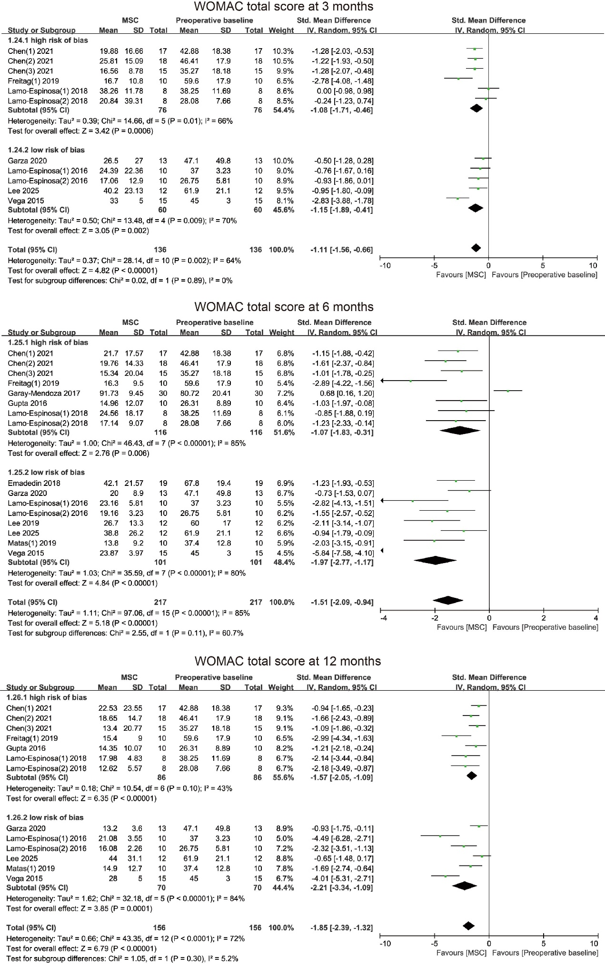
Supplementary Figure S7. Subgroup analysis of WOMAC total score after single injection MSC at 3, 6, and 12 months based on different risk of bias.

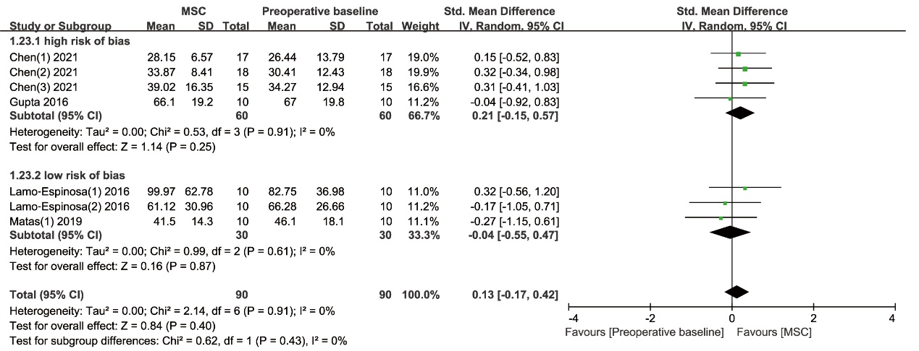
Supplementary Figure S8. Subgroup analysis of WORMS score (Articular cartilage) after single injection MSC based on different risk of bias.

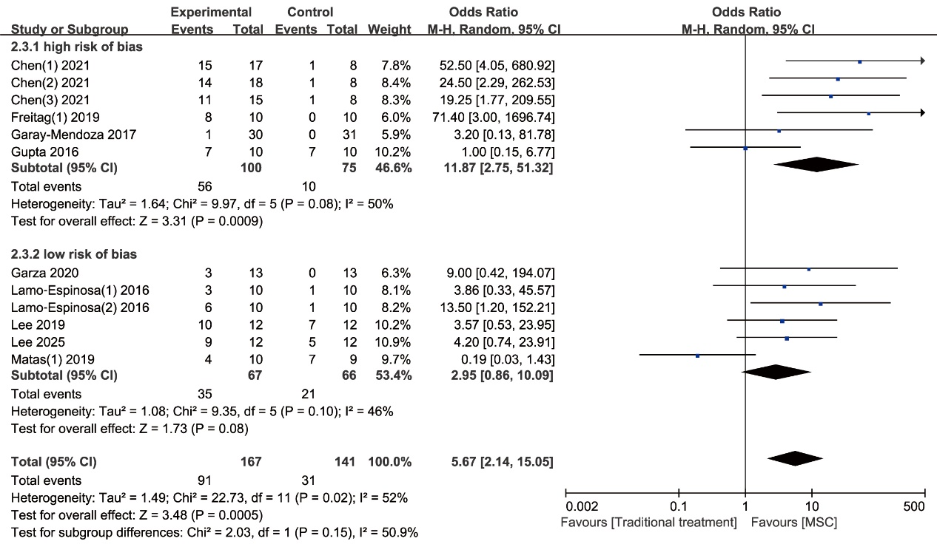
Supplementary Figure S9. Forest plots illustrating the subgroup analysis of single MSC injection and traditional treatment on adverse events based on different risk of bias.

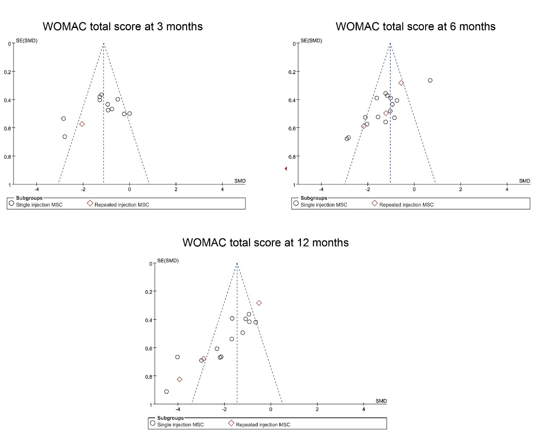
Supplementary Figure S10. Funnel plot showing publication bias of WOMAC total score at different time points in traditional meta-analysis.

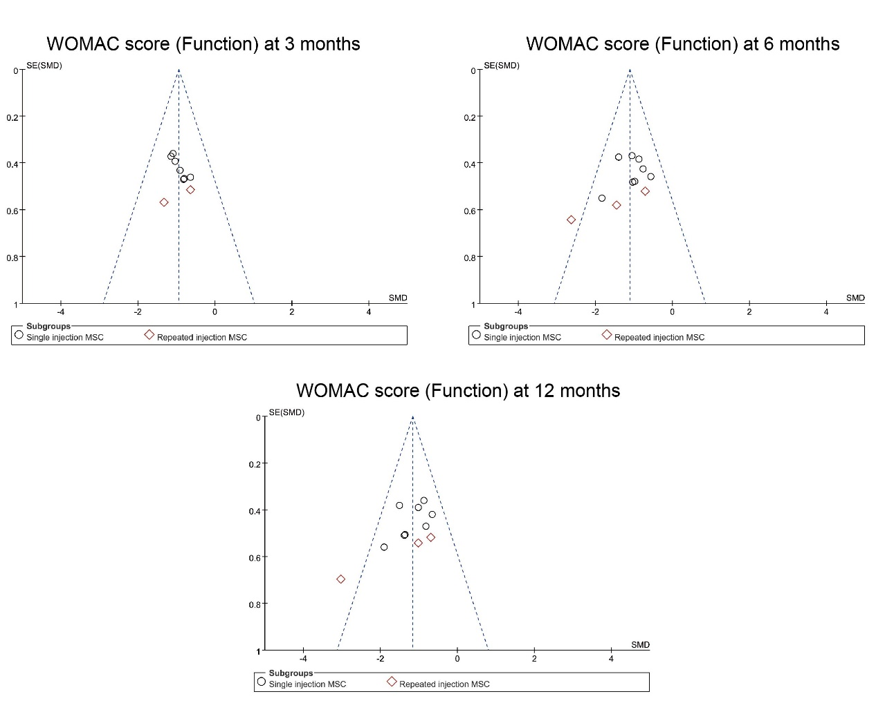
Supplementary Figure S11. Funnel plot showing publication bias of WOMAC score (Function) at different time points in traditional meta-analysis.
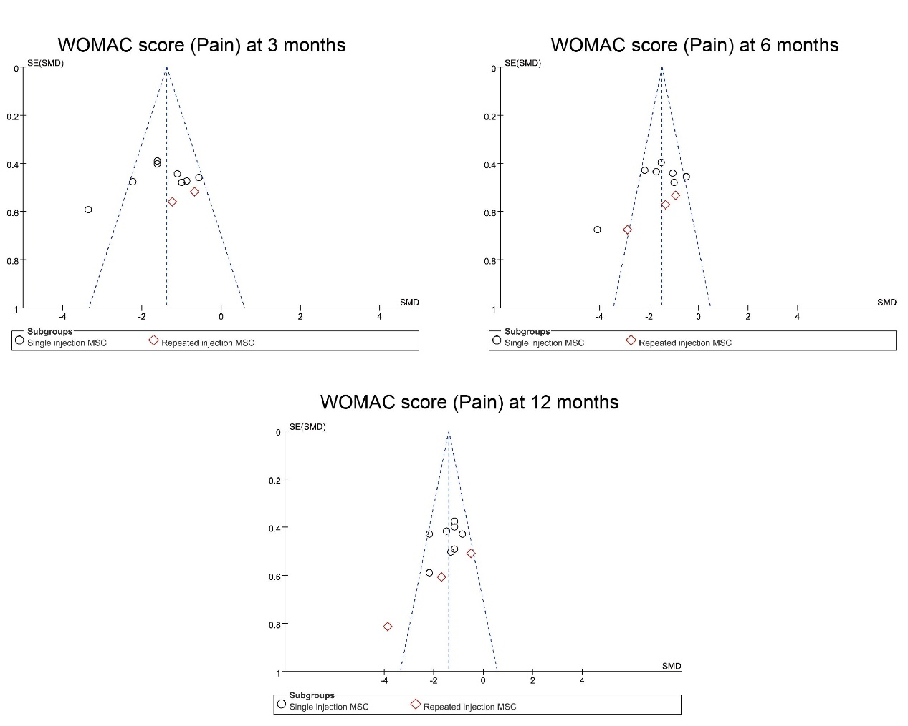
Supplementary Figure S12. Funnel plot showing publication bias of WOMAC score (Pain) at different time points in traditional meta-analysis.
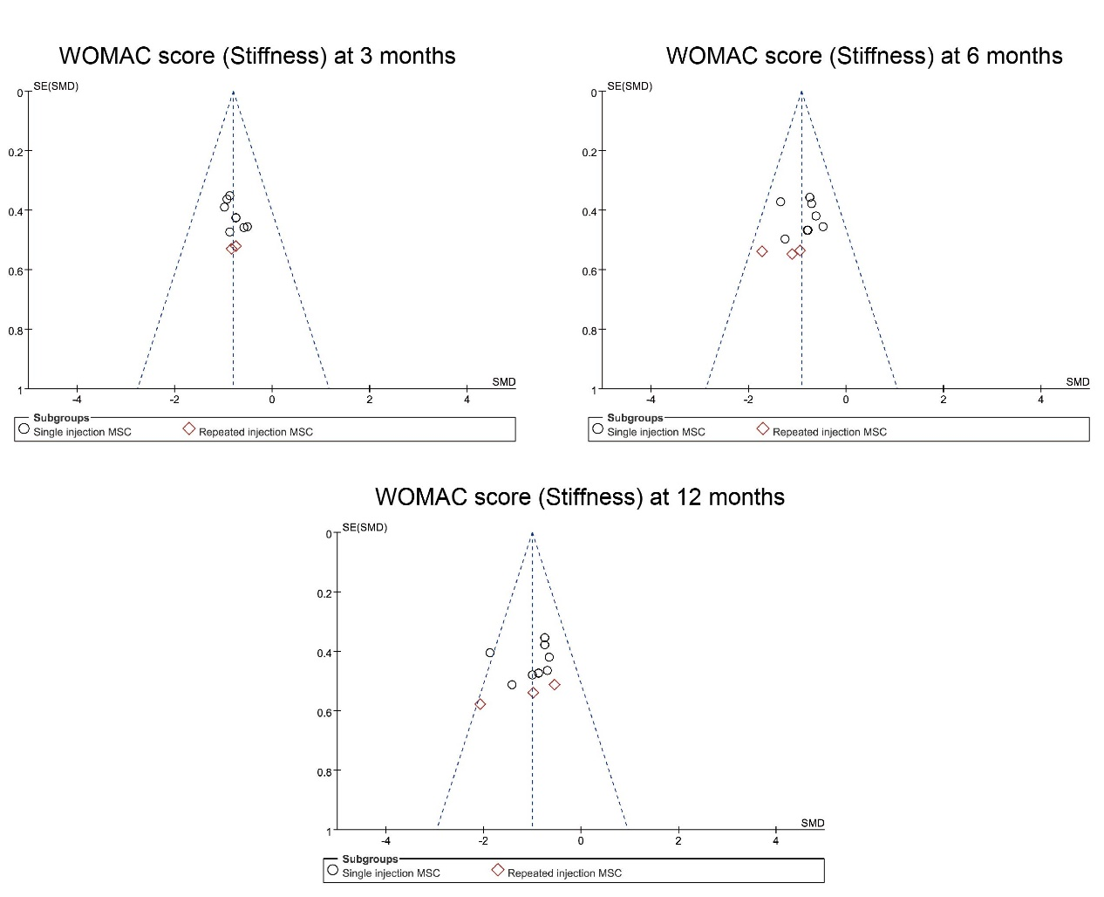
Supplementary Figure S13. Funnel plot showing publication bias of WOMAC score (Stiffness) at different time points in traditional meta-analysis.
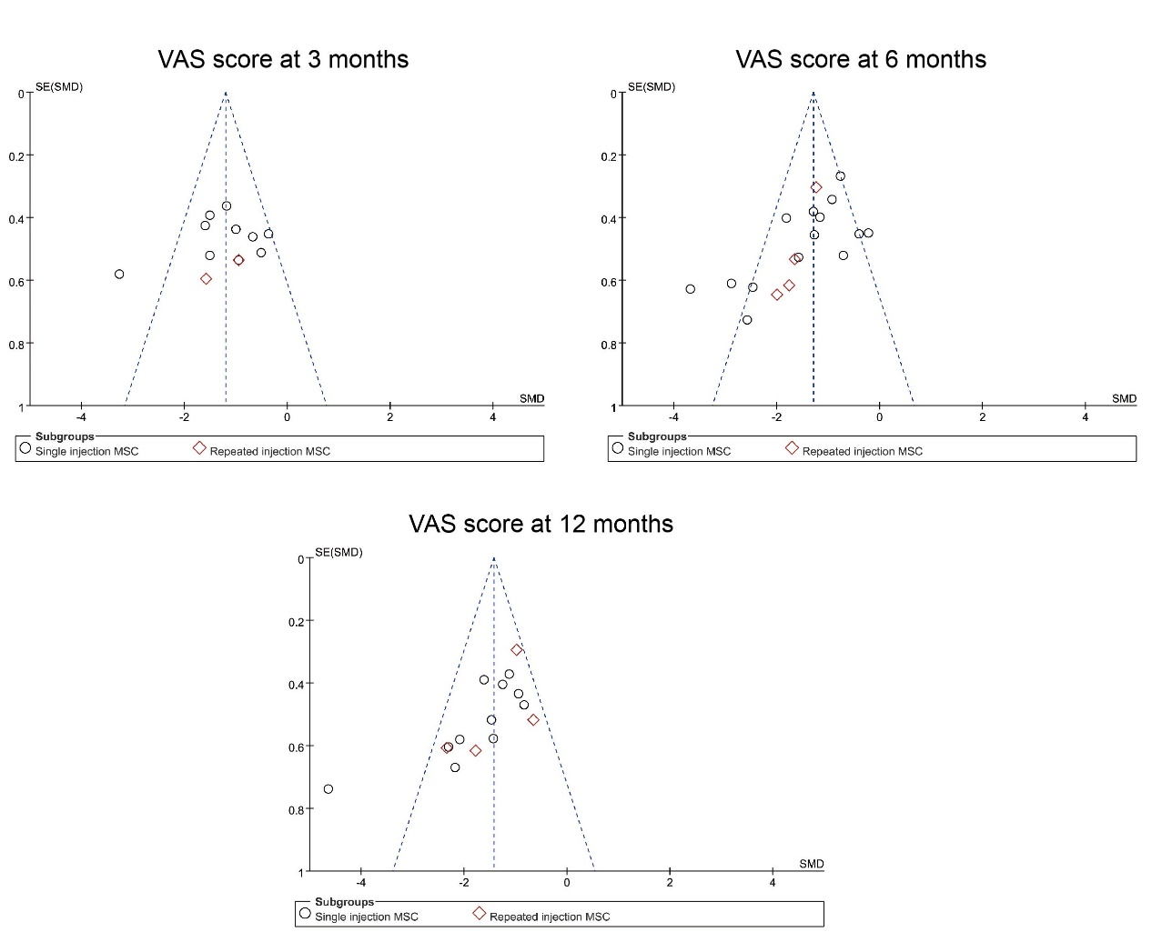
Supplementary Figure S14. Funnel plot showing publication bias of VAS score at different time points in traditional meta-analysis.

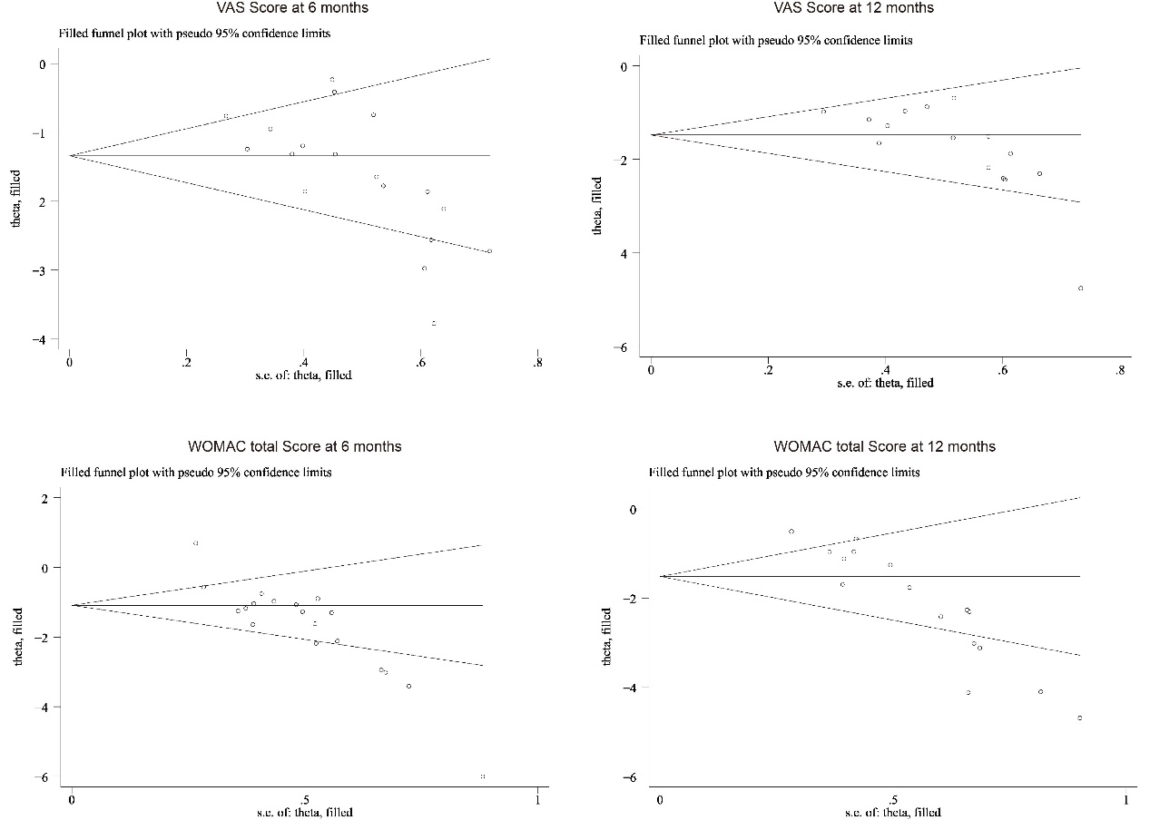
Supplementary Figure S15. Filled funnel plot with pseudo-95% confidence limits for WOMAC total Score at 6 months, WOMAC total Score at 12 months, VAS score at 6 months, and VAS score at 12 months.

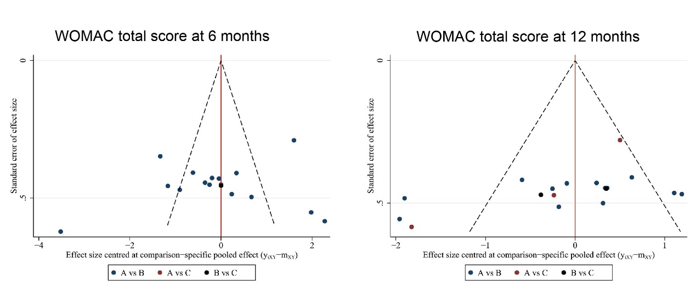
Supplementary Figure S16. Funnel plot showing publication bias of WOMAC total score at different time points in network meta-analysis. A: Traditional treatment; B: single-dose MSC injection; C: repeated-dose MSC injection.

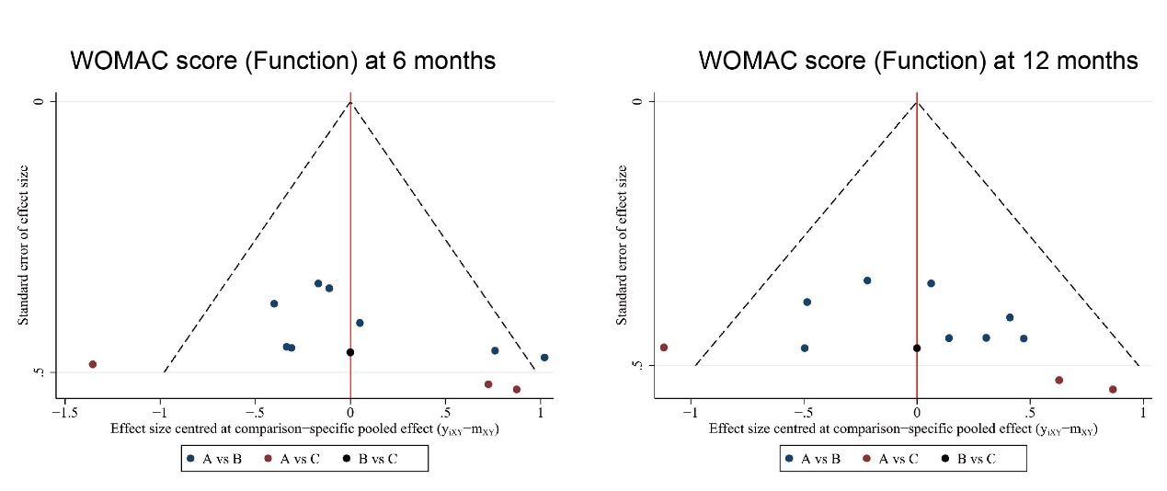
Supplementary Figure S17. Funnel plot showing publication bias of WOMAC score (Function) at different time points in network meta-analysis. A: Traditional treatment; B: single-dose MSC injection; C: repeated-dose MSC injection.

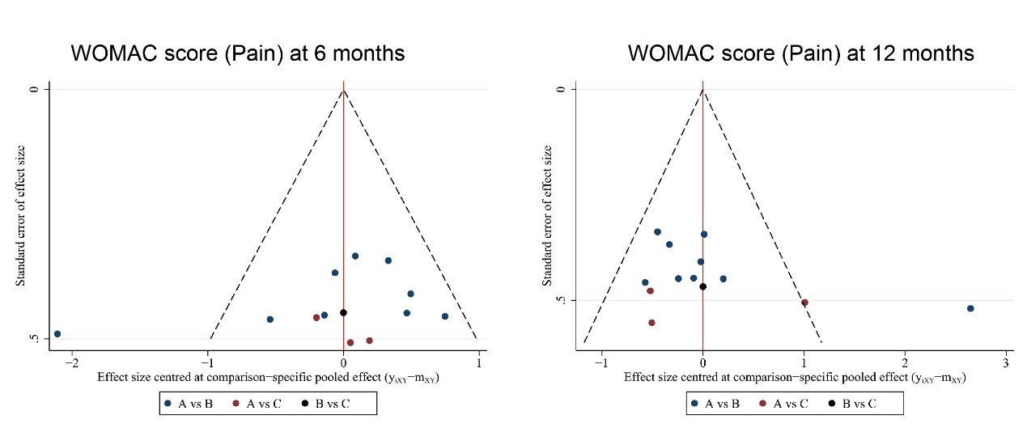
Supplementary Figure S18. Funnel plot showing publication bias of WOMAC score (Pain) at different time points in network meta-analysis. A: Traditional treatment; B: single-dose MSC injection; C: repeated-dose MSC injection.

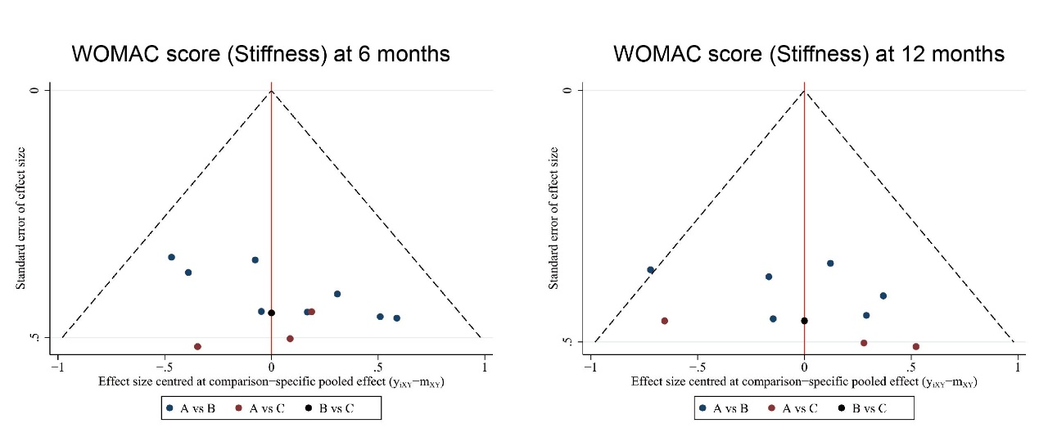
Supplementary Figure S19. Funnel plot showing publication bias of WOMAC score (Stiffness) at different time points in network meta-analysis. A: Traditional treatment; B: single-dose MSC injection; C: repeated-dose MSC injection.

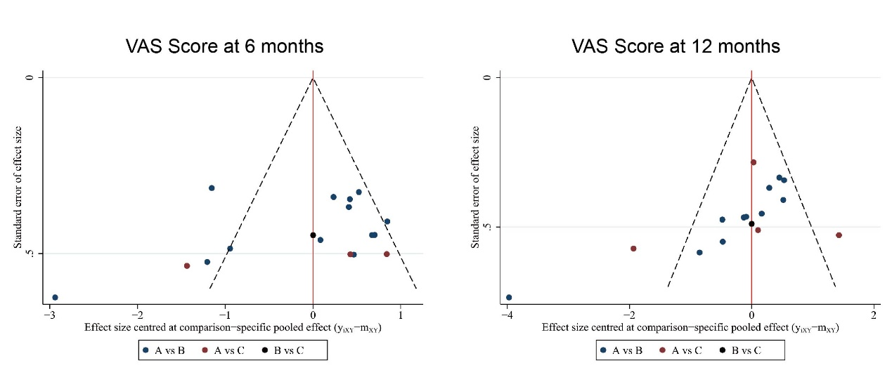
Supplementary Figure S20. Funnel plot showing publication bias of VAS score at different time points in network meta-analysis. A: Traditional treatment; B: single-dose MSC injection; C: repeated-dose MSC injection.

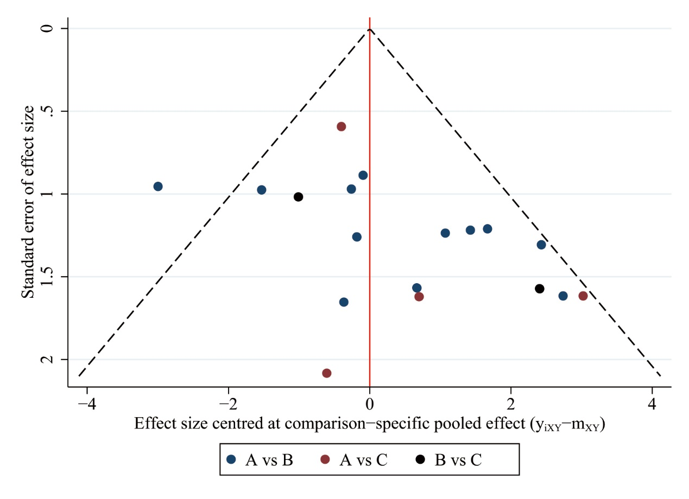
Supplementary Figure S21. Funnel plot showing publication bias of adverse events in network meta-analysis. A: Traditional treatment; B: single-dose MSC injection; C: repeated-dose MSC injection.

