Figure S2. Forest plot of subgroup analysis according to categories of ARDS of all-cause mortality (A), all-cause mortality within 1 month (B), all-cause mortality over 1 month (C), AEs (D), and SAEs (E)
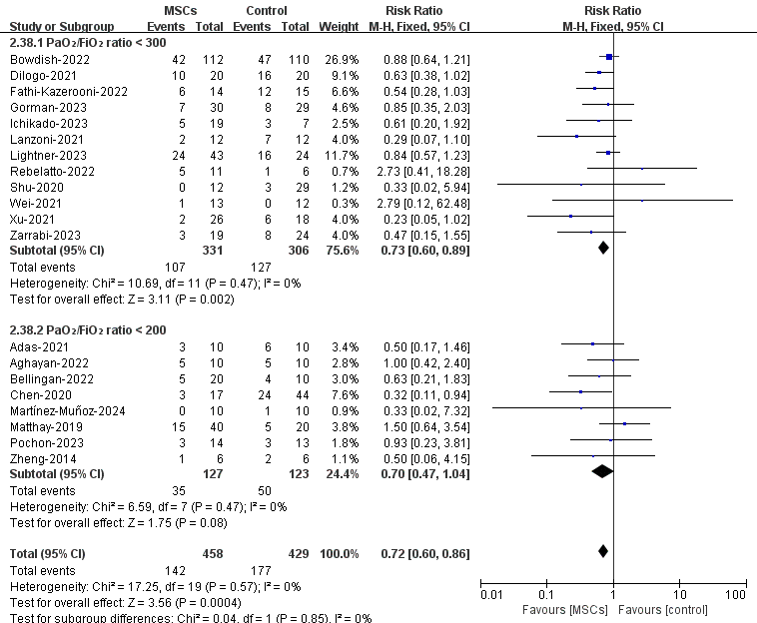
A

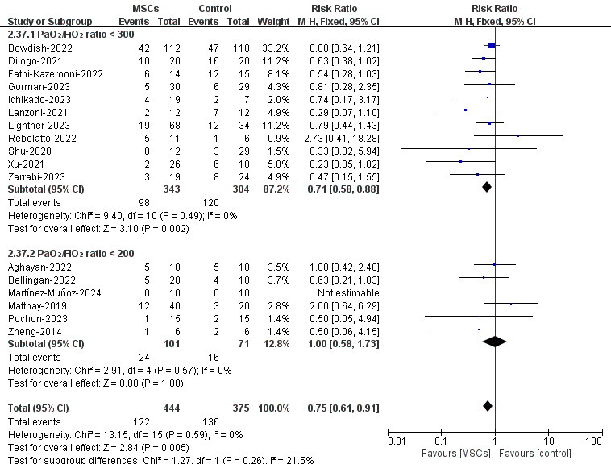
B

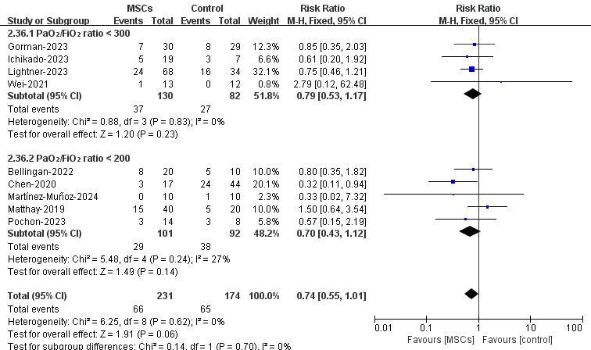
C

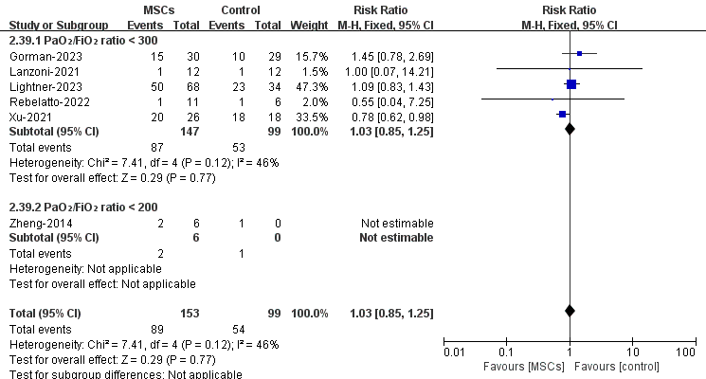
D

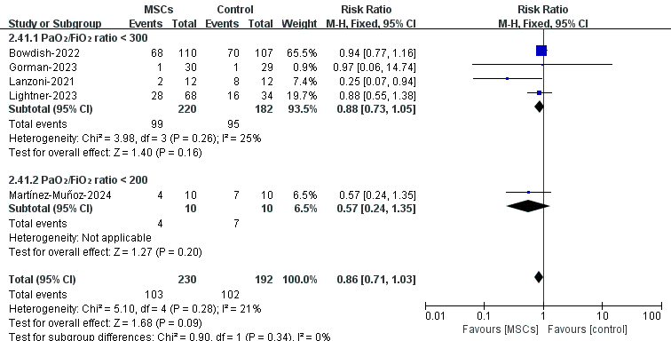
E

