Figure S3. Forest plot of days of hospitalization (A), duration of ventilation (B), ICU-free days within 1 month (C), length of stay in the ICU (D), and ventilation-free days within 1 month (E)

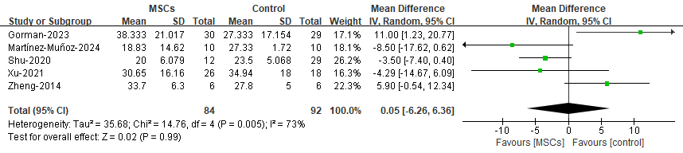A

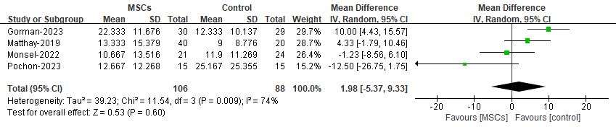B

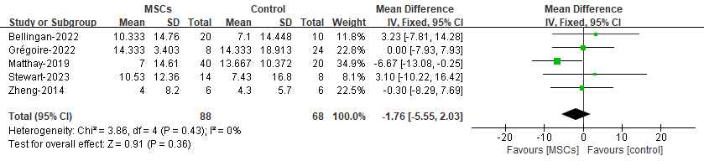C

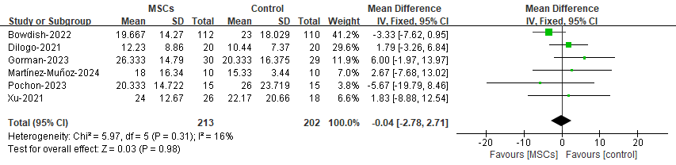D

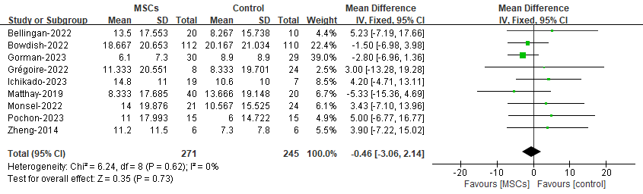E

