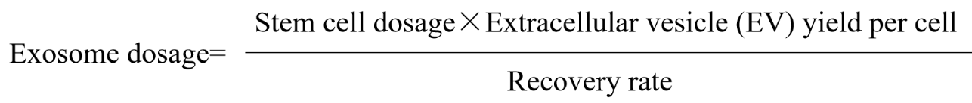
Supplementary Material 1：Exosome-to-stem cell dosage conversion formula
The conversion formula is derived from the following references：Exosomes derived from bone marrow mesenchymal stem cells protect the injured spinal cord by inhibiting pericyte pyroptosis.

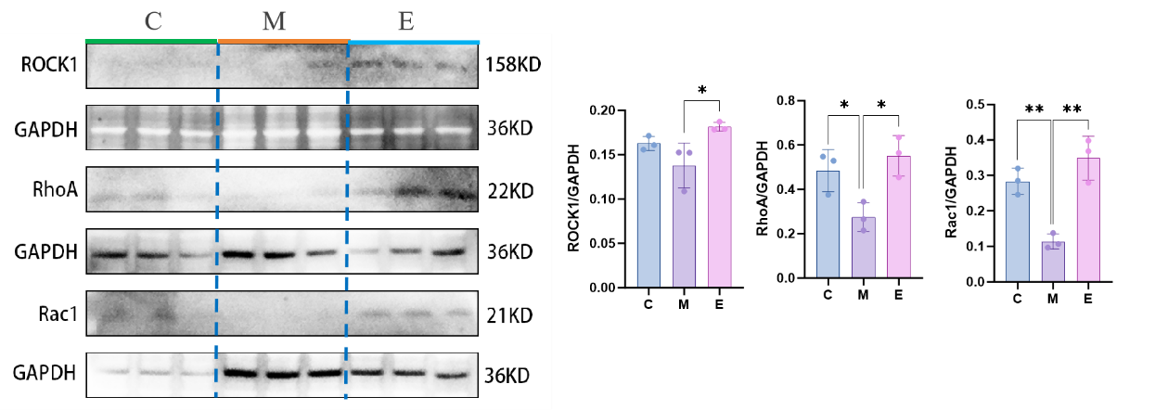
Supplementary Material 2: Western blot results of cytoskeletal proteins in lung tissues
The expression levels of cytoskeleton-related proteins in lung tissues were consistent with the changes in cytoskeleton-related protein expression levels in cells.

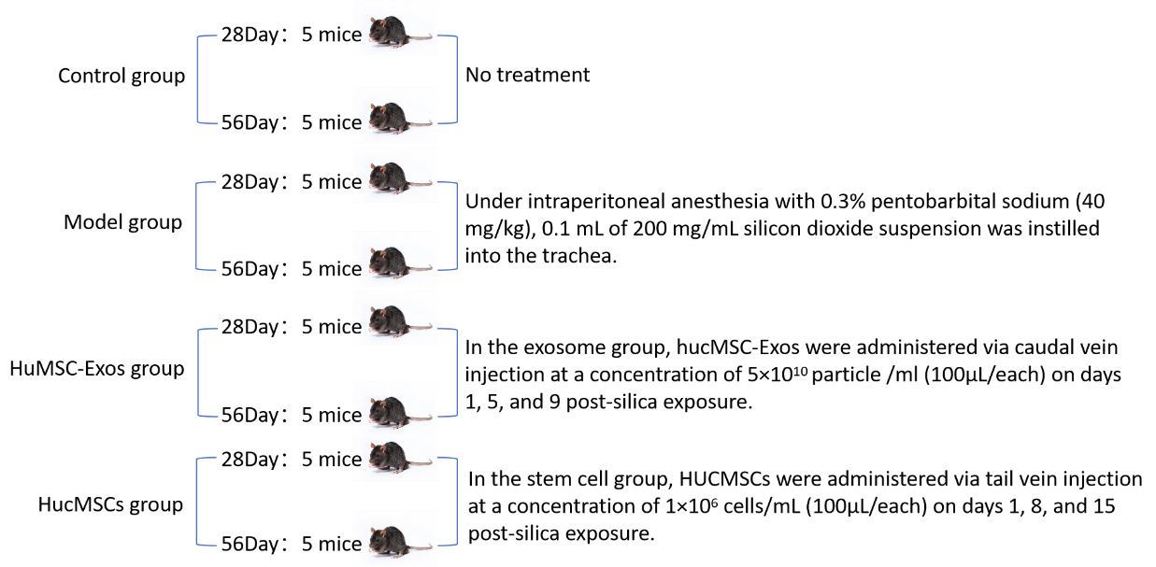
Supplementary Material 3：Animal grouping

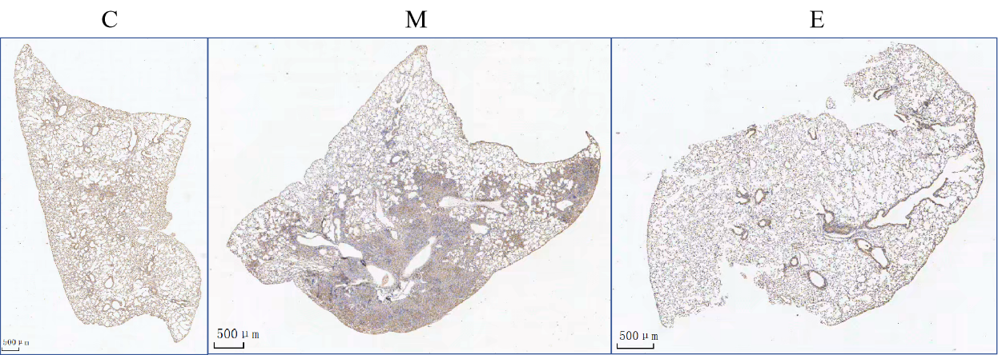
Supplementary Material 4：Immunohistochemistry for F4/80 in lung tissues of mice in each group
The brown color in the figure indicates macrophages.

