Supplementary Materials

Supplementary Figure 1. Scalable production process extracellular vesicles and animal study design.
Three-dimensional (3D)-mesenchymal stem cell spheroids were generated in serum-free medium using a micro-patterned well system. Extracellular vehicles (EVs) were isolated from the culture medium using a combination of filter and tangential flow filtration (TFF) system and measured for concentration and size using nanoparticle tracking (NTA); quality control was done using enzyme-linked immunosorbent assay (ELISA) and quantitative polymerase chain reaction (qPCR).
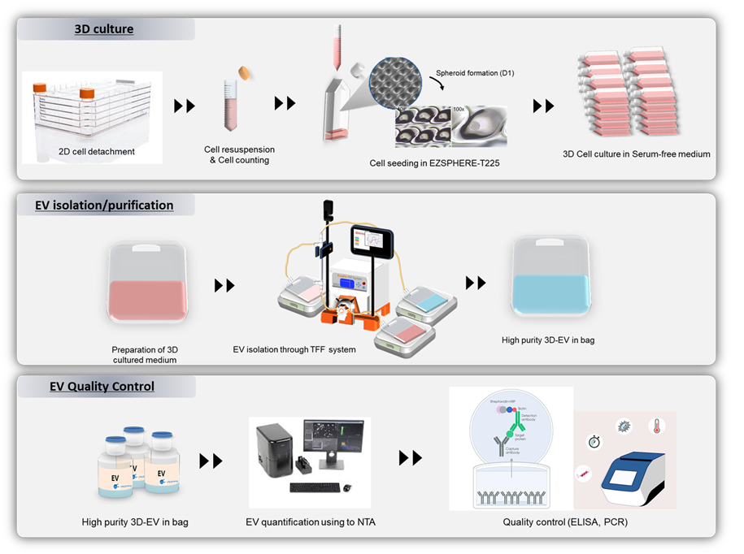

Nanoparticle tracking analysis (NTA)
The concentrations and size distributions of the isolated EVs were characterised by NTA using a NanoSight NS300 instrument (Malvern, Worcestershire, UK). In the NTA software program, the camera level was set to 14. NTA analysis of EVs after pre-diluted in vesicle-free PBS with EVs showed that PBS did not cause osmotic swelling of the EVs. The sample carrier cells were washed with ethanol at each EV measurement. The mean size and concentration (particles/mL) were calculated by integrating the data from three recordings.

Cryo-transmission electron microscopy (TEM)
Purified EVs were fixed with 1% OsO₄ dissolved in 0.1 M phosphate buffer (PB) for 2 h. The EM grid was placed Formvar side down on top of the EV drop for approximately 1 min. The grid was removed, blotted with filter paper, and placed onto a drop of 2% uranyl acetate for 15 s. The excess uranyl acetate was removed, and the EM grid was examined and photographed using TEM (JEM-1011, JEOL, Japan).
The direct visualization of EVs was examined by Cryo-transmission electron microscopy (TEM). Carbon grids (Quantifoil, R1.2/1.3, 200mesh, EMS) were made hydrophilic surface with glow-discharged in Pelco EasiGlow system. An aliquot (4 μL) of samples was applied on to the carbon side of EM grid and blotted for 1.5 s with humidity and temperature of 100 % and 4 °C. Then the sample was plunge-frozen into the precooled liquid ethane with Vitrobot Mark IV (FEI, USA). The samples were analyzed by cryo-electron microscope Talos L120C (FEI) at 120 kv.

MACSPlex
Tetraspanin proteins of EV were characterized using MACSPlex human EV kit (130-122-209, Miltenyi biotec, Germany). Briefly, MACSPlex exosome capture beads were incubated for overnight at room temperature. Beads were washed and incubated with CD9, CD63, and CD81 mix cocktail for 1 hr at room temperature. Beads were twice washed and performed by flow cytometry analysis (FACSLyric, BD Biosciences, USA). FACS data were acquired using FACSuite (BD Biosciences, USA) and analyzed using FlowJo software v10.8.1 (BD Biosciences, USA).

Supplementary Figure 2. Characterization of extracellular vehicles (EVs) obtained from 3D culture system.
(A) EVs morphology and structure were visualized using transmission electron microscopy and cryo-electron microscopy. (B) Size distributions and concentrations of the EVs were assessed using nanoparticle tracking analysis, represented in a histogram. (C) Tetraspanin markers such as CD9, CD63, and CD81 were analyzed using flow cytometry to evaluate surface protein expression. (D) EV negative markers, including gentamicin, albumin, calnexin, histone H3, GM130, and cytochrome C (ELISA).

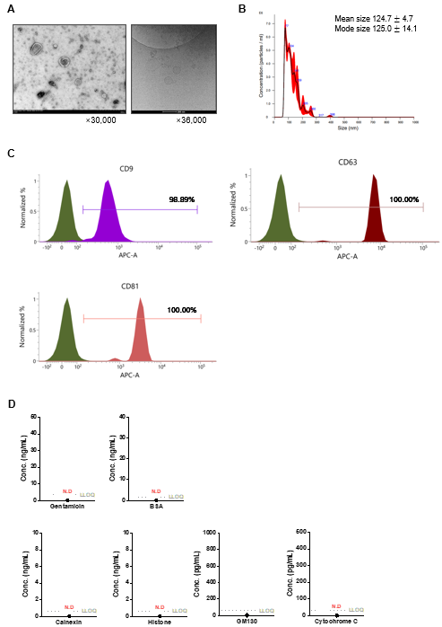

Supplementary Table1.
Gene | Forward Primer sequence (5’=3’) | Reverse Primer sequence (5’=3’)
IL-31 | (F) 5’-CACACAGGAACAACGAAGCC-3’ | (R) 5’-CGATATTGGGGCACCGAAG -3’
IL-1β | (F) 5’-TCAGCCAATCTTCATTGCTCAA-3’ | (R)5’-TGGCGAGCTCAGGTAC-TTCTG-3’
IL-6 | (F)5’-AGGGCTCTTCGGCAAATGTA-3’ | (R) 5’- GAAGGAATGCCCATTAACAACAA-3’
IL-17  IFN-γ  Occuludin  Filaggrin | (F)5’-TGTGATCTGGGAAGCTCAGT-3’  (F)5’-CTGATGGGAGGAGATGCTA -3’  (F)5’-TGGCAAGCGATCATACCCAGAG-3’  (F)5’-ATGTCCG CTCTCCTGGAAAG-3’ | (R) 5’-TCTTCTCGACCCTGAAAGTG-3’  (R) 5’-CGGGTGTAGTCACAGTTTTC-3’  (R) 5’-CTGCCTGAAGTCATCCACACTC-3’  (R) 5’-TGGATTCTTCAAGACTGCCTGTA-3’
GAPDH | (F) 5’-GCCACATCGCTCAGACACC-3’ | (R) 5’-CCCAATACGACCAAATCCGT-3’

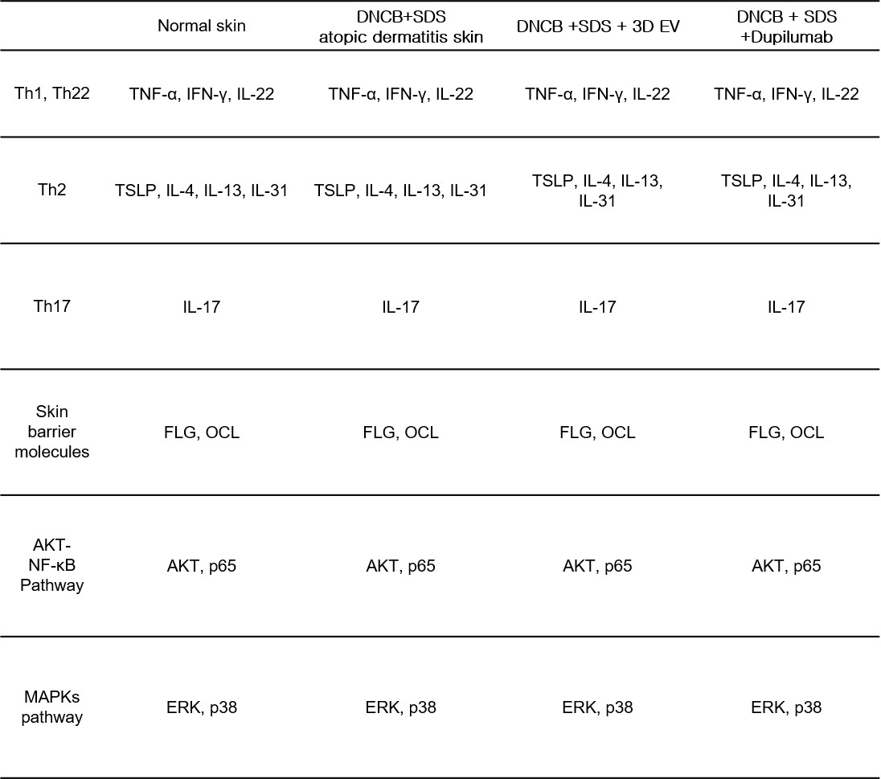
Table 2

