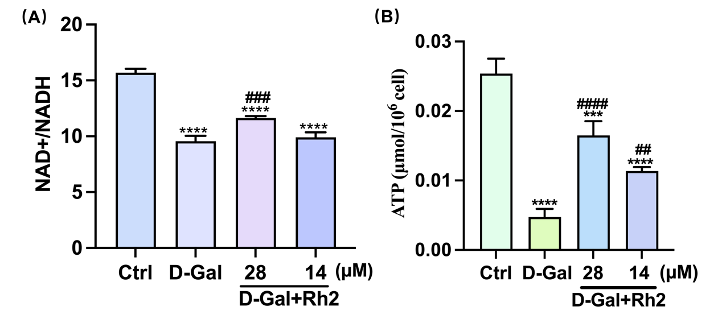
Figure S1 Rh2 regulated the metabolism function of mitochondria in senescent MSCs. (A) Levels of NAD^{+/}NADH in the D-Gal and D-Gal+Rh2 groups. (B) Levels of ATP in the D-Gal and D-Gal+Rh2. All experiments were independently repeated 3 times. (*P<0.1, **P<0.01, ***P<0.001,****P<0.0001 compared with Ctrl group; #P<0.05, ##P<0.01, ###P<0.001, ####P<0.0001 compared with D-Gal group)

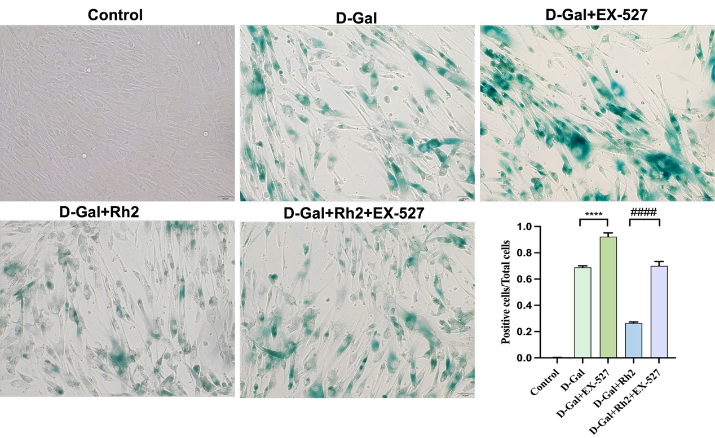
Figure S2 Activated SIRT1 by Rh2 controlled the senescent phenotype. A representative picture and histogram of SA-β-gal staining of senescent MSCs treated with the SIRT1 inhibitor EX-527 in the D-Gal and D-Gal+Rh2 groups. All experiments were independently repeated 3 times. (*P<0.1, **P<0.01, ***P<0.001,****P<0.0001 compared with D-Gal group; #P<0.05, ##P<0.01, ###P<0.001, ####P<0.0001 compared with D-Gal+Rh2 group)

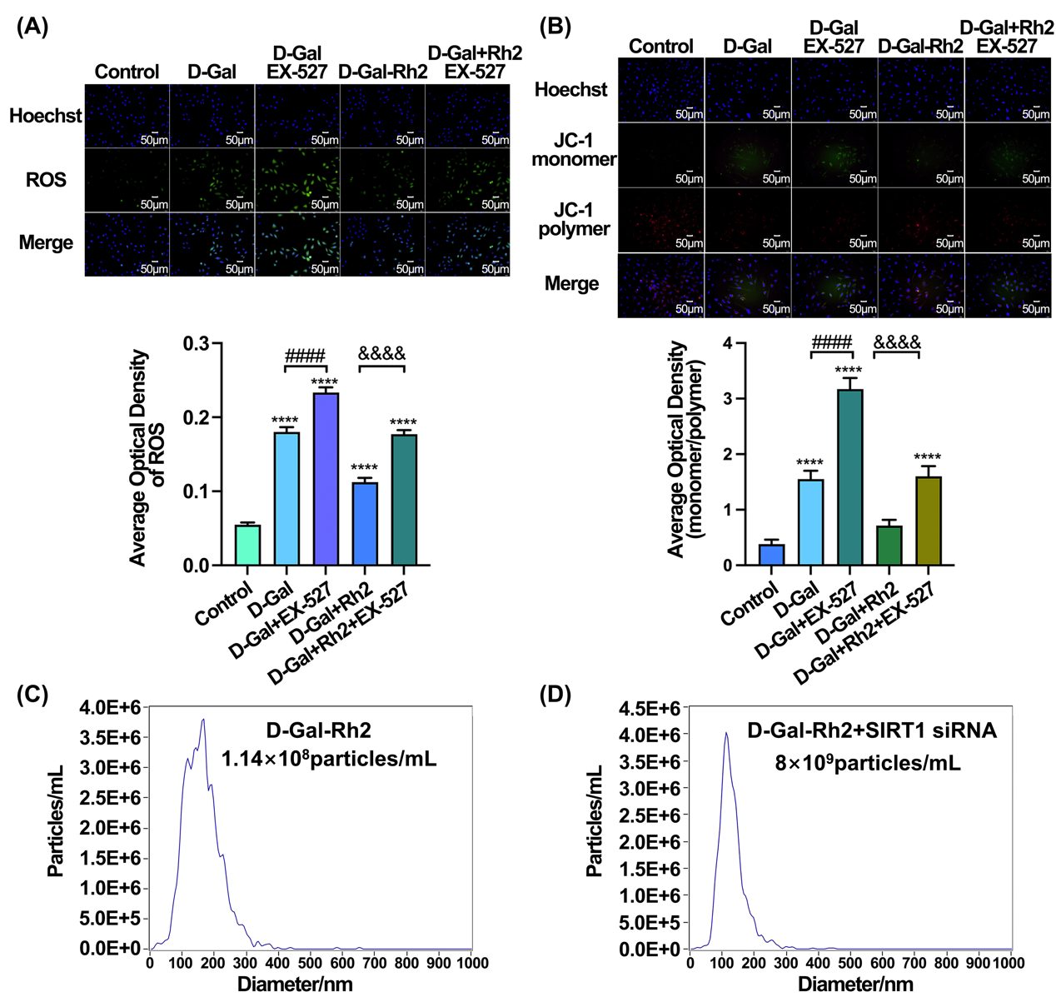
Figure S3 Activated SIRT1 by Rh2 controlled the function of mitochondria and lysosomes in senescent MSCs. (A) Representative fluorescent images of ROS levels and quantification of ROS levels under SIRT1 inhibitor EX-527 treatment in the D-Gal and Rh2-D-Gal groups. Scale bar, 50 μm. (B) Representative fluorescent images of mitochondrial membrane potential under SIRT1 inhibitor EX-527 treatment in the D-Gal and Rh2-D-Gal groups. Scale bar: 50 μm. (C) Average size and number of exosomes under SIRT1 knockdown in the Rh2-D-Gal group. All experiments were independently repeated 3 times.(*P<0.1, **P<0.01, ***P<0.001, ****P<0.0001 compared with Control group; #P<0.05, ##P<0.01, ###P<0.001, ####P<0.0001 compared with D-Gal group;&&&&P<0.0001 compared with Rh2-D-Gal group)

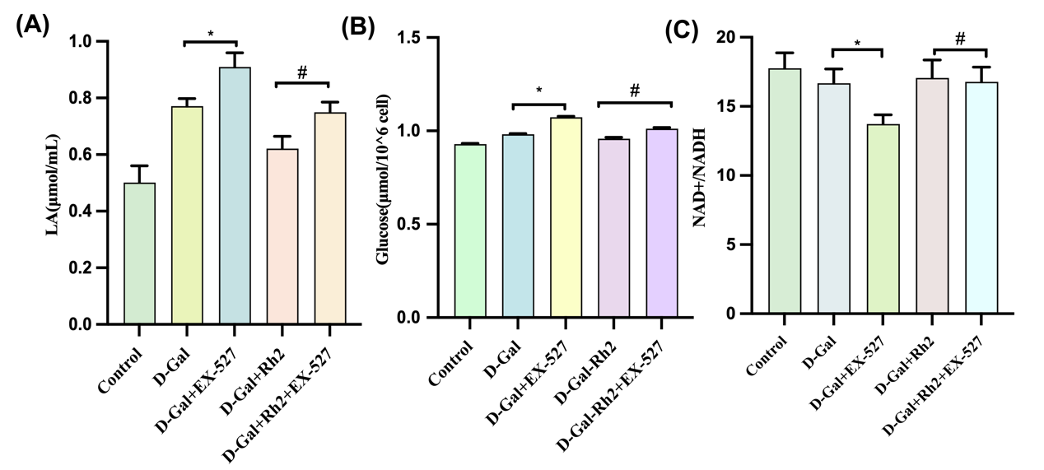

Figure S4 Activated SIRT1 by Rh2 controlled the metabolism function of mitochondria in senescent MSCs. (A-C) Levels of lactic acid (LA), glucose, NAD^{+/}NADH under SIRT1 inhibitor EX-527 treatment in the D-Gal and Rh2-D-Gal groups. All experiments were independently repeated 3 times. (*P<0.1, **P<0.01, ***P<0.001, ****P<0.0001 compared with D-Gal group; #P<0.05, ##P<0.01, ###P<0.001, ####P<0.0001 compared with D-Gal+Rh2 group)

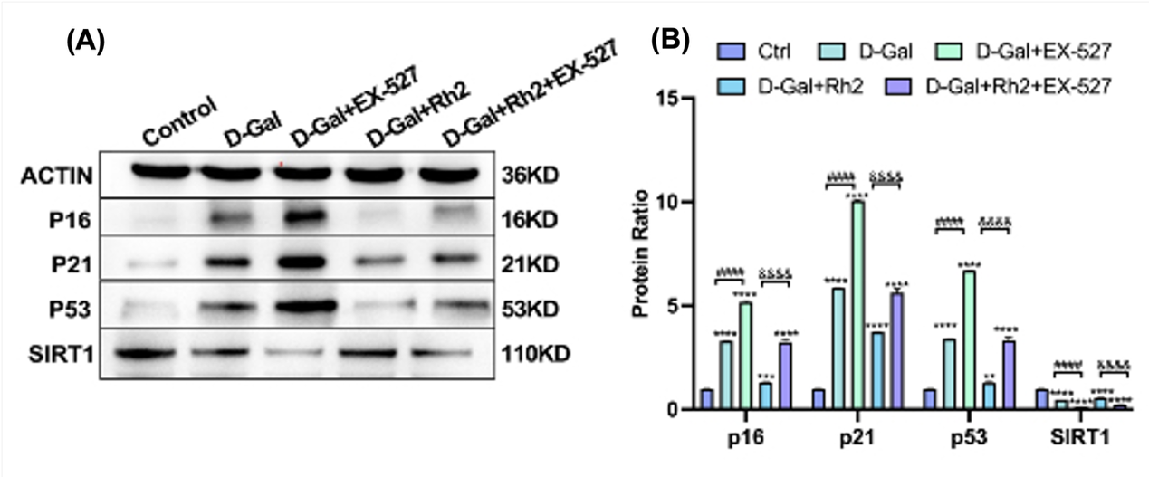
Figure S5 Activated SIRT1 by Rh2 controlled the senescent related biomarker in senescent MSCs. Representative western blot images (A) and quantitative histograms (B) of p16, p21, and p53 protein level in D-Gal and D-Gal+Rh2 groups following treatment with the SIRT1 inhibitor EX-527. Full-length blots/gels are presented in Supplementary Figure S14. n=3 in each group. (**Values are the mean±SD; (**P<0.01, ***P<0.001, ****P<0.0001compared with Ctrl group; ##P<0.01, ###P<0.001, ####P<0.0001 compared with D-Gal group)

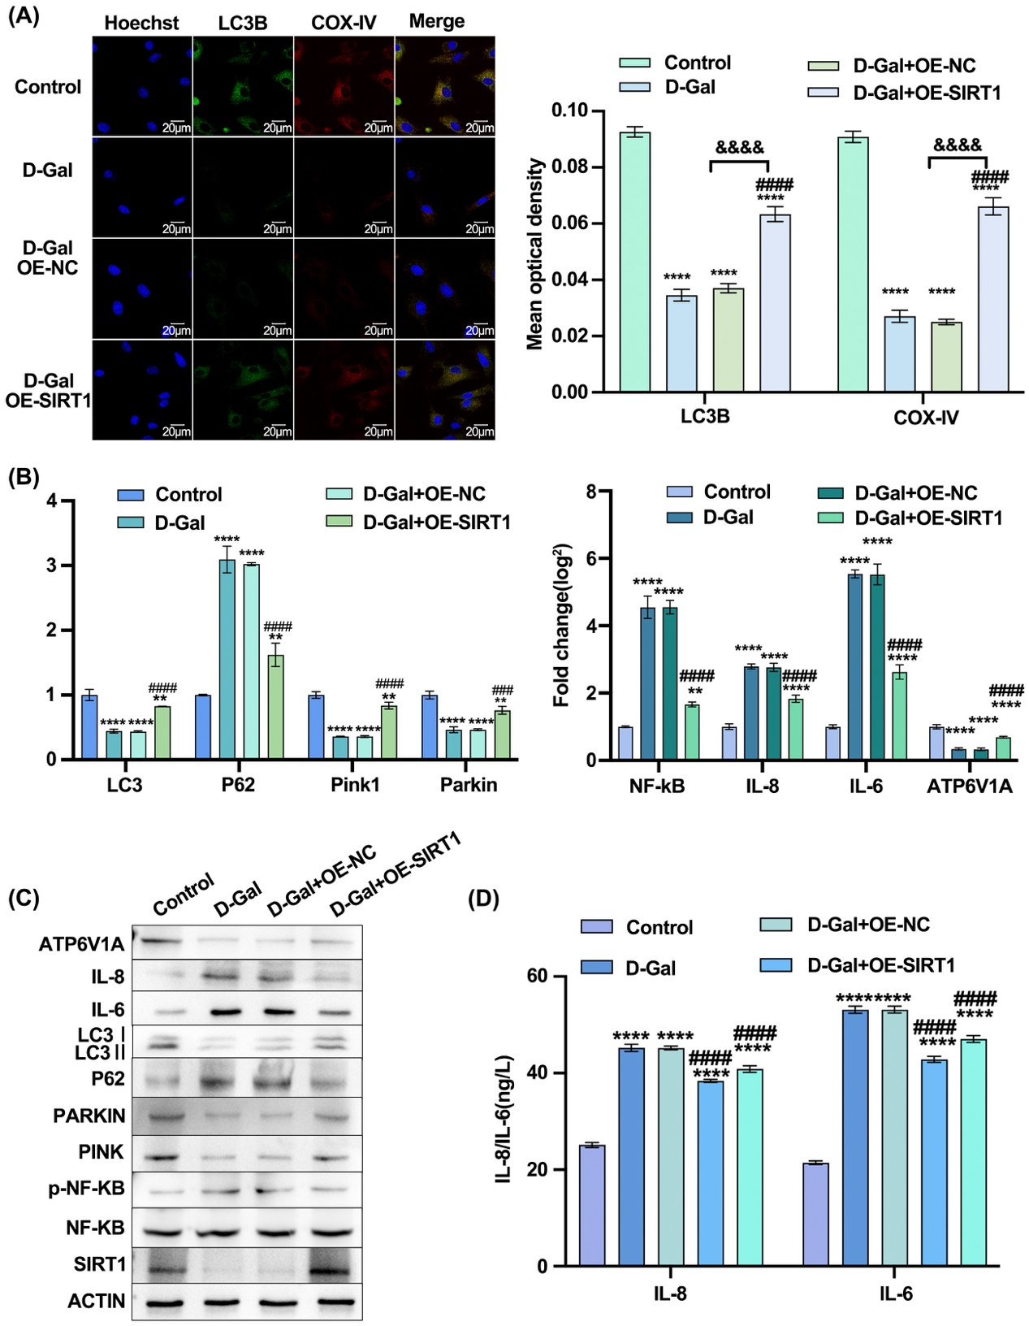
Figure S6 SIRT1 regulate mitophagy and lysosome in senescent MSCs. (A) Immunofluorescence colocalization staining of LC3B and COXIV when the SIRT1 was overexpressed in D-Gal group. (B) RT-PCR analysis of senescent related gene of mitophagy related gene of LC3, p62, pink1 and parkin, senescence related gene NF-kB, IL-8, IL-6 and lysosome regulation related gene ATP6V1A, when the SIRT1 was overexpressed in D-Gal group. (C) Western blot analysis of LC3, ATP6V1A, IL-6,IL-8, p62, SIRT1, PARKIN, PINK1 when the SIRT1 was overexpressed in D-Gal group. (D) ELLSA analysis of IL-8, IL-6 when the SIRT1 was overexpressed in D-Gal group. All experiments were independently repeated 3 times. (*P<0.05，**P<0.01，***P<0.001，****P<0.0001 compared with Control group; #P<0.05，##P<0.01，###P<0.001，####P<0.0001 compared with D-Gal group
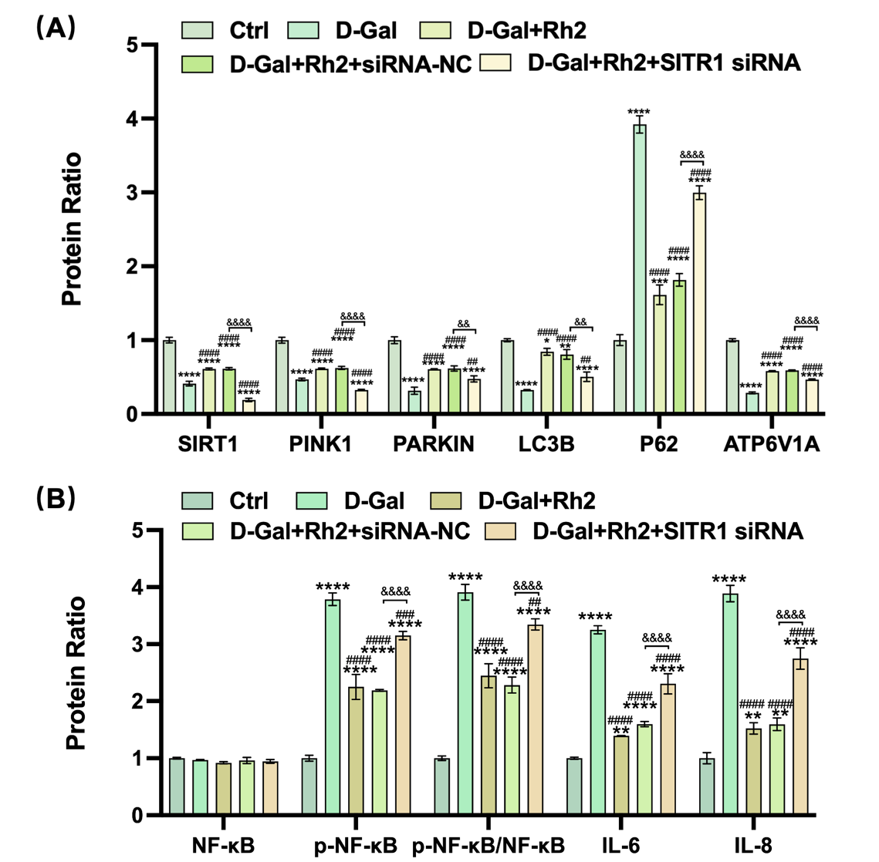

Figure S7 Rh2 regulated mitophagy and lysosome function by inhibiting the expression of SIRT1. A representative histogram of the levels of proteins SIRT1, PINK1, PARKIN, LC3B, P62, ATP6V1A (A) and NF-κB, p-NF-κB, p-NF-κB/NF-κB, IL-6, IL-8 detected by western blot analysis with the protein GAPDH as a reference. Values are the mean ± SD; n = 3 in each group.

Table S1. Primer sequences for qRT-PCR assays
Gene name | Forward (5’-3’) | Reverse (5’-3’)
GADPH | ACTCTACCCACGGCAAGTTCAACG | ATACTCAGCACCAGCATCACCCCA
SIRT1 | GGAGCAGATTAGTAAGCGTCTT | CACTTTCATCTTCCAAGGGTTC
LC3B | ACCAAGCCTTCTTCCTCCTG | CGGCTTCCTGTACATGGTCT
P62 | CTAGAGGGGCTTTGGTTCGT | GCTCCCCATGTCCATAGTCA
IL6 | TGCCTTCTTGGGACTGATG | TACTGGTCTGTTGTGGGTG
MMP3 | TTGAAGGTCTGGGAGGAG | AGCATTGGCTGAGTGAAA
IL1α | CAGCCCTTTACTGAAGATGAC | ATGATGAACTCCTGCTTGACG
IL3 | CTCTGTGCTGCCAGGTGTC | TCATAGGGCGGAAGTTGTC
GM-CSF | CTACAGTTTCTCAGCACCCACC | CTCCAGAGCACGCATGTCATTTA
IL8 | TGGTCTCAGCCACCCGC | CCCTGTGGCTTGGCGG
PINK1 | TACCGCTTCTTCCGCCAGTCG | GCTCTCCGCCTGCTTCTCCTC
PARKIN | GTGCCAATCTCCAGACTG | ATCGTTGAGCCTTGTGAC
ATP6V1A | ATGATGGCTGACTCTACCT | CTCCTACAATGCTGACACT
NF-κB | CCAGATAACTTCGGCATCA | GGTCATATTGTTACGCTCAC

