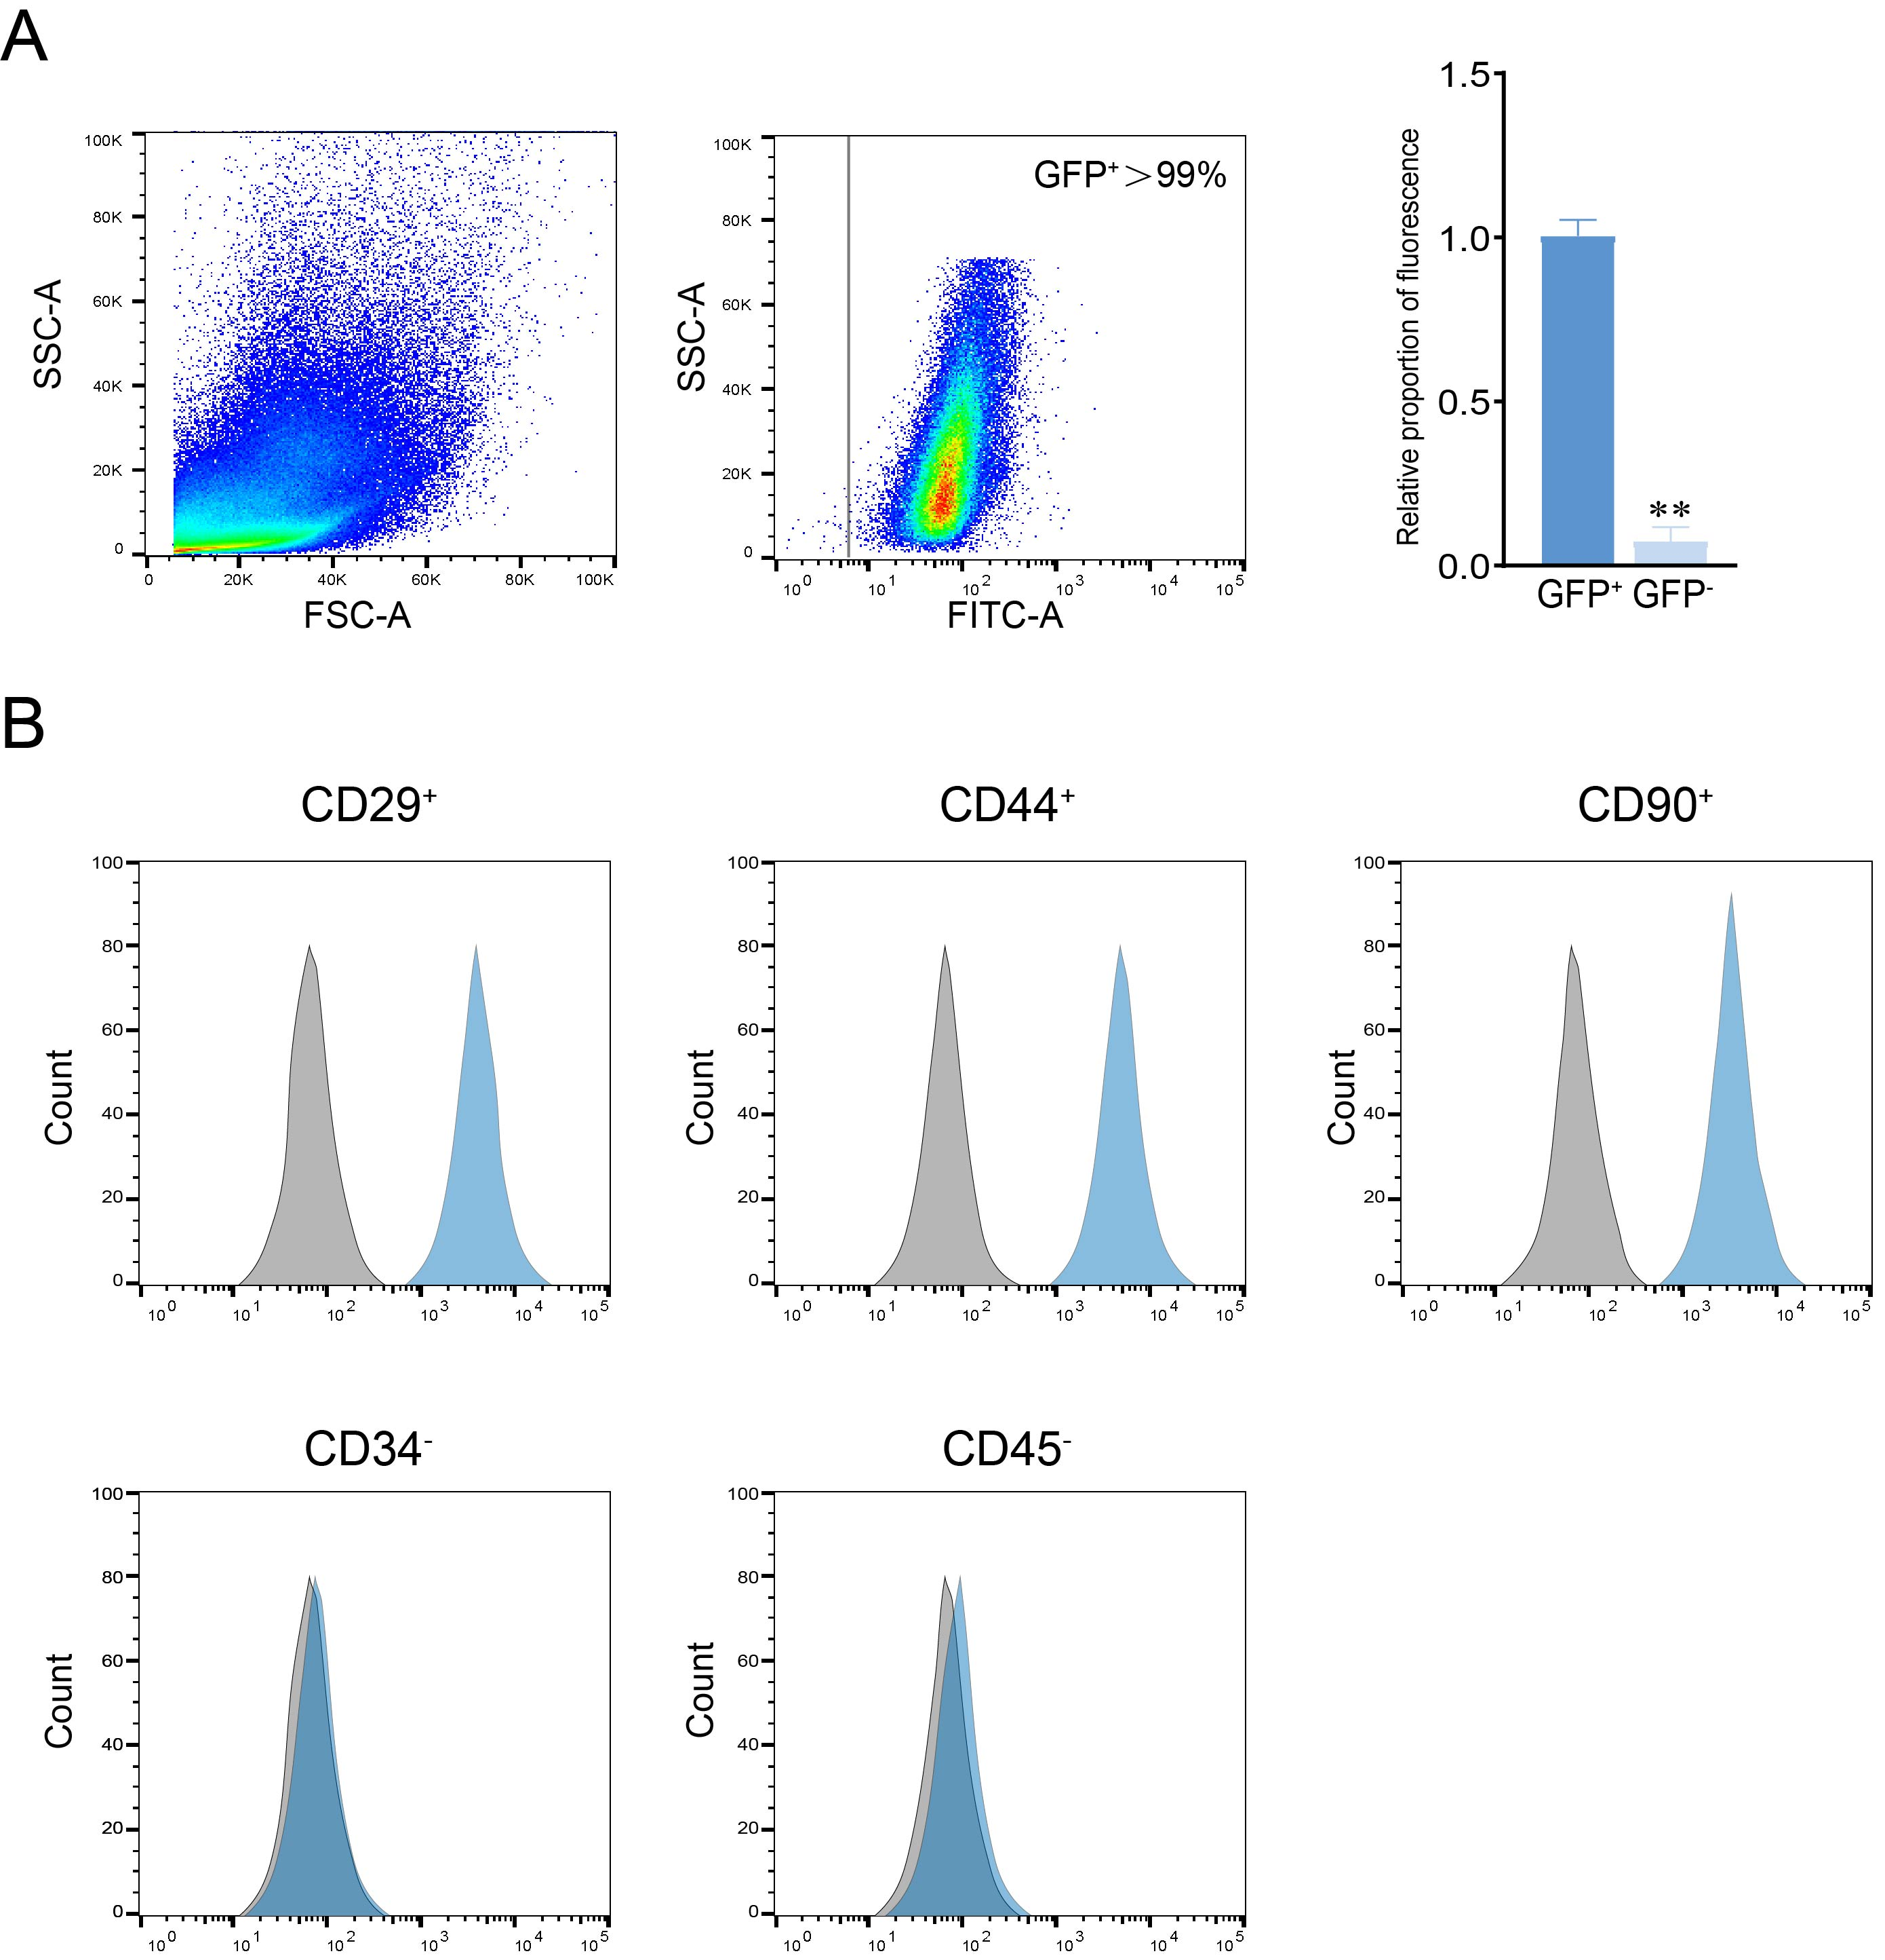Supplementary Figure S1. Purity validation of sorted GFP⁺ADSCs by flow cytometry.
(A) Gating strategy and post-sort analysis: Viable cells were gated based on FSC-A/SSC-A to exclude debris and dead cells. GFP⁺ cells were sorted from the viable cell population, showing clear separation from GFP⁻cells. Quantitative histogram of GFP fluorescence intensity confirmed >99% purity of sorted GFP⁺ cells (**P < 0.005 vs. GFP⁻control).
(B) Surface marker characterization of sorted GFP⁺ ADSCs: Histograms show high expression of mesenchymal markers (CD29, CD44, CD90; blue peaks) compared to isotype controls (gray peaks), and minimal expression of markers (CD34, CD45; blue peaks overlapping with isotype controls), confirming ADSC identity.

