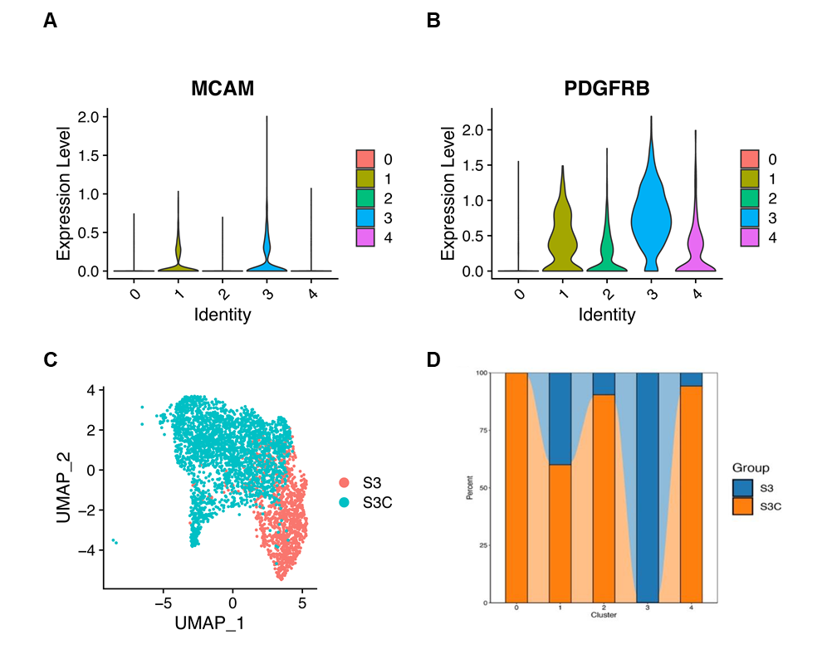
Supplementary Fig S1 - The marker expression and distribution among different subpopulations of undifferentiated and differentiated eMSCs
(A) CD146 and (B) CD140b expression of different subpopulations. (C) The distribution of undifferentiated (S3) and differentiated eMSCs (S3C). (D) The proportion of undifferentiated (S3) and differentiated eMSCs (S3C) in different subpopulations.

