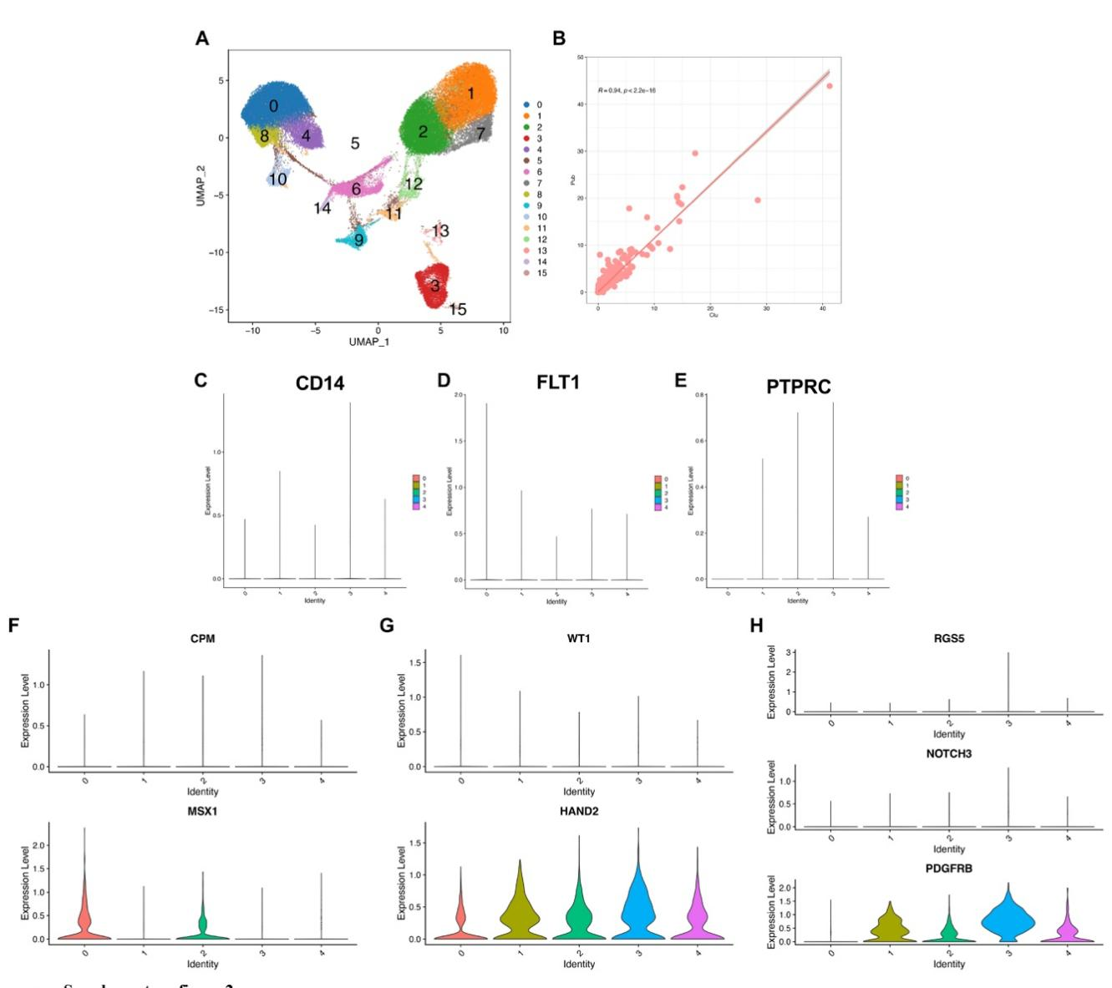

Supplementary Fig S2 - The primary human endometrial cell marker expression and distribution among different subpopulations.
(A) Unsupervised clustering of scRNA-seq data integrated primary human endometrial cells and cultured eMSCs. (B) Pearson correlation analysis of cultured and primary eMSCs. The gene expression and distribution of (C) CD14 - macrophage marker; (D) FLT1 - endothelial cell marker; (E) PTPRC – lymphocyte marker; (F) CPM - luminal epithelial cell marker; (G) WT1 - stromal cell marker and (H) RGS5 - perivascular cell marker among different cultured endometrial stromal subpopulations.

