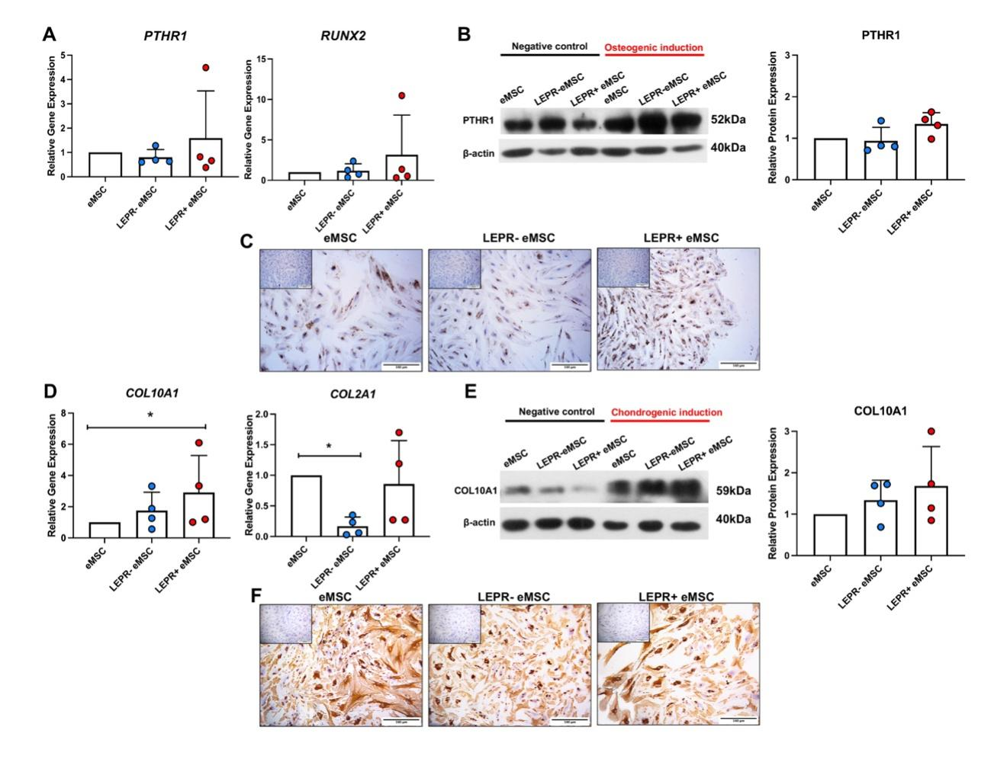
Supplementary Fig S3 – Determination of trilineage differentiation potential of different cultured endometrial stromal subsets
In vitro differentiation potential of eMSCs, LEPR⁻ eMSCs and LEPR⁺ eMSCs into osteogenic and chondrogenic lineages (n = 4). Comparison of relative mRNA levels of (A) osteogenic lineage specific genes PTHR1 and RUNX2, (D) chondrogenic lineage specific genes COL10A1 and COL2A1. Representative western blot images and quantitative analysis of (B) PTHR1 and (E) COL10A1 protein. Immunocytochemical staining of (C) PTHR1 and (F) COL10A1. Results are presented as mean ± SD; * P < 0.05; scale bar: 100 µm.

